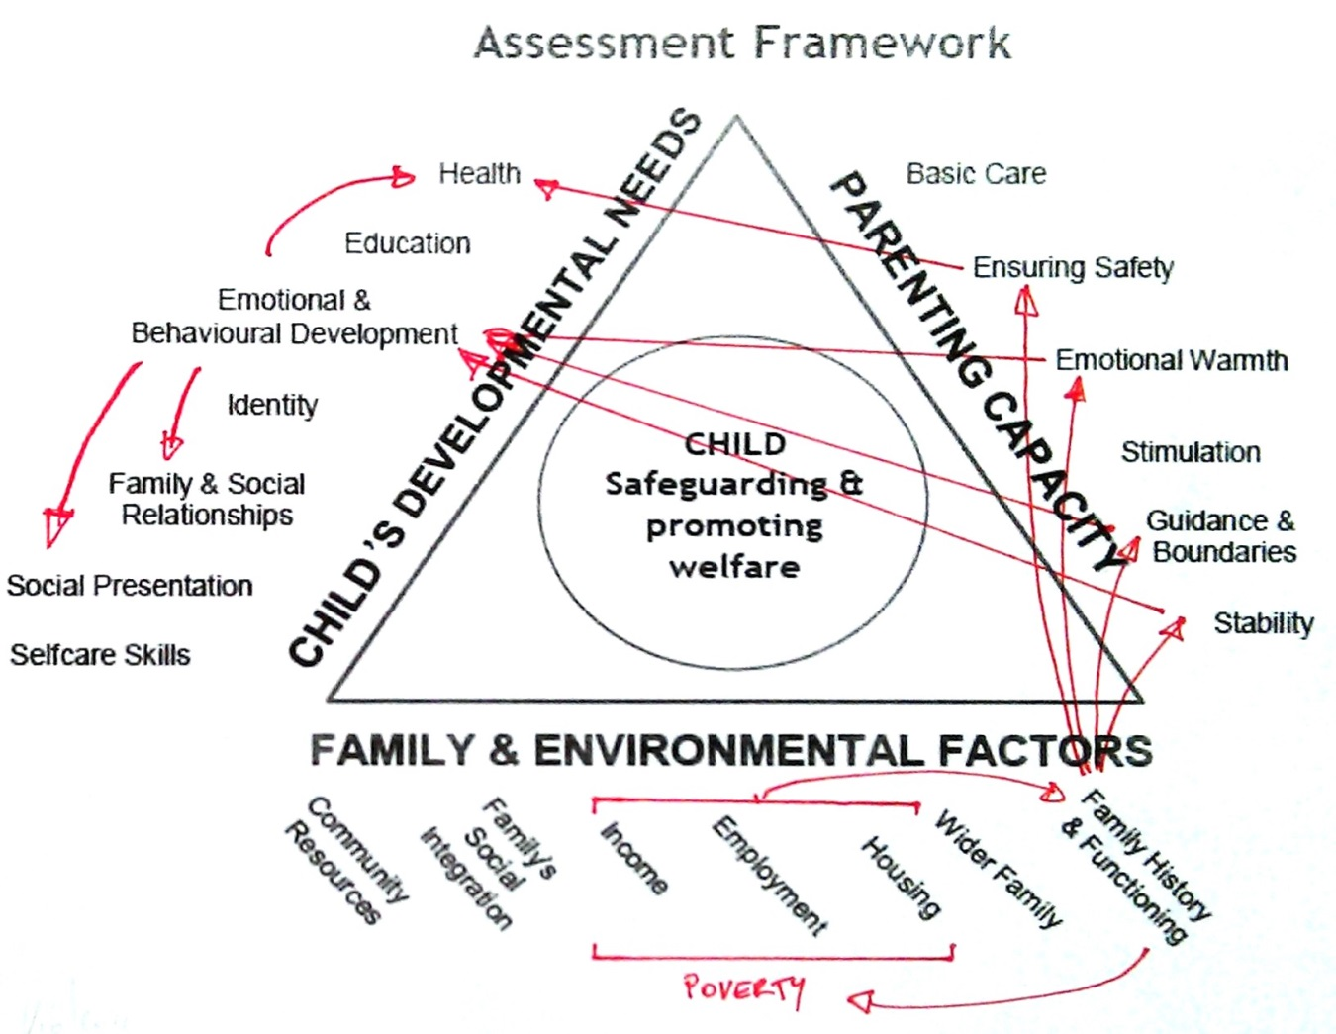
Emotional & Behavioural Impact

Internalise: Fear of being left alone when young, anxiety, and sleep disturbance. High levels of fear, anxiety, sadness and withdrawal. Low self-esteem and withdrawal and difficulties in self confidence. Associated with depression. Acceptance of violence in relationships.

Externalise: Increased tantrums. Anger, aggressive and anti-social behaviour. Conduct disorder. Increased propensity for violence in relationships.
Domestic Violence

The majority of the impact on the child's needs represented on the diagram to the right is to the emotional and behavioural development., particularly in terms of fear and anxiety. From violence or anticipation of violence.

Domestic Violence is strongly associated with child deaths within serious case reviews.

Domestic violence and poverty are statistically related, and the cyclical pattern of poverty contributing to the catalyst for violent incidents is often present.

It may be appropriate to add a withdrawal from the support functions of community resources as an effect of the family history and functioning. The absence of such services does not increase the propensity only fails to reduce it, hence not cyclical.

The violent situations impact upon the ability to provide a safe environment, emotional warmth, appropriate guidance and boundaries, and stability – the uncertainty of when the next incident may be leading to an environment of fear and anticipation. The cumulative impact of those factors all cause an impact upon the child's emotional and behavioural development as described above. Tolerance or perpetration of violence in future relationships may equally be represented by a direct link between guidance and boundaries and social presentation.

It is important to note that over 1/3 of children exposed to domestic violence do not appear to do any worse than other children within the community, and there are few available studies to determine which children will be affected.
Emotional & Behavioural Impact

Internalise: Little warmth to the child may result in the child feeling unloved and rejected. Unpredictable behaviour of the parents lead to feelings of fear or mood disturbance which may continue after the episode. Self esteem and sense of identity may suffer. Embarrassed of parent. Increased risk of self harm and suicide. Worthlessness and exclusion from parent putting their needs first.

Externalise: Behavioural problems and conduct disorders. Anger. Criminal activity may be present.

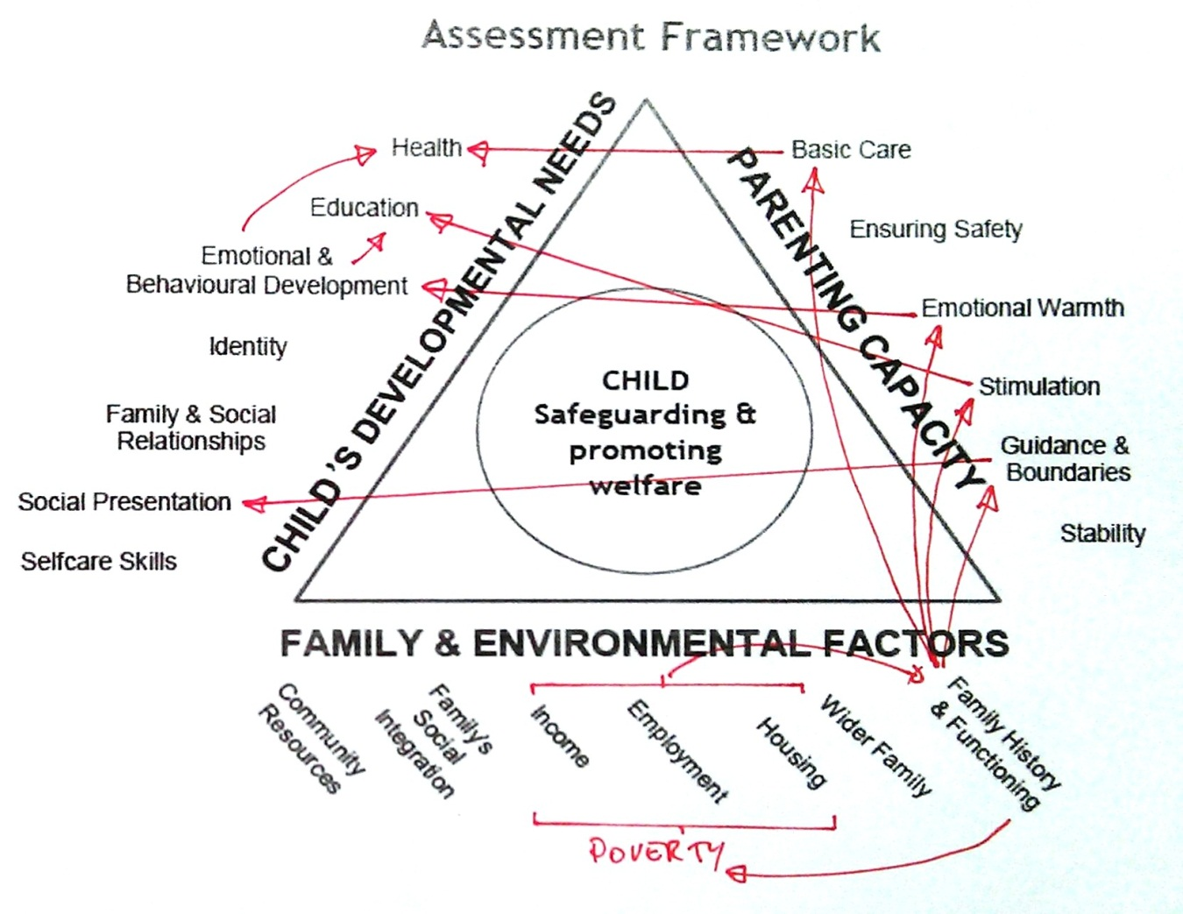

Mental Illness

There is a higher rate of mental illness for lone parents rather than couples. When the lone parent experiences mental illness there is no one else to take on the carer role.
When considering the impact of mental illness it is important to remember that the parent may not be symptomatic for long periods of time. This should be taken into account when considering impact.
A high percentage of murders committed by mothers in serious case reviews are linked to a household with a parent or carer with current or past mental illness. This is not recorded as a link between ensuring safety and health as this situation remains the exception rather than the norm for persons experiencing mental illness.
The affect of the parents mental illness is contained within the family history and functioning. The impact on the child's needs are distributed amongst a number of dimensions. The impact on the emotional and behavioural dimension is set out above. The child may adopt a carer role resulting in the child assuming adult responsibility and suffering a loss of childhood and being prevented from making friends their age. When young the failure to provide stimulation leads to delayed cognitive development. Children of alcohol or drug misusing parents tend to have significantly lower educational performance than their peers. The child may be pre-occupied with the home situation or a carer role may conflict. Attendance may suffer. School conversely may act as a safe haven and the child may gain a sense of accomplishment through sport or academic achievement.
Statistically significant numbers of adults suffer from mental illness. 30% of adults who suffer mental illness have dependent children. The majority of parent who experience mental illness do not harm their children as a consequence of the disorder. Many outgrow their parent's problems.

Children become more vulnerable to abuse or neglect when mental illness coincide with other difficulties. Mental illness is frequently a multiplicative factor than a cause of harm itself. Many of the difficulties can be addressed with support. It is of most concern when it is combined with other issues, i.e. as a multiplicative factor.
[Link from guidance & boundaries to social presentation may not be appropriate]
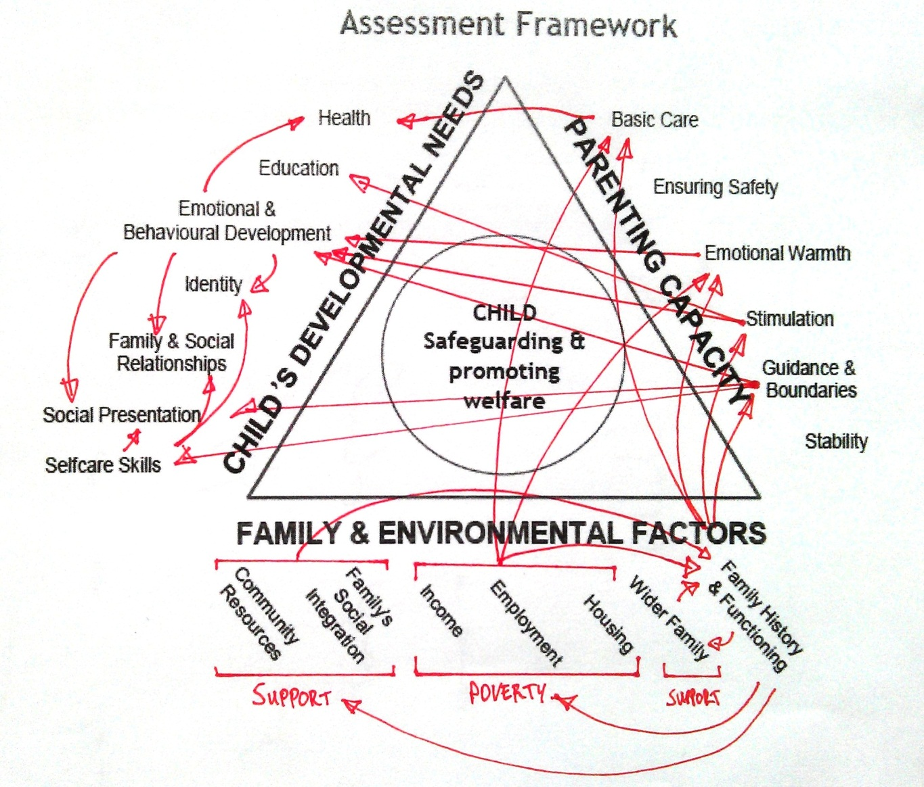
Emotional & Behavioural Impact

Internalise: Feeling unloved / unloveable. Low self-esteem. Increased crying / clingy when young. Reduced assertiveness and peer interaction. Lacks persistence & confidence Increased social isolation and unpopular. Increased risk of personality disorder and elevated symptoms of anxiety / depression.

Externalise: More uncooperative and non-compliant when young. Difficulty in emotional regulation. Aggressive disruptive and non-coperative behaviour continues.throughout childhood Clear link between juvenile crime and neglect.
Neglect

The majority of the impact on the child's needs represented on the diagram to the right are to the emotional and behavioural development. That impact in turn spreads through the other areas of development. The starting point for the process is the family history and functioning, i.e. the behaviour of the parent. A further line could be added to the diagram from the emotional and behavioural development to family history and functioning to represent challenging behaviour subsequently displayed, completing a cycle.

Parenting in poverty has a negative cyclical impact on the functioning of the family. It has a direct impact on the basic care provided and takes a toll on the emotional resources of the parent. Frequently there is a familial history of neglect which is represented in the interaction with the support network.

The household functioning is producing a direct negative impact on the basic care, emotional warmth, stimulation and guidance and boundaries. For the care to improve this is the area which would be required to change.

The care impacts predominantly on the child's emotional and behavioural development and the impact is set out in the box above. There is a direct effect on health and also an indirect affect through an increased likelihood of self harm.

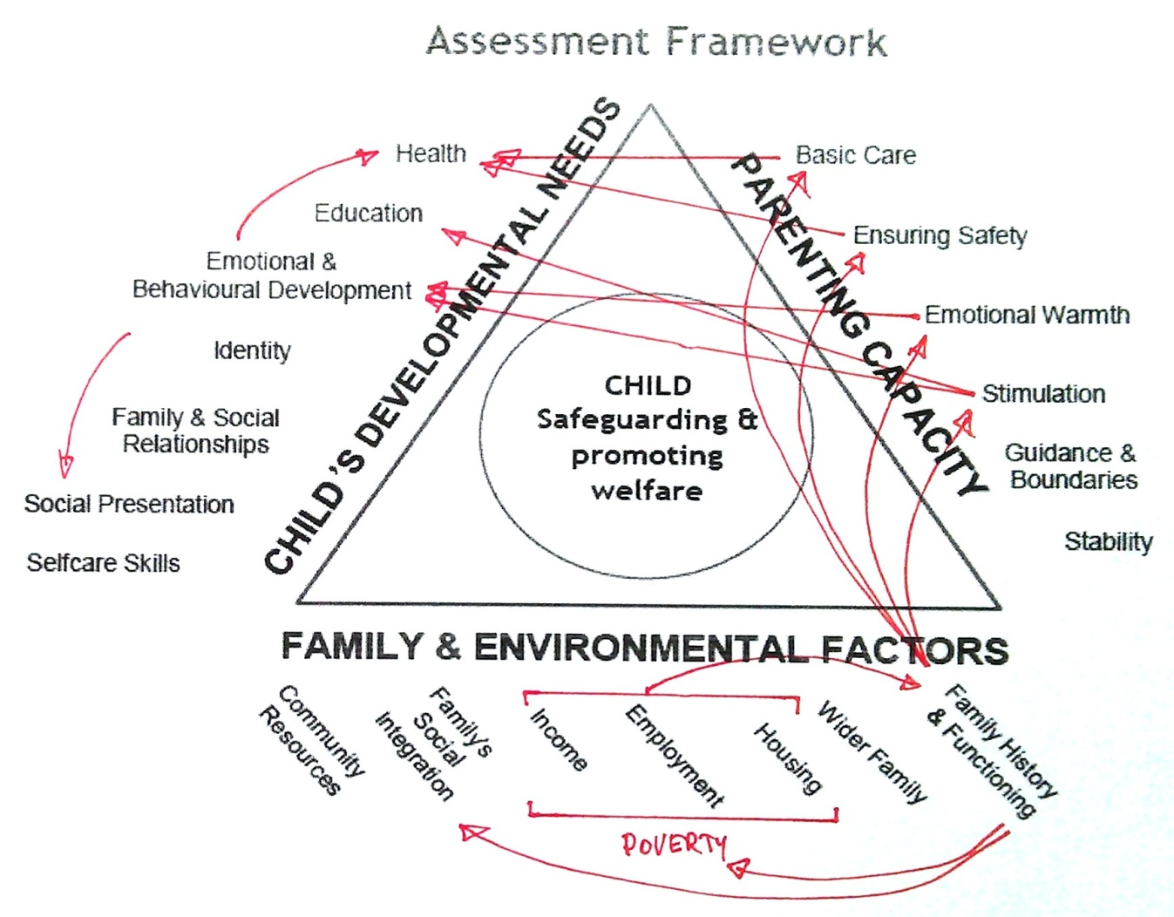
Substance Misuse
Emotional & Behavioural Impact

Internalise: Impaired attachment. Reduced warmth leads to leaving them feeling unloved and rejected. Low self-esteem, feelings of worthlessness and exclusion. Unpredictable behaviour of the parents leads to fear. Feelings of responsibility lead to guilt and blame. Confrontation from alcohol leads to fear. If a carer role is adopted then conflict with child's needs can produce feelings of guilt.

Externalise: Irritability. Failing to meet the child's expectations can lead to feelings of betrayal and anger. Aggressive, non-compliant, disruptive or anti-social behaviour may be present.

The impact on the child's development are split between Emotional & Behavioural development, Health and Education. Vulnerability of the children of a lone parent with substance misuse is greater than that of a couple.

It is estimated there are between 250k-350k children of drug users in the UK. The increased volatility in family relationships caused by alcohol can create situations where the child is at risk of physical harm.

The starting point for the process is the Family history and functioning containing the reason for the drinking an d the impact it has within the family home. The drug or alcohol use may lead to little emotional warmth being shown to the child leaving them feeling unloved or rejected. Alternatively the parent may only express emotion when they have been drinking leaving the child confused, and deprived of affection for the remainder of the time.

Family resources may be used to purchase drugs or alcohol rather than being spent on food and other essentials of basic care. The child may adopt a carer role resulting in the child assuming adult responsibility and suffering a loss of childhood and being prevented from making friends their age. When young the failure to provide stimulation leads to delayed cognitive development. Children of alcohol or drug misusing parents tend to have significantly lower educational performance than their peers. The child may be pre-occupied with the home situation or a carer role may conflict. Attendance may suffer. School conversely may act as a safe haven and the child may gain a sense of accomplishment through sport or academic achievement.

There is considerable evidence that many, if not most, children of parents with problem alcohol and/or drug use eventually 'outgrow' their troubled childhood and develop into balanced, productive adults and parents. Some will develop similar patterns of alcohol and drug use as a coping strategy.

