**FAMILY GROUP CONFERENCE (FGC) SERVICE**

*FGC is a family-led planning meeting in which the family is invited to come together to make a plan for a vulnerable child. As an important restorative intervention, it can be offered to develop effective family plans to support a range of issues affecting children, young people and their families. The benefits include: utilising an untapped resource particularly in terms of paternal family members; children are more likely to be living with parents and or relatives; family plans are largely adhered to and children remain at the centre.*

*FGC is a proven way of reducing demand on social care services. In Gloucestershire we have a Family Group Conference Service that is able to work with families for the following reasons in order to achieve a set of desired outcomes*.

|  |  |
| --- | --- |
| **REASON FOR REFERRAL** | **DESIRED OUTCOME** |
| * Avoid PLO * PLO – avoid proceedings * Pre birth * Prevent looked after episode * Stabilise kinship placement | AVOID A CHILD/YOUNG PERSON BEING LOOKED AFTER |
| * Stabilise kinship placement * Child in Care – Reunification | RETURN A CHILD/YOUNG PERSON TO THEIR FAMILY FROM CARE |
| * Stabilise/De-escalate Child in Need Plan * Stabilise/De-escalate Child Protection Plan * Divert Child Protection Plan * S47 Initial Child Protection Conference | AVOID/DE-ESCALATE CHILD PROTECTION PLAN |
| * Stabilise/De-escalate Child in Need * Prevent need for statutory social work involvement * Prevent need for other statutory involvement * Stabilise kinship placement * Pre-birth | FAMILY SUPPORTED TO HELP THEMSELVES  (AVOID/DE-ESCALATE STATUTORY INTERVENTION) |

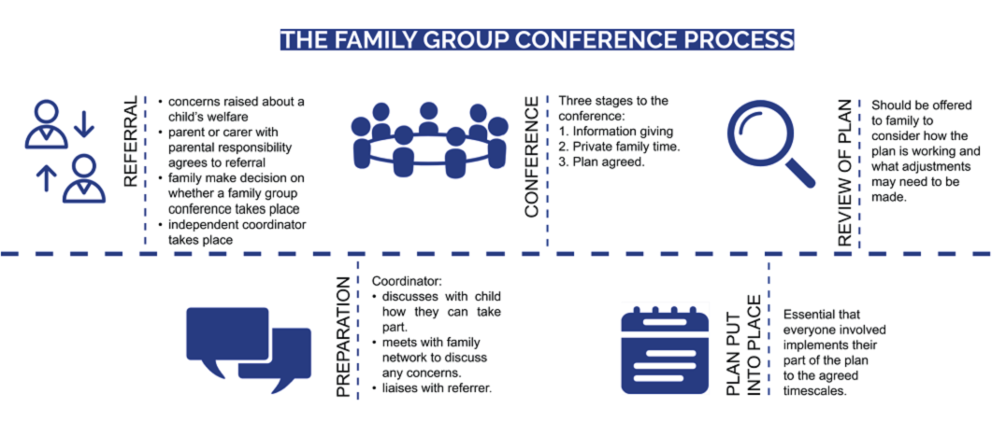

Family Group Conference – script for talking to families about FGC before making a referral.

*As part of my work with you, I want to ensure that you feel you have every opportunity to contribute to the plans we need to make to keep your child/children safe. We know that families can sometimes feel that the professionals are making all the decisions and that they aren’t given much say in what happens.*

*To make it easier for you and your family to be involved in making plans I would like to offer you the opportunity to have a Family Group Conference (FGC). This is a voluntary process, where you and your support network will be supported to work together to draw on everyone’s strengths and resources to make a safe plan for your child/children. It is an opportunity to have an open conversation, to hear and discuss concerns and come together to plan for the future. A FGC is an opportunity for everyone to be listened to including your child/ren. Anyone needing support through the process can have their own advocate who will help them to express their views.*

*The meeting is arranged by an independent FGC coordinator who meets everyone first to prepare for the meeting. The coordinator is independent of me. They are a* ***neutral*** *person. Their job is to help you to plan for the FGC and to chair the meeting on the day. They will not influence you to make a particular decision but they will help you and your family to think about the plans and decisions that will need to be made.*

*The meeting is in three stages. I and other professionals only attend:*

* *at the first stage (at the start of the meeting) to explain our worries about your child/ren and what needs to be addressed by the family in their plan; and*
* *at the third stage to agree your plan for your child/ren, provided it will keep them safe.*

*In the second stage, the middle part of the meeting, you and your family will be given time in private to draw up your plan which must address the worries and concerns and make sure your child/ren is kept safe.*

*If you think this would be helpful for you or you would like to know more, I will ask a coordinator to get in touch with you and your family to explain the process in more detail and answer any questions you have so you can decide.*

*Provide the family with the FGC postcard.*

*Complete the FGC referral form and send to:* [*fgc@gloucestershire.gov.uk*](mailto:fgc@gloucestershire.gov.uk) *or telephone 01242 532353 for a discussion regarding next steps.*

