

**Children in Care Strategy**

**2020-2023**

Improving the lives of children and young people

# Contents

Introduction

Our role as Corporate Parents

Priority 1: The child’s Voice

Priority 2: Access to Services

Priority 3: Health and Wellbeing

Priority 4: Safeguarding and Stability

Priority 5: Educational Achievement and Attainment

Priority 6: Preparation for Adulthood

Delivering monitoring and reviewing our action plan

Appendix 1 Headline Data Set

**Introduction**



This is the first Children in Care Strategy to be developed by Sandwell Children’s Trust. It provides a picture of services for Children in Care (CIC) in the borough, based on intelligence held by the Trust and available through national datasets.

The Strategy contains an assessment of needs which provides an insight into how we care for Children in Care and enables the Trust to effectively prioritise and plan for developments that can be expected to improve outcomes. The strategy recognises that provision needs to be flexible enough to react to the changing number of children in care and their diverse needs.

A secure and stable home life is fundamental to the successful development of all children and for children in care a successful placement is the most important factor in enabling them to flourish. Frequent moves between placements can have a drastic effect on the ability of children to succeed both in every areas of their lives.

This strategy sets out how Sandwell Children’s Trust (the Trust) understands the needs of our Children in Care (CiC) and Care Leavers as well as our understanding of the support available to them. The strategy also sets out our plan to improve outcomes for the children we care for.

This strategy will only be successful if priorities are shared and a joint approach is taken between the Trust, our children and all our partner agencies; hence this is very much a shared, multi-agency strategy. Collectively, we all place children It will be reviewed annually considering the changing needs of our children & young people. Sandwell Children’s Trust places children in care at the centre of everything we do.

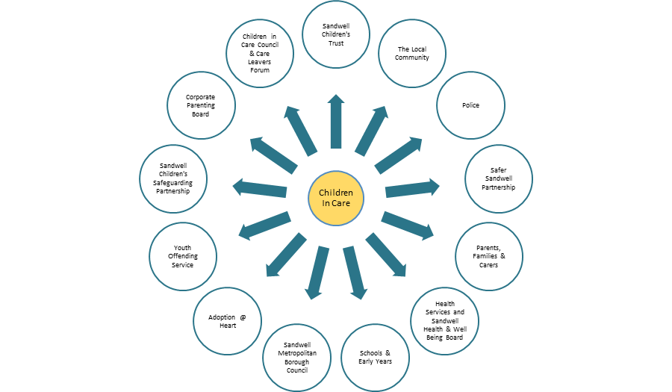

We recognise that all children need support from a range of adults; teachers, healthcare professionals and other support services. The Indices of Multiple Deprivation (IMD) 2019 shows Sandwell’s average deprivation score as ranked 12th most deprived local authority in England, out of a total of 317.  Our children have often had a poor start in life and may need additional support to live happy lives and achieve their potential. We endeavor to provide all our children with good quality wrap around care and provide excellent support to the people who care for them daily.

Many of our children have experienced trauma and have highly complex needs and behaviors that require individual tailored multi-agency support from a range of partners in order for them to reach their potential. We will endeavor to provide care which meets each child’s unique individual strengths and needs.

We recognise other people are important to our children and will work in partnership to ensure they have the best possible opportunities in life.

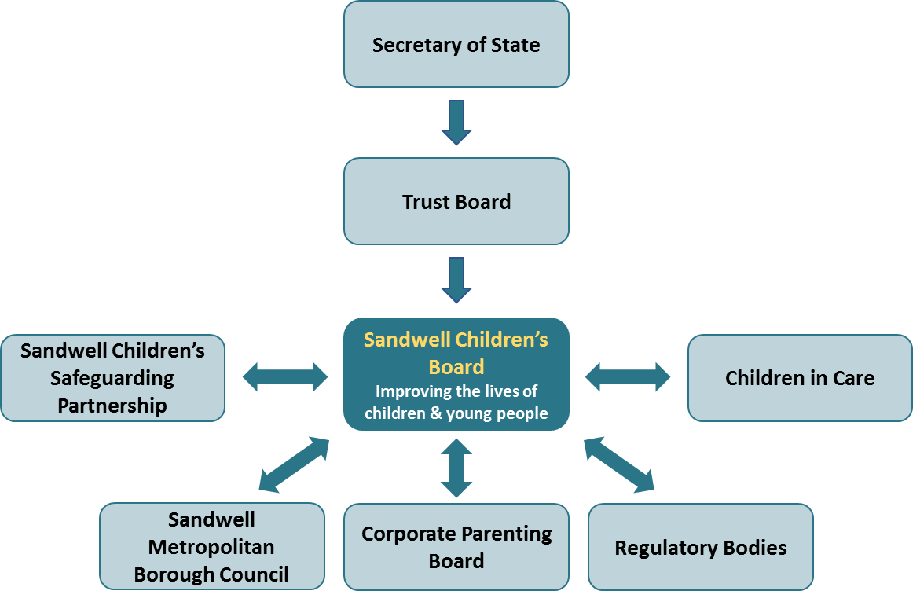

**Listening to our children & young people**

A series of round table workshops at Corporate Parenting Board in February 2020 brought together members of the Voices of Sandwell group (child in care council) and the Care Leaver’s forum with system leaders from across the partnership.

All voices were equal throughout the facilitated discussions and the accompanying virtual engagement exercise which was conducted through the Mentimeter platform. Our children and young people outlined their challenges, articulated their aspirations and frustrations and worked together with corporate parents to co-produce the priorities that are outlined in this strategy – essentially these priorities are the things that matter.

The priorities were revisited during July 2021 where children and young people had the opportunity to challenge progress, celebrate success and reflect on the impact of the Coronavirus pandemic.

**Our Role as Corporate Parents**

The term 'corporate parent' is broadly understood as how local authorities should approach their responsibilities for children in care and care leavers. A strong ethos of corporate parenting means that the sense of vision and responsibility towards the children they care for and their care leavers is a priority for everyone. Corporate Parenting Principles are referenced in Ofsted's Inspecting Local Authority Children's Services.

We believe that being a Corporate Parents means providing secure, nurturing and positive experiences for children and young people in our care wherever they live. Where a child or young person cannot safely stay at home, it’s up to us to provide them with the care, support and stability that they deserve. Our partners have a shared responsibility to act for the children and young people in our care as a parent would for their own child. Those partners come together with young people as Corporate Parenting Board.

Our Corporate Parenting Strategy is underpinned by the 10 messages that steer the work of our Corporate Parenting Board within the Corporate Parenting Pledge. These were adopted based on the Pledge drawn up from the messages delivered by more than 150 Care Experienced people at the National Care Experienced Conference 2019.

**Corporate Parenting Pledge**



**Our Corporate Parenting Principles**

The Corporate Parenting Principles are intended to facilitate as far as possible secure, nurturing, and positive experiences for Children Looked After and enable positive outcomes for them. The experiences of Children Looked After and care leavers, particularly in regard to whether they feel cared for and listened to, will therefore be an important measure of how successfully local authorities embed these principles.

The Corporate Parenting Principles set out seven principles that local authorities will have regard to when exercising their functions in relation to Children Looked After, as follows:

* To act in the best interests, and promote the physical and mental health and wellbeing, of those children and young people;
* To encourage those children and young people to express their views, wishes and feelings;
* To take into account the views, wishes and feelings of those children and young people;
* To help those children and young people gain access to, and make the best use of, services provided by the local authority and its relevant partners;
* To promote high aspirations, and seek to secure the best outcomes, for those children and young people;
* For those children and young people to be safe, and for stability in their home lives, relationships and education or work; and
* To prepare those children and young people for adulthood and independent living.

The Corporate Parenting Principles do not replace or change existing legal duties. The principles are intended to encourage local authorities to be ambitious and aspirational for their Children Looked After and care leavers.

The Director of Operations at Sandwell Children’s Trust and the Council’s Corporate Parenting Coordinator jointly chair the Corporate Parenting Strategic Board to co-ordinate and deliver on the action plan of the Corporate Parenting Board. The action plan is based on six work-steams:



**Priority 1 – The Child’s Voice**

## Aims

At Sandwell Children’s Trust we believe that the child should be at the heart of everything we do. Our approach to participation is based on the principle that all children have a voice and are encouraged and supported to exercise their right to be involved in all activities that influence their lives. Children and young people work alongside us to make decisions about the way we run our service. We are proud of our children and young people and work tirelessly to promote their rights and celebrate their achievements.

## How this links to our ambitions

The principles of ‘voice’ are underpinned by the four components of the ‘How Can I Help You?’ participation strategy:

* Invest, which is how we make sure that everyone knows the importance of participation, children and young people feel valued when working with us and that they have fun.
* Inform, which is how we make sure that children and young people understand the information they have access to, how they let us know what they are feeling and that they know exactly what their rights are.
* Involve, which is how we make sure that children and young people can design, develop and review the services that they receive, and how we in the Trust enable them to have their say.
* Influence, which is how we make sure that the work we do with children and young people makes a difference now and in the future.

## What we know

* We are proud of the relationship we have with our children and young people. The principles of our participation strategy have been adopted through the Sandwell partnership. Feedback from Ofsted identifies the strategy as ‘inspirational’.
* Children and young people actively inform the delivery of our service, and are involved in recruitment, induction, training, and auditing on a regular basis.
* Our children and young people are well known to staff across the Trust and are growing in confidence.
* The profile of participation has been raised across the Trust and is a key component of the Practice Framework and Practice Standards. The Voice of the Child Board meets monthly to monitor progress of the ‘four I’s’ in all areas of the Trust.
* We support young people over the age of 25, we believe as corporate parents this is our responsibility.

## What we have done

* Developed the ‘How Can I Help You?’ Participation Strategy which is an aspirational and inclusive approach to ensuring all staff within the Trust understand their role in recognising the child’s voice. The principles of this have been adopted regionally.
* Fortnightly Voices of Sandwell (Child in Care Council) and Care Leavers Forum meetings where young people talk about what is important to them.
* Hosted a regional child in care conference (called ‘How Can I Help You?’) where children, young people and corporate parents from 14 regional organisations came together to discuss issues.
* The corporate parenting board has been reconstituted to meet more regularly and to encourage more engagement with children and young people. The sessions now take place every three months, with children and young people co-chairing and facilitating each business and engagement meeting.
* Hosted sessions where children and young people meet with ‘system leaders’ to lobby for change. Examples of these include:
  + Care Leavers housing summit (agreement to award band A priority for all care leavers)
  + National takeover challenge (agreement to extend 100% council tax discount up to age of 25)
  + Seminar to Trust Board, where children and young people agreed pledges with Board members
  + Formally timetabled sessions with regulators and improvement partners where they speak with confidence about their role in the Trust
* Co-designed and co-delivered a range of events where children and young people celebrate their success or simply have fun. Examples of these include:
  + Hosted the first Care Leaver’s celebration event to recognise the achievements of our young adults.
  + Talent show for children in care
  + Christmas party for children in care and their carers, and Christmas meal for care leavers
  + Conference for staff hosted by young people with focus on the child’s voice
  + Regular programmes of activities during school holidays where children and young people learn new skills, make new friends and have fun. In 2019 some of our children and young people created their own ‘comedy video’ which was shared with corporate parents.
  + Annual ‘Voices Heard’ event
* Co-developed a range of publications to support children and young people.
* Develop an online local offer in conjunction with care leavers.
* Started work on the co-development of an online portal for care leavers.
* Worked with our children and young people to identify the kind of language we should be using around each other. This has led to changes being made, for example Looked After Children (LAC) became Children in Care.
* Improved the way that we get feedback from children and young people, by:
  + Introducing a children’s complaint leaflet
  + Improving the process around dealing with formal and informal complaints
  + Developed the I Say feedback mechanism which makes it easy for children and young people to have their say
  + Input into the design of the Health Passport App
* Introduced youth offending and UASC participation groups of young people
* Established links with several organisations that will improve outcomes, including Care Leaver’s Covenant, National Care Leaver’s Benchmarking Forum, Young People’s Benchmarking Forum, West Midlands Participation Network, Rees Foundation.
* Supported our children and young people through the pandemic
  + Coordinated the distribution of laptops and data cards to children in care and care leavers
  + Hosted regular virtual engagement events including quizzes, training and Christmas parties
  + Supported care leavers with food parcels and other emergency assistance
  + Increased the opportunity for young people to be rewarded for supporting the Trust – interviews, inductions and participating in events
* Gained the National Youth Agency ‘Hear by Right’ flagship accreditation to ensure that we are benchmarking our approach against the very best.

## What we plan to do

* Develop and deliver ‘How Can I Help You?’ training for all members of staff in the Trust to ensure that everyone understands their role
* Identify opportunities for further representative groups, specifically children on Child Protection Plans and Child in Need plans
* Coordinate a regional ‘Children in Care Olympics’ to coincide with the Commonwealth Games
* Develop the iCon programme (Young advisors) to recognise the children and young people that work with us. Activities currently undertaken (auditing, surveying, training, inducting, recruiting) to be brought into the iCon framework.

**Priority 2 – Access to Services**

## Aims

We aim to help children and young people in care gain access to, and make the best use of, services provided by the local authority and its relevant partners. We will ensure our Local Offer outlines the range of services the care leavers in Sandwell. We aim to ensure that we identify the key points in the commissioning process where our children and young people in Care and Care Leavers will have a voice and have a central input into service development.

## How this links to our ambitions

We will ensure all children have positive relationships with those people at the centre of their care. All children in care children require access to a range of services to meet their needs. Assessments of need will inform good quality timely care plans and placement plans. Personal education and health care plans will inform the care planning process. All plans and reviews of plans will be made with the child wherever possible. The child will be consulted at all points and their views considered. Looked after children have often had a poor start in life and will need additional support to ensure they have optimum health, both physical and emotional. The biggest indicator for good outcomes for looked after children is that of a good quality relationship with care givers and their social worker. We will ensure all children have positive relationships with those people at the center of their care. All agencies will work together to ensure our children have the best possible support.

## What we know

## In caring for children and young people of varying ages, experiences and needs, there is a need for different kinds of placements, so we need to make sure that there is a sufficient choice of placements within the Borough.

## We want our children and young people to feel cared for and valued. By providing a standard of care that gives them stability and security so they will have the best possible chance to achieve good outcomes and a quality adult life.

* It is important to celebrate the achievements of our children with our partner agencies. Each year we hold a Celebration of Achievement Awards Ceremony for all children and young people in care and care leavers. This ceremony celebrates the achievements of our children and young people and encourages them to continue to strive to reach their potential.
* The statutory guidance for promoting the health and wellbeing underpins all agencies responsibilities to work together to promote the health and wellbeing of children in care underpins all agencies responsibilities to work together to promote the health and wellbeing of Children and Young People in Care and Care Leavers, identify any gaps in health services and ensure that the right health services are commissioned.
* In response to the Children and Social Work Act 2017, the Leaving Care Service, has extended its service to all care leavers up to the age of 25 and consulted widely with care leavers and partners to develop our Local Offer to Care Leavers – which is now published on the Trust’s website.

## What we have done

* We provide support to families through robust edge of care offer;
* Clarified the remit and purpose of the Family Solutions Team, to focus on crisis response, supporting placement stability and providing advice to targeted services
* Updated and refreshed the SGO policy to that carers are clear on the support they will get from the Trust should they choose to apply for an SGO in respect of the children they care for
* Improved communication between the Trust and the Judiciary so that we can address emerging systemic issues of quality in a timely manner
* Ensured that connected carers have parity of pay, access to the support of a supervising social worker and full access to foster carer training
* We provide access to independent support from Advocates and Independent Visitors via a commissioned service for Children in Care and Care Leavers up to the age of 25.
* We are systematically reviewing the plans for all children in care within a framework of ‘valuing care’. This means ensuring that they are in the most appropriate placement to meet their needs and that progress can be measured, as well as being best value for money.

## What we plan to do

* In collaboration with partners and Adult Services the Transition Policy has been revised and as a proactive Corporate Parent, the Policy states that if a young care leaver’s Pathway Plan assesses that the young person requires services post 18, they will receive services from Adults Services without requiring to meet threshold under the Care Act Assessment.
* Further develop a children in care and care leavers mental health strategy with clearly defined pathways to access emotional wellbeing and mental health services.
* Refresh the Sufficiency Strategy and develop placement opportunities for young people to make sure we have placements that are suitable in type and location.
* Continue development of internal services along with relationships with key suppliers to ensure consistency in quality and value of service provision.
* Increase placement stability by tracking fragile placements and creating a Placement Support Team make up of Family Support Workers who will provide reactive support/interventions to support fragile long-term placements. The Virtual School, Caring to Care Team and CAMHS will work with the Team to provide swift wrap round support to placements.
* Build on our sufficiency capacities to ensure care leavers have greater choice of housing options to meet their individual needs and enable them to live independently
* Embed our approach to reviewing children’s placements within a framework of ‘valuing care,’ ie ensuring they are cost effective and have a positive impact on improving children’s lives.

Priority 3: Health and Wellbeing

## Aims

We will work to ensure that children and young people in or care are as healthy as any other child or young person living in the area. Each young person within our care is unique and will require different support specifically to meet their physical, emotional and mental health needs. We will work with our health partner agencies to ensure that children and young people in care are supported to achieve healthy outcomes. Through the delivery of this strategy, we will promote the health and wellbeing of all our children, young people and care leavers and strive to ensure that they leave care in better health than when they entered care.

## How this links to our ambitions

## Working to ensure that children and young people in the care of Sandwell are as healthy as any other child or young person living in the area.

## Continuing to work closely with children, young people and their carers to ensure that we understand their physical, emotional and mental health needs, and providing support to enable them to access the health service they need

## Supporting children and young people to make healthy lifestyle choices and to take responsibility for their own health.

## Ensuring that young people leaving care are able and confident to independently access appropriate adult health services.

## Making the right arrangements for those children and young people with complex health needs to experience a seamless, well planned transition to adult services at the right time.

## What we know

* The Children and Social Work Act (2017) and the Health and Social Care Act (2012), outline the duties of Clinical Commissioning Groups (CCG’s) and Local Authorities to promote the child’s physical, emotional and mental health and to act on any early signs of health issues.
* The Children in Care Strategic Health Group has a membership of key partner agencies responsible for ensuring that our children and young people in care are healthy, happy and achieve their potential. It meets monthly and identifies priorities for action. It also monitors performance to improve the physical and emotional health outcomes for children and young people in care and care leavers. In addition, the group provides a forum for escalation of risks and issues that have not been resolved at service level.
* Rates of completion of health, dental and immunisation checks have consistently improved since 2014 and are remain above national averages.
* Initial Health Assessments have met timescales of 20 working days of entering care, (reported on notification to the health team). Referral pathways are in place for young people who do not attend this appointment.
* The care leavers health passport has been modified and has now been adapted in the form of an APP that can be accessed on a mobile phone or laptop.

## What we have done so far

* All our Children and Young People in Care have a named health professional who is either their School Nurse, Health Visitor, Specialist Children in Care Nurse or Family Nurse.
* All our Children in Care are offered regular health assessments in a timely manner, in line with statutory requirements. The children and young people receive information about their health assessments before they happen, and they have the opportunity to give their views about their assessments afterwards. They should have a quality assured health plan in place written and agreed in partnership with them, and where appropriate with their carers also.
* We ensure that every Child in Care and Care Leaver is registered with a local GP and able to access local dental care.
* We ensure that every child in care has access to the mental and emotional health services that they need. We are developing a CAMHS strategy with the NHS Black Country and West Birmingham CCG to ensure that there is dedicated mental and emotional health service specifically for children and young people in care.
* Every young person preparing to leave care aged 16 years and 17 years is offered the opportunity to review their health with a health professional and is offered a summary of their health history.
* A range of health and performance data relating to our children and young people in care is collected and analysed on a quarterly basis and reviewed to identify areas for action or development.

## What we plan to do

* Review of the Children in Care Nurse service for children and young people in care to ensure capacity and resource is sufficient to meet the needs of the children and young people.
* Provide on-going health advice/ training specific to Children in Care and Care Leavers to Social Workers, Personal Advisors, Foster Carers, Health Professionals and Education teams
* Strengthen links between Mental Health Services and the Leaving Care Team. This will include a review of the current use of the Strengths and Difficulties Questionnaire (SDQ) and a relaunch of a refreshed SDQ Pathway
* Ensure every Care Leaver is able to access appropriate emotional and mental health services when necessary
* Support young people to have good sexual health, become good parents when they choose to, have specialist guidance and help where necessary
* Ensure the early identification of substance misuse and where needed support young people to access substance misuse treatment services. This needs to include routine screening for substance misuse as part of the annual health assessment and a clear referral pathway to services.
* Strengthen links with the Substance Misuse Team including training, guidance and support for Personal Advisors.
* Ensure children with additional and / or complex health needs have the right support to transition to appropriate adult health services. Effective alignment with both Education and Health Care Plans (EHCP) and Continuing Health Care is key to achieving this priority.
* Strengthen the links with Housing Solutions in line with a principle of the Care Act - “an appropriate and good quality settled home environment can have a significant impact on improving health outcomes and reduce health inequalities especially where vulnerable individuals are concerned. “

Priority 4: Safeguarding and Stability

**Aim**

All children, wherever possible will be supported to live with their parents or family if it is in their best interest, where this is not possible they will live in an alternative family setting or environment that replicates family life as closely as possible. Every effort will be made to either safely return children to their families or ensure they have a permanent alternative family as soon as possible. Where children cannot live with their families we will promote and maintain close links to their families as is considered safe.

**How this links to our ambitions**

* Children should be supported to live with their parents and in their own communities wherever it is safe to do so
* Intensive support should be offered to families of children at the edge of care
* Where a child cannot remain with their family, meaningful contact with their parents, siblings and other important people in their life should be carefully considered. The child's needs and welfare should be at the centre of all contact agreements
* If it is consistent with the child’s welfare a placement with family or friends will be the preferred option for children who become looked after.
* If a friend or family member is being considered for a placement they will be able to access good quality guidance and support, including exploration of the most appropriate means of securing their child's future which may be through a variety of means including; connected person fostering; alternative order such a special guardianship (SGO) or a private arrangement.
* All children should have a right to a family life. Should a family and friends placement not be appropriate under most circumstances a placement within a family setting should be sought, either with in house or independent foster carers. A few children cannot live within a family environment usually for a complex range of factors. In these circumstances care within a nurturing children's home may be the most appropriate option. However, the right to family life must remain and options to place within a family or to have meaningful contact with family should be considered as part of the care planning process.
* Where children are not expected to return home planning for a permanent placement will happen in a timely fashion. Options for permanence will always include consideration of
* Adoption
* Child Arrangement Orders,
* Special Guardianship Orders and
* Long term fostering

**What we know**

We strive to make sure that children have a positive experience whilst being in care, by affording them good quality care and support, a stable placement that meets their needs, a positive relationship with their Social Worker and access to advocacy service when needed. We also know that permanency needs to be secured at the earliest possible point to ensure each child benefits from a stable, nurturing family.

* We want our children and young people to feel cared for and valued. By providing a standard of care that gives them stability and security so they will have the best possible chance to achieve good outcomes and a quality adult life.
* In caring for children and young people of varying ages, experiences and needs, there is a need for different kinds of placements, so we need to make sure that there is a sufficient choice of placements within the Borough.
* We recognise the importance of listening to children and young people and responding proactively to them. We must seek their views about their care experience and explore with them how we can improve their lived experiences. Therefore, on an annual basis a survey of our Children in Care and Care Leavers is conducted.

**What have we done so far**

* We work hard to build and maintain relationships with the children we care for. The Council’s Recruitment and Retention Strategy promotes a stable workforce to ensure changes of Social Worker are avoided wherever possible and children have the opportunity develop a meaningful relationship with them.
* We have strengthened our approach to permanency and developed a permanence strategy across all service areas in the Trust.
* We have reviewed and refreshed our Long-Term Matching Process and Long Term Matching Panel.
* We have used a dedicated peripatetic team to drive forward plans for SGOs and support Discharge of Care Orders where appropriate for children placed at home.
* We have increased the number of adoptions through our partnership with our Regional Adoption Agency.
* We have developed robust systems for the monitoring of all unregulated placements, ensuring that children are in safe accommodation and feel safe.
* We have developed a Sufficiency Strategy to increase the number and range of placements available within the borough. This is to ensure children and young people are not living far from their home community. Our Fostering Strategy also focuses on increasing the quantity and quality of fostering provision in the borough to ensure the placements meet the needs of our children and young people.
* We have developed a Specialist in-house Fostering Scheme to support the opportunity for children placed in residential care to return to living in the Borough and a foster placement;

## Created a newly formed Horizons Exploitation Team supporting young people who are vulnerable to or being exploited including but not limited to Missing, Criminal Exploitation, Sexual exploitation and trafficked.

## Improved the timeliness and quality of return home interviews completed in timescale

**What we plan to do**

* Embed a practice and culture whereby permanency is considered from the outset in order to achieve a permanent, secure and nurturing family at the earliest possible point.
* Continue making use of SGO and improving the visibility of this when care planning.
* Maintain good relationship with the judiciary to improve their confidence in our planning & SGO planning
* Maintain relationships with Adoption @ Heart to make the best use of early permanence and progress adoption plans.
* Improve communication between Care Management, Children in Care, Fostering Services and the range of services now available for placement and family support, to ensure the best and most appropriate response for children.
* Outcomes for teenagers who come into care as a result of being beyond the control of their parents are poor. We will therefore work more intensively with families to ensure more teenagers are supported to remain at home.
* Review work on reunification of families and explore specific models of family assessment and support.
* Ensure that use of edge of care services focus more on those children that the most to gain from these services
* Review our contact service and role of contact supervisors

Priority 5: Educational Achievement and Attainment

**Aims**

We are aspirational for the children we care for and our care leavers and we believe that education is crucial to ensure that our young people are prepared for successful future life and work. We want all of our young people to achieve the very best outcomes throughout their educational journey. Our aim is to work with key professionals to close the educational gap between our young people and their peers. We aim to encourage and support the aspirations of the young people to pursue opportunities for education, employment and training (EET). Having appropriate stable and good quality educational provision will enable them to fulfil their potential. As Corporate Parents we must support them in their learning journey and afford them the same opportunities as their peers.

**How this links to our ambitions**

Our aim is to work with key professionals to close the educational gap between our young people and their peers. We aim to encourage and support the aspirations of the young people to pursue opportunities for education, employment and training (EET). Having appropriate stable and good quality educational provision will enable them to fulfil their potential. As Corporate Parents we must support them in their learning journey and afford them the same opportunities as their peers.

We must encourage and support young people to strive to achieve Grade 9-4 in English and Maths in their GCSE examinations.

Our Virtual School plays a key role, with its aim that all children and young people in the care of Sandwell become resilient and effective independent learners, so they can achieve their potential and become full and active participants in society.

**What we know**

The outcomes for Sandwell children in care have been rapidly improving through a partnership approach between Sandwell Virtual School, social workers in Sandwell Children's Trust, schools and health colleagues. Outcomes for 2018/19 outcomes; show a rising 3 year trend across all Key Stages as Sandwell CiC close the gap to all children national.

84% of our children attend good/outstanding school with only 3% of the cohort attend a setting judged to be Inadequate (this is +1% National).

1. **Early Years Foundation Stage** - Attainment outcomes have risen from outcomes in 2017/18 with the percentage of children achieving Good Levels of Development rising by 15% to 58%; with sharp increases in children’s Literacy (+15%) and Maths (+8%) skills.
2. **Key Stage 1** - Attainment outcomes have risen from outcomes in 2017/18 with the percentage of children achieving the Expected Standard + rising by +11% in reading, +13% in Writing and +21% in Math’s.
3. **Key Stage 2** - Combined RWM standards have risen by 22% and the gap is closing rapidly to all peers; significant percentage rises are noticeable in all elements – Reading (+11%), Writing (+23%) and Math’s (+16%) from the previous year.
4. **Key Stage 4**
   * A8 – Sandwell CiC achieved on average ½ a GCSE (or equivalent) grade per subject than all CiC peers nationally. This has improved on average by ½ GCSE (or equivalent) from 2017/18.
   * P8 – at -0.74 Sandwell CiC progress is closing the gap to all peers and this rate of progress is greater than that of CiC nationally (-1.24).
5. **Post 16 -** Due to the early interventions, the percentage of young person’s NEET at the end of year 11 has reduced over a 3-year period from 24% in 2017 to 14% in 2019.

## What we have done

* Tracked attendance, attainment and progress of all children in care
* Provide robust and accurate data to support the work of the LA in promoting the educational achievements of children in care
* Monitor and quality assure the completion of PEPs
* Manage, monitor and quality assure the use of the pupil premium plus and early years pupil premium so that it improves the educational outcomes of each individual child in care
* Provide appropriate individual support packages for identified children in care who are not performing in line with their predicted progress, through a variety of interventions
* Provide training, support and guidance to a range of professionals working with children in care, in particular, Designated Teachers, governors, social workers, foster carers
* Challenge and support education settings who are finding it difficult to meet the needs of children in care
* Challenge care planning decisions that do not appropriately meet the educational needs of the children in care
* Provide both Virtual School staff and other professionals with evidence based strategies for supporting children in care to achieve the best possible outcomes. E.g. recognised best practice by the Attachment Research Centre
* The Virtual School is a key stakeholder in the implementation of the LA Early Years Strategy
* The Virtual School is also a key stakeholder in the CiC and Care Leavers strategy

The Leaving Care Team promotes education, employment and training with our Children in Care and Care Leavers. The implementation of the NEET panel has enabled training providers to come together to discuss individual young people who are not in education, employment or training and offer them appropriate courses to meet their individual needs. The NEET Panel is chaired by the Care Leavers Service.

## What we plan to do

* Improve the quality of the Personal Education Plans (PEPs) so that there is more accountability in the targeting of the Pupil Premium (PP+)
* Education achievement is a determining factor in equipping our children for achieving their potential and a successful future. High quality Personal Education Plans (PEP’s) and the targeting of pupil premium plus will drive the identification and narrowing of the education gap for our CiC
* Make sure the child’s voice is central to the PEP process and that virtual access for children and carers is secure.
* To ensure all young people are supported to develop resilience so they are able to access learning
* The Virtual School will support children to experience positive educational transitions throughout their learning journey, both within a setting or between settings.
* Increase the number of Care Leavers gaining work experience within the Council, promoting an increase in those applying and gaining apprenticeships and traineeships within the Council and its associated companies.
* Ensure that every Care Leaver has a One Page Profile and is supported to complete or apply for relevant Education, Employment or Training opportunities, and therefore facilitating an increase in the number of Care Leavers and Children in Care accessing education, employment or training.
* Develop working relationships with local employers to promote and develop education and training opportunities within the borough, including apprenticeships, traineeships and training courses. This will include developing a partnership with Council associated companies, giving Care Leavers opportunities to gain full / part time work and work experience.
* Continue to promote and encourage young people to attend university

Priority 6: Preparation for Adulthood

**Aims**

We want all our young people’s preparation for independence to be defined by a young person’s needs and not their age. That our planning should begin early and be collaborative and involve young people and those around them. We want our young people to have ongoing support, opportunities for education and participation for them to continue to develop skills, knowledge, emotionally, educationally, practically, and for them to be safe and secure within their own homes.

**How this links to our ambitions**

* Young people will be encouraged and supported to remain in our care until they are ready to leave.
* Care leavers will live in suitable accommodation with appropriate support. A range of placement options will be commissioned to support placement choice.
* Care leavers will be encouraged and supported to continue to achieve, whether that is through formal education, training or in work.
* Care leavers will be provided with sufficient financial advice guidance and support to live independently.
* Often young people learn through trial and error. Where our care leavers have made negative choices, they will continue to be supported and given further opportunities to succeed.

**What we know**

* There is now a clear referral process to Adults services to allow young people with additional needs to assessed and identified earlier starting from 14 years old.
* We currently have 341 care leavers with a further 148 young people already identified as meeting a criteria to enter the service in the next 3 years:
* We have 307 young people 88.4% of young people aged 18-24 in suitable accommodation.  We know that this needs to improve and work with individuals to meet their needs and what they want in terms of accommodation as a young person.
* We know that from research that 1 in 4 care leavers have experienced of are experiencing mental health crisis.  We need to ensure that the specialist mental health support is available to young people at a time and age when they feel ready to address the concerns and not being linked to an age or time frames that are dictated by current services.
* We need to start the preparation to independence earlier to ensure that young people have the sufficient skills they need as they move on to their own accommodation – we know that this is required in advance of their peers and there is q requirement to review this with support in place through our carers, support workers and link professionals all who have a role to support and guide young people on their journey.

## What we have done

* Improved completion rate and quality of Pathway plans to ensure they are relevant and meet the needs of young people
* Restructured the care leavers service to be a 16 plus service to ensure we improve planning for transition
* Engaged with Adults service to regularly review children from age 14 that may require lifelong support to assist in planning for complex transition into adulthood
* Improved our ability to keep in touch; only 2 young adults are now not in contact and we continue to reach out to them
* Reduced the number of young people who are NEET
* Recruited 2 PAs to specifically work with the young people that reside in the training flats to ensure they have the appropriate independence skills to take on their own tenancies.

## What we plan to do

## Create user friendly plans which are riven and understood by children and young people in care.

* Allocate a Personal Advisor to a young person from the age of 16 years to work alongside of the social worker with the Pathway Planning.
* Launch social enterprise company run by care leavers who have experienced living alone and learned the skills; to provide floating support for younger care leavers
* Continue to work in partnership with the Virtual School and other providers to improve EET rates further
* Develop supported housing options for care leavers in cooperation with Housing and other providers.

**Governance- Being a Good Corporate Parent**

We are committed to improving the outcomes for all Children in Care and Care Leavers who live in the Borough and those who may live elsewhere. We have strong aspirations for Children in Care and Care Leavers, which is why the progress of this group of children and young people is a key priority for all partners, Elected Members and Trust Board members. We are all corporate parents and have corporate parenting responsibilities. The aspirations we have for the children we care for cannot be any different to what we want for our own children. This is why the Corporate Parenting Board will oversee progress of this strategy, measuring impact against each of the strategic areas and the associated actions.

Progress against this action plan will be monitored quarterly by the CiC Strategic Corporate Parenting Group who will, in turn, provide a regular progress reports to the Children’s Trust Board and Corporate Parenting Board.

This document has outlined our multi-agency strategy and how we are going to build on existing practice and further develop services for Children in Care and Care Leavers. A detailed annual action plan will be developed and agreed across all agencies to support delivery of the priorities set out in this strategy. The action plan will address the priority areas as identified within the strategy, identifying a key lead and timeframe for the completion of each action.

The action plan is intended to be a highly operational ‘live’ plan, subject to constant scrutiny, review and evaluation and the overall strategy will be reviewed on an annual basis.

**Appendix 1 – Headline Data Set**

