

**PARENTING ASSESSMENT: GUIDANCE DOCUMENT**

[](https://www.google.co.uk/imgres?imgurl=http://www.clipartbest.com/cliparts/ace/x68/acex68kMi.jpeg&imgrefurl=http://www.clipartbest.com/pen-writing-on-paper-cartoon&docid=M3nAl6foAL5VuM&tbnid=dnmilXX-Z6bHtM:&w=267&h=336&hl=en&bih=450&biw=853&ved=0ahUKEwjr-8W96unOAhVVF8AKHYsGAbAQMwhjKCcwJw&iact=mrc&uact=8)

***Introductory Note***

*This parenting assessment format has been adapted to incorporate the Department of Health Framework for Assessing Children in Need and their Families guidance and the tools provided through the C-Change model. It has been adapted to suit the specific needs of workers within North Somerset and should be used in all Pre-proceedings matters and care proceedings.*

*Guidance from the Association of the Directors of Children’s Services makes it clear that adults should be referred to as Ms, Mr, Mrs…and children should be referred to by their full names initially and thereafter by their first names. Professionals should be referred to as Dr, Ms, Mr, Mrs….with their professional role identified.*

*A parenting assessment which is undertaken within the Pre-proceedings Process should be written as if it were being prepared within the context of care proceedings and therefore requires the same formality.*

*Prior to completing any parenting assessment, you must complete a Parenting Assessment Plan which should include dates and venues for all sessions which you propose to complete. This Plan must be provided to the parent who is subject of the assessment and given to your legal representative (if you have legal representation) in order that it may be provided to the parent’s legal representative.*

*It is advised that you read the following documents in conjunction with this guidance document:*

*(i) Department of Health Framework for the Assessment of Children in Need and their Families;*

*(ii) Practice Guidance on Assessing Children in Need and their Families;*

*(iii) Safeguarding Children Living with Trauma and Family Violence: Bentovim, Cox, Bingley-Miller and Pizzey (2009);*

*(iv) The Child’s World, 2nd Edition: Jan Horwath (2009);*

*(v) Children’s Needs – Parenting Capacity, 2nd Edition: Cleaver, Unell and Aldgate;*

*(vi) Children Experiencing Domestic Violence – A Research Review: Stanley, Research in Practice;*

*(vii) Good Practice guidance on Working with Parents with a Learning Disability: University of Bristol (2016).*

*Preparation*

*In preparing your Parenting Assessment Plan, you should refer to your SWET document and, in particular, the key themes and issues which are identified in the statement. These themes will be a focus within your parenting assessment and should be explored within parenting assessment sessions; as such, they must be included within your Parenting Assessment Plan. It is suggested that you use your chronology to identify the key themes in the case which fall to be assessed.*

*Before commencing your assessment, you must identify any factors which could compromise it, for example, learning difficulties, language barriers or issues of race, culture or religion. It is essential that you identify these factors in planning your assessment and that adjustments are made. It is imperative that the person being assessed is able to understand the assessment and that you consider, and keep under review, whether they have the capacity to understand the questions being asked of them. You should be mindful of the approach required when working with vulnerable adults, including the benefits of representing information pictorially, repetition and session duration, and whether an advocate would be beneficial.*

*Your legal adviser will advise upon any issues with legal implications, for instance, the requirement for a PAMS based parenting assessment where a parent has an IQ of below 70.* ***If either parent has an IQ of below 70, then it is essential that a Parenting Assessment uses the PAMS framework and takes account of the Good Practice guidance on Working with Parents with a Learning Disability: University of Bristol (2016).***

*When planning sessions, give careful consideration to the duration and frequency, particularly if reflection is expected between sessions. You should also consider additional time to consider reflection on further issues which arise.*

*It is important to consider how you will gather the information which you need about the care being provided to the child/ren by the person being assessed. Careful consideration of the following issues is required:*

*1. How will you engage with the parents in a meaningful assessment process, using a relationship-based approach?*

*2. How can the assessment focus upon specific issues, having regard to what is already known about the family?*

*3. What further information needs to be gathered about the family?*

*4. Which family members and professionals are key to the assessment? What will be their involvement and how will roles be defined?*

*5. What methodology and tools are available to elicit the required information?*

*6. How will your approach support the parent’s learning process, ability to reflect, and achieve change?*

*7. How will you assess and measure change?*

*8. How will you communicate your intentions and conclusions to the parents?*

*It is also important to consider the views and interventions of multi agency colleagues and you may wish to consider joint working/interviewing to support this process (e.g. mental health workers or drug/alcohol agencies). You may consider it necessary for there to be a formal Professional Partnership Agreement specifying issues such as the frequency of visits, the testing to be completed, who will be responsible for particular elements of the assessment, and when and how information will be shared. This will be particularly important where it is possible that a parent may indicate that they are not in agreement with information being shared but where professionals have a duty, for reasons of child protection, to share information.*

*It is important that you also consider how you will assess where the parent being assessed is in the cycle of change and that you, and they, identify and set goals within the assessment period which are measurable and which address the themes in issue. It is suggested that one of your early sessions includes the completion of a scaling exercise where the Social Worker and parent both have the opportunity to explore the understanding of the other’s concerns and to enable a comparison of the parent’s views with those of professionals. This may have been addressed previously within Signs of Safety work.*

*It is suggested that you include further sessions with the parent after conducting your analysis so as to inform your exploration of their ability to change and support required.*

*The Plan should be prepared using a week to week calendar-type schedule which will incorporate all appointments, meetings, support work, supervised contact etc. There should be one planned session per week which will have a specific focus which should be identified in advance. Through your work with the family and completion of the Single Assessment Form you will have formed a clear view of the areas in which the parent has specific strengths and weaknesses. You should be determining the assessment tools that you wish to use relevant to the domains and dimensions which you consider require the most focus.*

*You may also wish to involve family members in the planning of your assessment as they may play a crucial role in the support provided to the family. It is essential that family members who do offer a supportive role are clear as to the expectations of them and the need to share information and contribute to the assessment process. It is recommended that you convene a family meeting within the first two weeks of the assessment process, with a written agreement being drawn up, and signed, following that meeting.*

*Once prepared, you should ensure that all parent/s sign the Parenting Assessment Plan to confirm their agreement and understanding.*

*A transparent working relationship with the parent will be key to a successful assessment process. It is, therefore, important that you are receptive to feedback from families about your practice.*

*It is also recommended that you should review your Assessment Plan at least once during the assessment process. This will often take place at the half way point and seeks to measure progress and enable you to make any necessary adjustments. This could be incorporated into your initial Plan.*

*It is also strongly recommended that any Assessment Plan enables you to consider each parent’s ability to care for a child whether separately or together, and the ability of the parents to separate (if appropriate).*

*Assessment*

*A good chronology is essential to a robust parenting assessment. Assessment is the process of gathering information and organising that information using the dimensions of the Assessment Framework in order to analyse the parenting offered. You must use the information in the chronology and consider and compare this with your observations of the child and their family, and the information gathered within parenting assessment sessions.*

*The chronology entries should be analysed prior to commencing your assessment in order to identify the themes which are relevant to each entry. A similar exercise can be completed in respect of your parenting assessment sessions and any observations of the child and/or their family. This will allow you to identify the recurrent themes and then, within your written parenting assessment, address each in order of priority and significance. It is suggested that your first interaction with the parents as part of the assessment process involves going through the chronology and genogram, to identify any differences in the family story and potentially correct factual errors.*

*Turning to the assessment triangle, it is essential that you gather information about all three domains (i.e. Child’s Developmental Needs, Parenting Capacity and Family and Environmental Factors). It is probable that there will be overlap between the domains, applying them across all of the evidence you have (including, but not limited to, your assessment notes, contact notes, reports from other professionals, etc).*

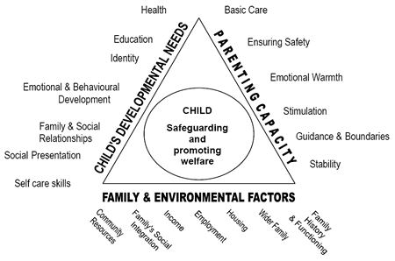***Department of Health Framework Triangle****:*

Glossary

‘*Domain’* = The 3 main sides of the triangle.

‘*Dimension’* = The 6 or 7 sub-divisions of the 3 domains.

*You are referred to the Department of Health Guidance to the Framework for Assessment which contains the description of each of the sub-dimensions within each domain. It is suggested that you remind yourself of the descriptions before commencing your assessment and review before writing your analysis. It is important to remember that the domains (the sides) of the triangle are explored systemically so that you consider the interconnections and interactions between different pieces of information.*

*Your Parenting Assessment will include consideration of the parent/s:*

* *response to a child and his or her behaviour or circumstances;*
* *the manner in which they are responding to the child’s needs and the areas where they are experiencing difficulties in meeting needs or failing to do so;*
* *the effect this child has on them;*
* *the quality of the parent – child relationship;*
* *the child's attachment style;*
* *the parent's history of attachment (i.e. to their parents);*
* *understanding of the child’s needs and development;*
* *comprehension of parenting tasks and the relevance of these to the child’s*
* *the impact of any difficulties they may be experiencing themselves on their ability to carry out parental tasks and responsibilities (distinguishing realisation from aspiration);*
* *the impact of past experiences on their current parenting capacity;*
* *ability to face and accept their difficulties;*
* *ability to use support and accept help;*
* *capacity for adaptation and change in their parenting response;*
* *What other professionals report in terms of capacity to change.*

*Analysis*

*The assessment triangle will support you to identify how each of the domains within the triangle impacts upon another domain, i.e. cause and effect. In considering your analysis, you should explore and compare each theme with each of the three triangle domains. You can then apply the facts which are relevant to your analysis to both the theme and the relevant domains, remembering that there will be may areas of overlap.*

*Your ability to translate a deficiency or strength in “parenting capacity” across the triangle to “child’s needs” is a critical part of the analysis process and must be carefully performed and clearly explained.*

*Having completed the assessment of the three domains, you will have listed strengths and weaknesses against each area (dimension) of the triangle. This means that you will have categorised all of the evidence collated during your assessment but in order to use this to formulate your analysis, you must then consider how the various dimensions on the triangle interact with each other. You may find it beneficial to annotate your chronology and any case notes with the theme which is pertinent within that recording/incident as this will further support your analysis by providing specific examples.*

*There are key questions which you should ask yourself:*

*1.* ***What is causing this behaviour or fact to occur?***

*2.* ***What does this fact or behaviour mean for this child?***

*This will ensure that your analysis meets the legal requirements of meeting the significant harm test (“the threshold test”) as you will then be making and exploring a link between the parent’s behaviour and its specific impact on the child.*

*You must remember to consider both primary impacts and secondary impacts. Any direct impact on a dimension in the Child’s Needs domain is likely to have a further indirect negative or positive impact upon other dimensions. Therefore, when you have established that a child’s need is being directly impacted by the care they are receiving, you need to consider whether there are any further consequences of this in other dimensions of the Child’s Needs domain, whilst also remaining alert to whether the child is internalising or externalising their behaviours. Remember, however, that you must have evidence to support any contentions you make, whether these are of primary or secondary impacts upon the child.*

***Example:***

***The child’s emotional and behavioural development is being impaired because of lack of emotional warmth. What is the consequence of that impact? Is the child demonstrating internalised or externalised behaviours? If externalised behaviours are apparent, is the challenging behaviour having an impact on the child’s “Education”, “Family and Social Relationships”, or “Social Presentation”? If the impact is internalised, what is the impact? The parents’ lack of emotional warmth is not having a direct impact but the secondary consequence can impact on a number of other dimensions.***

*Not only do you need to consider the impact on the child of the concerning behaviour but you also need to explore how significant (or entrenched) that impact is. It is vital that you evidence your concerns referencing the themes identified within the chronology. Consider the following issues:*

*1.* ***Pervasiveness:*** *How many areas of family life are affected by the concerns?*

*2.* ***Intrusiveness:*** *How bad is the impact of the concerns?*

*3.* ***Frequency:***  *How often does the concern arise?*

*4.* ***Modifiability:*** *What impact to other factors have upon the concern?*

*5.* ***Duration:***  *How long has the concern continued or will it continue?*

*6.* ***Unusualness:*** *Exceptional factors are important in their own right as they may*

*evidence a severe need, e.g. suicide attempt.*

*Ability to Change*

*You should reference and explore within your Parenting Assessment plan and the assessment process Prochaska & DiClemente’s model of change (see Jan Horwath’s “A Child’s World”). Use of the C-Change model, with clear, agreed and measurable targets, will support your assessment of the parent’s capacity to change and address the concerns which you have identified.*

*You will need to determine where the parent is within the cycle of change in respect of each theme which you identify as causing the child harm. This will allow you to assess and analyse how likely the parent is to be able to effect, and maintain, change. It is likely that this analysis will be supported by your assessment of the “Family History and Functioning” as this will evidence the parent’s circumstances.*

*Where you assess that a parent is within the “contemplation” stage of change, you should consider Morrison’s “7 steps of contemplation”. This, in conjunction with any use of the C-Change model, will support you to identify more precisely the parent’s level of acceptance and understanding whilst also considering the link between their commitment to change and the effort made.*

*Use of the C-Change concept of “Barriers to Change” and “Facilitators of Change” will enable you to consider which of the areas in which there is less progress could be improved through the provision of support. When identifying support, you need to comment upon the suitability and availability of support, and provide your opinion as to whether that support is sufficient to enable the parent to overcome any deficits in their parenting.*

*Conclusion*

*It is not sufficient to conclude simply that the parent cannot provide good enough care. The impact upon the child of the parenting that they are likely to receive needs to be explained, with a description of the likely impact of the future development of that child.*

**Headings**

Your case is likely to be heard in either Weston-super-Mare or Bristol. Your header, in the top right hand corner, will reflect where the hearings take place.

**Local Authority and Social Worker Details**

In this section, you need to set out your details, including your name, role and professional address (for all Social Workers: Town Hall, Walliscote Grove Road, Weston super Mare, BS23 1UJ).

**SECTION 1: INTRODUCTION**

**Paragraph 1.1:**

This section asks that you set out detail of your employment within the Local Authority presently, and your previous experience. You should set out when and where you gained your qualification from, and the time periods and roles in which you have been employed.

**Paragraph 1.2:**

It is important to identify who the assessment concerns, both parents and child/ren. It is recommended that in discussing the children you should, throughout your assessment, refer to them, and undertake your analysis, in chronological order, oldest to youngest.

Where one or more of the children is not the biological child of the parent being assessed, it is important that this is identified, and that the relationship between the child and that parent is confirmed.

In this section, you are asked to detail the materials which you have used in preparing your assessment. The following are examples but are not exhaustive of the possible materials available to you:

(i) Social Care records held by North Somerset Council;

(ii) Social Care records held by another Local Authority (which should be identified);

(iii) Reading of all documents within the Court bundle (identifying any particularly important documents);

(iv) Reading of any capacity assessments which have been completed in respect of the parent;

(v) Reading of supervised contact notes;

(vi) Reading of reports received from multi agency professionals (identifying the professional);

(vii) Meetings and discussions with the parent;

(viii) Meetings and discussions with any family members;

(ix) Meetings and discussions with other professionals.

**Paragraph 1.3:**

This section asks you to list the themes which you identified in your Parenting Assessment planning. Examples include, domestic abuse, parental drug misuse, parental alcohol misuse, physical chastisement, and neglect. You should identify the themes in order of priority and, where possible, explore them in the same order within your assessment.

You need to identify who has parental responsibility for the child/ren. If an individual does not share parental responsibility for all children, please identify which child/ren they share parental responsibility for and how they obtained parental responsibility (e.g, through marriage, being named on the birth certificate or acquiring through a court order or formal agreement).

**SECTION 2: BACKGROUND**

Within this section, you should summarise the key concerns for the child/ren and the circumstances which have led to Social Care intervention and a parenting assessment being deemed necessary. You should think of this section as being the back cover of a book – in essence, it provides an outline picture of the concerns; it will support your analysis using the third domain of the assessment triangle – Family and Environmental Factors.

It is important that, in your background, you set out the most significant incidents of concern. You should not go through each and every entry in the chronology. In describing these incidents, it is equally important that there is reference to the themes which you have identified and set out within Section 1.

The background should not be lengthy and should not detail every aspect of the case; indeed, the majority of incidents will be relevant when you provide focussed analysis later in your parenting assessment.

**SECTION 3: METHOD OF ASSESSMENT**

This section will provide detail of the assessment process. It is important that you evidence that you are not reliant upon one source of evidence alone but that your assessment is, instead, a holistic analysis of all of the evidence available to you.

You should provide confirmation that the parent being assessed was provided with a Parenting Assessment Plan which set out the dates of all appointments, and, where possible, provide the date upon which this was provided to them. This will be important in the event that the parent does not engage with the assessment process.

As it should be possible to read the assessment as a standalone document, it is suggested that you list the appointments which were offered, the themes which you proposed to explore within each session and discuss the parent’s engagement with the process. It may assist to include in a tabular format, an example of which could be (with examples to assist):

|  |  |  |  |
| --- | --- | --- | --- |
| **DATE** | **TOPIC TO BE EXPLORED** | **DID PARENT ATTEND? (WITH REASONS WHERE NO ATTENDANCE)** | **ENGAGEMENT WITH THE SESSION** |
| *05.03.2018* | *Childhood experiences and relationship history.* | *Yes* | *All topics were explored and a timeline drawn up.* |
| *12.03.2018* | *Domestic abuse and understanding of this upon a child.* | *Yes but arrived 20 minutes late.* | *Time was limited by Ms X’s late attendance. She was not willing to discuss any issues within her current relationship.* |
| *19.03.2018* | *Child’s Needs (Part 1)* | *No – no reason provided and no prior cancellation.* | *Session could not be completed.* |

You must set out any issues relating to the parent’s learning ability and, where issues or difficulties exist, or where there have been recommendations made by an expert as to how to work with the parent, set out what supports or assistance were provided during each session. For instance, where a parent has a learning issue which do not meet the criteria for a learning difficulty, and there is a recommendation that they will need short sessions, you may have offered more sessions but for shorter periods in order to meet this need.

If a parent has a diagnosed learning difficulty, it is good practice that a PAMS based parenting assessment is completed. If this form of assessment is not undertaken, it is likely to be challenged should the matter come before a Court and would not comply with the relevant guidance.

You should also, within this section, reference the tools used within your assessment. You must be mindful that those reading your assessment may not understand the purpose of the tool and it is, therefore, helpful to provide a short synopsis of the purpose of the tool. Examples of tools include:

(i) The Neglect toolkit;

(ii) Attachment style interview;

(iii) The HOME inventory;

(iv) The Family Pack of Questionnaires and Scales.

Throughout the parenting assessment process you will be challenging the parents, allowing them time to reflect, and then following up in subsequent sessions. This will assist in determining the parent’s ability to demonstrate insight and how / if this translates into any behavioural change.

You should also identify, if appropriate, any particular techniques which have been used in undertaking your assessment, such as Motivational Interviewing or the principles of Kolb’s learning theory of assistance, when you seek to challenge a parent.

It is important that, within your assessment methodology, you include observations of the parent with the child/ren. This will assist you to explore the parent’s responses and practical parenting abilities.

Finally, it is essential that you reference any national guidance, including:

(i) Department of Health Framework for Assessment of Children in Need and their Families; and/or

(ii) Good practice guidance on working with parents with a learning disability (University of Bristol, 2016).

This is the underpinning basis of your assessment.

**SECTION 4: IDENTIFIED BARRIERS TO AND FACILITATORS OF CHANGE**

In order to assess whether a parent has the capacity to change, it is important that you identify and assess the factors which are both preventing them from effecting change and which enable them to effect change. This will require that you have identified the concerns/themes as a first stage.

A barrier to change is an issue, whether emotional or tangible, which prevents or limits a person’s ability to effect change. There are a variety of barriers within the context of a person’s parenting capacity and guidance around this is contained with the C-Change manual.

A facilitator for change is something, internal or external, which assists or supports a person to address concerns and effect change. This is, again, addressed within the C-Change manual.

You are not, in Section 4, asked to consider the impact of the barrier or facilitator but merely to identify what barriers and facilitators exist. Your analysis will be provided at Section 10 of your assessment.

**Paragraph 4.1: Priority and Relevance**

The priority and relevance of a factor requires you to consider whether a specific change in behaviour is a priority for a parent or whether other issues are of greater importance. You also need to explore the relevance of a particular change compared with other pressures faced by the parent. For instance, does the parent regard regular attendance at contact sessions with their child/ren as being of greater, or lesser, importance than spending time with friends? You are therefore being asked to consider whether a change is of such significance and relevance to a parent that in itself it acts as a facilitator for change, or whether the change is of low importance and relevance and thus is a barrier to change.

Key questions to answer when writing your analysis are:

(i) What change, if any, does the parent believe is needed?

(ii) What change does the parent consider to be the most important to improve their child/ren’s life?

(iii) What does the parent think would be positive factors if they made the change?

(iv) What does the parent think would be less positive factors if they made the change?

(v) What does the parent consider to be the least important changes being asked of them?

(vii) How important does the parent believe that the changes identified by Children’s Social Care are?

(viii) How must time does the parent think will be needed to make the change and how does this compare with the child/ren’s timescale?

(ix) How important, applying a scale of 1 to 10 (where 10 is high importance), does the parent consider each area of change to be?

(x) What is the parent’s ability to reflect upon what happened, why it happened, what the consequence was and what should happen next?

|  |
| --- |
|  |

**Paragraph 4.2: Knowledge and Skills**

When addressing knowledge and skills, a parent’s capacity to learn will be significant. You need to consider previous involvements with the parent and compare these with their current presentation. For instance, is there any variation between that parent’s previous knowledge and skills and their current knowledge and skills?

Knowledge and skills will, to some extent, have been considered within your Parenting Assessment Plan and methodology (at Section 3 of the assessment template); you should consider and reference any particular needs in this section and explore whether they act as a barrier or facilitator to change and, in respect of barriers, whether any potential supports can assist the barrier to become a facilitator.

When writing your analysis, you should consider the following questions:

(i) Does the parent require additional knowledge or skills in order to make the necessary changes?

(ii) How can you best communicate with the parent in order that they understand the issues or concerns?

(iii) How does the parent describe the issues or concerns?

(iv) What area of parenting does the parent feel that they do well or feel most comfortable with?

(v) What area of parenting does the parent find the most difficult?

(vi) What is the parent’s ability to reflect upon what happened, why it happened, what the consequence was and what should happen next?

**Paragraph 4.3: Motivation and Intentions**

It is recommended that any assessment addresses motivation in four contexts:

(i) *Needs and expectations*;

What are the parents’ goals? What do they see as being the value, to them, of the necessary changes? What do they see as being the risk, to them, of the necessary changes?

In exploring the individual’s motivations, you should assess their needs and expectations, fears and the strength of their attachment to current behaviours. It is worth remembering that a fundamental principle in a professional/parental relationship is the need for a sense of autonomy and control over what is happening. This should be reinforced as you complete your assessment.

(ii) *Attitudes, beliefs and feelings*;

What are the individual’s beliefs, attitudes and feelings about the work and services which professionals deem necessary? What are their beliefs about the consequences of their own behaviours?

It is important, when writing your assessment, to bear in mind that you are considering not only the change (or lack of) which a parent has effected but also their capacity to effect and sustain that change in the future. Although research supports the view that insight and recognition are relevant to the likelihood of change, other factors come into play and it is the assessors role to assess the different factors in order to develop a better understanding of the extent of the parent’s motivation.

(iii) *Identity and social role*;

What impact does the social context in which the parent/family lives have upon the parent’s own identity and motivation?

(iv) *Self-confidence and efficacy*.

It is advised that in this area, you refer to your assessment of the parent’s knowledge and skills and consider how these factors impact upon their motivation and confidence in achieving change.

The following key questions should be considered when preparing your analysis:

(i) What is the parent’s experience of working with Social Care and other services and do they feel able to work with those services?

(ii) What is the parent’s expectations of Social Care’s involvement?

(iii) How would the parent describe themselves and how others would perceive them?

(iv) What does the parent think about the situation with their child/ren?

(v) What does the parent think others around them may think about the situation with their child/ren?

(vi) Does the parent believe that they have the knowledge and skills to enable them to make changes in their life?

(vii) What has assisted the parent to address any difficulties which they have previously experienced?

(viii) What is the parent’s main reason for considering making the change?

(a) They are told to?

(b) They want to?

(c) Their children need them to?

(ix) Who does the parent regard as benefitting from them making the changes?

(x) What support does the parent believe would be available to them as a result of contextual factors (e.g. family, community, etc)?

**Paragraph 4.4: Habits and Automatic Responses**

Automatic responses can have a significant impact upon a parent’s functioning and emotional responses to a child/ren. It is, therefore, important that you consider whether particular behaviours are intentional or are habitual.

The key questions to consider when analysing a parent’s habits or automatic responses are:

(i) How does the parent cope with and respond in stressful situations?

(ii) How does the parent cope with and respond in a stressful parenting situation?

(iii) How does the parent react, objectively and subjectively, when their child behaves in a particular way?

(iv) Is the parent aware or able to consider whether they think about how to react before reacting and if yes, when does the habit arise?

(v) How long has this behaviour continued?

(vi) What prompted the reaction to start?

(vii) Is the parent able to identify a situation in which they did not respond in this way and can they identify what was different?

(viii) How does the parent consider that their life would be if the behaviour was no longer present?

**Paragraph 4.5: Contextual Factors**

Contextual factors vary from individual to individual.

You need to consider the following:

(i) Would the parent make the changes without pressure from Social Care?

(ii) Does the parent feel that they have control over the nature of the changes being asked of them?

(iii) Does the parent feel that they have control over how the changes are made?

(iv) Are practical or financial issues preventing the parent from accessing the support offered?

(v) What does the parent believe that friends and family would say about the changes identified as being necessary?

(vi) Is the parent’s relationship with the Social Worker good enough to work towards change together?

(vii) What professional support, if any, does the parent believe necessary to enable positive changes to be made

(viii) Does the parent feel that, with support, they could make changes?

(ix) What additional support, for instance from family and friends, does the parent believe that they would need in order to make changes?

(x) Are all professionals working with the family supporting the parent’s sense of autonomy, self belief and links with formal and informal support networks?

(xi) Are all professionals working together to help the parent identify the goals and make changes as necessary?

(xii) Are all professionals working with the parent in the right way?

(xiii) Where do any difficulties in relations between a parent and professionals lie and what can be done to address those difficulties?

(xiv) Is the parent’s attachment style impacting upon their working relationships with professionals?

(xv) Does any professional need to adapt or modify their approach in order to improve the working relationship?

(xvi) What is the parent’s practical engagement with services?

**Paragraph 4.6: Facilitators of Change**

What are the factors or behaviours which support, or may support, a parent to change or adapt their behaviours and parenting? Would these facilitators support a parent to sustain any changes which they may make?

Within this section you should consider the strength of the facilitators, and where they fit within the assessment triangle. You should also consider their relative strengths when compared with the parental barriers to change.

**SECTION 5: CHILD’S DEVELOPMENTAL NEEDS**

This section seeks to present a portrait of the child currently whilst also considering their needs in the medium and long term. The child’s needs are at the heart of the assessment process.

Section 31(9) of the Children Act 1989 defines harm as *“…ill treatment or the impairment of health or development”.* The following additional definitions are provided:

(a) *Development means physical, intellectual, emotional, social or behavioural development*;

(b) *health means physical or mental health*; and

(c) *ill-treatment includes sexual abuse and forms of ill-treatment which are not physical*.

This includes the effects of seeing or hearing the ill treatment of another and affects the child’s physical, intellectual, emotional, social and behavioural development. Ill treatment also includes physical, emotional and sexual abuse.

It is important that you have a clear understanding of the typical needs of a child of the subject child/ren’s age(s) and are able to set out concisely what additional needs this particular child or group of children have.

It is likely that much of the information required within this section will be contained within the assessments (e.g. Single Assessment or Child and Families Assessment) which have been completed previously. It is essential that where information is drawn from other sources, the source is clearly identified.

You must consider each child’s needs individual, addressing the eldest child first and the youngest child last.

**Paragraph 5:1: Health**

This section asks you to consider the child’s:

(a) Physical health;

(b) Dental health;

(c) Optical health;

(d) Mental/emotional health.

You will also, within this section, need to consider the medical treatment accessed or received by the child whilst in their parents’ care, including any gaps in such treatment. In addition, you should consider any recent medical assessments.

This section will require you to have obtained information from other professionals and, in particular, the child’s G.P., School Nurse and/or Health Visitor.

**Paragraph 5.2: Education**

Within this section, you should explore and analyse the child’s educational experiences and attainment. This will involve you considering their ability to learn, ability to engage in learning, progress, and attendance. You would be expected to have obtained information from school and pre-school professionals.

Whilst it is often the case that such information will be provided within Core Group meetings, you should also be alert to the potential for professionals to withhold certain information when in the presence of a parent and it is therefore advised that you also obtain information from professionals directly from that professional.

**Paragraph 5.3: Emotional and Behavioural Development**

Information regarding the child’s emotional and behavioural development will frequently be based upon observations of their presentation and information received from other professionals. You should consider their presentation within different environments (such as home and school) and attachments with different individuals/carers (for instance, parents, or family members) and explore any differences in their presentations. Within this section, you should consider the nature and quality of the child’s attachments, their temperament, their ability to adapt to change, their response to stress, and their self control.

**Paragraph 5.4: Identity**

The child’s identity needs, and their role within the family, will be important considerations, particularly where a potential long term care option is placement outside of the family. It is important that this is explored as fully as possible.

Your assessment of the child’s identity should consider the child’s view of themselves and their abilities, their self image and their self esteem. This may include consideration of race, religion, age, gender, sexuality and disability, as well as feelings of belonging and acceptance by family, peer group and wider society.

**Paragraph 5.5: Family and Social Relationships**

Family and social relationships will often overlap with a number of other areas of the assessment triangle. This section will invite you to explore the child’s attachments with their parents, siblings, other family members, other significant adults and with peers. It is important that, within this section, you explore both the child’s current presentation and their future needs.

**Paragraph 5.6: Social Presentation**

You should consider the child’s behaviour and presentation (e.g. withdrawn, anxious, frozen or fearful behaviours, or violent or aggressive behaviour) and attachment patterns. You may wish to set out how the child’s behaviour differs from what would be expected of a child this age.

This analysis will involve exploration of issues such as the child’s physical presentation (including their clothing and hygiene), their gender and culture and religion.

**Paragraph 5.7: Self Care Skills**

This section will require you to consider the child’s self-care skills, having regard to the skills which would be expected of a typical child of their age. This will necessitate the assessment of the child’s practical skills (such as dressing and feeding), the opportunities available to them to gain confidence and practical skills in order to undertake activities away from the family, and, in respect of older children, independent living skills.

It is particularly important that, within this section, you explore the impact of a child’s experiences and vulnerabilities on the development of their self care skills.

**SECTION 6: FAMILY AND ENVIRONMENTAL FACTORS**

**Paragraph 6.1: Family History and Functioning**

Family history will necessitate consideration of both genetic and psycho-social factors.

Family functioning will be influenced by the individuals who live in the household, their relationship to the child, the changes in the family/household composition, and the parent’s own childhood experiences. You should, when considering the family history and functioning, prepare, with each parent, a chronology of their own experiences and life events, to support your assessment of the family history.

This section will also involve some exploration of the sibling relaitonships and the parents’ abilities to manage those relationships having regard to any impact which they have upon the individual child.

You should, furthermore, also consider the parental strengths and difficulties and any relationship issues as between the child’s parents, whether they remain as a couple or are separated.

**Paragraph 6.2: Wider Family**

This section requires you to consider who the members of the wider family are, and their relationship both with the child’s parents and the child themselves. You should, however, go beyond this and explore those who form part of the family’s support network, even if not related to the family. Consider, within your assessment, the role and importance of the individual to the child, and to the parents, setting out what their importance is and any support or involvement they have with the family, including the frequency.

**Paragraph 6.3: Housing**

You should consider the family’s housing conditions and whether the family has available to it the amenities and facilities (such as water, heating, sanitation, cooking facilities, sleeping arrangements, cleanliness, hygiene and safety) appropriate to the age of the child and other household members. Any factors which you identify should be considered having regard to their impact on the child’s upbringing.

**Paragraph 6.4: Employment**

You should explore each parent’s employment histories, and any current employment, including their pattern of work and any changes. In so doing, you should consider the impact of the work upon the child, and how the parent’s employment is viewed by the parent themselves, other family members and the child. You must also explore the child’s experience of work and its impact upon them.

**Paragraph 6.5: Income**

You should set out the income available to the family, and its source. It is essential that where a family is in receipt of benefits, you explore whether they are in receipt of all benefit entitlements.

You should also consider the sufficiency of the income to meet the family’s needs, and the security of the income.

Where there are issues regarding the family’s income and this impacts upon other areas of the assessment triangle (for instance “Housing” or “Stability”), these impacts should be identified, with specific regard to their impact upon the child.

**Paragraph 6.6: Family’s Social Integration**

Assessment of a family’s social integration will require you to explore the family’s involvement in the local neighbourhood and community, and their ability to become integrated with such in the future. There will, therefore, be some overlap with a parent’s motivations and intentions. In exploring this domain, you must remain focussed upon the child’s needs and the impact of integration or failure to integrate upon the child.

You should also consider the degree of the family’s integration or isolation, their peer groups, support networks and the importance attached to them, in addition to the longevity and stability of the integration.

**Paragraph 6.7: Community Resources**

The content of this section may differ depending upon the stability of the family’s housing. If the family is at risk of eviction from their current accommodation, you will have to consider both their existing community resources and potential future community resources.

Community resources comprise all facilities and services in a neighbourhood, including universal services of primary health care, day care, schools, places of worship, transport, shops and leisure activities. You must, however, also consider the availability and accessibility of the resources, the standard of the resources, and the impact, or potential impact, of the resources upon the child and their parents.

**SECTION 7: PARENTING CAPACITY**

**Paragraph 7.1: Basic Care**

Meeting a child’s basic care needs involves providing for the child’s physical needs, with appropriate medical and dental care, and provision of food, drink, warmth, shelter, clean and appropriate clothing and appropriate personal hygiene.

**Paragraph 7.2: Ensuring Safety**

If a parent is ensuring the child’s safety, then they should be able to adequately protect the child from harm or danger, ensuring that the child does not have contact with unsafe adults/other children, and that they are protected from self-harm, hazards and dangers both in the home and the community.

**Paragraph 7.3: Emotional Warmth**

Emotional warmth involves ensuring that the child’s emotional needs are met and providing the child with a sense of being specially valued, supporting the child to have a positive sense of their racial and cultural identity. A parent who is able to provide emotional warmth would, amongst other things, ensure the child’s requirements for secure, stable and affectionate relationships with significant adults, offer appropriate sensitivity and responsiveness to their needs and offer appropriate physical contact, comfort, and cuddling, sufficient to demonstrate warm regard, praise and encouragement.

**Paragraph 7.4: Stimulation**

Stimulation involving promoting the child’s learning and intellectual development through encouragement and cognitive stimulation and promoting social opportunities. A parent would be expected to, amongst other things, encourage the child’s cognitive development and potential through interaction, communications, talking and responding to the child’s language and questions, encourage and join in with play, promote educational opportunities, enable the child to experience success, ensure school attendance and facilitate the child to meet the challenges of life.

**Paragraph 7.5: Guidance and Boundaries**

In offering guidance and boundaries, a parent should enable the child to regulate their own emotions and behaviours. The parental tasks include demonstrating and modelling appropriate behaviour and control of emotions and interactions with others, and guidance through setting boundaries so that the child can develop an internal model of moral values and conscience. The parent should also model appropriate social behaviour for the society in which the child is being raised. The aim of guidance and boundaries is to enable the child to grow into an autonomous adult, holding their own values, and be able to demonstrate appropriate behaviour with others rather than having to be dependent on external rules. The parent would be expected to avoid over protecting the child from exploratory and learning experiences. This area of the triangle includes social problem solving, anger management, consideration for others and effective discipline and shaping of behaviour.

**Paragraph 7.6: Stability**

A parent who offers stability would provide a sufficiently stable family environment to enable a child to develop and maintain a secure attachment to their primary caregiver in order to ensure optimal development. This would include ensuring that secure attachments are not disrupted, providing consistent emotional warmth over time and responding in a similar manner, adapting responses according to the child’s developmental progress.

**SECTION 8: CHILDREN’S WISHES AND FEELINGS**

It is essential that each child’s wishes and feelings are addressed within your assessment, and that there is regard to the child’s age and understanding. You will need to consider observations of and discussions with the child, the outcomes of any direct work, and thus, it is important that you obtain a full update from other professionals working with the child who may also have gathered the child’s views.

**SECTION 9: SUPPORT**

As a result of Article 8 of the European Convention on Human Rights (right to respect for private and family life), and Articles 7, 8 and 9 of the UN Convention on the Rights of Children (the right of the child to be brought up by and know their parents), the Local Authority has a duty to provide any support which can be reasonably provided to parents in order to support a child to remain safely within the family network.

In Re G (A Child) [2013] EWCA Civ 965, the Court of Appeal held that within any public law proceedings, the Court has to consider whether a Local Authority, or others, can provide the necessary support and assistance to a family which is required in order for a child to remain within the care of their family.

There is, therefore, a requirement for the Local Authority’s assessments to clearly evidence what supports could be provided to a family and why those supports would or would not be sufficient to enable the child to remain in his or her parents’ care.

Thus far in your assessment, you will have identified the key concerns which exist in relation to the parent, the barriers for the parent effecting change, the facilitators for the parent effecting change and explored the child’s needs and the parent’s ability to provide satisfactory parenting. Whilst, in some cases, a change of behaviour or pattern may be required, it is frequently the case that support or the provision of resources could overcome at least some of the parenting deficits identified.

**Paragraph 9.1: Available Supports**

By identifying areas of need clearly, you will be able to comment upon whether a specific support will address the harm resulting from an inability to meet a particular need.

In this section, you should identify each support which has been provided to the family or may be available to them in the future, both from Social Care and from external agencies. It is important that you think widely and creatively and that you do not adopt a linear approach to your assessment.

Any support provided previously or interventions previously attempted can be considered to determine whether it was directed appropriately, and whether there are any other interventions which may be more suitable.

You should consider potential supports in a thematic manner so that there is a consistent approach within your assessment. It is suggested that you refer to your LPM referral document or, in urgent cases, SWET as you will have set out the supports previously provided and detailed, in brief, the outcome of those supports.

**Paragraph 9.2: Effectiveness of Supports**

Having identified the past and potential future supports, you should then consider whether each has been or may be effective and, in so far as you are able, explore why they have or have not been successful.

In relation to each potential support, you should explain whether, on balance, that support would reduce the harm the child may face or has faced to an acceptable level and what the resulting level of harm has or might be.

**SECTION 10: ASSESSMENT OF CAPACITY TO CHANGE**

This section combines the information which you have gathered about the parent’s understanding of the concerns, their barriers to and facilitators of change and your observations to provide a view as to their overall ability to effect change. Change requires the parent to demonstrate the motivation and capacity to change, as outlined in The Child’s World (Horwath, 2009).

It is essential that, throughout the parenting assessment process, you are clear with the parent as to the areas of concern which need to change.

Prochaska & DiClemente’s comprehensive model of change contains 5 steps:

(i) **Contemplation:** Start of the change process;

(ii) **Determination:** Informed decision to change;

(iii) **Action:** Rehearsing new behaviour, thinking and relationships;

(iv) **Maintenance:** Sustaining and internalising new behaviour;

(v) **Lapse:** The return to some or all old behaviours.

In addition, there are 2 blocks to change:

(i) **Pre-contemplation:** Denial, blame, defence or not being aware of the problem;

(ii) **Relapse:** The lapse phase detailed above.

Morrison describes 7 steps of contemplation as follows:

(i) **I accept there is a problem**;

(ii) **I accept that I have some responsibility for the problem**;

(iii) **I have some discomfort about the problem**;

(iv) **I believe that things must change**;

(v) **I can see that I can be part of the solution**;

(vi) **I can make a choice**;

(vii) **I can see the next steps towards change**

You should review the parent’s position in the cycle of change at various stages throughout your assessment, both for the purposes of your assessment and to encourage the parent to continually review their situation in the hope of increasing their insight into the concerns.

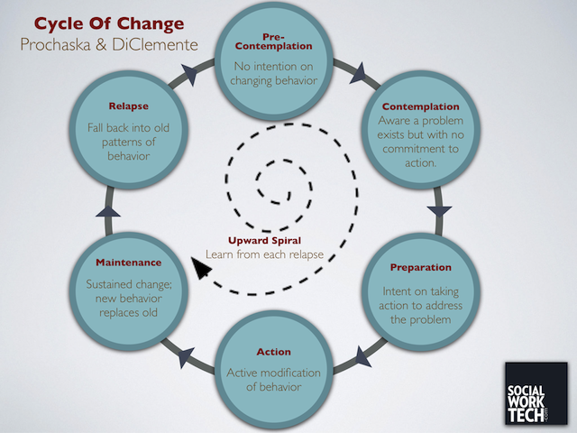

Use of the C-Change model will further support your assessment of a parent’s ability to change as will consideration of the dual continuums of commitment:

|  |  |  |  |
| --- | --- | --- | --- |
|  |  | **Evidence of Actual Change** | |
|  |  | **Insufficient** | **More than Sufficient** |
| **Assessment of Barriers and Facilitators of Change** | **Good potential for Change** | Potential not demonstrated in reality. Were the barriers underestimated or goals unrealistic? | Capacity to change is good. Evidence supports this assessment. |
| **Change is Unlikely** | Likelihood of change is very low. | Actual change is unexpectedly high. Were the barriers overestimated or goals insufficient? |

It is strongly advised that you do not use terms such as “disguised compliance” but rather focus upon the tangible evidence which you are able to gather. A useful tool when considering the true motivation of a parent is to consider the dual continuums of commitment to change and effort.

|  |  |  |
| --- | --- | --- |
|  | **High Commitment** | **Low Commitment** |
| **High Effort** | Genuine commitment | Tokenism  Superficial compliance |
| **Low Effort** | Compliance  Imitation  Approval seeking | Dissent  Avoidance  Sabotage  Barriers |

Therefore:

High commitment + High effort = Genuine commitment

High commitment + Low effort = Tokenism / superficial compliance

Low commitment + High effort = Compliance / imitation / approval seeking

Low commitment + Low effort = Dissent / avoidance / sabotage / barriers

In assessing a parent’s ability to change, you will need to challenge a parent’s opinions and determine whether they are reflective, thus enabling you to comment upon their likely future ability to change.

**Paragraph 10.1: Impact of Identified Barriers to Change**

In this section you will consider, in turn, each of the Barriers to Change which you identified earlier in the Assessment and analyse their impact upon the parent’s parenting capacity. You are referred to the points made within the introduction to this Guidance (“Analysis” and “Assessment” sections).

**Paragraph 10.2: Impact of Identified Facilitators of Change**

This section invites you to analyse each of the Facilitators of Change which are available to the parent. You should consider what impact each has upon that individual’s parenting capacity and how, in turn, that impacts upon the child and to what extent.

**Paragraph 10.3: Observations**

Within this Paragraph you can provide an overview of the steps / actions taken by the parent to overcome any barriers or use the facilitators available to them and describe what impact, if any, this has had upon their parenting capacity and therefore, upon the child.

You will also, within this section, discuss their engagement with the work undertaken by professionals and if and how this has impacted upon the Barriers/Facilitators themselves. Have the Barriers reduced and the Facilitators increased? Have the Facilitators not been as powerful as anticipated? Has there been no change?

**Paragraph 10.4: Conclusion**

The conclusion should offer a short summary of the key concerns and findings, but your analysis should be set out in detail at Section 11, alongside your recommendations.

**SECTION 11: ANALYSIS AND RECOMMENDATIONS**

When using the assessment triangle, analysis requires that you consider the way in which the three domains and multiple dimensions interact for this child or these children. It is important that you avoid generalisations and that you focus upon the needs which you have identified the child/ren as having. Your assessment should remain *child centred* and *rooted in child development.*

Your analysis of a deficiency or strength in parenting capacity and application of this to the child/ren’s need is critical. Using your assessment of the interactions between the domains, and having identified the strengths and weaknesses of the parent in each dimension, you will have the evidence to enable you to identify the child’s unmet needs and the best responses to them. It is important that whilst analysing the significance of the impact of a behaviour on each domain, you also take a view as to the cumulative nature of multiple impact across many dimensions of need.

Through your work with the family and your assessment sessions, you are likely to have formed views about the family’s interactions, operations, how the family interacts with the wider environment and how the children’s behaviours influence the parents and wider environment (the “processes”). It should be possible for you to test your hypotheses by mapping out a number of processes on the assessment triangle itself and observing whether the map correlates with your evidence and whether your belief about the impact upon the child/ren is correct.

It is suggested that you test your hypotheses by mapping a number of the “processes” onto the assessment triangle in order to assess whether your hypothesis is supported by the available evidence, and to explore whether your view regarding the impact upon the child is accurate. It is important to recognise that processes may be:

(i) Linear: Where one factor leads to another and then on to another; or

(ii) Circular: Where a factor leads back to an earlier factor.

You must also explore both primary and secondary impacts, as any immediate impact is may have other positive or negative impacts upon the child or the care which they are receiving. It is important that your assessment explores both the direct and indirect impacts.

The following steps may assist in identifying the cause and effect and in highlighting areas of need or strength upon which your analysis should comment:

1. Identify the key facts, placing each on the triangle next to the corresponding dimensions (your categorization);

2. Identify on the triangle (using lines) any dimensions of concern which you consider impact upon another.

Be alert to the fact that any direct impact upon a dimension in the Child’s Needs domain is likely to have a further indirect negative or positive impact upon other dimensions. If you identify that a child’s need is being directly impacted by the care which they receive, you should then consider whether there are any further consequences of this in other dimensions of the Child’s Need domain. Consider also whether the child is internalising or externalising their behaviours.

At all times, however, you must consider whether you have evidence of an impact upon the child. It is likely that you will find that there are both positive and negative impacts and you must consider how much weight is afforded to each. In doing so, consider your level of concern and the factors set out at page 5 of this guidance document (the issues of intrusiveness, pervasiveness, modifiability, frequency, duration and unusualness) as this will support you to identify the areas of need which will most likely be affected by the issues.

Analysis including linking it to harm to a child generally:

*Children who witness domestic violence are at risk of suffering physical harm by becoming involved in the parental conflict, and suffer emotional harm both during and after the relevant incident in the aftermath. Domestic Violence will rarely take place outside of a situation of conflict which a child will find frightening. Children may portray a wide range of reactions to the exposure of domestic violence in their home. A child of nursery age does not understand the meaning of the abuse and may believe they did something wrong, this self-blame may cause the child feelings of guilt, worry, and anxiety. Younger children do not have the ability to express their feelings verbally and these emotions can cause behavioural problems. They may become withdrawn, non-verbal, and have regressed behaviours such as clinging and whining. Other common behaviours for a child being a victim of domestic violence are eating and sleeping difficulty, and concentration problems.*

Analysis linked to harm suffered by the specific child:

*X is known to have witnessed domestic violence and displays behaviour consistent with having been harmed through exposure to domestic violence. Such effect is in my view likely to be a cumulative effect from repeated exposure, examples of which are contained within the chronology. Upon becoming voluntarily accommodated X was not willing to engage with the foster carer choosing to hide behind a cushion for 4 ½ hours. This was significantly beyond the normal reticence to engage that would be expected in this situation.*

*Prior to being accommodated X had been seen to be anxious and would not speak at nursery. Since becoming accommodated X’s anxiety has begun to stabilise although he still requires a high degree of reassurance and praise. X needs to continue to have a stable placement to internalise the consistent message of safety being instilled by the foster carer.*

**An analytical process:**

Throughout your assessment, you must analyse whether the evidence which you gather supports your hypotheses and, ultimately, your conclusions.

**The “so what?” question:** In drawing the lines across the triangle, you will be able to clearly see the processes which impact upon the family.

You have observed that the parents fail to provide emotional warmth to a child. You therefore highlight the “Emotional Warmth” dimension as you anticipate that this will have an adverse impact upon the child’s emotions and behaviours. If you have observed such an impact, you would draw a line from “Emotional Warmth” to “Emotional/Behavioural Development”. If there is no observable impact, then you could not draw a line or highlight “Emotional/Behavioural Development” as there is currently no evidence of any impact.

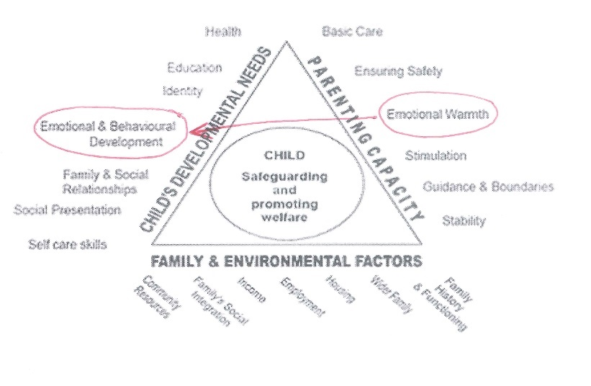

**The “why is this happening?” question:**

If a parent is not providing emotional warmth to a child, it is important to explore what drives this behaviour. Having already marked the dimension “Emotional Warmth”, you may consider that the parent’s own experience of being parented or external influences may impact upon their behaviour. In this instance, you would highlight “Family History and Functioning” and draw a line between this dimension and “Emotional Warmth”. You will then have a linear connection between “Emotional Warmth”, “Family History and Functioning” and “Emotional and Behavioural Development”.

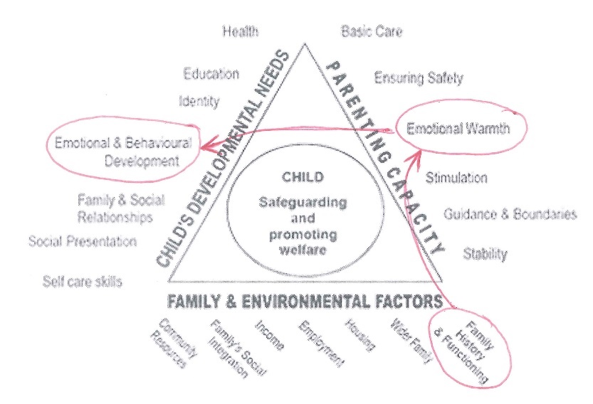

If you consider that that child’s emotional and behavioural development is impaired due to a lack of emotional warmth, you must go on to explore the consequence of that. Is the child internalising or externalising behaviour? If the behaviour is externalised, is the challenging behaviour impacting upon the child’s “Education”, “Family and Social Relationships” or “Social Presentation”, for instance? If the behaviour is internalised, are other aspects of the child’s functioning being impaired? In this instance, you may wish to link factors between the “Parenting Capacity” and “Child’s Developmental Needs” domains but always be alert to the availability of evidence and examples. If you do not have evidence available to demonstrate your hypothesis, be prepared to consider whether your hypothesis is, in fact, incorrect.

For example, if your hypothesis is that one impact of a child’s “Emotional and Behavioural Development” will be problems with concentration, yet school staff report that the child is thriving, you may need to re-explore your hypothesis or obtain more information from the school. You may also discover that there are positive processes in place, such as a supportive “Wider Family”.

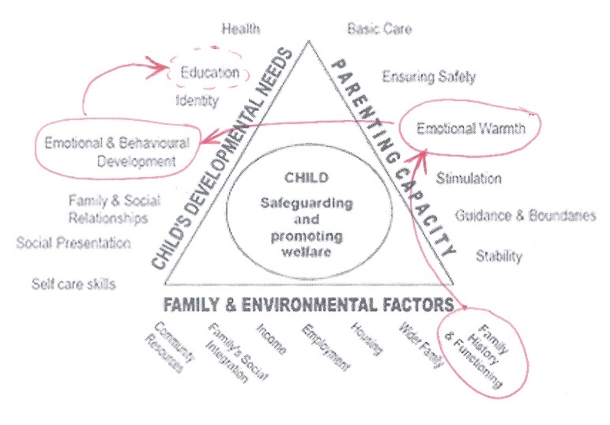The above process can be repeated for each theme/process which you identify in respect of the family.

by examining the processes and identifying both the positive and negative factors, you will have obtained a holistic analysis as to the functioning of the family.

**SECTION 12: STATEMENT OF TRUTH**

You are reminded that you are signing a formal statement of truth. The document must be correct to the best of your knowledge and belief.