KENT COUNTY COUNCIL (KCC)

SOCIAL WORK FRAMEWORK

A framework for delivering Social Work in Adult Social Care and Health, Older people and people with a Physical Disability (OPPD)

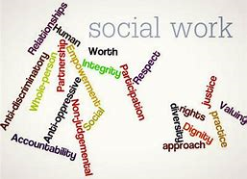

SOCIAL WORK FRAMEWORK - CONTENTS

No. | Contents |  | Page Number
Purpose of the Framework

1. | INTRODUCTION |  | 4
2. | NATIONAL Definition of Social Work |  | 4
3. | KCC VISION of the OPPD Social Work Function |  | 4
Standards, Principles and Values

4. | PCF The Professional Capabilities Framework (PCF) |  | 5
5. | SCCF Kent Social Care Capability Framework (SCCF) |  | 6
6. | POLICY FRAMEWORK National |  | 6
7. | LEGISLATIVE Framework |  | 7
8. | WHAT WILL be delivered? |  | 7
9. | WHO ARE the Clients who would benefit from a Social Work service? |  | 8
Operational Procedures

10. | SOCIAL WORK FUNCTION – Client Pathway |  | 8
11. | PREPARING and progressing the Assessment |  | 10
12. | CARE AND SUPPORT Planning |  | 10
13. | REVIEW Process |  | 10
Function Management – Process and Principles

14. | SUPERVISION |  | 10
15. | WORK Levels |  | 11
Performance monitoring process

16. | REPORTING and Quality Audit |  | 11
17. | QUALITATIVE Reporting requirements |  | 11
APPENDICES

APPENDIX 1 |  | Social Work Threshold Checklist |  | 12
APPENDIX 2 |  | Social Work Consultation Form |  | 13
APPENDIX 3  APPENDIX 4 |  | Social Involvement and Review Form  KCC Tool Kit - Methodologies and Tools  - Strengths Mapping  - Genogram  - Ecogram/Ecomap  - Chronology – Guidance and template  - Strengths based assessment – supporting information |  | 14  18
APPENDIX 5 |  | KOLB Critical Reflection in Supervision 23

- INTRODUCTION

The Kent County Council Social Work Framework has been developed to describe how the provision of a social work function will be developed and delivered in Kent. This Framework applies to the Older People and Physical Disability, Adult Social Care and Health Directorate.
PURPOSE OF THE FRAMEWORK

The Framework will be used by all staff within the division as a frame of reference and guidance in relation to social work provision.

It should be noted, that although this framework has been developed to describe the delivery of social work within Kent; the concepts, practice, standards and principles contained in this document also apply to all practitioners* employed in the delivery of social care - regardless of job title, qualification and/or registration status.

*Practitioner = Social Work, Nurse or OT Qualified Registered Practitioner, Team Manager or Senior Practitioner and non-registered Case Officers.

- NATIONAL DEFINITION OF SOCIAL WORK

In July 2014, the two bodies representing international Social Work, the International Federation of Social Workers (IFSW) and the International Association of Schools of Social Work (IASSW), agreed the following global definition:
‘Social Work is a practice-based profession and an academic discipline that promotes social change and development, social cohesion, and the empowerment and liberation of people. Principles of social justice, human rights, collective responsibility and respect for diversities are central to Social Work. Underpinned by theories of Social Work, social sciences, humanities and indigenous knowledge, Social Work engages people and structures to address life challenges and enhance wellbeing’.

Essentially, Social Work provides help for people to take control of and improve their lives when their security, safety or ability to participate in life or society may be restricted.

- KCC VISION FOR OPPD SOCIAL WORK

The KCC vision for delivering the social work function is shown in the Transformation Operating Model (2018) below;

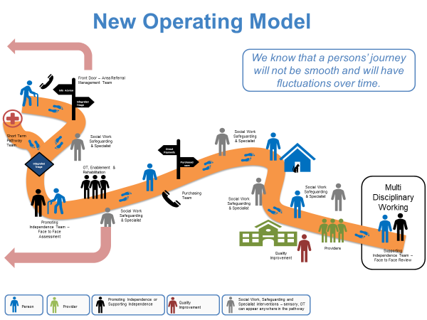

Click Link: OPPD Operating Model

- THE PROFESSIONAL CAPABILITIES FRAMEWORK (PCF)

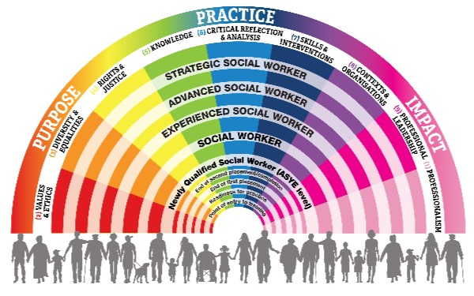
The Professional Capabilities Framework (PCF) is an overarching professional standards framework for all areas and levels of Social Work, originally developed by the Social Work Reform Board, and now managed and delivered by British Association of Social Work (BASW). The PCF:
- Sets out consistent expectations of Social Workers at every stage in their career
- Provides a backdrop to both initial Social Work education and continuing professional development after qualification
- Informs the design and implementation of the national career structure
- Gives Social Workers a framework around which to plan their careers and professional development
The Professional Capabilities Framework contains nine domains. Each one has a main statement and an elaboration. Then at each level within the PCF, detailed capabilities have been developed explaining how Social Workers should expect to evidence that area in practice.

The nine capabilities should be seen as interdependent, not separate. As they interact in professional practice, so there are overlaps between the capabilities within the domains, and many issues will be relevant to more than one domain. Understanding of what a Social Worker does will only be complete by taking into account all nine capabilities.

For further information see:

PCF Framework

- KENT SOCIAL CARE CAPABILITY FRAMEWORK (SCCF)

The Social Care Capability Framework (SCCF) is for all Registered Practitioners in Social Care.

The SCCF aims to:

- Support the practitioner to develop capability in their profession
- Enable the practitioner to progress in their career so that their expertise can be used in the best way possible for the people of Kent
- Ensure that the practitioner can remain registered (as a social worker, occupational therapist or nurse).

The framework sets out the expected capabilities at different levels of experience for registered practitioners in Kent.

- POLICY FRAMEWORK

In addition, there are a range of established KCC policies which also govern the delivery of Social Work practice and these will continue to apply within the Social Work framework. Key policies are:

- Vulnerable Adult Joint Working Protocol (2017)
- Kent & Medway Multi-agency Policy and Procedures to Support People who Self Neglect.
- Supervision Policy
- Assessment
- Eligibility Criteria Policy
- Care and Support Planning Policy
- Promoting Independence Through Review
- Risk Assessment and Management
- Supporting Transgender Users of Our Service

The full range of policies can be found at the following link:-

http://knet/directorate/SCHW-documents/Pages/SC-policies.aspx

- LEGISLATIVE FRAMEWORK

Key legislation is detailed below (please note this list is not exhaustive):-
- Care Act (2014)
- Mental Capacity Act (2005)
- Mental Health Act (1983 amended 2017)
- Human Rights Act (1998)
- Equalities Act (2010)

- WHAT WILL BE DELIVERED
KCC SERVICE DELIVERY FRAMEWORK

Clients can expect to receive the following service from the KCC Social Work function, as determined by the KCC understanding and definition of what Social Work is and what it should deliver.

Within the OPPD Social Work Team, Practitioners will deliver:-

- Social Work intervention: A planned short-termed intervention using Evidence Informed Practice to assess and support the client.

- Interventions will be underpinned by the application of professional knowledge and skills relating to relevant theoretical models, research, legislation, social work tools, assessment of needs and risks;

- Use of resources and using relationship based and person-centred practice skills; along with a commitment to work collaboratively with other professionals and relevant persons.

- Using strengths based Social Work to draw out what is working well for the person; what change is required and who would be best placed to enable the person to achieve the change and for how long. This will include a clear professional analysis of a person’s situation and a detailed plan for change.

- Working through conflict and supporting the positive management of risk and safety.

- Promoting well-being – ensuring that well-being is linked to other areas of a client’s life such as social inclusion

- Challenging systems and decisions that are oppressive or discriminatory and up-holding the person’s Human Rights and Equality rights in law.

- Planning appropriate case closure and ending relationships in conjunction with a person-centred approach.

- Engage in professional supervision, critical reflection and self-care in order to apply and develop professional resilience.

- WHO ARE THE CLIENTS WHO WOULD BENEFIT FROM A SOCIAL WORK SERVICE?

The majority of requests for help through the ‘front door’ of the council will not require an immediate Social Work assessment or even a response from social care. These requests will come from a wide range of Kent citizens covering a broad spectrum of age, gender, ethnicity, religion, etc. Not everyone will need Social Work input because their needs can be met through other services such as signposting to the voluntary sector. Please refer to Appendix 1 Social Work Threshold Checklist.

- SOCIAL WORK FUNCTION - CLIENT PATHWAY
Referrals to the Social Work function will follow the pathway outlined below.
Referral / Consultation | Referrals can be made at any point on the client pathway by completing the Consultation form (Appendix 2.) and sending to the Social Work email box for the relevant area.
Following Consultation | The Social Work Threshold criteria will be applied to determine if a referral to the Social Work function is appropriate.  The decision will be made by a Senior Practitioner who will determine the next steps. For example:  - The provision of Information, advice and signposting to the referrer.  - Joint work with another team and Social Worker allocated as an involvement.  - Social Work taking sole responsibility and allocation to worker.
Assessment | Clients who require Social Work input and are held within the Social Work function will be assessed by a practitioner from the Social Work team, using a strengths-based, person-centred approach; including how needs impact on family members or others in their support network  The Social Work team will also act as key or additional workers for the majority of Vulnerable Adults within adult social care. These clients may require longer-term support within the social work function.
Care and support planning / ongoing Social Work | The social work practitioner will work with the client and any informal carer the client has, or wants to be involved, to understand the client’s goals and how we can meet agreed objectives.  The Social Work Involvement and Review plan (Appendix 3), can be used to assist the practitioner in identifying goals and how they are to be met. The practitioner will ultimately develop a Care and Support Plan if involvement is to be ongoing in another team, or services are required.  *It is expected that social work involvement will be time limited to 16 weeks. Clients requiring a longer period of intervention will be discussed and agreed in Supervision.
Review | A proportionate review will be carried out within 4 weeks of the commencement of any new social work intervention. This may be carried out sooner depending on the need identified by the social work practitioner.  If a client is still open to the Social Work function after 16 weeks of the referral date, a formal review must be carried out by the responsible practitioner and discussed with their Line Manager in supervision to inform ongoing requirements and identify potential closure or transfer timelines.  The social work practitioner will regularly review the social work intervention and will discuss with their Senior Practitioner. The social work practitioner should use critical reflection to understand the dynamics of the involvement and discuss how to progress – this is to avoid drift and dependency.
Case closure or transfer | Once the agreed outcomes have been met and the final review completed, the client will be closed or transferred to another team or agency.

- PREPARING AND PROGRESSING THE ASSESSMENT:

Practitioners should refer to the KCC Assessment Policy and Practice Guidance when preparing for assessment.

Assessment Policy and Practice Guidance

Additionally, please see the Department of Health and Social Care Strengths-Based Framework (published Feb 2019).

Strengths-Based Approach Practice Framework

- CARE AND SUPPORT PLANNING:
Further information on developing or adding to Care and Support plans after Client assessment can found in the Care and Support Planning Policy and Practice Guidance on KNET.
CARE AND SUPPORT PLANNING POLICY

- REVIEW PROCESS:
Further information on undertaking Review can be found on Reviewing Care and Support Plans

FUNCTION MANAGEMENT - PROCESS AND PRINCIPLES

- SUPERVISION:

Reflective practice is key to effective Social Work and high quality, regular formal supervision should be an integral part of Social Work practice. Reflective support can be provided via Senior Practitioners, Practice Advisors and peer-peer.

Supervision should be based on a rigorous understanding of the key elements of effective Social Work supervision, as well as the research and evidence which underpins good Social Work practice. Supervision should challenge practitioners to reflect critically on their cases and should foster an inquisitive approach to Social Work.

For further guidance please see:

http://knet/directorate/SCHW-documents/Documents/Supervision%20Policy.pdf

and also BASW PCF Level Descriptors

- WORK LEVELS IN THE SOCIAL WORK FUNCTION:

Work levels will be monitored within the Social work function for Registered Practitioners and Case Officers. Supervisors will consider levels of complexity within the social work involvement and the skills and experience of practitioners when allocating work. ASYE work levels will be monitored in consultation with ASYE Assessors.

- REPORTING AND QUALITY AUDIT PROCESS – Quantative Reporting
PERFORMANCE MONITORING PROCESS

Key responsibility for managing and monitoring activity within the Social Work function will sit with the Social Work Service Manager, supported by the Social Work Team Managers.
Key reporting activities will be monitored using Key Performance Indicators (KPI’s) which will include:
Numbers of Consultations and Outcome.
Numbers of Referrals accepted.
Reasons for referrals.
Length of Involvement
Outcomes at Closure.

- QUALITATIVE EVALUATION:
The Social Work Service Manager, in collaboration with Practice Advisors and Social Work Team Managers, will seek to capture social work practice via the use of case evaluations, service user feedback and practice development sessions. This is in order to capture excellent social work practice and identify opportunities for learning and development.

SOCIAL WORK THRESHOLD GUIDANCE
APPENDIX 1 – SOCIAL WORK THRESHOLD GUIDANCE

This threshold criteria will apply if the person in contact with the client considers that Social Work input may be required.

Consideration should be based on the client situation and whether the issues identified are presenting a high level of risk to the client and/or support networks. If signposting, equipment, private or voluntary sector support, enablement, functional assessment or case co-ordination can’t or doesn’t address the eligible needs/issues, then contact should be made to the Social Work function for further advice/support in the first instance.

Domain | HIGH RISK / CONCERN  TIER 4: SOCIAL WORK
Client status | Client frequently and/or consecutively presenting with a situation that is or appears to be: unpredictable / intense / complex .
 | Person is known to disengage from services prior to risks being addressed
 | Vulnerable adult (who may require joint response under the VA Joint Working Protocols) who finds it difficult to maintain working relationships with one or more significant support services/agencies
Presenting need | Multi-faceted range of needs and risks which impacts on one or more of the following areas: emotional, physical, environmental, mental health and wellbeing
 | Complexity of social situation indicates urgency of response or a deeper level of involvement to prevent or stabilise crisis.
 | Presenting need is anticipated to be difficult to accommodate or provide support for (e.g. there is a gap in service provision or a dispute about how the need will be met).
 | Complex Best Interests Meeting required and the Person’s wishes appear to be in conflict with their registered LPA/POA/Court appointed Deputy. There is a potential for the Person’s case to be taken to the Court of Protection/DOL in the community assessment may be required.
 | Complex alcohol, substance misuse issues or poly substance misuse/alcohol issues have been identified and there is a lack of engagement for the Person and/or their Carer which produce specific and related risks
 | The Person is subject to a DoLS authorisation in which a complex review of care and support needs has been requested
 | Problematic or contentious family issues / dynamics which cannot be resolved within other service offers
 | Client appears to be at risk of harm which cannot be addressed within other service offers.
 | No Recourse to Public Funds – Human Rights Assessment required

SOCIAL WORK CONSULTATION FORM

The following sections should be completed by the referrer:
Name of referrer
Team
Contact details – telephone or email
Date and time of call | ____/____/____ |  | Use 24 hr clock -
Client details
Name of client
ID number (if existing client)
Address
Date of Birth
Contact details – telephone or email
Is the Client aware of the discussion |  | YES |  | NO
Please give details of the client’s key issue/s and/or reason for the consultation:
APPENDIX 2 – SOCIAL WORK CONSULTATION FORM
The following sections should be completed by the Social Work team
Consultation carried out by: (name of staff member)
Date and time of consultation | ____/____/____ | Use 24 hr clock -
Outcome of consultation
Referral is appropriate for social work. Provide outline details of planned approach and client issue to be addressed | Plan:
Referral is not appropriate for social work. Please tick relevant reason. | - Lack of capacity within the team
 | - Referred to another team
 | - Not appropriate
Date referrer informed of outcome

APPENDIX 3 – SOCIAL WORK INVOLVEMENT AND REVIEW FORM
Client Name: | ID: | Date of allocation:

- What are the concerns?

Whose concerns are these? Consider professional concerns / person’s concerns / societal concerns.
Does the person consent to involvement? On what statutory basis are we proceeding?

- Clients goals?
Supplement with wellbeing web, ladder of support, other social work tool.

- Agency goals (include multi-agency)?

4. What are the strengths of the person/their network?
Consider what are strengths? How to use these strengths to meet goals?

- What is the likelihood of harm happening? How severe is the risk?
List concerns; Rate risk 0 – 10 (0 being worst risk and 10/10 no risk).
How would the client and others rate the risk? Supplement with Risk Assessment if required.

- What have we tried and learned already?
Remember, can we try again?

- Do we need any emergency planning and emergency action?
What needs to be done first, by who? Is there a contingency plan?
What is our Escalation Process?

STEP 1:  Agree a Plan | Who is doing what:
STEP 2:  Build the desire to change | How will the plan be implemented, what steps are required?
STEP 3:  Making the change | Planning Notes / updates:
STEP 4:  Sustaining the change | Planning Notes / updates;
STEP 5:  Transfer / close | Details:

REVIEW OF SOCIAL WORK INTERVENTION:

Date of initial review:

Outcome of Review: | Closed | Closed and transferred | Needs to remain open
- Clients goals met:
- Agencies goals met:
Date of 2nd review (if applicable)
Outcome of 2nd Review: | Closed | Closed and transferred | Needs to remain open
- Clients goals met:

- Agencies goals met:

- Involvement ended within weeks? | No of weeks:

Practitioners Name: | Date:
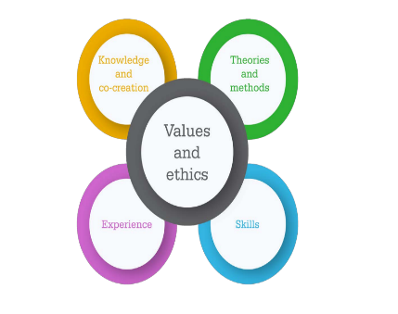
KcVETS model stengths-based-approach-practice-framework-and-handbook.pdf

METHODOLOGIES AND TOOLS
APPENDIX 4 – KCC TOOLKIT

Practitioners are encouraged to utilise Social Work tools and methodologies as part of the strengths-based approach to assessment. Tools include: -

- Strengths-mapping
A focused discussion with the person about their strengths can lead to new opportunities to develop and share skills and make new connections. This is sometimes referred to as a ‘strengths-mapping exercise’. This method of assessment builds a picture of the individual’s strengths and of the community around them. There are two types of strength: ‘soft’ and ‘hard’, each of which applies to the individual and the community.

- ‘Soft’ strengths

Individual | Community
Personal qualities | Links with neighbours
Knowledge and skills | Community groups
Relationships | Shared interest groups
Passions and interests | Community leaders

- ‘Hard’ Strengths

Individual | Community
Health | Health and social care services
Finances | Leisure
Housing | Schools
Transport | Community buildings

During the assessment it may be helpful to consider the following questions:

-In order to remain as independent as possible, what strengths (knowledge, experience or expertise) does the individual already have and how could these be enhanced?

-In order to enable an individual to remain as independent as possible, what other skills, knowledge, experience or expertise do people directly or indirectly involved in the person’s life already have or need to acquire?

-It is also important for the practitioner to have an objective understanding of the individual’s views and to ensure that strengths, needs and outcomes have not been over- or underestimated. In order to do this, it may be necessary to speak to others in the individual’s network (ensuring consent is obtained) and/or seek evidence.

The Department of Health and Social Care Framework for Strengths-Based approach provides a comprehensive model of strengths-based practice using the KcVETS practice framework. Link below;
stengths-based-approach-practice-framework-and-handbook.pdf
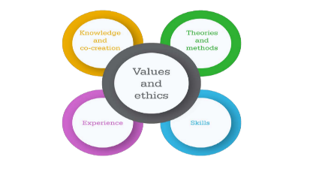KcVETS model

- Genogram

Genograms are visual tools used to explore a client’s social relationships across time. Typically, these are familial relationships. In general, the genogram is useful in gathering information, understanding relationship dynamics and behavioral patterns, promoting the client’s self-understanding, conducting assessments, and guiding the practitioner to interventions.

The use of the genogram in Social Work practice is supported by the profession’s knowledge base as well as its values and ethical standards. A central benefit is that this instrument introduces a client to the principles of systems theory, which are fundamental to Social Work practice. The framework can help practitioners determine the sources of presenting issue(s) and the focus of interventions.
Additionally, Social Work emphasises the “not knowing” stance, acknowledging the client’s socially constructed understanding of his or her world and fit within that world. The genogram offers insight into that very understanding. For example, the genogram offers the opportunity to define and explore the family by acknowledging the client as the “expert.” The genogram invites the client to share personal identification in terms of race, gender, ethnicity, and cultural affiliation, which aligns with the discipline’s emphasis on understanding the various aspects of identity.
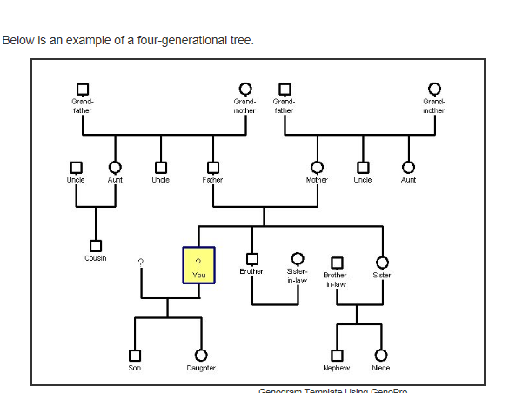

- Ecogram / Ecomap

An ecogram is essentially a diagram of a social ‘solar system’ in which a family genogram is placed in the position of the sun at the centre and other important people and institutions in their life are depicted with circles around the centre, like planets around the sun.

Ecomaps not only document the connections between family members and the outside world, but they also provide a way to visualise the quality of those connections either as positive and nurturing or negative wrought with conflict and stress.

Connections can also be considered strong or weak. An ecomap can be a powerful tool for discovering possible sources of depression and anxiety as well as uncovering hidden support systems in friends, neighbors, clubs, professional agencies, charities, and social or religious organisations.

. 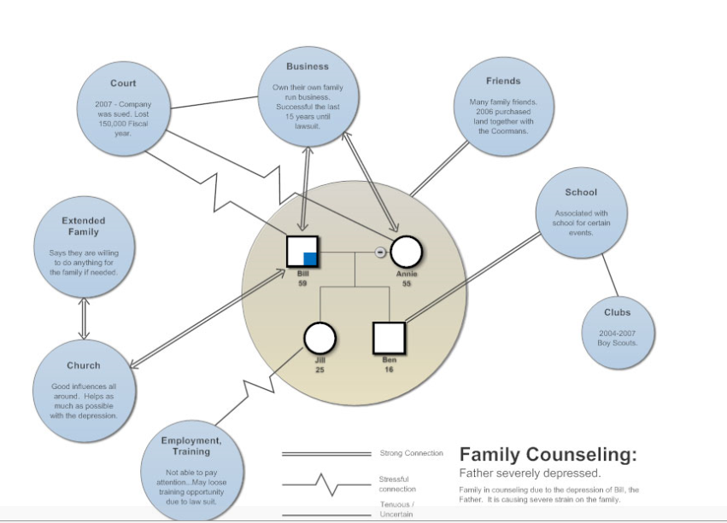

- Chronology

The importance of good knowledge of the case history, past events, and interventions that have been tried before and their success or otherwise - was underlined by the research (Brandon et al., 2008 and 2009; Farmer and Lutman, 2009).

This may be particularly important in long-term, chronic cases, to help avoid the ‘start again syndrome’ that has been identified. Developing a chronology can help to build a holistic sense of the wider picture - the real experience of the person, the real risks which they face.

A chronology is an ordered, dated record of significant events in the person's life. It can help identify patterns of events, concerns, positives, strengths and unmet needs. It provides a clear account of all significant events in a person’s life to date, based on knowledge and information held by the agencies involved with the person and their family; reflects the best knowledge a department has about a person’s history at a point in time.

- When Should a Chronology Start?

A Chronology should be created at the point when Social Workers first become involved with a person and their family. It must cover all involvement, from the first point of contact, referral and assessment; taking account of the whole history including periods of case closure, new contacts and referrals etc.
If there is no existing Chronology when a case is re-opened or transferred, one must be created as a priority. While making a Chronology on an open case can be time consuming, it is a valuable way to understand the person’s history and the current issues.

- When Should a Chronology be Updated?

When there is a significant event.
When the person is reviewed or re-assessed.

- What Should be in a Chronology?

Any significant event or change which has an impact on the person. All relevant information should be included whether regarded as positive or negative for the person. Professional judgment must always be used when deciding what information to add.

The following should be included, but the list is not exhaustive:

Change of circumstances: changes of carer, address, legal status, school, family circumstances and household composition;
Issues for the Person: the person’s views, physical or mental health, incidents of abuse, losses, developmental issues, educational issues including out of school episodes, personal achievements, incidents of running away/going missing, incidents re bullying, gender or culture, offending or police involvement, safeguarding concerns;
Family issues: changes in family composition, loss and separation, Domestic Violence, financial or housing problems, physical or mental health, substance misuse, homelessness, imprisonment, victimization;
Professional involvement: Referrals with source, assessments, significant decisions, interventions, Information from previous LAs, involvement of Specialist Services

Effective and concise summarising is key to the production of a good chronology. When examining the events around the death of Khyra Ishaq, Pemberton (2010) suggests that when drawing up a skeleton chronology, the entry: “March 2006. Pattern of defaulted appointments emerging”, is more effective than detailing each individual missed appointment. Similarly, an entry that reads December 2014 – July 2016: There have been 15 reported incidences of domestic abuse between Mr and Mrs Smith. These have increased in frequency is more powerful than listing each incident.

- What Should Not be in a Chronology?

This list is not exhaustive:

SW visits - these points should be in the assessment or the case notes (although specific issues/disclosures may be relevant);
Analysis;
Descriptions;
Dialogue;
Copy of case recording;
Insignificant telephone contacts with parents/carers.

Social Work Chronology Template

Person’s Name
Swift ID

Date | Incident or sequence of incidents relevant to the person’s situation | Source | Significance

Social Work practitioners have access to a range of tools, Social Work theories, methodologies and access to professional development support to utilise during the application of Social Work practice and in the pursuit of continued Professional development. Practitioners are encouraged to use appropriate tools and theories, ensuring they are relevant for the person being assessed and proportionate to the assessment being carried out.

These include:

- Collingwood Theory Circle
- Kolbs – Circle of Learning
- 1:1 – reflective support from Professional Development Educators
- Systems theory
- Empowerment theory
- Mental Capacity Assessment
- Best Interests Assessment
- Carers Assessments
- Maslow Hierarchy of Needs
- Tom Kitwood’s Person-Centred Dementia wellbeing.

This list is not exhaustive

Critical thinking  APPENDIX 5 – KOLB CRITICAL REFLECTION IN SUPERVISION | Identifying how we know what we know
Analysis | Breaking something down into parts
Reflection | Looking back at what has happened and looking forward to what will happen
Reflexivity | Identifying your impact on a situation

(Research in Practice for Adults, 2012)

