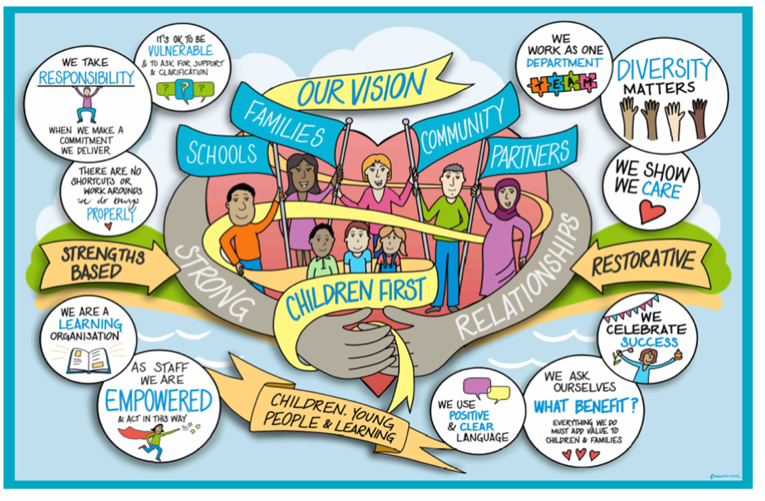
Quality Assurance Framework
Early Help & Children’s Social Care

Introduction
West Sussex County Council is committed to putting Children First and improving in everything we do. We are clear about the positive change we want to achieve for our children and that a ‘What Good Looks like’ approach needs to be taken to ensure that they receive the highest quality services in order to deliver the best possible outcomes for children, their families, and carers.

Our Vision

The West Sussex approach puts the child first. We work with children, families, communities, our partners and schools in a restorative, strength-based way. Strong relationships are at the heart of what we do

Our Vision is to provide children in West Sussex with the right help and support at the right time, so they are kept safe, enjoy strong and enduring relationships and are afforded the best permanent care possible.

This Quality Assurance Framework outlines all of the Quality Assurance activity in Early Help and Children’s Social Care, providing an overview of the purpose, processes and tools used and how these link together. It is deliberately centred on six key areas of activity. The Framework provides details of each activity and is an important support and reference tool for managers and practitioners.

The Performance Assurance and Action Board will oversee and monitor the impact of the Framework and will agree a calendar of Quality Assurance activity. The quarterly Quality Assurance report will continue to bring together work into one place, so key learning is identified, and the impact of agreed actions are monitored through the Performance Assurance and Action Board.

Our Quality Assurance processes within Early Help and Children’s Social Care enables us to robustly relate performance management data to quality assurance by the use to three key questions:

- What do we know about the quality of practice?

- Is the child/ren’s voice and lived experience evident within practice?

- Does quantitative and qualitative data demonstrate we are embedding practice?

Answering these three questions ensures we are mindful of the importance of reviewing the quality and impact of our work, whilst identifying the strengths of our service delivery and understanding the challenges of embedding our Framework. Embedding the Framework is by far the greatest challenge, but by having open, honest conversations within day-to-day practice, as well as practice forums to review the impact of the Framework and to identify solutions to overcome challenges, we are completing the reflective cycle to evolve our practice.

Six Key Areas

Our Quality Assurance Framework (QAF) has six key stages. Each stage is proactive, to inform action and improve outcomes for children and young people, which are at the heart of our work.

- Standards - what standards are we aiming for?
- Tools – How are we using a range of Quality Assurance tools against those standards?
- Analysis - What do the results of using those tools tell us?
- Review – How do we demonstrate that children and families are better off?
- Learn - What do we learn from this to feed back into practice?
- Impact - what are the outcomes for children and families?
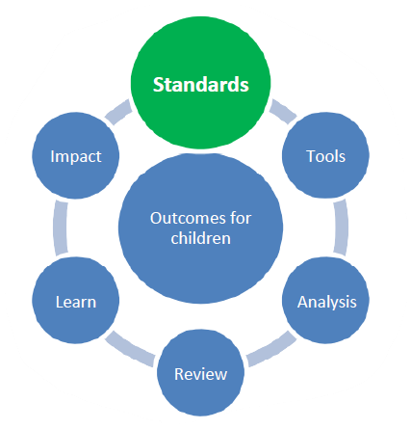

Each aspect of the Framework has a reporting line, ensuring that key reports are considered in a range of different contexts to include West Sussex Children and Young People’s Scrutiny Committee, Corporate Parenting Board, Directorate Leadership Team (DLT) meetings and Service Management Team (SMT) meetings.

Governance
In keeping with SESLIP (South East Sector-Led Improvement Programme) principles, the QAF operates a system of distributed leadership, to enable ownership, accountability, and challenge throughout the organisation, including:

- West Sussex Children and Young People’s Scrutiny Committee
- Overall ownership and leadership by the Directorate Leadership Team (DLT) which sets the strategic direction for Quality Assurance and provides scrutiny/sign-off of the QAF, quarterly reporting, learning summaries, composite action plan, and performance dashboard.
- Responsibility for practice learning and development held by the Principal Social Worker
- Strategic lead for ensuring the QAF is developed and managed by the Head of Safeguarding/Head of Service Conferencing & Reviewing
- Quality Assurance and Practice Development Service will enhance this work, build capacity and support improved quality.
- All managers are involved in delivering Quality Assurance activity.

Additionally, service and team performance meetings are used to monitor, analyse and drive performance at a locality level, through; key performance indicators; budget; workforce data such as vacancies, turnover, sickness absence, caseloads, workforce development; implementation of service plans and complaints and compliments.

Key Area One - Our Practice standards
The starting point for the Quality Assurance Framework is being clear about ‘what good looks like’. The Practice Standards are the criteria against which the quality of auditing results is evaluated. Practice Guidance will support auditors and practitioners to undertake audits and moderation in line with the Practice Standards and the Practice Model. social work practice standards

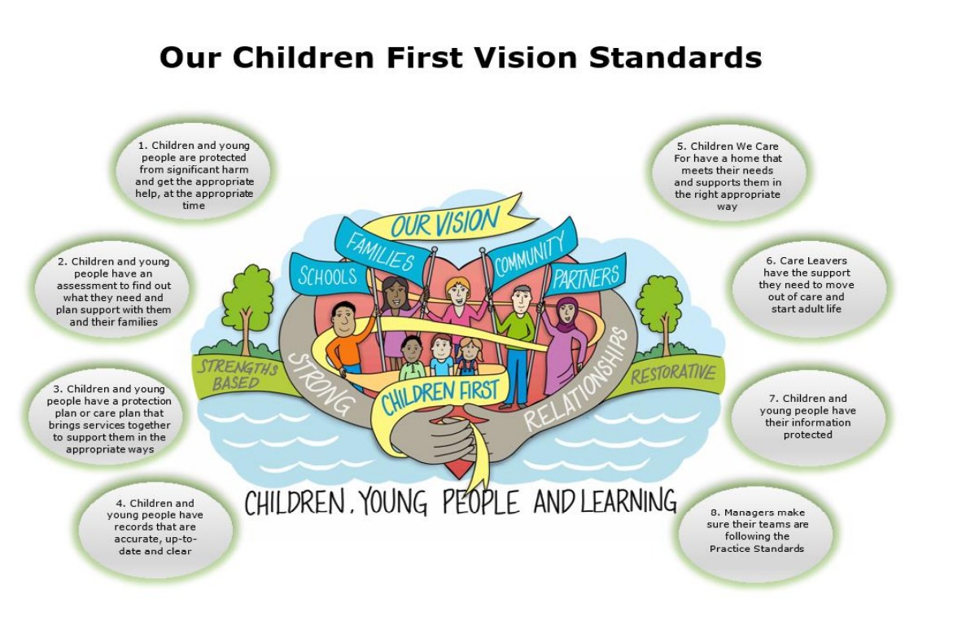

All staff are responsible for ensuring that the quality of their work is of the highest standard and that this is reflected in the quality of case recording and outcomes for children and families. All staff are responsible for embedding a culture of learning and continuous improvement in their teams.

Team Managers have a particular responsibility to ensure that practice standards are met, and to take corrective action when necessary. They must:

- Quality assure work through supervision, observations of practice, guidance and by auditing case files
- Ensure service quality by implementing procedures governing induction, supervision, exit interviews, developmental conversations and by giving staff feedback about the quality of their work
- Promote and practise high support and high challenge to their team to maintain and improve practice.

Children’s records
We are responsible for maintaining a clear, up to date and accurate case record, which is accessible and enhances children’s understanding of their history and experiences. In other words, we are the guardians of children’s memories, and it is important that these memories are recorded in the files we keep. These records belong to the child and can help them at a later stage to understand their story. Therefore, records need to:
- Be clear, transparent and free of jargon
- Be careful in our use of language
- Be timely and accurate
- Be Accessible
- Be co-created (“Nothing written about me without me”)
- Include photos and other records
- Include praise, recognise children’s potential and talk to their strengths
- Be uploaded to Mosaic using the right forms and workflow

Family Safeguarding Model
We are changing the way we work with parents by introducing the Family Safeguarding model. This is a whole family approach to child protection, providing help and support to families and children in need from different professionals working as one team, building on the family’s strengths and identify positive change.

This will have an impact on the approach to auditing, since auditors and moderators will be expected to identify and record that the Family Safeguarding model is being appropriately applied. Reflective discussions will be required to example where the practice has adopted and implemented the Family Safeguarding model approach and principles. Collaborative audit invitations will be extended to those professionals working with the family to evidence the impact of the model, and approaches, on improving the outcomes for the child.

These include capturing evidence of the following:

- Motivational interviewing – that a strengths-based conversational approach has been adopted, encouraging families to choose change
- Multi-disciplinary teams – the family has a team of specialists working together to address parental domestic abuse, mental health and substance misuse (if relevant)
- The Family Safeguarding workbook & family programme – the tool is effectively used to complete an assessment of need, leading to a programme of tailored support
- Group case supervision - monthly supervision for each case, with input from every professional working with the family has taken place

Practice Learning Roles and Responsibilities A - Z

All staff are responsible for ensuring they uphold high quality practice standards and that this is reflected in the quality of case files and outcomes for children and families, monitor their effectiveness and are responsible for embedding a culture of learning and continuous improvement in their teams. Those conducting practice evaluations, Practice Learning Review and other quality assurance approaches share responsibility for ensuring that frontline staffs are actively engaged in the quality assurance.

Assistant Directors are responsible for setting overall strategic direction and are accountable for the operational delivery of Children’s Social Care. They ensure that services are in line with West Sussex County Council priorities and budgetary constraints.

Assistant Director Safeguarding, Quality and Practice is responsible for oversight of this framework, for Conference and Reviewing Service and the Practice Learning Reviewers Team. This team reviews practice, raises challenge, offers support and identifies themes of practice in their areas of responsibility. It is their responsibility to ensure the quality assurance processes in place are robust and consistently applied.

Conferencing and Reviewing Service perform quality assurance functions as part of BAU. Children who are the subject of child protection plans and children we care for benefit from regular independent reviews chaired by the Conferencing and Reviewing officers (CROs). The CROs have a responsibility to ensure children receive a timely and effective support to achieve best outcomes without delay. The CROs utilise practice alerts to avoid delay in children’s plans progressing and services achieving the agreed outcomes for children. They also use a Practice Recognition to note where the quality of social work practice is assessed to be making a difference to a child’s outcomes.

Executive Director Children, Young People, and Learning has an overall responsibility to both lead members and corporate management to ensure that the service is being delivered to the highest quality levels possible, and that where this is not the case, plans are then put in place to deliver change to make it so.

Heads of Service have a particular responsibility to ensure that quality assurance activity is carried out thoroughly and consistently, that the findings are acted upon and shared with staff and that teams build an effective relationship with the Quality Assurance Service. Heads of Service must ensure they have an understanding about what constitutes ‘good’ across all levels of their service and work with the Directorate Leadership Team to ensure whole service quality and cohesion.

Practice Development Officers promote individual training and development in the Children’s Social Care service. This includes mentoring and coaching practitioners, undertaking reflective supervision and disseminating informed and evidence-based interventions. Evaluation of training is also undertaken.

Principal Social Worker (PSW) represents the views of the frontline staff to senior managers and champions frontline practitioners and the quality of practice. The PSW supports the continual learning and development of the workforce and the service.

Service Managers have a particular responsibility to ensure that quality assurance activity is carried out thoroughly and consistently, that the findings are acted upon and shared with staff and that teams build an effective relationship with the Quality Assurance Service.

Quality Assurance and Practice Development supports all staff and managers to deliver high quality, effective services in accordance with legislation, policy, procedures, practice standards and strategic priorities. The Practice Development team supports operational managers but does not replace their accountability for the services that they manage.

West Sussex Safeguarding Children’s Partnership is the key statutory mechanism for ensuring that relevant organisations in a local area cooperate to safeguard and promote the welfare of children and their families. The Quality Assurance Subgroup coordinates multi-agency thematic self-evaluation and scrutiny events. The Case Review Group (CRG) oversees inquiries and disseminates learning from serious incidents and deaths.

Principles and Purpose of Auditing
Children's files should be a rich source of information about the life experiences of the child, both adverse and positive, the presenting needs and services provided, the quality of practice, recording and management support, and the outcomes for the child that point them towards a happier, more fulfilled future. They should also provide a clear account for children who wish to access their records at a later date. Audits help to identify good practice, to consider what interventions and other factors have contributed to children's outcomes, and to promote reflection, learning, professional curiosity and debate.

How we Learn About our Practice in West Sussex
Learning from practice is only purposeful if we manage to close the learning loop and deliver service improvements. The learning from all our quality assurance activity will be drawn together into a quarterly report and reviewed within our accountability cycle. The diagram below illustrates how our practice learning leads to a continuous cycle of service improvement.

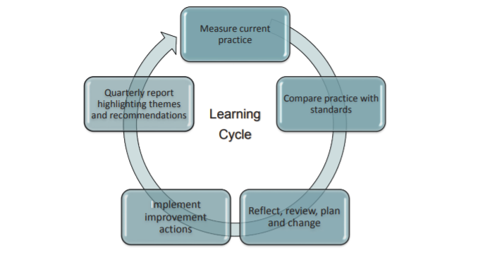

A combination of quantitative and qualitative information allows us to measure standards and outcomes. Quality assurance is evidenced by the following sources:

Key Area Two - Our Tools
Collaborative Case Audits
Learning Audits - Thematic audits- Multi-Agency Audits - Quality Assurance Dip Sampling – Partners in Practice

Case Management and Core Data
Monthly Performance Data and Performance Review - Case Management Dashboard
Daily Dashboard -DLT Dashboard - Chat (children’s Service Analysis Tool)

Family and Staff Feedback
Parent/Carer Survey – Feedback Children and Young People – Compliments and Complaints - Improvement Parentship – Social work Health Check – Bright Spots Survey – Pulse Survey

Practice Reviews
Practice Alerts (Conferencing and Reviewing Officers) - Reflective Practice and Action Meetings - Supervision and Group Supervision - Internal Peer Reviews – Quarterly Self Evaluation

Audit Guidance

Collaborative Case Audit

Audit Process - The annual schedule of auditing activity will routinely contribute to measuring the following core areas of practice:
- Assessment of need and risk to children and young people
- Direct work with children, young people and their families
- Safety planning and the effectiveness of intervention
- Quality of review, progress of plans and outcomes for children
- Management oversight and the quality of supervision
- Partnership working and effectiveness of multi-agency meetings & reviews

Audit https://www.proceduresonline.com/westsussex/cs/

Steps
The audit tools incorporate social work practice standards but focus on evidence and impact for the child. The auditor will check particularly the journey and the experience of the child through the services over the last six months. Through this Framework, quality assurance of supervision and management oversight will also be strengthened, as well as the quality and consistency of practice.

Audits of children’s experiences will be selected by the Quality Assurance Service using the Ofsted Annex A case list. The list will be sent out at the beginning of each month. Service Managers having received the list will be required to set up a meeting with the social worker and team manager. The meeting with the social worker and team manager is good practice and mandatory.

Auditors
Upon receipt, auditors should:
- Check on the allocation list/MOSAIC to confirm the allocated practitioner has not changed
- Check that the record is not restricted – if necessary, submit a request to gain access
- Contact the practitioner and team manager to arrange a suitable time to undertake the audit alongside them. If this is a child we care for or a child subject to child protection planning, wherever possible, the Conference Reviewing Officer should also be engaged in the discussion
- Review the case file, including reviewing the chronology, case summary and Covid-19 RAG rating, if applicable.

Auditors will have the opportunity to analyse the case file and identify any matters to discuss with the social worker and team manager. This should include areas of good or outstanding practice and learning. If required, any immediate safeguarding concerns identified must be escalated immediately to the allocated social worker’s Team Manager, relevant Service Manager and Head of Service. Additionally, the auditor must notify the Assistant Director for Safeguarding, Quality and Practice, and also:

CSCQualityAssuranceTeam@westsussex.gov.uk.

In the collaborative meeting (recommended to be up to 60 minutes), using the audit tool as a guide the auditor and those present at the meeting will hold a reflective discussion and review the impact of the intervention for the child. This will provide an opportunity for the social worker to identify areas of good practice and areas for improvement, and to plan any actions required to improve the child’s experience and outcomes.

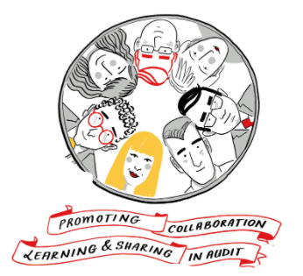

Audits will cover contemporary practice and only consider events where they are relevant to current or recent impact on the child. The key to grading the practice needs to be the impact of the work on achieving good outcomes for the child, rather than simply the extent of compliance with processes. The auditor must record the rationale for each grade given.

The auditor will identify and set out any actions required, based on their audit and improvement plan. The recommendations must include an analysis of the impact on the child of the actions proposed. Actions must be timebound and SMART.

Moderation of case auditing is intended to provide challenge, support consistency of understanding about the quality of practice, and promote a shared understanding of good practice. There are two types of moderation, reflective moderation and a monthly group moderators’ meeting.

Moderators
Upon receipt, reflective moderators should:
- Check on the allocation list/MOSAIC to confirm the allocated practitioner, team manager, auditor and any other relevant practitioner
- Check that the record is not restricted – if necessary, submit a request to gain access
- Contact the allocated practitioner, team manager, auditor and any other relevant practitioner to arrange a suitable time and place to undertake the moderation alongside them. If this is a child we care for or a child subject to child protection planning, wherever possible, the CRO should also be engaged in the discussion’
- Review the case file, including reviewing the chronology, case summary and Covid-19 RAG rating, if applicable.
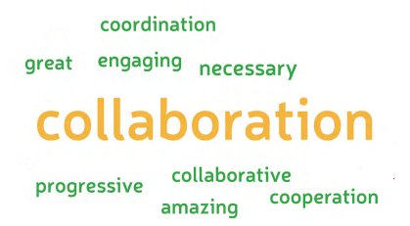
Moderation is a participative learning process giving an opportunity for each professional involved to reflect and receive feedback.

Moderators will complete the moderation by the end of each calendar month, alerting QA via the clipboard, and sending a copy of their moderation via Mosaic to the QA in-box.

The moderator will alert the practitioner, manager and auditor that they have completed the moderation on Mosaic; this will be via a case audit alert. It is good practice to send an email notification that the moderation has been completed, and the outcome.

Key Area Three – Analysis
Self-Evaluation
We undertake a quarterly Self-Evaluation, based on the Ofsted Framework, to assess current quality of frontline practice and areas for development. The Self-Evaluation, and associated Action Plan, are informed by findings from quality assurance activity and performance management framework outputs.

Quarterly Quality Assurance Reports
The Quarterly Report will analyse our audit activity and note the areas of improvement and areas for development, and explain:
- Why they are a priority – i.e., how each issue impacts on children’s outcomes
- What we proposed to do to address them
- How we think this will improve practice and service delivery
- When we expect that the difference will be observable
- How we will measure the impact

The Action Plan will be maintained on an ongoing basis. Priority actions will be agreed through a combination of the Quality Assurance Service, Senior Improvement officers, Senior Management Team and Directorate Leadership Team.

Progress against all actions will be monitored on an ongoing basis and drift/delay escalated through audit sponsors.

Key Area 4 Review - All completed audits and moderations will identify the corrective actions that need to be taken by practitioners and managers. Each action will be given a date for completion (maximum 4 weeks) and managers will be expected to monitor the progress of this via supervision. All actions must be completed within the specified timescale.

Group Moderation Meeting - All audits will be moderated. This will be either individual or by group moderation meeting. The moderator will meet (in person or virtually) with the auditor to discuss the outcome and agree a grading. This can also provide a learning opportunity to reflect on areas of strength and areas to develop in auditing practice.

The moderator will alert the practitioner, team manager and auditor that they have completed the moderation.

Supervision - Supervision discussions following the audit should reflect that an audit has taken place, the learning derived and that any actions identified have been completed. Audit discussion should be included in each supervision until the actions have been completed and signed off by the manager.

Escalation - If the service area does not agree with the final moderator grading, this can be escalated to QA Head of Service for a 3/4-way meeting, or quality assurance of the moderated audit. The outcome of escalation will determine the direction of the case work, e.g., if graded inadequate, the ‘Inadequate’ escalation process will be followed, and a case note placed on file to reflect this. If the audit is upgraded, this will be recorded on the case file as a Mosaic case note.

Good or outstanding - When children’s experiences are graded as good or outstanding, these can be used to reflect on the areas of positive learning and success and examples of good practice.

Inadequate Audit - Reflective Practice & Action Meetings - When case work is deemed inadequate by the auditor, it will be moderated immediately by the allocated Moderator or by the Quality Assurance Manager or a member of the Quality Assurance team. Where the moderation confirms the grade, the ‘Inadequate’ process should be followed. Guidance -review audit following the reflective meeting August 2021 (003)

Audits inadequate for a second time - In the rare event that the re-audit at three months is graded inadequate for a second time, the Assistant Director for Safeguarding, Quality and Practice will escalate to the Assistant Director responsible for the child/family in question. It will be the responsibility of the Head of Service and Service Manager to resolve the matter to a satisfactory standard and improve outcomes for the child.

If the child’s experience has still not improved after a follow-up audit three months after the re-audit, a final escalation will be made to the Executive Director of Children, Young People and Learning. Audits Graded Inadequate Three Month Review of Actions and Progress August_ (003)

Thematic Audits - Thematic audits scheduled throughout the year look at emerging areas of concern, test hypotheses from our data analysis and explore areas of practice in more depth to gain greater insight into the experiences of children and their families.

Thematic audits are used to assess the quality of work in specific areas. They are usually narrow in focus, seeking to examine particular aspects in depth. Thematic audits are undertaken at least every two months with themes agreed at monthly Senior Management Team (SMT) meetings and overseen by an agreed Audit Sponsor. Thematic audits may be triggered by:

- Child Safeguarding Practice Reviews
- Ofsted findings/ action plans
- Concerns identified from performance data
- Concerns identified by senior managers
- Previous audits which require re-auditing

A standard thematic process will be followed which includes planning, audit form design, audit completion, analysis of findings, action planning, reporting and close-the-loop activity. This allows for flexibility to meet the needs of audits whilst supporting consistency of audit practice.

Multi-Agency Audits
Multi-agency audits will continue to be managed through the Quality Assurance (QA) Sub-Group of WSSCB and will always include a contribution from, and often leadership through, Children’s Social Care. Findings from these audits will be incorporated into Children’s Social Care Quarterly Reports.

Single Service Audits
Children overseen by some service areas do not fit neatly into the standard monthly audit template. These include:
- Early Help
- Emergency Duty Team (EDT)
- Fostering Service (FS)
- Multi-Agency Safeguarding Hub (MASH)
- Residential Service
- Youth Justice Service (YJS)

To ensure ongoing quality assurance of these services, bespoke auditing arrangements are agreed with the relevant Service Manager, using a single service audit process. Findings, including agreed actions to address areas of concern, are reported quarterly using a single service audit reporting template.

Supervision and Supervision Auditing
Supervision and management oversight are fundamental ways of understanding and quality assuring practice. All children’s records should have a record of supervision at least every 8 weeks, and Child Protection being every 4 weeks. This should be recorded using the standard supervision form within Mosaic. Supervision should mirror the underlying quality assurance principles in being child-centred, restorative, outcome-focused, positive and reflective, and should be carried out in accordance with practice standards.

Auditing of Supervision
Auditing of supervision helps to identify any variability in quality and regularity of supervision and management oversight.

Supervision auditing takes place through a section within standard monthly audits and within some thematic audits. Findings are collated within relevant audit reports.

Monitoring Statutory Planning Meetings
The Conferencing and Reviewing Service completes monitoring forms following each Child Protection and Looked After Child statutory meeting. These are completed on Mosaic using standardised forms. Any identified concerns requiring immediate attention are raised with the relevant practitioner/manager/Head of Service via the formal practice alert process. If immediate attention is not required, findings are collated and reported quarterly, including actions to address identified concerns.

Practice Observation
Observation of practitioners, both in their everyday work and at meetings, is an important element of quality assuring frontline social work. This enhances the quality assurance undertaken through case file audits to understand more fully the way practitioners work, support and build relationships with children and families.

Observation of social work practice by Heads of Service, Service Managers and Team Managers helps them to better understand the experience both of practitioners and families, and the quality of practice present. Team Managers should undertake a minimum of 4 practice observations per year.

Feedback from Children and Families
Feedback helps us to understand how services and interventions are experienced by children, young people and families. This in turn helps us to improve practice to make a positive difference to children’s outcomes. It informs our service improvement agenda and action planning in the relevant area, which is overseen at Assistant Director level. Feedback is drawn from a range of sources including the below:

- Children in Care Council, which feeds directly to the member-led Corporate Parenting Board
- WSSCB held its 2020 Annual Conference on the Voice of the Child to ensure that children are seen and heard, and we are implementing practice changes as a result of their feedback and our learning
- Service user feedback forms: this includes a current exercise on feedback regarding child protection conferences
- Mind of My Own: We are in the early stages of our contract with the National Youth Advocacy Service (NYAS) and are looking to develop performance reporting for both this and Mind of My Own, in order to identify themes and targeted areas for improvement.
- Annual reporting on compliments and complaints, which we use to inform learning and practice development

Workforce Feedback
Staff feedback is crucial to understanding the strengths of, and challenges facing, the organisation. Such feedback helps managers to understand workers’ experiences and to shape service delivery; engaging staff in Quality Assurance activity helps them to see it as a learning tool. Feedback from frontline workers is gathered from a number of sources, including:

- Case file audits, undertaken face-to-face and in accordance with restorative principles
- Practice Observation
- Practice Week – this to be reviewed once the current COVID-19 crisis has passed, to determine ongoing commitment and objectives
- Supervision
- WSCC Annual staff survey (Pulse)
- ‘Go See’ visits to service area teams, undertaken by Senior Managers and the Principal Social Worker
- Practitioner-led Forums

Workforce feedback has already led to a number of practice and management changes. For example:

- Feedback from teams has informed revised supervision guidance and processes, and our audit work indicates that this is leading to improved rigour of management oversight, with work still to be done
- Practice Standards

Workforce Development
Audit activity itself enhances managers’ skillsets, including identifying both outstanding and poor practice; increasing understanding and application of practice standards; and learning from feedback (from frontline workers, other managers and audit moderators).

The West Sussex Learning Academy is a virtual centre for learning and development for children's social workers and includes: The Assessed and Supported Year in Employment (ASYE) programme; continuing professional development; learning from quality assurance and research-informed practice.

West Sussex Safeguarding Children’s Partnership Learning Events following Child Safeguarding Practice Reviews and learning from audits will continue on a multi-agency basis, to support improved practice across partner services.

Key Area Five - Continuous Learning
A learning organisation knows that there is always room for improvement, based on knowledge of the service and frontline practice, feedback provided from children, young people and their families including complaints and wider learning from child practice reviews.

Case Reviews led by the Case Review Group
Child safeguarding practice and other local reviews are undertaken under the direction of the Safeguarding Children’s Partnership in relation to children where abuse or neglect are known or suspected and either the child dies, is seriously harmed or there are concerns about the way in which organisations and professionals worked together to protect the child. Reviews focus on identifying and embedding learning in order to support improvements in professional practice across the partnership.

Complaints and Compliments
Complaints and Compliments made to Children’s Social Care are a rich source of learning about where and how we can improve our services and the experience of children and families. The Complaints Team liaise directly with the service involved and produce quarterly updates and an annual report which identifies themes and feeds into our self-evaluation.

Key Area Six – Impact - Close the Loop Activity
For audit to have its full impact and value, it is essential that there are mechanisms in place to ensure that the audit findings have been responded to, specific recommendations actioned and case outcomes for children improved accordingly: we call this ‘closing the loop’. There are several audit assurance methods in place to close the loop on audit findings. For collaborative audits graded Requires Improvement or Good, the completion of the audit and moderation actions sits with the social worker’s line management. For audits graded Inadequate, there is a comprehensive re-audit process, involving Service Managers, and Heads of Service, with further escalations to Assistant Directors and Executive Director. The child’s case files remain on a re-audit cycle until we are assured that the practice is no longer inadequate, and outcomes have improved for the child.

For thematic and bespoke dip sample audits, there is a formal arrangement entered into between the sponsor of the audit (Head of Service) and the auditor from the Quality Assurance Team. Once the audit is completed and the overview report signed off, the sponsor will assume responsibility for the audit recommendations and actions. The auditor from the Quality Assurance Service will support for a further period of three months. This support will include measuring the implementation of the recommendations at six weeks and quantifying the progress made in achieving the audit’s goals and objectives at three months; producing a brief ‘close the loop’ overview report demonstrating impact of the learning and implementation. Individual actions for children arising from a thematic audit will continue to be tracked by the Quality Assurance Service until completed.

All completed audits and findings are cross-referenced with existing action plans, service plans and strategies: this is to ensure that recommendations are aligned with wider Council activity, that everyone involved has a single, accurate understanding of the facts, and that duplication is avoided.

Dissemination of Learning – The learning from quality assurance and audit activity will be disseminated and used to improve practice across the Directorate. We incorporate a blended approach, combining a series of learning opportunities such as:
- Top ten learning highlights
- Multi-agency briefings from multi agency audits
- Multi-agency scrutiny event
- West Sussex Children and Young People Scrutiny report
- Annual Conferencing and Reviewing Report
- Quarterly Quality Assurance Report
- Quarterly Self evaluation
- Light bite sessions
- Practice improvement workshops

Conferencing and Reviewing Service
Quality assurance in the Conference and Independent Reviewing Service is about placing an emphasis on quality of outcomes for children. This means that children and young people have the opportunity to participate and contribute and have their voices heard. A main feature of the conferencing and reviewing Service is to quality assure activity, ensuring the intervention and care planning improves outcomes for children. Standards of practice are addressed through two routes, an informal route designed to monitor drift and delay and a formal route through the practice alert process.

The Conference and Reviewing Annual report provides a clear opportunity for senior managers of the local authority and elected members to consider the messages from the service and is a valued contribution to the scrutiny function, enabling future planning and development of the quality assurance functions.

Owner | Date | Review Date | By Whom
Linda Steele  Assistant Director Safeguarding, Quality and Practice | November 2021 | April 2022 | Linda Steele

