|  |  |  |  |
| --- | --- | --- | --- |
| Version | Date | Changed by | Summary of change |
| 1.0 Final Draft | 04/03/2021 | SKK | Implementation of version control |

**Kent AMHP Service - MHA Electronic Statutory Forms Process**

**Final Draft Feb 2021**

**1.Background**

On 1 December 2020, an amendment to the Mental Health (Hospital, Guardianship and Treatment) (England) Regulations 2008 came into effect that enables many of the statutory forms under the Mental Health Act 1983 (MHA) to be communicated electronically. This amendment applies to England only. After 1st February 2021 only the new forms should be used.

Follow link for full DHSC Guidance.

<https://www.gov.uk/government/organisations/department-of-health-and-social-care>

This document gives guidance regarding the implementation and use of electronic forms within the Kent AMHP service.

Some information regarding the submission of completed paperwork will need to be provided by partner agencies including KMPT and private providers. We are currently awaiting confirmation of their policies and process. These areas have been highlighted accordingly in this document and will be updated accordingly.

**2. Information Governance statement/ GDPR:**

*Successful partnership working depends on effective communication, but information exchanges need to be managed because:*

* *We are expected to share information – but we also have to protect people’s privacy, uphold their rights, prevent data misuse, and remain within the law.*
* *We need to ensure our staff are supported and clear about their responsibilities and boundaries.*
* *We need to ensure the confidentiality, integrity and availability of the information we receive and hold.*
* *We must all uphold the principles of GDPR*

**3. Location of new statutory MHA forms:**

* There are links to the new statutory forms on the AMHP service S Drive.

\\invicta.cantium.net\KCCRoot\Shared Local\SHQ\ASD MH\MH AMHP Service\AMHP Information Pack\005 MHA PROCESSES, FORMS & LEAFLETS\005 Legal Process & Forms\004 MHA Detention Paperwork

* You will find two uploaded versions of each form in this section. One is a MS Word and should be used when you want to send documents electronically and will be typing straight into the documents. When sending the documents electronically this will need to be converted to a Pdf to avoid them being tampered with and ensure that they are secure.
* The other link if for a Pdf version of the forms and this link should be used if you need to print hard copies.
* Forms can also be accessed via the Mental Health Act 1983 Statutory Forms website.

<https://www.mentalhealthlaw.co.uk/Mental_Health_Act_1983_Statutory_Forms>

**4. Storage of completed Statutory MH Forms:**

* There is a single email box for receiving and sending statutory paperwork called:

[amhpstatutorymhaforms@kent.gov.uk](mailto:amhpstatutorymhaforms@kent.gov.uk)

* All staff will need to add this to their KCC inbox (please see appendix below for further details on how to do this).
* All electronically completed medical recommendations, s135(1) and s135(2) Warrants should be sent/received to this inbox.
* Documents must not be stored in the inbox.
* Warrants will be stored on the AMHP Service S: drive until used or not required before being returned to the court and then deleted.
* The s135 flowchart has been updated to reflect these changes.
* Medical recommendations will be uploaded to the client’s record on RiO and then deleted from the inbox. When uploading to RiO please can you ensure that it states ‘MHA paperwork’ somewhere within the title This process is explained further in point ‘4’ of this document.
* The email address has been cascaded to partner agencies including KMPT, NLFT and Cygnet, etc. Other providers will need to be advised of the process as required.
* All correspondents from this inbox must be GDPR compliant and ideally sent to and from nhs.net and gov.uk addresses.

**5. Initial scrutiny and recording the location of forms:**

* It is the responsibility of the Shift Coordinator to check Medical Recommendations submitted electronically on the day for potential errors. If amendments are required, they should contact the doctor and ask for these to be corrected and the form resubmitted (or delegate this task).
* The form should then be uploaded to RIO Clinical Documents by either the coordinator or delegated to a SWA to carry this out. It should then be deleted from the ‘Statutory MHA forms’ inbox by the person that uploads to form.
* A record of the where the medical recommendation is stored must be recorded on RIO and the AMHP Shift Report within the ‘Action/AMHP’ column.

**6. Submitting MHA Forms following assessment:**

* When making an application for a patient’s detention, it is the responsibility of the AMHP to ensure that their application is submitted with two accompanying medical recommendations, as a complete package (unless using S4 then only one recommendation is required). This means that forms cannot be submitted via a mixture of methods, they must either all be submitted electronically or as hard copies.
* Forms can be a mixture of the new paperwork formats, but both must be on the updated statutory paperwork.
* Electronic forms should be considered equivalent in status to paper forms – neither is more valid than the other and both methods legally valid.
* If submitting paperwork or returning a warrant to the court, staff must send this from the [amhpstatutorymhaforms@kent.gov.uk](mailto:amhpstatutorymhaforms@kent.gov.uk) inbox, not from personal KCC email.
* Currently the opportunity to submit electronic paperwork will be limited due to issues around connectivity.
* This means that most forms will need to be submitted as hard copies. Medical Recommendations will need to be printed out and taken to the assessment so it can be added to the suite of papers.
* Due to current printing challenges, it may be necessary to ask a KMPT colleague to print the Medical Recommendation off for you. If you are being met by a backup, they may be able to do this and bring to the assessment.
* The AMHP also needs to provide an outline report for all new admissions on the SS466 form and this needs to be submitted with the section papers.

**7. Submitting MHA forms to KMPT in Hours (Monday to Friday 9-5):**

* Forms served electronically should be sent by secure email to the specified locality email address, i.e., Canterbury, Dartford or Maidstone. These addresses are:

Dartford Locality  
KMPT.MHASECTIONPAPERSDARTFORD  
[kmpt.mhasectionpapersdartford@nhs.net](mailto:kmpt.mhasectionpapersdartford@nhs.net)

Canterbury Locality   
KMPT.MHASECTIONPAPERSCANTERBURY [kmpt.mhasectionpaperscanterbury@nhs.net](mailto:kmpt.mhasectionpaperscanterbury@nhs.net)

Maidstone Locality   
KMPT.MHASECTIONPAPERSMAIDSTONE – [kmpt.mhasectionpapersmaidstone@nhs.net](mailto:kmpt.mhasectionpapersmaidstone@nhs.net)

* Anybody serving a form by electronic transmission should include in the email subject line:

1. The ward to which the patient is admitted.
2. The initials of the patient and RIO number.
3. A brief description of the attachments (e.g., Section 2 Application or Form H3 etc)

* Additional responsibilities (AMHPs, MHA Administrators and Clinical Staff):

1. The AMHP must ensure that applications are accompanied by the supporting medical recommendations.
2. Both clinical and administrative recipients of applications are responsible for checking that these appear to be duly made and founded on the necessary medical recommendations.
3. For patients not yet admitted to hospital the AMHP should, prior to the patient arriving at the hospital, seek confirmation from clinical staff on the ward to which the patient will be admitted that the application has been received and the patient can be admitted pursuant to it.
4. The Mental Health Act Administrators will have access to these inboxes and the receiving nurse will call the administrator so they can scrutinise the paperwork and then H3 can be completed by the receiving nurse.

**8. Submitting MHA forms to KMPT Out of Hours (from 17:00 hrs to 09:00am weekdays, weekends and bank holidays)**

* Out of hours (as defined above) there will be no access for ward staff to the designated email inboxes used in hours, therefore AMHPs should upload all paperwork to RIO clinical documentation and ward staff will be able to access this to receive and scrutinise the paperwork.

**9. Submitting MHA forms to Private Providers and other NHS trusts:**

* **Cygnet Maidstone** have requested forms are sent to:

[Chcl.maidstonemhaa@nhs.net](mailto:Chcl.maidstonemhaa@nhs.net)

* **Cygnet Godden Green:** Guidance from Alison Rickard (MHA administrator):

Any section papers in hours can be sent to any of the emails below which are monitored by the MHA Administrator.

During the evening, weekends and when the MHA Administrator is not on duty papers should be sent directly to the wards using the relevant generic email address.

MHA Administrator:

[ali.rickard@nhs.net](mailto:ali.rickard@nhs.net)

Generic email addresses for both wards:

[CHCL.goddenfemaleacute@nhs.net](mailto:CHCL.goddenfemaleacute@nhs.net) (Oakwood Ward – acute)

[CHCL.goddenfemalepicu@nhs.net](mailto:CHCL.goddenfemalepicu@nhs.net) (Castle - Ward PICU)

These email address can be accessed by the MHA Administrator, all first level nurses and ward managers.

* **Kent & Medway Adolescent Hospital (AKA Woodlands House) (North East London Foundation Trust) (NELFT) (CAMHS):**
* Electronic papers should be emailed to:

[Sectionpapers.kmah@nelft.nhs.uk](mailto:Sectionpapers.kmah@nelft.nhs.uk)

* Arrangements with other providers will need to be established as required.

**9. Conveying**

* When an application for detention is submitted electronically and conveyance is delegated under Section 6 MHA83, a paper copy of the delegation form is not needed but the AMHP will need to provide evidence of a completed application, supported by the necessary medical recommendations. The Government guidance states:

*‘Where an AMHP submits an application for detention electronically and then delegates conveyance of the patient, for example to ambulance staff, a paper copy of the form is not needed to indicate that conveyance is lawful so long as the AMHP can provide evidence of a completed application supported by the necessary medical recommendations. In line with paragraph 17.26 of the code of practice, agencies should agree local policies and procedures regarding the nature of authorisation given by AMHPs (and others) when authorising people to transport patients on their behalf.’*

* Providing evidence that an electronic application has been submitted may not be practical and therefore should Ambulance staff not be satisfied, a letter confirming authority to transport the patient to a named hospital where they will be liable to be detained under the MHA can be provided. The current form SS463 ‘Authority to Transfer’ would suffice.
* Submission of the statutory forms should always be made prior to conveyance.

**10. Training and Support:**

* An email will be sent asking for feedback from members of the AMHP service to advise what training and support that they may find valuable regarding this new process.

**11. Amendments and corrections**

* We are still awaiting further clarification on this issue TBC

**12. Other issues that may be encountered-**

* This is an evolving document, and it is likely that issues will be raised within practice.

**Appendix 1 - Adding** [amhpstatutorymhaforms@kent.gov.uk](mailto:amhpstatutorymhaforms@kent.gov.uk) **to Outlook**

1.To add another mailbox, launch Microsoft Outlook then click the **File tab** > **click Info tab** > **Account Settings**

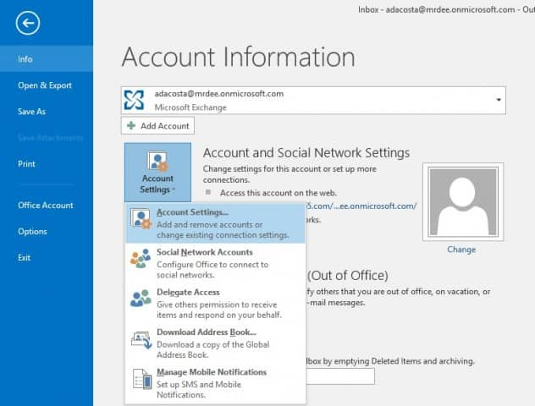

**2.**In Account Settings, select your current Mailbox and click Change

**.**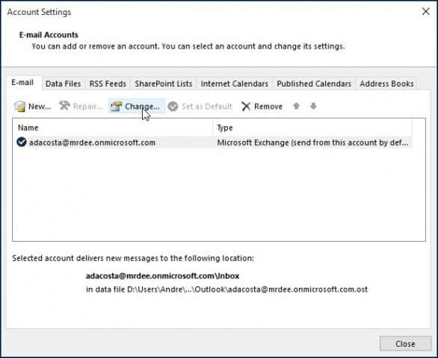

**3.**On the next screen select**More Settings**

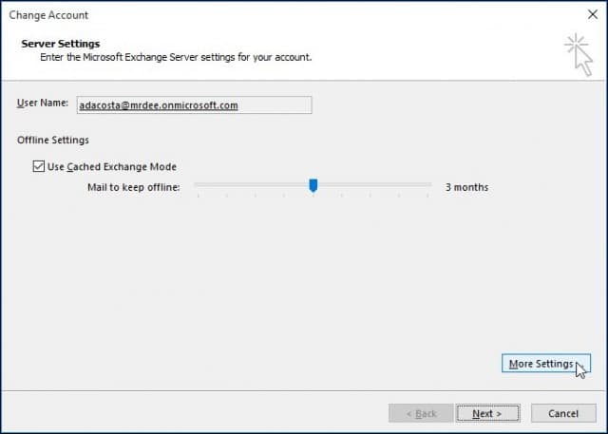

**4.**Select the Advanced tab and click the **Add**button

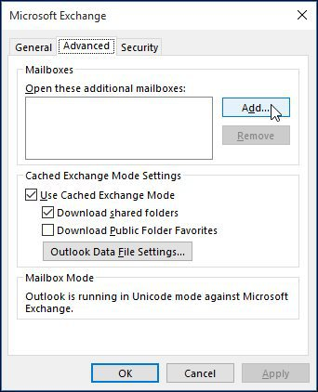

5. Type in the name of the mailbox then Click **OK -** [amhpstatutorymhaforms@kent.gov.uk](mailto:amhpstatutorymhaforms@kent.gov.uk)

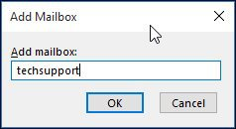

6. **.**Once the name of your mailbox is created, click **Add**and**Apply**.

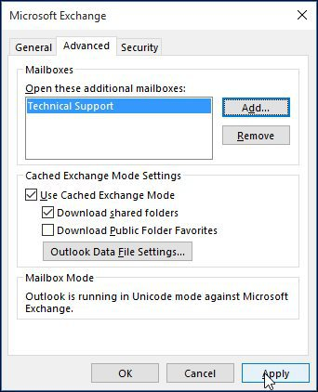

**7.**Finish out the wizard by clicking Next, and then Finish on the Change Account screen.

You may have to closedown Outlook and then open it again to show the inbox

**Appendix 2 – Sending an email from** [amhpstatutorymhaforms@kent.gov.uk](mailto:amhpstatutorymhaforms@kent.gov.uk)

When using this inbox, you need to amend the “from field” and send from [amhpstatutorymhaforms@kent.gov.uk](mailto:amhpstatutorymhaforms@kent.gov.uk) not from their your own inbox, otherwise replies will not be picked up. The instructions for this are also below if you are not able to access the word document instruction –

Add “from field”

**Outlook Desktop App – Windows**

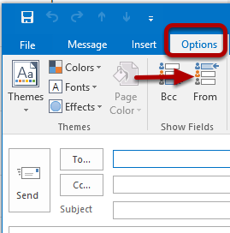

1) By default, the **From** field will not be displayed when you compose a message. To display the **From** field click on the **Options** tab and select **From** in the **Show Fields** section. Now the **From** field will be displayed when composing a message in the future.

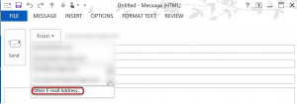

2) When composing a message click on the **From** in the drop-down box and select **Other E-Mail Address.**

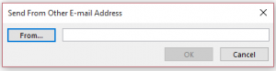

3) Click on **From.**

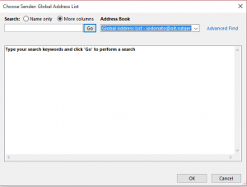

4) Choose **More columns** and make sure **Global Address List** is selected. Search for the address you want to send from and click **OK**.

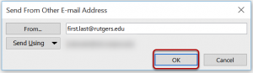

5) Once you have entered the **Alternate Email Address** you would like to use and click **OK**.

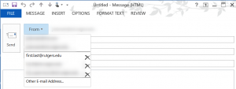

6) The next time you compose a message the **Alternate Email Address** will be available from the **From** Drop

If you are still not sure how to add an inbox please call IT on **03000 415555**

*End of Document*