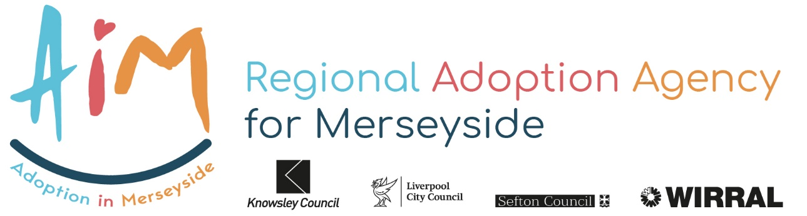

ADOPTION PANEL POLICY AiM 2020/2021

1. THE ADOPTION PANEL

Medical Advisers

The AiM’s Adoption Panel has made arrangements with Liverpool NHS Alder Hey Children’s Hospital and Wirral, Arrow Park WHICH TRUSTS to appoint 3 Medical Advisers who carry out all the functions as set out in the Adoption Agency Regulations 15, Part 2 and 4 of Schedule 1,17,25,31 and 36.

1.2 AiM Adoption Agency is required to have an Adoption Panel, the make up of which is determined by the Adoption Agencies Regulations 2011. The Panel will meet regularly, weekly or less depending on agenda requests, but in exceptional circumstances an emergency Panel will be arranged to prevent delay for specific children.

Sufficient Adoption Panels will be arranged to meet the approval needs of adopters and the matching of children to meet the necessary time scales.

Panel members are from a range of different professional and personal backgrounds and include people who have personal experience of adoption. An independent person with knowledge of the needs of Looked After children will Chair the panel. All panel members will be recruited, inducted and appraised in line with the regulations, all members will sign a Panel membership agreement and the Agency will maintain an up-to-date record of all Panel members.

The Panel will be supported by a professional Adviser who is a manager from the Adoption Service, a legal Adviser from each of the 4 Merseyside Local Authorities Legal Services, and three Adoption Medical Advisers who are also voting members. Panels are supported by a Panel Administrator/Minute-taker.

1.3 Conduct and Procedures of the Panel

All Panel meetings are fully recorded with particular attention paid to the reasons for Panel Recommendations. In situations where there is insufficient information to enable the Panel to make a recommendation the Panel may request the agency to obtain other relevant information and may defer the item while this is undertaken.

Where there is an evenly divided Panel or a serious difference of opinion amongst Panel members the Chair may ask for more information to be made available to the Panel before a recommendation is made. Where the Panel is not unanimous, dissent from the majority view and serious reservations expressed by individual Panel members about a particular recommendation will be recorded in the Panel Minutes for consideration by the Agency Decision Maker. Where adoptive applicants attend and make verbal representations to the Panel these will also be noted.

The presence of non-Panel members at Panel meetings can pose limitations which may inhibit the proper working of an Adoption Panel. The Agency recognises however that it can be helpful for new prospective Panel members and new Social Workers joining the Agency who may in the future be bringing cases to Panel to attend one Panel meeting as an observer. Similarly, there may be other professional workers for whom attending a Panel might be a valuable training opportunity. The Panel Adviser will agree when observers can attend Panel and for which items. No more than two observers will be permitted to attend any Panel meeting.

Any Panel member who has knowledge, either in a personal or a professional capacity, of a case under consideration should declare an interest and inform the Chair or Vice-Chair of the Panel accordingly. It may be considered inappropriate for him/her to be present during discussion of the case. Any person who is otherwise a member of the Panel, but who is presenting a case shall not be a voting member of the Panel throughout the discussion of that case.

1.4 Training for Panel Members

The Adoption Agency undertakes to provide a minimum of one annual training session for Panel members. Panel members will be consulted on the content and format of the training day. There is a clear expectation that Panel members will attend.

1.5 The functions of the adoption panel are to consider:

1.51 Whether a prospective adopter is suitable to be an adoptive parent.

* It may also consider and give advice regarding the number of children the prospective adopter may be suitable to adopt, their age range, gender, likely needs and background.

1.52 Whether a prospective adopter would be a suitable adoptive parent for a particular child. It must also consider and may give advice to the agency about:

* the authority’s proposal for the provision of adoption support services for the adoptive family;
* the arrangements the adoption agency proposes to make for allowing any person contact with the child;

1.6 Recommendation of the Panel

1.7 Timescale and Procedure

The Adoption Agency Decision Maker will be supplied with copies of all the reports considered by the Panel on each Agenda item. Panel Minutes will be forwarded within five working days.

The Panel Adviser will also be available to the Agency Decision Maker for consultation if required. Where the Panel has provided the agency with advice, the Agency Decision Maker may express a view on this advice and in relation to prospective adopters; this may be taken into account during the matching process.

The final decision in relation to any application will be made within 12 (To be checked with current processes and the time ADM is allowed) working days of the Panel meeting.

The decision reached by the Agency Decision Maker will be recorded on the child’s case record (LA Childs Domestic Adoption Pathway)and the adopter’s case record (AiM Adult Recruitment Pathway). This will also include any view the Agency Decision Maker has on the Panel’s advice. If the Agency Decision Maker does not accept the adoption Panel’s recommendation, they will discuss this with another senior person in the agency who is not a member of the Panel. The outcome of this discussion will be recorded on the child’s case record if this was in relation to a match. Letters confirming the Agency’s decision will be sent out as required to adoptive applicants. The child’s parent /Guardians will be notified by the agency as appropriate. Letters to parents and guardians will be facilitated by the child’s social worker/Local Authority.

1.8 Where the Agency Decision Maker proposes not to approve.

Where the Agency Decision Maker makes a qualifying determination that the prospective adopters are not suitable to adopt a child:

A formal letter will be sent to the prospective adopter advising them that the agency proposes not to approve them as suitable to adopt a child (this is a “qualifying determination”).

A copy of the recommendation of the adoption Panel will be sent with the letter if the Panel’s recommendation is different.

The letter will advise the prospective adopters that they have 40 working days starting with the date on which the notification is sent to: - Accept the determination (or pre-empt the outcome by withdrawing their application), make written representation to the agency or apply for a review of the determination by an Independent Review (IRM) Panel by writing to the Independent Review Panel Administrator.

If the prospective adopter does not make any representations to the agency or apply for an independent review within the 40 working day time limit, the agency will proceed with its decision and notify the prospective adopters of that decision in writing together with the reasons.

If representation is received within the 40 working day time limit, the agency may decide to refer the case back to the adoption Panel but is not obliged to do so. If the agency does refer the case back to the adoption Panel the adopters will be invited to attend the Panel and the Panel will make a fresh recommendation on whether the adopters are suitable to adopt a child.

The Independent Review Mechanism (IRM), which came into operation on 30 April 2004, gives prospective adopters the right to apply to an independent body for a review of their case if their adoption agency does not propose to approve them as suitable to be adoptive parents. This is known as a “qualifying determination”. The Independent Review Panel has the power to only consider qualifying determinations. Other complaints regarding the adoption agency should be dealt with through the normal complaint’s procedure.

If the prospective adopters decide to apply for an Independent Review of the determination the manager responsible for the Adoption Service will liaise with the Independent Review Panel Administrator in respect of any application to that panel. The agency will supply the information required by the IRM Panel in a timely manner and will send one or more representatives to the IRM Panel and ensure that those attending are in a position to assist the panel. The Agency will meet the costs incurred by the IRM in undertaking the review

The Agency Decision Maker will reach a final decision in relation to the application within seven working days of receiving the recommendation of either:

* The Agency adoption panel
* The IRM Panel

In making a final decision the Agency Decision Maker will take into account

the recommendations of the IRM Panel and the adoption Panel. The IRM

Panel does not have the power to overturn the agency decision.

As soon as possible after making the decision the Agency will notify the prospective adopters of the decision stating the reasons if it is considered that the adopters are not suitable to adopt. If the Panel’s recommendation is different from the Agency’s decision, the Agency will also provide the prospective adopters with a copy of the Panel’s recommendation.

Where the IRM Panel has made a recommendation, the agency will, according to regulation AAR 27.10 send the IRM Review Panel Administrator a copy of the decision on the prospective adopter’s suitability to adopt.

1.9 Quality Assurance

The Panel has a role in monitoring adoption work in the Agency, which will contribute to the development of adoption practice in the Agency. The Panel will keep abreast of the trends and initiatives locally and nationally and extend its experience and knowledge. The Agency will provide Panel training at least annually jointly with the adoption team.

The activities of the Panel will be scrutinised internally by means of an annual report to Senior Managers and Elected Members of the four AiM Local Authorities and externally by the Commission for Social Care Inspection.