Contact: |  | Add your logo here
Direct Tel:
Fax:
email:
Your ref:
Our ref:

Private and Confidential
Add parent/guardian here if applicable
Add name here
Add address line here
Add address line here
Add address line here
Add post code here

Add date here

Dear Add name here

 | Legal Letter: You Must Go to Court for a Breach Hearing

The Court gave you a Add court order / programme here. You have not kept to the rules of your Order.

On Click here to enter a date. you Add reason for breach here. This means you have ‘breached’ your court order.

Information about you will be shared with the court for a Breach Hearing.

You must go to a Breach Hearing at:

 | Place: Add place here
 | Date: Add date here
 | Time: Add time here

Please treat this letter as an official instruction telling you:
‘You must go to court’.

It is up to you to get legal help from a solicitor. The court cannot wait for you to get a solicitor on your actual court date. The court will only sort out what happens to you on your court date.

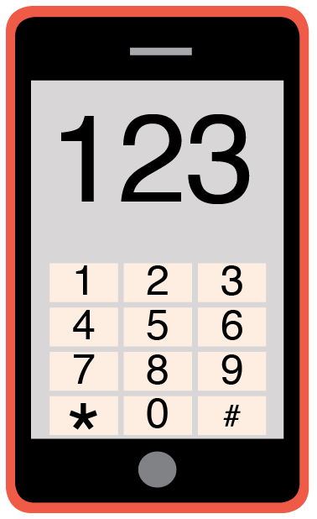 | Please phone me on Add phone number here to talk about any problems you have coming to this meeting.
 | When you do not come to the court Breach Hearing a warrant may be made.
 | You may then be arrested.

Please remember to still keep to your court order rules. The court may hear about your actions and how well you keep to your court order rules.

Yours sincerely,

Add name here
Add role here

Add cc. Parent/Carer here

