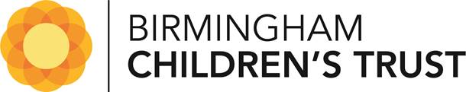
Young People Feedback Form
Tell us what you think!
We are asking children and young people to tell us what it was like having a children’s worker and how they helped you. We would also like to know if there is anything they could have done better. We will use your feedback to make sure our workers know what they are doing well and what we should change.
Question 1: How old are you? ……………………. Years old

Question 2: Do you understand why you and your family had a children’s worker?
  Fully Understand ◻ |   Understand a little ◻ | Do not understand ◻
 |  | ?
Question 3: Why do you think you and your family had a children’s worker? Please write a few words or a short sentence

Question 4: Do you agree with the sentences below? | Fully agree | Agree a little |   Do not agree
- My workers explained things to me in a way I could understand | ◻ | ◻ | ◻
- My workers listened to my views | ◻ | ◻ | ◻
- My workers involved me in decisions about me and my family | ◻ | ◻ | ◻
- I could talk to my workers about my worries | ◻ | ◻ | ◻
- My workers spent enough time getting to know me and my family | ◻ | ◻ | ◻
- My workers did the things they said they will | ◻ | ◻ | ◻
Question 5: Do you agree your workers have helped you and your family?
Fully agree ◻ | Agree a little ◻ | Do not agree ◻

Question 6: What help did your workers give you and your family? Please write a few words or a short sentence

Question 7: Is there any help you needed that you did not get? Yes ◻ No ◻
If yes, what is missing?

Question 8: How happy are you?
Very happy ◻ | Quite happy ◻ | Not happy ◻

Question 9: What could we have done better for you and your family?

Thank you for your feedback!



