Overall Risk Assessment Analysis and Conclusions (with) Recommended Actions with Timescales
The collection of information needs to be organized, carefully considered, and then applied to an evidence-informed framework of indicators of risk as well as protective factors. Ideally the following areas should inform that process:
Concerns identified
Strengths or mitigating factors identified
Is there a risk of significant harm for this baby? It is crucial to clarify the nature of any risk - of what? From whom? In what circumstances? etc. - and to be clear how effective any strengths or mitigating factors are likely to be
Will this risk arise:
    - Before the baby is born.
    - At or immediately following the birth?
    - Whilst still a baby (up to 1 year old)?
    - As a toddler? or pre-school? or as an older child?
    - If there is a risk that the child’s needs may not be appropriately met. e. What changes should ideally be made to optimise well- being of child? If there is a risk of significant harm to the child.
What changes must be made to ensure safety and an acceptable level of care for child? E.g. How motivated are the parents to make changes?
How capable are the parents to make changes?
What is the potential for success and history of making change as assessed by professionals?
This new risk estimation framework tries to offer a useful template for workers to locate the information they have collected. Workers should identify which are present as a starting point and then examine the balance of risks and strengths across the three areas of unborn, parent and wider considerations. Judgements then need to be made about the balance as well as the mix of risks and protective factors to draw some preliminary conclusions. It may also identify where there are gaps and time permitting, those need to be covered.
The strengths of this structure are that it is generic and therefore all- embracing but it requires the support from other additional tools when the balance of risks and strengths is unclear or professionals are stuck.

Indicators of risk and protective factors to inform analysis

 | RISK FACTORS | PROTECTIVE FACTORS
UNBORN CHILD | Unwanted/concealed pregnancy  Pregnancy as a result of rape  Complex medical needs/special needs such as disability or substance withdrawal Unrealistic expectations of baby Poor engagement and/or cooperation with ante-natal services  Low birth weight Premature birth Stressful gender issue Foetal abnormalities | Wanted pregnancy Healthy pregnancy and good foetal development  Realistic expectations of baby  Good engagement and co-operation with agencies  Attends all necessary adult as well as child health appointments
PARENTS | Childhood experience of neglect and abuse Lack of positive parenting role models  e.g. care leaver  Lack of awareness of child’s needs  Lack of preparation for the child’s birth  Abuse or neglect of previous children Siblings removed Presence of mental health, substance misuse, learning difficulties that could | Positive childhood experiences  Good parenting role models  Good awareness of child’s needs  Good preparation for birth  Absence of any parental issues that could impact on their ability to parent Previous positive experiences of being a parent

 | impact on their ability to parent  Very young or immature parent Poor contact with professionals Inability to work with professionals  Unattached to unborn baby  Exhibits inappropriate parenting plans  No plans  Inability to prioritize baby’s needs Perceptions different  /abnormal  Denial of past abuse Violence/abuse of others  Post-natal depression Past antenatal or postnatal neglect  No commitment to parenting  Lack of self-care skills Low reflective function Communication difficulties  No recourse to public funds  Asylum seekers | Good contact with professionals Realistic expectations and understanding about potential issues Significant changes to health behaviours demonstrated and  sustained (e.g. stopped smoking or drinking) Early signs of bonding to the child Improvements in reflective function Evidence of understanding about the impact of early life experiences  Ability to reflect and work on relevant issues  Evidence of establishing daily routines and making the home safe and secure for the child Commitment to providing for all the child’s basic needs – food, clothes, warmth, personal hygiene, comfort, safety, stimulation, age- appropriate activities etc.

FAMILY, HOUSEHOLD OR ENVIRONMENTAL | Poor adult relationships, domestic abuse, and violence Relationship disharmony/instability Frequent changes of partner/multiple relationships Inappropriate associates  Homeless or unstable housing  Poor home conditions Frequent moves of house  Significant debt/unemployment Lack of family or community support Criminal activity  /anti-social behaviour Inappropriate social networks – such as violent or deviant Unsupportive of each other  Pets – uncontrolled and/or potentially dangerous Mistreated animals | Good adult relationships  Stable home in good condition  Stable finances and employment  Well supported by family and wider community Support for the  expectant mother of at least one caring adult An alternative, safe, and supportive residence for expectant mothers subject to violence and threat of violence  Safe storage of drugs, safe storage, and disposal of injecting equipment  Ability to manage associates who are part of a history of substance misuse Contingency plans in place in the event that parents unable to provide adequate supervision e.g. a named responsible adult

I am including a couple of examples of supplementary specific frameworks that may offer some further guidance to workers.

Unborn babies of children in care or care leavers

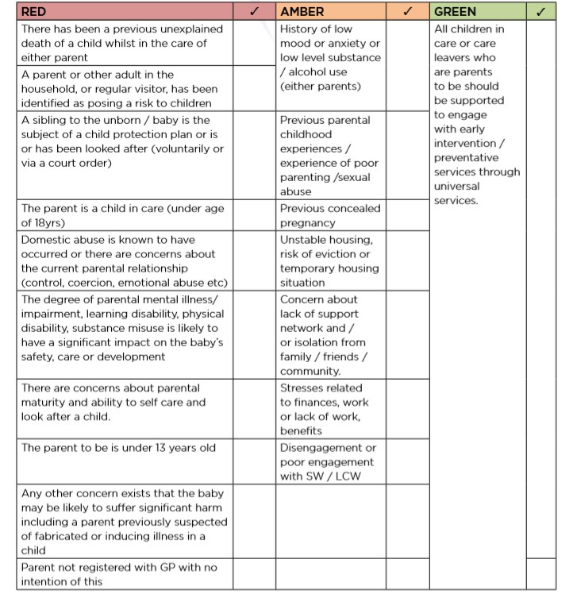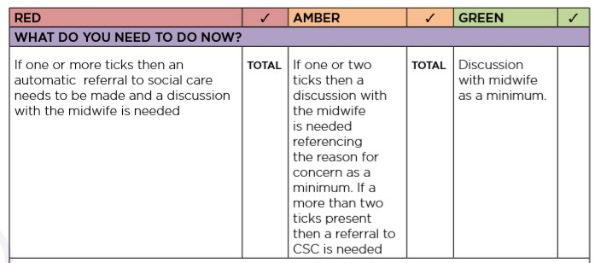

Specific risk measures where substance misuse is the presenting concern

Baby | Parent | Environment
Prematurity  Equipment dependency (e.g. oxygen)  Medically fragile status  Irritability/hyperactivity/ poor sleeping  Lethargic (increases risk for neglect)  Feeding difficulties  Special medication needs | Denial of drug/alcohol use in spite of indication of use  Parent’s belief that drugs/alcohol are not a problem for her/him in spite of indication to the contrary  Non-compliance with substance misuse treatment programme  Entrance into drug/alcohol treatment within the third semester No prenatal care  Non-compliance with prenatal care  Unwanted pregnancy  Parental history of abuse during childhood  Unrealistic expectations/perceptions of the child’s behaviour  Severe intellectual limitations/ developmental disability | Unstable living situation (homeless) Safety or health hazards in the home  Lack of preparations for infant  History of family violence  Presence of known drug user in the household  Siblings with untreated health problems Siblings without current immunizations Siblings with untreated developmental delays or school problems

Prior removal of a sibling from the parent’s custody
Previous allegation of child abuse/neglect Serious medical problems
History of mental health problems
History of violent behaviour
Hostility towards the child
Rejection of the child
Abandonment of baby in hospital
Denial of infant’s
problems/ symptoms
Refusal to cooperate with health care team
Lack of responsiveness to
infant’s needs
Poor skills in providing care of the infant

In many ways there are boundaries to the analysis. For parents who present with their first pregnancy the prediction of harm is a best guesstimate: the proof of the pudding only comes post-birth. The initial decision will clearly be how safe is the baby remaining with the parent/s post-birth whilst a further assessment is undertaken about seeing whether the hypothetical has become the reality. It matters therefore that the issue around what happens after the birth is attended to in some detail and should include:

Birth and discharge planning considerations
How long the baby will stay in hospital Level of Supervision required.
How long the hospital will keep the mother on the ward
The arrangements for the immediate protection of the baby if it is considered that there are serious risks posed to the e.g. parental substance misuse
The plan should include the risk of potential abduction of the baby from the hospital particularly where the plan is to remove the baby at birth
The plan for contact between mother, father, partner, extended family, and the baby whilst in hospital. Consideration to be given to the supervision of contact - for example whether contact supervisors need to be employed Consideration of any risks to the baby in relation to breastfeeding e.g. HIV status of the mother; medication being taken by the mother which is contraindicated in relation to breastfeeding
To plan for the baby upon discharge, where alternative care has been agreed, e.g. discharge to extended family members; mother and baby foster placement; foster care and supported accommodation
The Social Worker may need to seek a legal order to protect and safeguard the new born baby and there will need to be a discussion with the hospital to agree the child remaining on the ward until this has been resolved in the court.
The court order may not be immediately available; however, the social worker and the hospital must agree the best plan in the safety and interest of the new born baby. (A paper copy of the legal document

If may not be available to the social worker. The social worker must have identification document and follow the discharge from hospital process in the tools section of this document). The discharge from hospital process should be followed swiftly and should not delay progressing care for the baby).
Contingency plans should also be in place in the event of a sudden change in circumstances
The Children’s Emergency Duty Team (Out of Hours Service) should have all discharge information as soon as it is agreed. A written discharge plan will be agreed between the hospital and the social worker and uploaded onto the child’s file.

Post-birth assessment
What to look for when assessing parenting capacity
One needs to consider parent–child interaction and parental readiness to change, parents’ understanding of concerns and parents’ intention and commitment to change. As a practitioner, it is important that you establish the actual evidence to answer these questions.
Where there is cause for concern about what is happening to a child, it is important to gather information about how parenting tasks are being carried out by each parent/carer in terms of:
- their response to a child and his or her behaviour or circumstances
- the manner in which they are responding to the child’s needs (see appendix 2 for guidance on age-focused developmental expectations)
- the areas where they are experiencing difficulties in meeting needs
- the effect this child has on them as individuals and parents/carers
- the quality of the parent–child relationship
- their understanding of the child’s needs and development
- their understanding of concerns about the child’s safety and/or well- being; their comprehension of parenting tasks

- the relevance of the parenting tasks to the child’s developmental needs; the impact of any difficulties they may be experiencing themselves on their ability to carry out parental tasks and responsibilities
- the impact of past experiences on their current parenting capacity
- their ability to face and accept their difficulties
- their ability to use support and access help
- their capacity for adaptation and commitment to change in their parenting response.
Physical care and wellbeing
Is there any reason to be concerned about the child's physical care and wellbeing in terms of?
Nutrition and feeding? Physical warmth?
Physical Health?
Mental and emotional health? Safety and Protection?
Cleanliness?
Possessions and personal space? Pets and animals?
Visitors to household?
Parents emotional involvement with the child?
If any of these may be issues, explore them in more detail as follows: Nutrition and Feeding
Regularly fed? Enough food? Appropriate food? Patiently handled during feeding. And/or not punished for not eating? Encouraged to eat?
Encouraged to develop appropriate skills? Flexible routines? Parent aware of child being over or under weight? Parent seeking help regarding

nutrition/feeding problems? Evidence that child is thriving. Or any reason to suspect that child is not thriving?
Is there anything about 'nutrition and feeding' that seems likely to have a significant negative impact on the child? If so, what is it and what is the impact?
Physical warmth
Appropriately dressed for the weather. Bedroom appropriately heated? House in general is appropriately heated?
Is there anything about 'warmth' that seems likely to have a significant negative impact on the child? If so, what is it, and what is the impact?
Physical Health (includes dental)
Physical health needs are anticipated by parent? And get an appropriate and timely response?
Expert advice is sought appropriately regarding non-emergencies? Expert advice is sought appropriately regarding emergencies?
Expert advice is acted on?
Any special needs of child are understood and appropriately acted on?
Parent ignores or does not recognize needs for diagnosis and/or treatment of physical health needs?
Parent acts in a way that increases likelihood of poor physical health (This may include not taking known appropriate prevention measures and/or not acting on advice in this respect).
Is there appropriate and active management of any head lice?
Is there anything about 'physical health' that seems likely to have a significant negative impact on the child? If so, what is it, and what is the impact?
Mental and emotional health

Parent ignores or does not recognize need for diagnosis and/or treatment of mental and emotional health needs.
Parent refuses to allow or provide or facilitate diagnosis and/or treatment of mental and emotional health needs.
Parent acts in a way that increases likelihood of poor mental and emotional health?
Is there anything about 'mental and emotional health' that seems likely to have a significant negative impact on the child? If so, what is it, and what is the impact?
Safety and protection
Child is not left alone inappropriately.
All babysitters are over 14? And known to child?
And are adults or young people without obvious problems that may affect ability to care for child?
Safe physical boundaries? (e.g. not allowed/able to wander from home, and /or parents have clear idea of limits of play areas).
Safety equipment in use? (e.g. stairgate regarding under 5s, fireguard etc.). Windows and doors cannot be opened by child if unsafe for them to do so? Appropriate safety measures in place?
Dangerous household substances kept safely? (e.g. bleach, cleaners, or insecticide etc.).
Dangerous personal items kept safely? (e.g. medication, needles, drugs etc.). Dangerous household equipment kept safely? (e.g. cookers, electrical appliances, knives, lighters etc.).
Effective supervision in potentially dangerous situations - in and out of home? Child not expected/allowed to do inappropriate dangerous tasks (e.g. cooking, lighting fires, supervising very young siblings etc.).
Any history of fire-setting? (Inside or outside the home?

By any member of household?)
Is the garden (area immediately around home) safe? (In terms of dangerous objects, boundaries, balconies, stairwells etc.)
Is there anything about 'safety and protection' that seems likely to have a significant negative impact on the child? If so, what is it, and what is the impact?
Cleanliness
General hygiene in home is reasonable?
Animal faeces (etc.) are under control? And out of reach of child? Old food is cleared away?
Rubbish is safely disposed of. Child has clean clothing available.
Child does not smell. And especially is not teased or rejected by peers because they smell?
Bedding is clean and dry? Food is stored hygienically. Toilets are not fouled.
There are facilities for washing and bathing? And they are used regularly? Does house have an unclean smell?
Is there anything about 'cleanliness' that seems likely to have a significant negative impact on the child? If so, what is it, and what is the impact?
Possessions and personal space Child has own clothing.
Child plays with appropriate toys and possess toys of own?
Child has personal space (e.g. bedroom) - including personal privacy? Child has appropriate personal possessions.

Is there anything about 'possessions and personal space' that seems likely to have a significant negative impact on the child? If so, what is it, and what is the impact?
Animals and pets
Are the pets appropriately cared for?
Are pet's needs prioritized over those of child?
Are pets safe in terms of harm to child? (e.g. biting, poisoning, smothering etc.)
Is significant proportion of family income being spent on pets? To the detriment of the child?
Is denial to access to, or ill-treatment of, a pet used to control or punish the child?
Are animals avoidably harmed by any member of the household?
Do parents ensure child learns to behave appropriately with pets, and take appropriate responsibly for them?
Is there anything about 'pets and animals' that seems likely to have a significant negative impact on the child?
If so, what is it, and what is the impact?
Visitors to the household
'Visitors' may be of concern if they are 'strangers' - i.e. adults or young people who have no significant relationship with the child - or are unrelated adults or young people who live or spend significant time at the child's home. Using this definition:
Is the child's home often frequented by 'visitors' - i.e. adults or young people who have no significant relationship with them?
Is the child effectively left in the care of 'visitors'?
Does the presence of the 'visitors' disrupt the child's normal routines, or result in inappropriate routines?

Do 'visitors' needs take precedence over the child's needs? Do 'visitors' stay overnight?
Are 'visitors' genuinely friends of a parent, or are they exploiting or abusing a parent?
Is there anything about 'visitors' that seems likely to have a significant negative impact on the child?
If so, what is it, and what is the impact? Parent's emotional involvement with child Child not comforted when distressed?
Parent expects comfort form child when parent distressed? Child is denigrated.
Child is not rewarded/praised for effort to achieve?
Or no pride taken by parent in child's achievements of efforts? Or parent emphasizes and/or punishes failure?
Parent has limited physical and emotional contact with the child? Affection is not shown and expressed?
Parents have negative attitude toward child.
Parents lack emotional maturity. (e.g. do they genuinely care for/support each other and can they articulate this?)
Sense of belonging and togetherness and security in the family? (i.e. sense of parent’s commitment to the child and to protect the child?)
Child is free to express themselves
Is there anything about 'emotional involvement' that seems likely to have a significant negative impact on the child? If so, what is it, and what is the impact?

Also consider the way in which the parent interacts with the child in the following terms:
Style of Interaction Indicators Controlling overt hostility Physically abrupt
Physically rough Angry Impatient Controlling Covert hostility
Ignores child's mood and wishes Demonstrates pseudo-sensitivity
Child's wishes not seen as important or are devaluated by parent Unresponsive
Parent distant and emotionally unavailable Parent disinterested in child
Sensitive
Parent is alert to child and child's needs, and attuned to them Inept - all of the above
Parent unable to maintain coherent pattern of sensitively, or sustain over time
Also consider the attachment of parent and child. Routines
Routines are age appropriate regarding meals, bedtimes, access to television, school attendance, homework?

Routines are consistent and consistently applied?
Is there anything about 'routines' that seems likely to have a significant negative impact in the child? If so, what it is and what is the impact?
Controls
Child is locked or shut in rooms or cupboard etc.?
Child is subject to punishment or sanctions that cause damage or pain?
Parent not able to instigate/ maintain appropriate controls and/or maintain structure/routines and/or ensure safety and protection
Is there anything about 'controls' that seems likely to have a significant negative impact in the child? If so, what it is and what is the impact?
Parent's expectations of child Age appropriate?
Ability appropriate?
Poor awareness of child's needs?
Poor awareness of child's developmental progress? Unrealistic?
Significant inconsistent?
Child inappropriately expected or allowed to act as carer for parent or sibling?
Is there anything about 'parents’ expectations' that seems likely to have a significant negative impact in the child? If so, what it is and what is the impact?
Domestic Violence
Does the child experience domestic violence as part of family life? ('Experience' means being aware of, not just being actually involved in it or seeing it. Violence includes assault, verbal abuse, and threats).

Is there anything about 'domestic violence' that seems likely to have a significant negative impact in the child? If so, what it is and what is the impact?
Parent's behaviour
Parent not able to instigate and maintain basic routines?
Parent's behaviour is chaotic and/or unpredictable and/or inconsistent?
Parent allows multiple carers especially if they do not have a relationship with the child?
Parent allows age/gender inappropriate carers? Parent leaves child unattended?
Parent provides reactive rather than proactive care? Parent treats animal better than child?
Parent acquires possessions for themselves, but markedly less so for child.
Parent provides better living conditions for themselves then for child. (e.g. bedrooms).
Parent does not help child to know right from wrong.
Parent involves child in criminal/drug related/anti-social behaviour?
Parent does not appropriately attempt to address child's inappropriate behaviour? This includes committing offences, causing damage, being abusive and/or threatening, not attending school etc. Parents allows, or does not discourage, or fails to prevent bullying by siblings.
Is there anything about 'parents behaviour' that seems likely to have a significant negative impact in the child? If so, what it is and what is the impact?
Appendix 3 offers some sample worksheets to support staff both in the pre- birth and post-birth assessments and can also be used as educational as well as assessment orientated.



