Supervision Agreement

Children at the heart of Effective Supervision

Supervision Agreement
This Supervision Agreement is made between:
Name of Supervisee: | Job Title:
Name of Supervisor: | Job Title:
Date of Agreement:

The purpose of this Supervision Agreement is to serve as a resource for our work together.
Aims of Supervision
Supervisee: To have a safe relationship to reflect on challenging issues, positive outcomes and to feel supported in practice.
Supervisor: To provide a safe and supportive supervisory environment that promotes engagement, effective, safe practice, and professional development.
Regularity of Supervision
- We will meet at least ..... times a year – once every ..... weeks for a session. This will only change in the event of annual leave, sickness or emergency situations.
- Formal supervision sessions will be for 1.5 to 2 hours each.
- If there is a need to meet outside of our regular times for work related issues this will be respected, explored and accounted for as informal supervision.
- We will book the dates for supervision, any probationary period, and appraisal in advance, confirming the next appointment at the end of each session and arranging to meet at a mutually convenient place and time.
- If the arrangement needs to be changed the onus is on the person who needs to make the change to notify the other, giving as much notice as possible.
Interruptions
Interruptions will be kept as a minimum. These will occur in emergency situations only.
We will both take responsibility for ensuring that we meet in a private and confidential space.

Recording of Sessions
We agree to abide by the guidelines as laid down in the Supervision Policy document with regard to confidentiality and standards for note and record keeping.
The supervisor will take main responsibility for recording supervision discussions. A copy will be given to the supervisee to sign. These are uploaded on Sharepoint.
All case discussions from supervision will be recorded directly onto the child/family file.
Content of Supervision
- Case-work - decision-making and reflection
- Caseload - workload management
- Career – professional development
- Care - Line management and organisational accountability

At the end of each session we will agree any action points necessary; we will review the effectiveness of our sessions every 12 months.
Statement of Service
The Supervisor will endeavour to provide the following:
- Consistency
- Regular support
- Availability
- Professional experience
- Sensitivity

Statement of Responsibility
- The supervisor will maintain line management responsibility.
- The supervisee will follow plans as agreed during supervision sessions and work to meet timescales set.
- Both supervisor and supervisee will come prepared for supervision with an agenda
- Both supervisor and supervisee will maintain a commitment to equal opportunities in relation to both service-users and staff.
- It is the responsibility of both the supervisor and supervisee to recognise, respect and value people’s differences via promoting equality of opportunity.

Confidentiality
Minutes will be kept by both supervisor and supervisee and we know they belong to HCC as stated in the policy. (Held on Sharepoint/discussions about children on MOSAIC)

Plan for providing feedback to one another and handling stumbling blocks and/or disagreements:
We will strive for openness between us, and any difficulties that may arise within the supervision relationship should be discussed between us in the first instance. If this is simply not possible – for whatever reason – the person who is dissatisfied with the relationship must follow the guidelines as laid down in the policy document.

Our plans for handling disagreements/stumbling blocks are:
- Discuss with each other during supervision.
- Arrange a meeting outside of supervision to discuss with each other.

We have read, understood and agree with the content of the Supervision Policy and this Supervision Agreement.

Supervisee Signature: ……………………………………..

Date: ……………………………………………………………

Supervisor Signature: ………………………………………

Date: ……………………………………………………………

APPENDIX 2

Group Supervision Process

Group supervision should be facilitated using the Signs of Safety process, with a facilitator, an advisor, the practitioner bringing the case and their team colleagues as observers/ participants. This offers a tight structure in order to help keep the session focused, ensure everyone is able to participate and avoid situations where observers/ participants become over-involved in the details of the family’s situation or the manager and other more experienced practitioners are seen as ‘experts’.

The following provides a brief description of the process to be followed – further information can be found in Signs of Safety Group Supervision Process Handbooks and the guidance accompanying the Mosaic Signs of Safety Group Supervision Record.
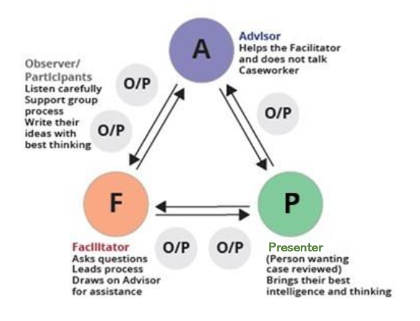

- Introductions
- Genogram – facilitator draws out family structure
- 3-5 minute description of the child or young person’s situation
- Worker’s goal – what do they want out of the consultation?
- Draft danger / worry statements
- What’s working well? – ask questions that will help capture this
- Safety and other scales – suggest scaling questions that could be used with the family etc.
- What are we worried about? – focus on behaviour that is harmful/ damaging, suggest questions then move on to danger statements
- Safety goals – participants write down potential safety goals in language/ words and pictures that parents, children and young people could understand
- Review and next steps – what has been most helpful for the practitioner? Is this enough for now?
APPENDIX 3
 | Worries | Strengths | Goals
Elicit  First question | - What are we worried about?  - What harm has happened to any child in the care of these adults?  - What is the danger to this child if left in the care of this mother?  - What makes this situation more complicated? | - What’s working well here?  - What are the best attributes of this mum’s/dad’s parenting?  - What would the child say are the best times she has with her dad?  - When has the mum fought off the depression and be able to focus on the child? | - What needs to happen?  - What do you need to see to be satisfied the child is safe enough that we can close the case?  - What would the mum say that would show everyone the child can come home?  - Where would the teenager say he wants his life to be at 18?  - What do we need to do to create a relationship where we can talk about difficult issues?
Amplify  Behavioural detail: What would  you see? | - When has that harm happened?  - How often; how bad?  - How did that incident affect the child?  - What language can we use to say that so the mum and child can easily understand?  - How long has this harm been happening?  - Give me the first, worst and most recent examples of harm. | - When has that good thing happened? How often?  - How did the mum fight off the depression? How else?  - How does the neighbour help?  - How did you get her to open up?  - How is the parenting programme making things better for the child?  - What did the dad do to make those contact visits really enjoyable for his kids? | - Describe the details of the behaviour you would want to see that would tell you this child is safe?  - How many people do you think should be involved in this safety plan?  - What is the father’s willingness/capacity to do this?  - Is this plan written in a way the child understands it?  - How will the mental health services involvement help make this plan work?
Reflect  Meaning | - Which of the danger statements do you think is the most important (or easiest) to deal with first?  - Which danger would worry the parents most?  - Of all the complicating factors which do you think is the most important to deal with? | - Which of the strengths are most useful in terms of getting this problem dealt with?  - Which aspects of their parenting/family life would mum and dad be most proud of? | - Where do you rate the child’s safety with this mother on a scale of 0–10?  - Is this a plan that the parents believe in? On a scale of 0–10, what confidence would they say that they have in it keeping the child safe?
Start over | - Are there any worries that we have missed? | - Are there any other good things happening in this family that we have missed? | - Are there any other important things that we have missed in the plan?

