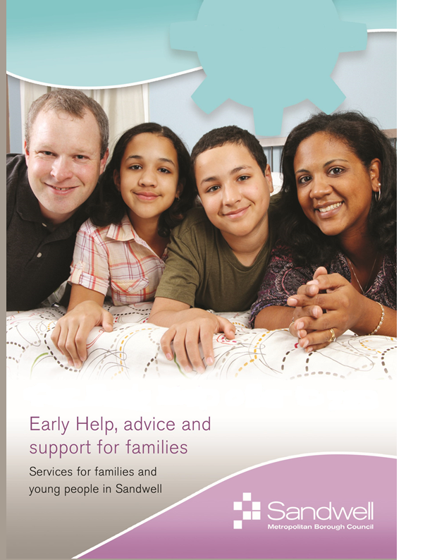

|  |
| --- |
| **TIPTON**  **Sandwell Local (Tipton)**  **Princes End**  **High Street, Tipton, DY4 9JB**  **Tel: 0121 569 7291 Mob:** 07917087966 |

**ROWLEY REGIS**

**Sandwell Local (Rowley Regis)**

**Payne Street, Blackheath, B65 0DH**

**Tel: 0121 569 7296 Mob: 07799 348259**

**Strengthening Families Service**

**Strengthening Families Service**

**OLDBURY**

**Sandwell Council House**

**Freeth Street Oldbury, B693DE.**

Tel: 0121 569 7295 Mob: 07471 029760

**WEST BROMWICH**

**Sandwell Local (West Bromwich)**

**The Court House,**

**High Street, West Bromwich B708LU**

**Tel: 0121 569 7293 Mob: 07584534015**

**SMETHWICK**

**Sandwell Local (Smethwick)**

**Smethwick Council House**

**High Street, Smethwick, B66 3NT**

**Tel: 0121 569 7297 Mob: 07901 111237**

**Strengthening Families**

**In**

**Sandwell**

**We can support with….**

**Strengthening Families Service**

**Targeted Support Services**





**WEDNESBURY**

**Sandwell Local, (Wednesbury) Wednesbury Town Hall,**

**Holyhead Road, Wednesbury WS10 7DF**

**Tel: 0121 569 7294 Mob: 07901 111237**

**• One to One Parenting Support**

**• Group Parenting Training**

**• Protective Behaviours Interventions**

**• Routines and Boundaries**

**• Appropriate/Inappropriate Chastisement**

**• Low Level CSE Work/Internet Safety**

**• Sexualized Behaviour**

**• Support with Budgeting and Debt Management**

**• Anger Management in the Home**

**• Offending Behaviour**

**• Anti-Social Behaviour (ASB) and Peer Pressure**

**• Enhanced Youth Support**

**• Support School Attendance**

**• Safer Families Project**

**• Behaviour Support in the Home**

**• Employment and Training Support**

**• Impact of Domestic Abuse on the Family**

**• Primary Mental Health Work**

**• Poor Home Conditions**

**• Entrenched Neglect**

**• Young Women’s Group**

**• Positive Activities for Young People**



Targeted Family Support

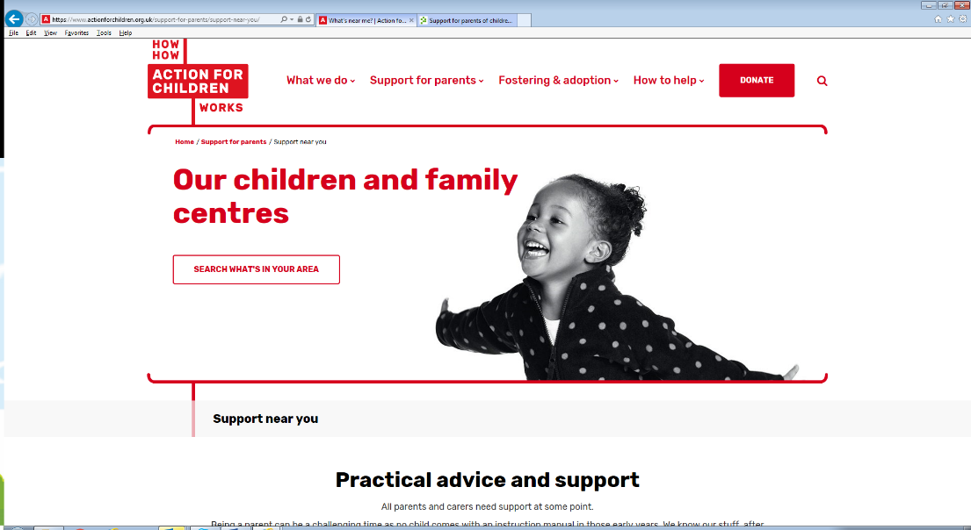

jj

**Sandwell Children’s Trust**

**offer support to children,**

**young people and parents or**

**carers. By working with you**

**as early as possible we can**

**support you to help your**

**family to have the best**

**start in life.**



**This service has been explained to me by:**

**_________________________________**

**From Sandwell Metropolitan Borough Council**

**• Early Help for you and your family: If you need extra support, we will work with you and family members to assess your needs. We will discuss and agree a plan to help you. If your child has a disability we can work with you to agree early support that will help meet your family’s needs. If we are not able to offer you support ourselves we will always advise you about what is available and we can help to put in touch with the services you need.**

**• We will agree together what needs to change and we will work to achieve this: Once we have agreed**

**to offer you support we will agree a Team Around the Child Plan. The TAF plan will say who needs to do what. Some of the actions will be things that you or other family members do, but the plan will also say what help and support we will provide.**

**• We can help if things become really difficult: We understand that families can go through difficult times. Things like money worries and lack of work can all impact on family relationships. You may be concerned about alcohol or drug misuse, violence or mental health problems within the family.**

**• Help with young children: for example with younger children some parents find it hard to establish a bed-time routine. We may be able to offer advice through a local Children’s Centre or arrange for a family worker to visit you at home.**

**• Help with older children: for example if your children are older or if you are a teenager yourself, the Team Around the Family Plan might focus on things like family relationships. Our family workers will listen to everybody’s points of view and help you to agree on what needs to happen to get on better. This will include someone to talk to if you feel unsafe.**

**• We will listen**: **We have experience in supporting families from a range of communities and cultures. We can spend the time needed to understand your concerns. We will listen about the good things, and about the challenges and frustrations that may be causing you concern.**