Strengthening Families Service

Meet the managers

Sandwell Strengthening Families Service

Strengthening Families teams have been in operation in Sandwell since 2014, the service was previously known as COG (community operating groups) teams. There is a Strengthening Families Service team based in all six towns of Sandwell.

Each Strengthening Families Service team has a manager and is staffed by a combination of Senior Strengthening Families Practitioners and Strengthening Families Practitioners, who between them will offer support to children, young people and families.

Regular multi-agency meetings continue as the backbone of the service, bringing together professionals who work in the local community to share resources and make sure that support is well targeted.

Our shared ethos is about placing the needs of children at the centre, taking a solution focused approach to motivate and enable families to make lasting changes that enable children to thrive and succeed.

All practitioners will use the EHM system and share the same core skills, using outcome focused plans and the ‘outcome star’ model to chart and evidence the progress made by families towards goals that they have agreed with the pratcitioner

Strengthening Families Teams can be contacted during normal office hours. Requests for early help support should be submitted on an Early Help Assessment.

Strategic Lead for Early Help
Kate Griffiths

Email: Kate_griffiths@sandwellchildrenstrust.org


Service Manager for Strengthening Families Service
Rofia Noreen
Email: rofia_noreen@sandwellchilrenstrust.org



Oldbury Strengthening Families Team
Manager – Claire Stephens
Email - claire_stephens@sandwellchildrenstrust.org



Rowley Strengthening Families Team
Manager – Lisa Lowe
Email: rowley_strengtheningfamilies@sandwell.gov.uk

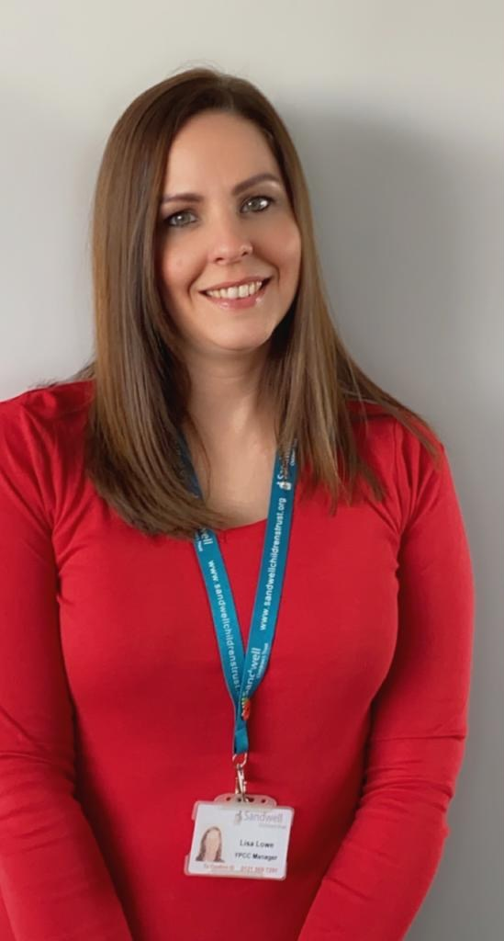
Smethwick Strengthening Families Team
Manager – Barry Cole
Email: smethwick_strengtheningfamilies@sandwell.gov.uk


Tipton Strengthening Families Team
Manager – Naomi Clarke-Huggan
Email: tipton_strengtheningfamilies@sandwell.gov.uk

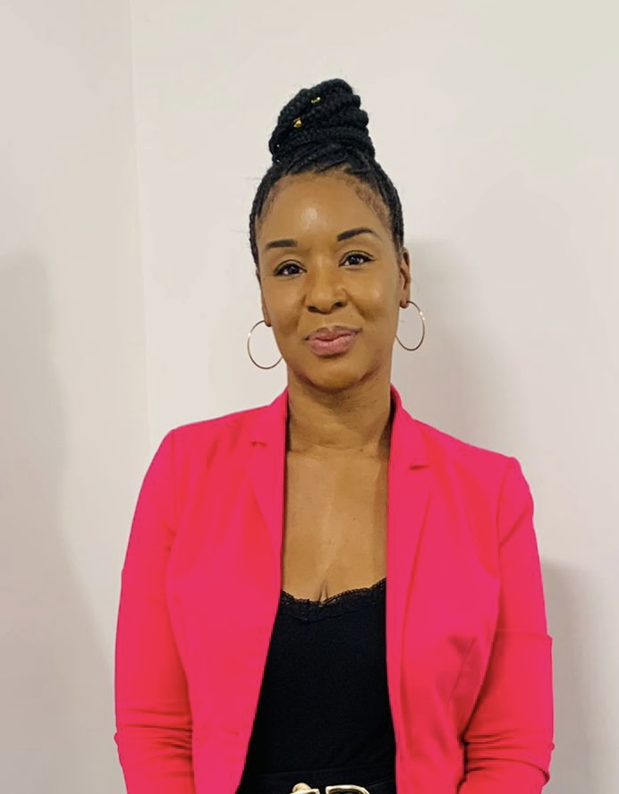

Wednesbury Strengthening Families Team
Manager – Kevin Smith
Email: wednesbury_strengtheningfamilies@sandwell.gov.uk



West Bromwich Strengthening Families Team
Manager – Suki Sian
Email: westbrom_strengtheningfamilies@sandwell.gov.uk



