Practice Note for all SCT Practitioners, Managers and Staff:
Knowledge and Skills Statements (KSS)

Social work is a complex system with many aspects. It is vital that those who work in all parts of the system have a broad understanding of the key areas. The Knowledge and Skills Statements (KSS) are an important set of standards that set out what practitioners should know and be able to do in specific practice settings as a Social Worker, Practice Supervisor and Leader. In total, there are 29 standards that evidence what is required of practitioners within certain roles and identifies where they may need to develop further. They are used as guidance to help and inform our assessments, planning, intervention and achieve permanence when working with families whilst informing our critical analysis and simultaneously thinking about the impact of our work. The KSS are used to support everyday practice and are used to inform recruitment, workforce development, performance appraisal and career progression (BASW, 2018).
The Knowledge and Skills Statements (KSS) have been developed to enable Social Workers to prioritise learning and development to impact the quality of their practice. There are separate KSS for practitioners, Practice Supervisors (Managers) and Practice leaders on one which also focuses on achieving permanence. This will ensure that children and families receive high quality support that is consistent and results in improved outcomes. This is the reason why the Knowledge and Skills Statements are one of the three overarching principles of our Practice Framework and Model alongside the Child’s Journey and Children and Young People’s Participation.
The importance of the KSS has also been recognised throughout the National Assessment and Accreditation System (NAAS) which sets out an expectation for Social Workers to reach advanced levels of practice knowledge and skill, which will be formally accredited. Being able to understand and apply the KSS will support assessment under NAAS which is why it is important that we continuously refresh our understanding of these as part of our practice development.
This Practice note will explore what the Post Qualifying Standards - Knowledge and Skills Statements (KSS) are and why these are important within your role. It will also explore how the KSS are supported by our Practice Framework and Model. The KSS will be linked to the role of the Practitioner and Team Manager/ Supervisor to help support how the KSS can be used within practice, further providing information around implementing these within supervision, planning and interventions.
What are Post Qualifying Standards - Knowledge and Skills Statements (KSS)
The Knowledge and Skills Statement (KSS) are aspects of practice that inform child and family practitioners in their work with children and families and are a set of national standards that help and support practice.

Knowledge and Skills Statements for Child and Family Practitioners
For frontline practitioners and practice supervisors, the 10 KSS statements have been determined as the post-qualifying improvement standards as set out under Section 42 of the Children and Social Work Act 2017. They set out professional standards, the attainment of which demonstrates an expertise or specialisation (GOV.UK 2018). The KSS are applicable at every stage of your career, illustrated in the image below which provides an overview of the Post-Qualifying Knowledge and Skills Statements for practitioners.
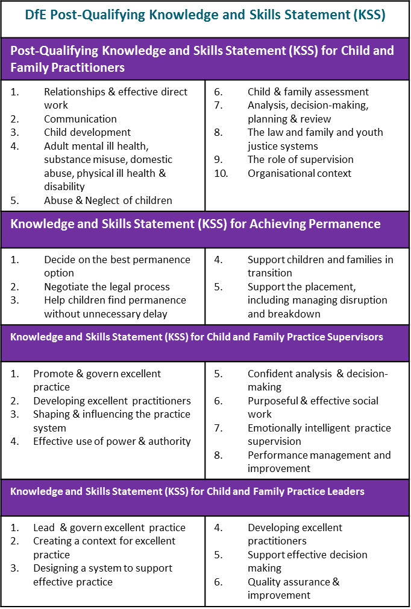

Knowledge and skills statements for Achieving Permanence
There are 5 Knowledge and Skills Statements in this section are for Social Workers, Managers and Support Staff and contribute to achieving permanence for children. Permanence means making a plan for a child which lasts throughout their childhood. The KSS also supports practitioners who are making long terms plans for children who are likely to become looked after children, or who are already looked after. Understanding the range of options for permanence inside and outside of the care system which deliver good outcomes, giving children a sense of security, continuity, commitment, identity and belonging to ensure future positive life chances is important.
Knowledge and skills statements for Practice Supervisors and Leaders
The KSS also supports Practice Supervisors whose primary function is to supervise the practice and decision-making of Approved Child and Family Practitioners, and to develop the skills of individuals and teams within child and family social work services. There are 8 KSS in this section which require experience of working with a high level of social complexity and risk of harm and is likely to require substantial experience of working within the statutory system (BASW 2018).
Alongside supervisors, there are 6 KSS that also underpin the work undertaken with Practice Leader/s who are qualified social workers with the day-to-day operational responsibility across the whole local system for child and family social work practice and for child and family practitioners and practice supervisors. Most usually, this is referred to as the Assistant Director of Children’s Social Care or Director of Family Services. It may be that a few, mainly larger employers, would regard themselves as having more than one practice leader
Assessed and Supported Year in Employment (ASYE)
The KSS are also used as framework of assessment for the Assessed and Supported Year in Employment (ASYE), a programme that gives Newly Qualified Social Workers extra support during their first year of employment. It is important for Practice Supervisors to have knowledge of KSS at practitioner level to provide effective support to their newly qualified and experienced staff. NQSW should have an initial assessment against this KSS to help identify learning needs and objectives, which feed into their professional development plan during supervision, mid-year and final assessments.
National Assessment and Accreditation System (NAAS)
More recently, the KSS have been used as a measure of good practice in the National Assessment and Accreditation System (NAAS). Where it is felt a worker can embed and work within the KSS confidently within practice, NAAS assesses the worker against the KSS and ensures this is accredited.
Following this, workers will be able to reflect and understand their current level of knowledge and skill and work towards areas of further development. This will also support the organisation in delivering consistently good practice to improve outcomes for children and families as well as understand the workforce needs through this endorsement process. This can continue to be reflected upon within supervision, performance management and learning and development.
Why are the KSS a key part of Sandwell’s Practice Framework and Model?

- The KSS support you in your role when working in partnership with children, young people, their families and partner agencies. They also provide you with a knowledge base that will strengthen collaborative working when completing assessments, plans, updating plans and reviews. Partnership working with the child and the family is critical to success and sustained change, with everyone playing their part as a team around the child to support and facilitate the improvements that need to be made.

- A sound understanding of the KSS on permanence identify the expectations within your role which will help work towards achieving this at any stage of our work with children and their families.

- Applying the KSS, supports practitioners to understand the complexities within and surrounding families. This enables you to work in a way that recognises the importance of adopting an approach that focuses on strengths, relationships and any trauma with families when identifying risks, harm and needs. This means considering the experiences of the family, reflecting on how they feel and our approach to their engagement.
- The KSS support supervision and reflective spaces by enabling practitioners to seek support and critically reflect with Managers when making decisions to safeguard children. These are important standards for Newly Qualified Social Workers to meet their formal requirements but also to support practitioners at all levels to reflect in and on the work completed with children, young people and families.

- Understanding the importance of culture and identity is a thread that runs throughout the KSS to demonstrate informed use in practice of the influence of cultural and social factors on child development, including different parenting styles whilst considering the impact of poverty, inequality and diversity.
How using the KSS and the Practice Framework and Model strengthens our practice
This section will provide an example of how the KSS and other elements of the Practice Framework and Model can be used to help support good practice when working with children and families. This will highlight the skills needed to ensure these standards are met as well as the tools that can be used within practice to achieve these. A full list of the KSS are available to view within the further reading section of the practice note. It is important to note that these will be interlinked and relate to each other across all areas of practice.
Toby’s Case Study:
Toby is 6 years old and has two younger siblings who are 3 and 1. Toby’s mum is 27 and has no relationship with the fathers to the children. She was subject to Child Protection Planning when she was a child due to neglect and has been the victim of domestic abuse within her relationships as an adult. She suffers with low mood, anxiety and depression and is isolated from her family because of her relationship choices.
Toby has been coming into school late most mornings, complaining he is hungry and tired. He tells his teacher that he has been awake with his younger brothers as his mum won’t wake up. His clothes smell of urine and he has been seen falling asleep in class.
A Single Assessment now needs to be completed.

When thinking about Toby’s circumstances we first need to understand what is expected of you by understanding the role of child and family social work (KSS 1) to ensure that Toby and his family are offered help and support that is likely to create positive change. To understand his lived experiences and family circumstances, as part of the work we do, we must carry out and complete a robust assessments of Toby and his family’s circumstances. Child and Family Assessment (KSS 6) and will support you in understanding the steps that need to be taken to begin the assessment process, which includes seeking support from your supervisor along the way. These processes form part of our doing model and will provide you with a framework when working with Toby and his family so that when you plan your intervention, you are more likely to make a difference.
It is important to use effective direct work with children and families (KSS 5) by building relationships with Toby and his family that are meaningful, which support you to identify the right type of support to the family that is relevant to the needs or risks. You will need to consider Toby’s age and stage of development as well as his individual needs when planning any work with him. Working closely with Toby’s mother, using direct work tools such as cultural genograms, the child’s journey, chronologies and life story work supports us in building relationships whilst also adopting a trauma informed approach to understanding the child and family’s experiences. Understanding that Toby is part of a wider network will support you when completing your assessment and planning for the Toby and his family as you will have understood the risk and protective factors and his overall lived experiences.
In Toby’s case, his mother has been struggling with her mental health and there are clear concerns around neglect. Understanding Adult mental ill health, substance misuse, domestic abuse, physical ill health and disability (KSS 3) and Abuse and neglect of children (KSS 4) will support practitioners in accessing assistance from other professionals to better assess the impact of this on Toby and his family circumstances. This will contribute to the assessment and ensure any behaviours that may indicate a risk or increasing risk to him are identified and equally supported. Working with Toby, his mother and wider agencies will ensure a collaborative approach, working in partnership to achieve better outcomes for Toby and his siblings as support will be offered at the right time and at the right level, thus leading to sustained changes.
Thinking about partner and partnership working, completing visits, direct work and intervention and considering throughout all aspects of work, the family’s culture, identity and links to their wider community (KSS 5) will ensure that Toby has a robust assessment. We know that when understanding the impact of neglect in the lives of children such as Toby, a robust assessment and analysis (KSS 7), using risk assessment tools such as the Graded Care Profile 2, adopting a trauma informed approach to understanding the family’s circumstances whilst remaining child centred will be required to keep Toby and his siblings safe. This approach will also indicate the prospect of positive change for the child and include information from a range of sources such as school, the GP, wider family, health visitor etc.
You can explore ways to understanding the children’s journey through understanding the family’s history and journey through services. Using the family’s chronology can support you in this area, identifying patterns of behaviour, risk, strengths and responses from Childrens services and supporting agencies over time.
The information you gathered through your planned interventions with Toby and his family will allow you to apply professional judgement of the circumstances and understand the level of risk given the cumulative and presenting concerns. This would need to take into consideration the age and stage of development (KSS 2 Child Development) of the children and their vulnerabilities if receiving neglectful care.
Analysis, decision-making, planning and review (KSS 7) will support you in understanding that for Toby this is something that has happened over time and cannot be attached to one specific incident. It is therefore important we work with Toby and his mum and supporting professionals to understand the root cause and contributory factors. We know that the family are isolated, his mother has been in abusive relationships and has herself experienced neglectful parenting, and she is struggling with her mental health.
Using the KSS to understand what is expected of you within your role, underpinned within a legislative framework (KSS 8 and KSS9) will ensure your work with families is meaningful, strengths, relationship based and trauma informed drawing on a range of resources to understand the family functioning. Analysing risk of harm or future harm to Toby is a vital process within understanding (through assessment) the services that will protect him but also what will help him to recover from what he has experienced. The KSS will help shape the work that we do and can be reviewed with your team manager/supervisor throughout various processes to ensure intervention remains meaningful.

Reflective Spaces and Supervision.
Regular supervision and reflective spaces will ensure there is management oversight and direction giving practitioners the opportunity to reflect on the progression of the case and work through any areas where they feel stuck (KSS 10). You will need to be able to manage the specific tasks, seeking support from your peers and supervisor to ensure the support in place for Toby is keeping him and his siblings safe. If there are further concerns raised around Toby’s safety and wellbeing or the support in place is not properly utilised you will need to take the necessary steps to safeguard him with guidance from your manager.
Team Managers and Practice Supervisors need to be aware of their responsibilities and expectations of them under the KSS. For example, KSS 2 (developing excellent practitioners), KSS 4 (the effective use of power and authority) and KSS 8 (Performance Management and Improvement) are all areas that managers should be implementing in their day to day practice. A common setting for the effective use of KSS would be in supervision, as adhering to these standards will allow for reflection and effective direction to take place. The manager in this case would work with the practitioner to reflect on the difficulties encountered during practice, recognise professional limitations and provide support and professional change when needed.
Using the practice framework and model’s reflective questions throughout supervision will support you in applying critical thinking and analysis to our intervention with a children young people and their families. The reflective questions can also assist with a self-assessment of our own application and knowledge of the Practice Framework and Model of Practice.
How to evidence the KSS and Good Practice Points
As Practitioners and Managers, it is therefore essential that we:
- Continue to refresh our understanding of the KSS.
- Know and understand how each of the KSS relates to our practice and how we apply them to a particular child/young person/young adult and family we are working with.
- Use the KSS to help inform our critical analysis and thinking about the impact of the concerns on the children/young people and young adults.
- Use the KSS as guidance to help and inform our assessments planning and intervention with a child/young person/young adult and their family.
- Use KSS to improve our practice and better the outcomes for the children and families we work with. Understanding what is expected of us within our role.
- Use supervision and reflective spaces to understand where practitioners can strengthen their implementation of KSS suing this as a guide to improving practice and learning and this will support us in applying the necessary skills within our practice, intervening with families in a way that understand their experiences, culture and identity communicating in a way that is understood by the child and family
Further information and reading
- Practice notes relating to the Practice Framework and Model, The Childs Journey, Child Participation, Relationship Based Practice and Trauma Informed Practice are available on Tri-X.
- The Practice Framework and Model Booklet, Information relating to the Child’s Journey, Participation and KSS and practice learning workshops on the Learning and Development Pages.
- Post Qualifying Standards for child and family practitioners:
https://assets.publishing.service.gov.uk/government/uploads/system/uploads/attachment_data/file/708704/Post-qualifying_standard-KSS_for_child_and_family_practitioners.pdf
- KSS for child and family practice supervisors:
https://assets.publishing.service.gov.uk/government/uploads/system/uploads/attachment_data/file/708705/Post-qualifying_standard-KSS_for_child_and_family_practice_supervisors.pdf
- https://www.ccinform.co.uk/knowledge-hubs/national-assessment-and-accreditation-system-naas-hub/

Date of Practice Note: September 2021
Date to be reviewed: September 2022
Authorised by: Beyond Auditing Practice and Development Team: Pauline Dunkwu, Faye Walker and Aman Basi.

