Practice Note for all SCT Practitioners, Managers and Staff:
Cultural Genograms

What are Cultural Genograms?
A cultural genogram is a pictorial representation of the relationships and experiences within a family. It is a visual tool that enables engagement with the family and provides the practitioner with an overview of individual and group culture within a family.
A cultural genogram is created using a key agreed with the family, which can include a combination of text, symbols, shapes, colours, lines and captions which capture the family and significant relationships over at least three generations. This key is used to depict a range of factors such as gender, the quality of different relationships and strengths. It can also be used to identify safeguarding concerns such as substance misuse, domestic abuse, sexual abuse, neglect etc. This is illustrated in the cultural genogram below:

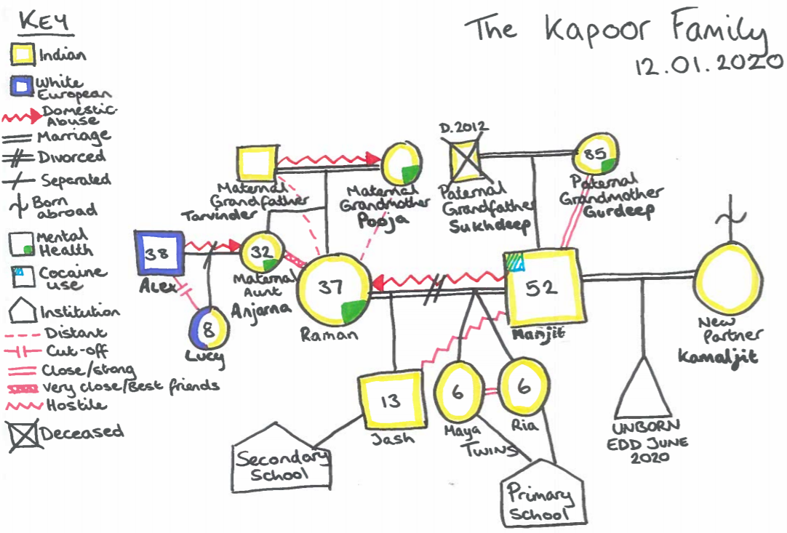
As can be seen above, a cultural genogram provides a range of information regarding who is part of the family, the quality of the relationships and how they function. This can be used to develop a better understanding of the family’s culture, identity, beliefs, traditions and values. This needs to inform our assessments, plans, analysis and decision making which will enable us to be culturally competent in the way that we practice.
Why are Cultural Genograms needed?
In Sandwell Children’s Trust, cultural genograms are part of our Practice Framework and Model and are linked to relationship-based practice which focuses on building, maintaining, and sustaining trusting relationships with children, young people and their families. Developing cultural genograms are essential interventions to complete with children, young people and young adults and families as part of our role as practitioners.
Cultural genograms are an important part of our work with children/young people and families especially where there are safeguarding concerns. They need to be used to inform our interventions when completing assessments and plans. We need to ensure that when we build our relationship with the family and undertake our work with them, that our understanding and analysis of the family’s culture and identity is integral to the assessment, planning and intervention with them.
Practitioners must start building a trusting relationship with children and families as this will be more effective when completing cultural genograms (refer to the building blocks as part of relationship-based practice). Creating a cultural genogram helps the family to tell their own story from their perspective, understand their network and explore how their network can positively influence the intervention and plan.
A cultural genogram also enables us as practitioners to talk about potential risks that might impact upon children in a more sensitive way. In some circumstances, these might also relate to intergenerational patterns within families. Exploring these relationships with families helps to map out patterns and themes in a visual way such as those relating to neglect, mental health, domestic and sexual abuse and contact with people that might pose a risk to children. This supports our families to see the reason for professional concerns and what changes are needed to reduce them. It also strengthens our knowledge about the family by using their voice which will enable more effective interventions due to focusing on both the presenting concerns and possible root causes. Working in this way is more likely to secure better outcomes for children and young people.

Theoretical underpinnings of a Cultural Genogram
Cultural genograms are developed using Social GGRRAAACCEEESSS. This acronym relates to Gender, Gender Identity, Geography, Race, Religion, Age, Ability, Appearance, Class, Culture, Education, Ethnicity, Economics, Spirituality, Sexuality and Sexual Orientation (Burnham 2013). Using Social GGRRAAACCEEESSS supports us to recognise the importance of using a practice approach which recognises the different aspects of the identities of the families that we work with. Practitioners also need to be culturally competent when undertaking work with children and their families.
Cultural genograms are also underpinned by a range of theoretical approaches such as systemic, and attachment theories which recognise the importance of understanding current behaviours, relationships and functioning in the family context. It is an inclusive tool ensuring that significant individuals who might not be blood related including friends and social supports can be considered. The cultural genogram can also be expanded to include professionals or organisations involved with a family and wider network.

How to develop a Cultural Genogram
A cultural genogram can take a few sessions to complete and each session you can bring back the version you had in the last session and build upon what we know already. This is a working document used with the family and can be developed separately with different family members. This is also a useful direct work tool with children, to understand their live experiences through their perspective. We need to be mindful that culture is fluid and changes over time and as such, our genograms need to reflect these changes. Some preparation is needed to ensure that cultural genograms are undertaken in the most effective way. Sitting down with the family and explaining what a genogram is, the purpose of it and agreeing how best to complete it is important. When explaining what a genogram is it might be useful to think of the language used as most people may not be aware of the term ‘genogram’ but most may recognise the phase ‘family tree’. Using a relationship-based approach will ensure that the family is informed about the purpose of the intervention, how long it might take and the feelings that it might evoke. This will enable you to consider with them how, when, with whom and where to undertake the work and any support that might be needed as part of the process particularly when the session ends.
A cultural genogram is created using a key agreed with the family which can include a combination of text, symbols, shapes, colours, lines and captions which capture the family and significant relationships over at least three generations. This key is used to identify a range of factors such as gender, the quality of different relationships and strengths. It can also be used to identify safeguarding concerns such as substance misuse, domestic abuse, sexual abuse, neglect etc (see appendix 1 on page 4 which is an example of genogram symbols that can be used). The session needs to be interactive and creative and can be completed using; flip charts, coloured pens, pictures and stickers. Cultural Genograms can now also be created on the new Windows Laptops, as they are touch screen and can be put into tablet mode, allowing for an interactive experience with families.

Initial points to consider when completing a basic three generational genogram:
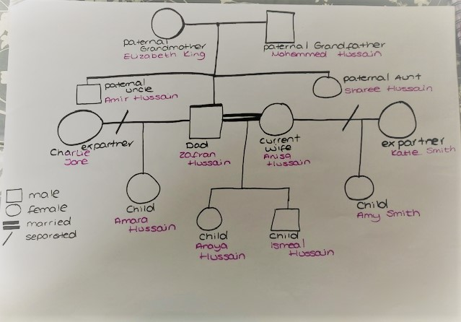
- Start by creating a basic three generational genogram, focussing on the significant people within the family and who is identified as supportive (See Illustration 1)
- Think about introducing a key and the child/young person/adult can choose symbols and colours to represent different elements throughout.
- Include age, gender, relationship status (married/separated/deceased)
- Any children of the three generations specific to the support network– include ages.
Illustration 1
- Also include at the top of the page the date the genogram was created
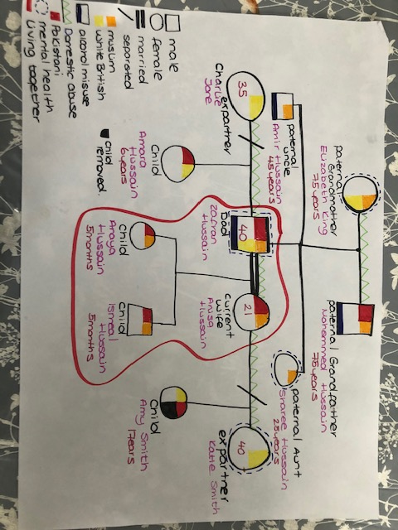
Additional points to consider when developing a cultural genogram:

- Identify the ethnicity and religion and of everyone in the family and include this on the genogram using a symbol/key identified by the family (See Illustration 2).
- Identify who lives in which household (See ‘living together’ in the Key shown)
- Identify patterns and themes in each individual’s history and functioning e.g. domestic abuse, mental health etc,
- Include any previous professional involvement including Children’s Services, with everyone identified on the genogram.
- Discuss the quality of relationships between family members. This can be illustrated by a specific symbol (as shown in illustration 2).
Cultural genograms can be revisited and updated weeks or several months later to reflect the current circumstances of the family. As practitioners we also need to consider our approach when working with families to ensure that it is informed by a respectful stance, professional curiosity and appreciative enquiry. We also need to be mindful that different family members may have differing views on family relationships, family culture or strengths identified. This can then be used to inform the assessment that we complete with the family.
Reflecting upon our approach when working with all our families in supervision, group supervision and training is important to ensure that we identify and address any assumptions or bias that might emerge due to our own value base as practitioners. Some suggested questions to use in supervision/group supervision have been provided within the practice note to support our reflection and use of professional judgement. (see appendix 2 on page 4). Practitioners also need to consider other factors such as the impact of secondary trauma on themselves when creating genograms, where families may share emotive or adverse experiences.

How can I evidence this work on the child/young person/young adults file?
- Cultural genograms created with the child, young person, young adults, parents and carers to be uploaded onto documents linked to the visit case note providing an analysis of the session.
- Link information obtained from the cultural genogram to your assessment particularly the analysis and rationale for decision making.

Good Practice points
- Creating Cultural Genograms with the family will strengthen relationships with the family and ensure that both resources as well as risks are identified.
- As the case progresses and updated cultural genograms are completed, reflect on the differences in the genograms, what does this tell you about the family or individuals within it? How does this shape your planning?
- Even if it done separately, try and engage a range of family members in the creation or updating of the genogram to ensure that it is holistic and inclusive
- Aim to identify areas of strength and resilience in a family, not just concerns

Further information and reading
- Practice notes relating to the Practice Framework and Model including cultural competence and Relationship based practice are available on Tri-X.
- The Practice Framework and Model Booklet, Information relating to the Child’s Journey, Participation and KSS and practice learning workshops on the Learning and Development Pages.

Appendices
Appendix 1: an example of genogram symbols that could be used when creating cultural genograms.
Appendix 2: Reflective supervision questions that can be used during Supervision.

Date of Practice Note: September 2021
Date to be reviewed: September 2021
Authorised by: Beyond Auditing Practice and Development Team: Pauline Dunkwu

