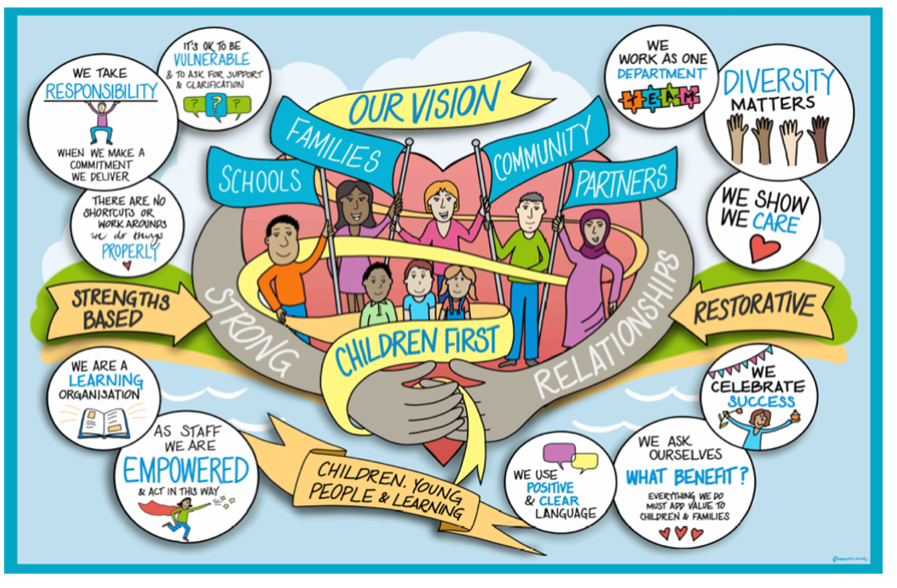

Changing a Care Plan following Agency Decision Maker (ADM) decision of adoption

Index | Subject | Page
 | Contents | 2
 | Changing a Care Plan following ADM decision of Adoption - Workflow | 3
1. | Introduction | 4
2. | Option One: Change of care plan when an ADM decision has already been made for adoption, but the Court has not made a final order as the care proceedings are ongoing. | 4
3. | Option Two: Change of a care plan away from adoption when a Placement Order is in place and needs to be revoked. | 5
4. | Informing the Agency Decision Maker if a Court denies the making of a Placement Order | 5

Changing a Care Plan following ADM decision of Adoption - Workflow

Change of care plan following ADM decision for adoption but final order not yet made by the Court
Change of care plan from adoption when a Placement Order has already been granted.

Review Permanency Panel Meeting to be held
Children we Care for Review to be held (CLA Review)

Children we Care for Review to be held (CLA Review)
Legal Advice to be sought from allocated Legal Advisor

Legal Advice to be sought from duty Legal Advisor

Following paperwork to be completed:

- Change of Care Plan away from Adoption form
- Re: B-S analysis and Adoption Welfare Checklist
- Impact Chronology
- Updated Child Permanence Report
- Care Plan updated

Following paperwork to be completed:

- Change of Care Plan away from Adoption form
- Re: B-S analysis and Adoption Welfare Checklist
- Impact Chronology
- Updated Child Permanence Report
- Children We Care for Care Plan updated

ADM Slot to be booked via acdadoptionpaneladmin@westsussex.gov.uk

Liaise with the Local Authority Agency Advisor for support and advice

ADM Slot to be booked via acdadoptionpaneladmin@westsussex.gov.uk

Liaise with the Local Authority Agency Advisor for support and advice

- Introduction
The aim of this practice guidance is to assist the Children's Social Care teams with the requirements and process of changing a child’s care plan following an Agency Decision Maker (ADM) has decided that the child should be placed for adoption.

When the Agency Decision Maker (ADM) has decided that a child’s care plan to be presented to the Court is one of adoption, this can only be changed if the ADM gives agreement. There are two distinct scenarios when this process will need to be followed.

- Option One: Change of care plan when an ADM decision has already been made for adoption, but the Court has not made a final order as the care proceedings are ongoing.
Approval of a care plan that is no longer one of adoption for a child will need to be sought before the local authority final evidence is filed. This process may be needed for example if there is a change of circumstances such as a newly identified alternative permanency option, which has been assessed as suitable for a child. A Children We Care for Review should be held to discuss these proposals.

If it is considered that a change to the final care plan should be made, legal advice should be sought from the allocated legal advisor. If proceeding, with a change of care plan a review decision by the ADM is required and further information will need to be provided to evidence the rationale or the change of care plan.

The following steps will need to be completed:

- ‘Change of Care Plan away from Adoption’ form to be completed, summarising the rationale and evidence for requesting this change. This will need to include the views of those in the child’s network, for example Conferencing and Reviewing Officer (CRO), Children’s Guardian, parents/carers, social worker, and managers.
- The Re BS analysis and adoption welfare checklist is required to be updated.
- The impact chronology will need to be updated.
- Update of the Child Permanence Report, quality assured by Team Manager
- Care Plan to be updated
- Agency Decision Maker slot to be booked as per the Practice Guidance: ‘Submitting to ADM for an Adoption Decision’.

- Option Two: Change of a care plan away from adoption when a Placement Order is in place and needs to be revoked.
When a Placement Order has been granted by the Court, but the Local Authority has not been able to find an appropriate match for permanency through adoption and the local authority seeks to change the care plan. A Child We Care for Review under the adoption agency regulations 2005 and a Review Permanence Planning Meeting will need to be held.

Additionally, the legal advisor via the duty solicitor should be contacted for legal advice on the proposed application. Once the application is made the child will become party to proceedings and will be legally represented.

The following steps will need to be completed:

- ‘Change of Care Plan away from Adoption’ form to be completed, summarising the rationale and evidence for requesting this change. This will need to include the views of those in the child’s network, for example Conferencing and Reviewing Officer (CRO), Children’s Guardian, parents/carers, social worker, and managers.
- The Re BS analysis and adoption welfare checklist is required to be updated.
- The impact chronology will need to be updated.
- Update of the Child Permanence Report, quality assured by Team Manager, summarising the rationale and evidence for requesting this change.
- Children we Care For care plan to be updated to capture the changes which have occurred and its impact on the child and their needs. This must include updating information about the parents and their views if known and their ability to care for the child, any change of PR, contact arrangements and any significant changes which impact on the child and their future permanence.
- Agency Decision Maker slot to be booked as per the Practice Guidance: ‘Submitting to ADM for an Adoption Decision’.

- Informing the Agency Decision Maker if a Court denies the making of a Placement Order

If the Court do not approve the local authority care plan of adoption and do not make a Placement Order. The Agency Decision Maker should be informed by emailing the Local Authority Agency Advisor via acdadoptionpaneladmin@westsussex.gov.uk advising that the plan for adoption was not approved by the Court and the reason for this. In addition, the ADM should be advised of the child’s final court approved care plan.

Review / Contacts / References
Document title: | Changing a Care Plan following ADM decision of adoption
Date approved: | 21 April 2022
Approving body: | Policy & Practice Steering Group
Last review date:
Revision history:
Next review date: | April 2024
Document owner: | Linda Steele Assistant Director Safeguarding and QA
Lead contact / author: | Hazel Birchmore, Local Authority Agency Advisor  Kelly Steele, Service Manager Permanence Team

