Genograms

A genogram is a visual pictorial description of a family. A genogram may begin with a basic “2D” description of a family: simply drawing and naming who is in the immediate family unit, their gender and ages.
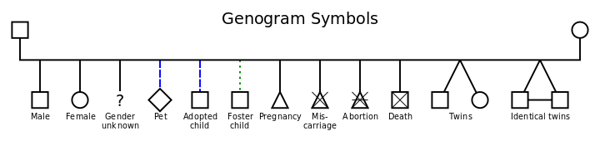
However, a genogram can be greatly expanded to include (but not restricted to): the individuals; how they are related; composition; generations; relationships; deaths; marriage; separation etc;. It is a rich and meaningful tool that can be used as direct work, assessment and intervention.

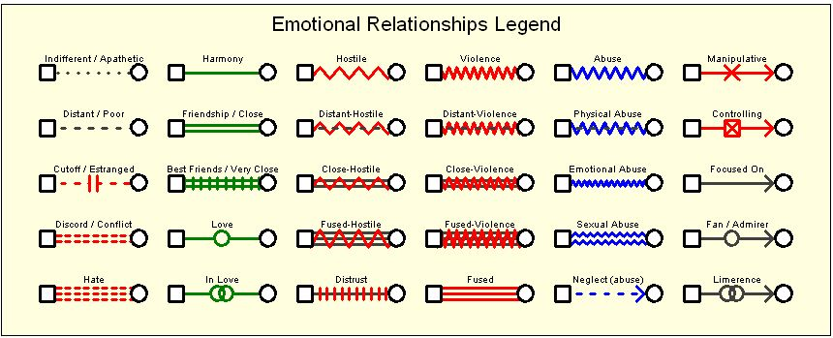

The purpose of a genogram is to help both the practitioner and the family better understand their family story, their family history and the significance of the individuals within the family.
The aim is that the genogram will be used as a focus to gather information about the wider family and family history. The practitioner brings their skill in remaining curious; such as using circular questioning techniques in order to better understand what context the children in the family exist within. Further knowledge can be used alongside a genogram such as the use of social GRACES (John Burnham) where the letters represent different aspects of the family experience such as: Gender; Race; Age; Community; Education and so on. The possibilities are endless and not restricted.
Genograms are an ongoing interactive and “live” record that can be added to and revisited at any time to build depth of understanding, bring reflectivity and encourage perspective of a family; the dynamics at play and the potential patterns of behaviour and experience.
Further information and resources are available on Research in Practice (https://www.researchinpractice.org.uk/children/)
Tool: Using Genograms (part of Analysis and Critical Thinking in Assessment)
Genograms are diagrams that map out relationships within a family and across generations (usually at least three). This is an exercise to strengthen relationships between the social worker and the family, and increase understanding of the key issues in a child’s story. Download the Analysis and Critical Thinking in Assessment handbook to access Tool 2: Using genograms.

Online learning package: Relationship-based practice and child protection
Film four of this 2020 online learning package considers clear recording, chronologies, genograms, and a child’s perspective.

