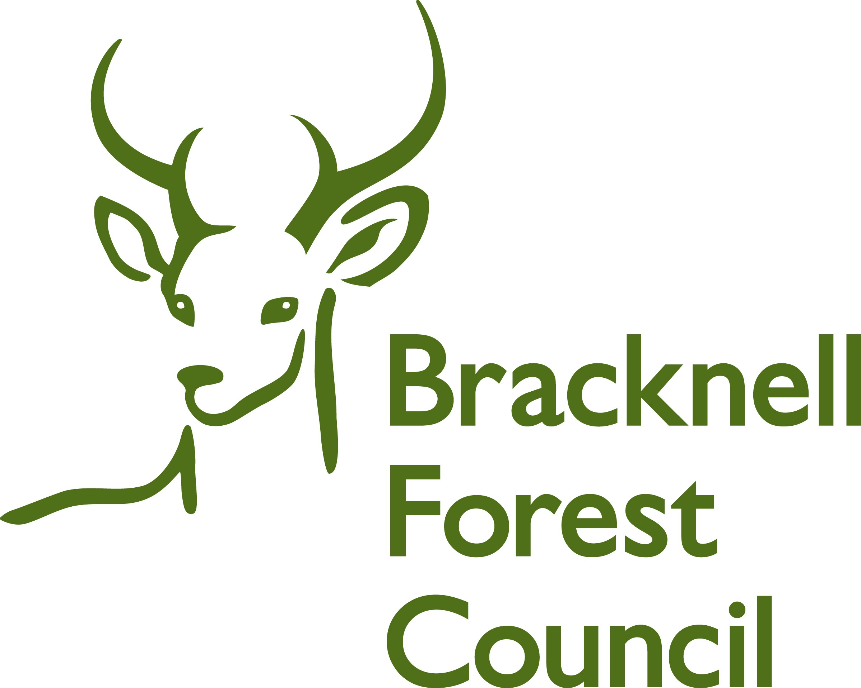
BRACKNELL FOREST FAMILY PLACEMENT TEAM

REPORT FROM FOSTER CARERS’ ADULT CHILDREN
LIVING AT HOME FOR CARERS’ REVIEWS

Name

Age

Parents
Names

We’d like you to be as open and honest as you can about answering these questions. Please answer as many as you can. This form will be used at your parent/s annual review.

Have there been any changes in your family life since the last review?

Have there been any changes for you since the last review?

What has been the most challenging this year re fostering?

Is there anything that is especially good or helpful for you connected with the foster children?

Is there anything that is especially good or helpful for you connected with the foster children?

How are you involved with the foster children, if at all? In what way do you help them?

How do you feel your parents manage fostering?

How do you feel about your family fostering other people’s children?

You also have a supervising social worker who will offer support to you and your parent/s.
Is there anything you would like him/her to do, or you need to say to them?

Thinking about fostering, what would you like to happen in the future?

Is there anything else you’d like to say?

Signatures

Signed

Date

Many thanks for completing this form.

