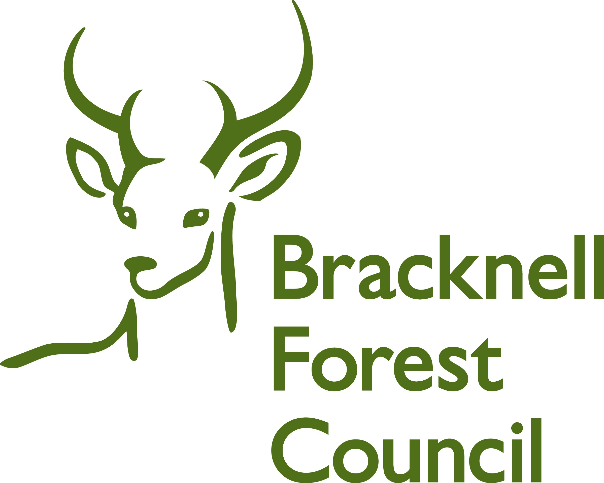
BRACKNELL FOREST FAMILY PLACEMENT TEAM

REPORT FROM FOSTER CARERS’ OWN CHILDREN 5—12 YEARS

Name

Age

We’d like you to be as open and honest as you can about answering these questions. Please answer as many as you can.

Have there been any changes in your family life since the last review?

Have there been any changes for you since the last review?

Have you found anything hard to cope with because of the foster children? If so, what is it?


Is there anything that is especially good or helpful for you living with the foster children?

What do you like to do with the foster children?

Do you help the foster children? In what way do you help them?

Do the foster children help you? In what way do they help you?

How do you feel about your family fostering other people’s children?

Lots of people visit your home about the foster children, is there anything that you’d like to say about these people?

Is there anything else you’d like to tell us?

Do you come to the Children of Foster Carers Group? If not would you like to?

If you would like to talk to anyone about fostering, please tell your mum or dad or your supervising social worker.

Please write your name for us.

Signed

Date

Thank you for completing the form.

