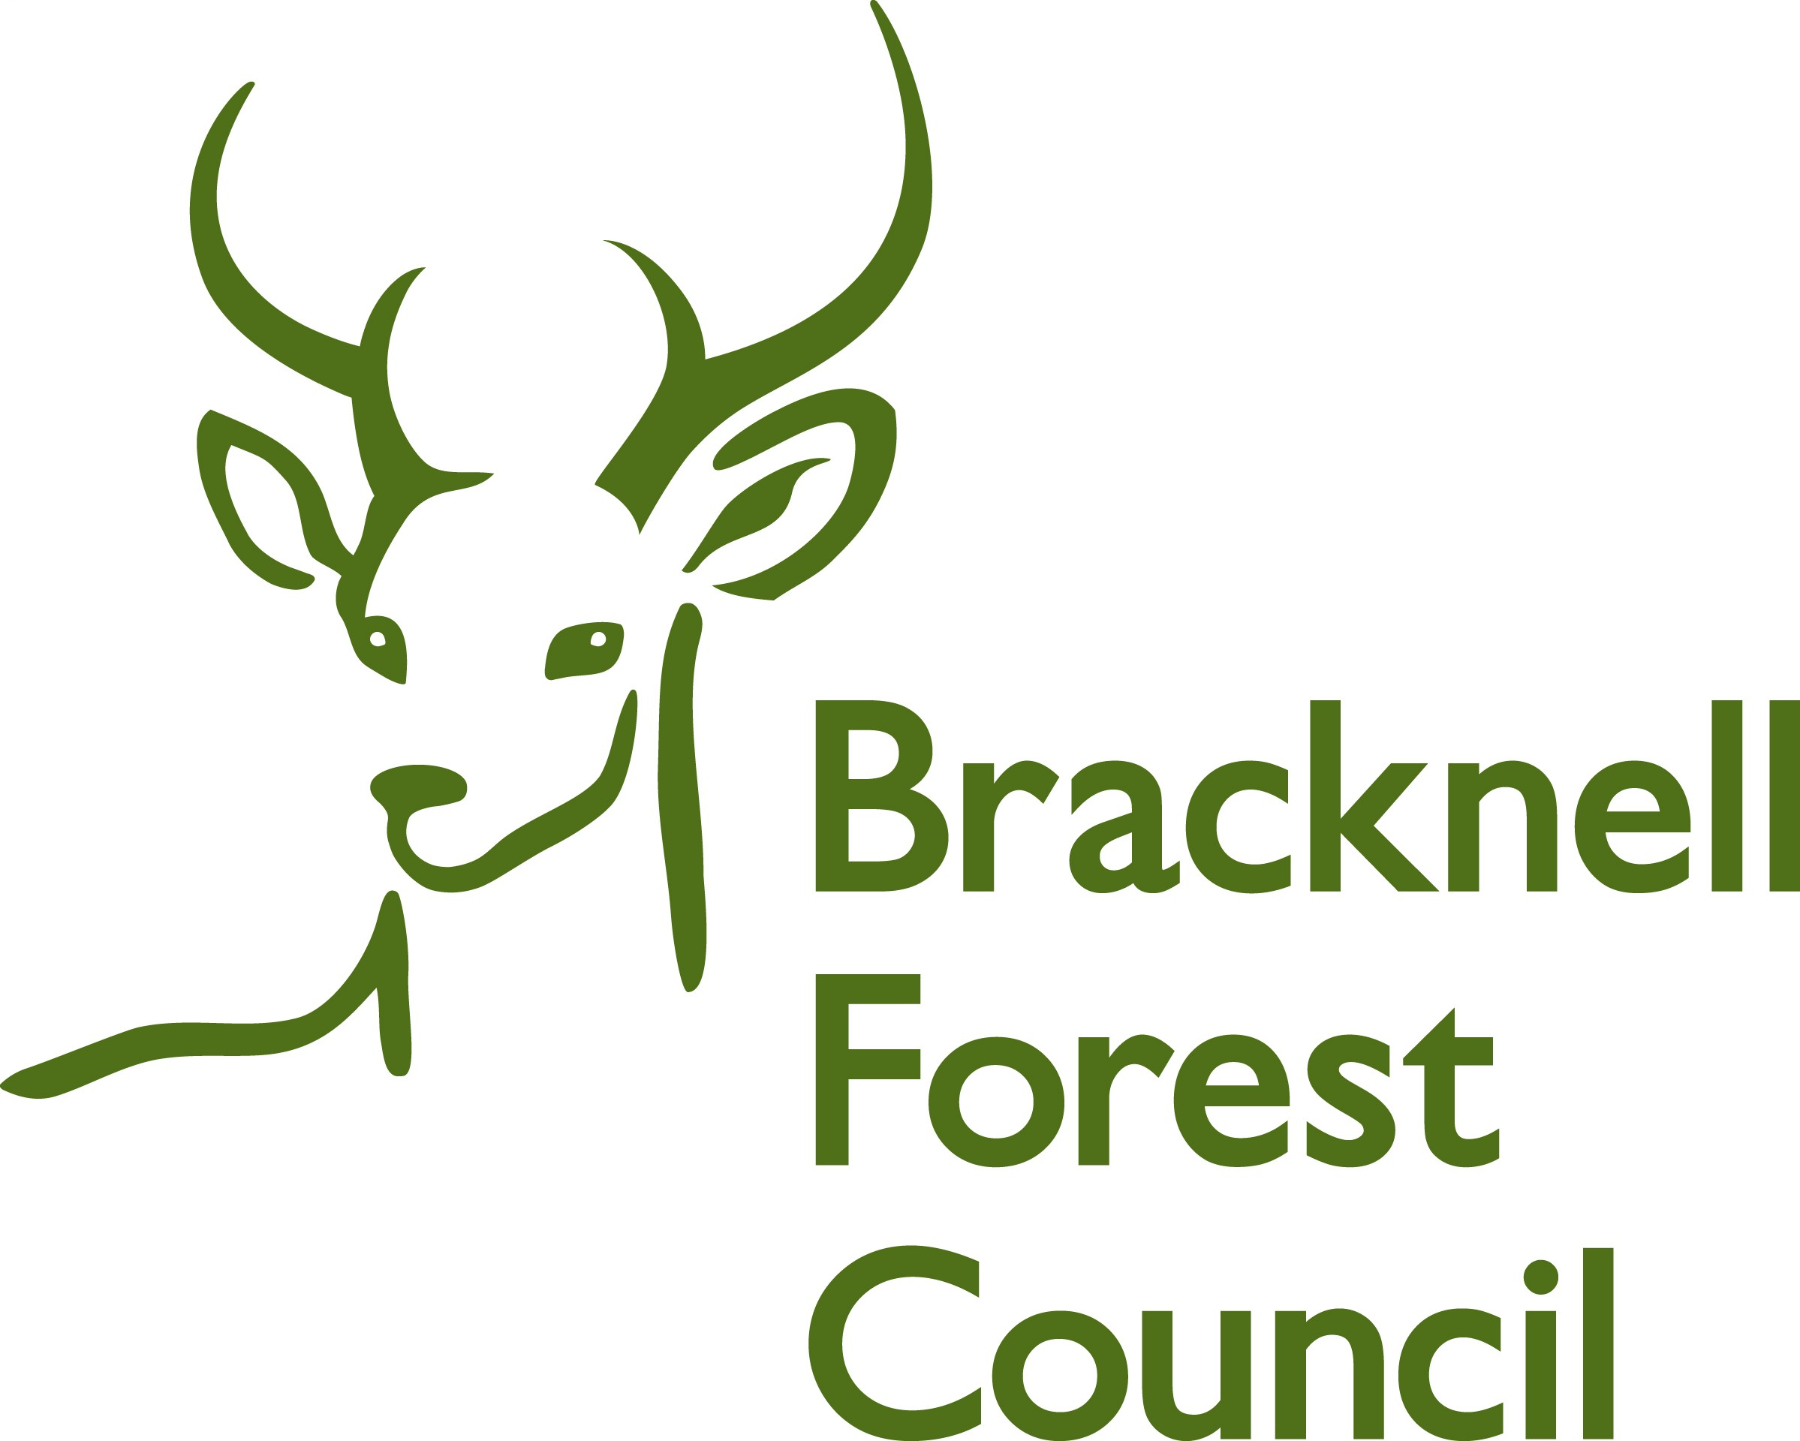
BRACKNELL FOREST FAMILY PLACEMENT TEAM

REPORT FROM FOSTER CARERS’ OWN CHILDREN 13 + YEARS

Name

Age

Parents
Names

We’d like you to be as open and honest as you can about answering these questions. Please answer as many as you can. This form will be used at your parent/s annual review.

Have there been any changes in your family life since the last review?

Have there been any changes for you since the last review?

Have you found anything hard to cope with because of the foster children? If so, what is it?

Is there anything that is especially good or helpful for you connected with the foster children?

Do you help the foster children? In what way do you help them?

Do the foster children help you? In what way do they help you?

How do you feel about your family fostering other people’s children?

Thinking about the people who visit your home for the foster children, is there
anything that you’d like to say about these people?

Thinking about fostering, what would you like to happen in the future?

Is there anything else you’d like to say?

Do you come to the Children of Foster Carers Group ? If not would you like to?

If you would like to talk to anyone about fostering, please tell your mum or dad or your supervising social worker. This can be the reviewing officer who will come to meet with your parent/s

Signatures

Signed

Date

Many thanks for completing this form.

