BRACKNELL FOREST FAMILY PLACEMENT TEAM
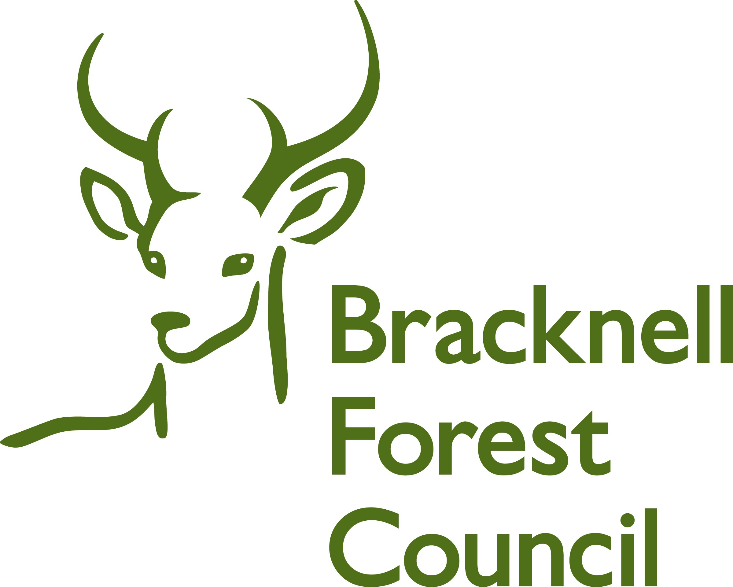

Child’s Feedback

Your name ___________________________

Do you know who lives in your home with you?

Yes No

Has anyone new come to stay with you?

Yes No



What special things do your carers do with you ?

Do you have your own bedroom?

Yes No

If you don’t have your own bedroom, do you have a place to go to play on your own?

Yes No

Do your foster carers ask you what you
like to eat?

Yes No

Do you get something different to eat every day?

Yes No

If you want something different, can you ask for it?

Yes No

If you are sad,
do you tell your foster carer?

Yes No

When you are happy,
do you tell your foster carer?

Yes No

When you ask, does your foster carer let you take a friend home for tea or to play games?

Yes No

Doe your foster care take you to play groups, dance classes, swimming or sports classes?

Yes No

Does your foster carer help you with your school work?

Yes No

What is good about where you live now?

What is not so good about where you live now?

How happy are you with your foster carer?

How happy are you with the place where you live?

How happy are you with your social worker?

