BRACKNELL FOREST FAMILY PLACEMENT TEAM
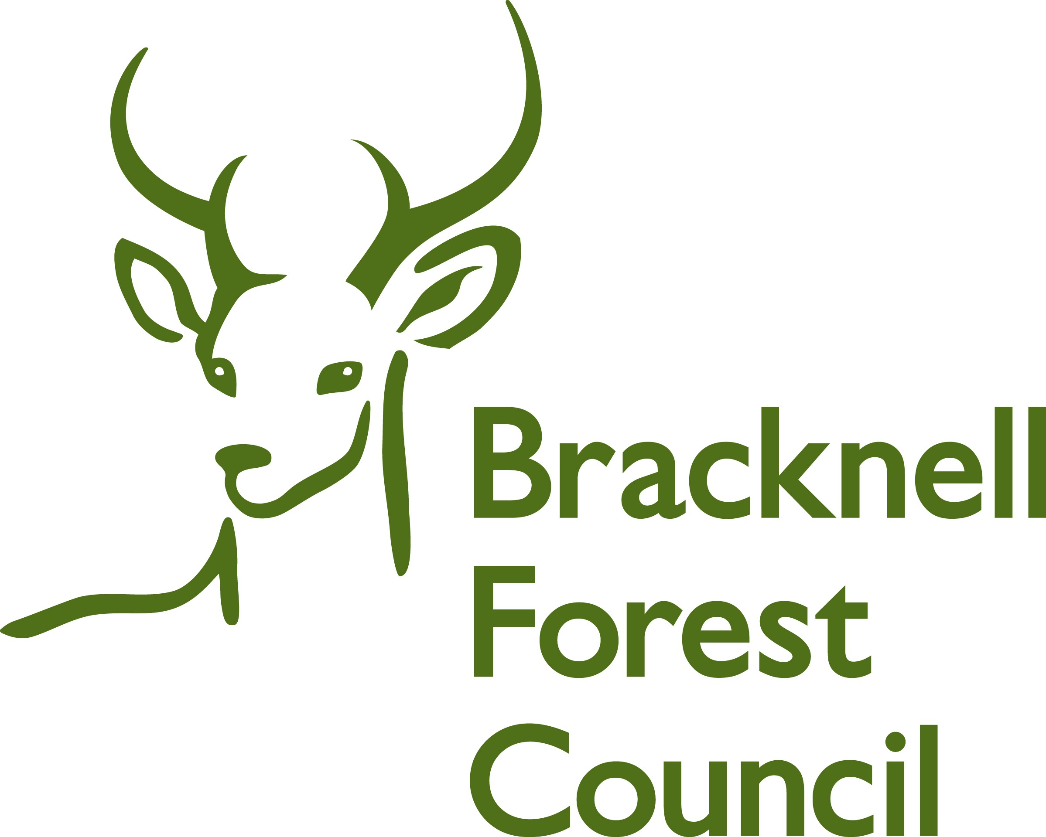

Child’s Feedback

Your name ___________________________

Did you see the book with pictures of your foster carer, your room, their house and their pets?

Yes No

Were you shown pictures of other people living in the house and told who they were?

Yes No

When you arrived at your new foster home, was everyone happy to see you?

Yes No



What special things did they do to make you feel happy when you arrived?

Do you have your own bedroom?

Yes No

If you don’t have your own bedroom, do you have a place to go to play on your own?

Yes No

Do your foster carers ask you what you
like to eat?

Yes No

Do you get something different to eat every day?

Yes No

If you want something different, can you ask for it?

Yes No

If you are sad,
do you tell your foster carer?

Yes No

When you are happy,
do you tell your foster carer?

Yes No

When you ask, does your foster carer let you take a friend home for tea or to play games?

Yes No

Does your foster care take you to play groups, dance classes, swimming or sports classes?

Yes No

Does your foster carer help you with your school work?

Yes No

What is good about where you live now?

What is not so good about where you live now?

Has your foster carer talked to you about how long you will stay with them?

Yes No

If you have to live with another family, has your foster carer talked to you about it?

Yes No
How happy are you with your foster carer?

How happy are you with the place where you live?

How happy are you with your social worker?

