BRACKNELL FOREST FAMILY PLACEMENT TEAM
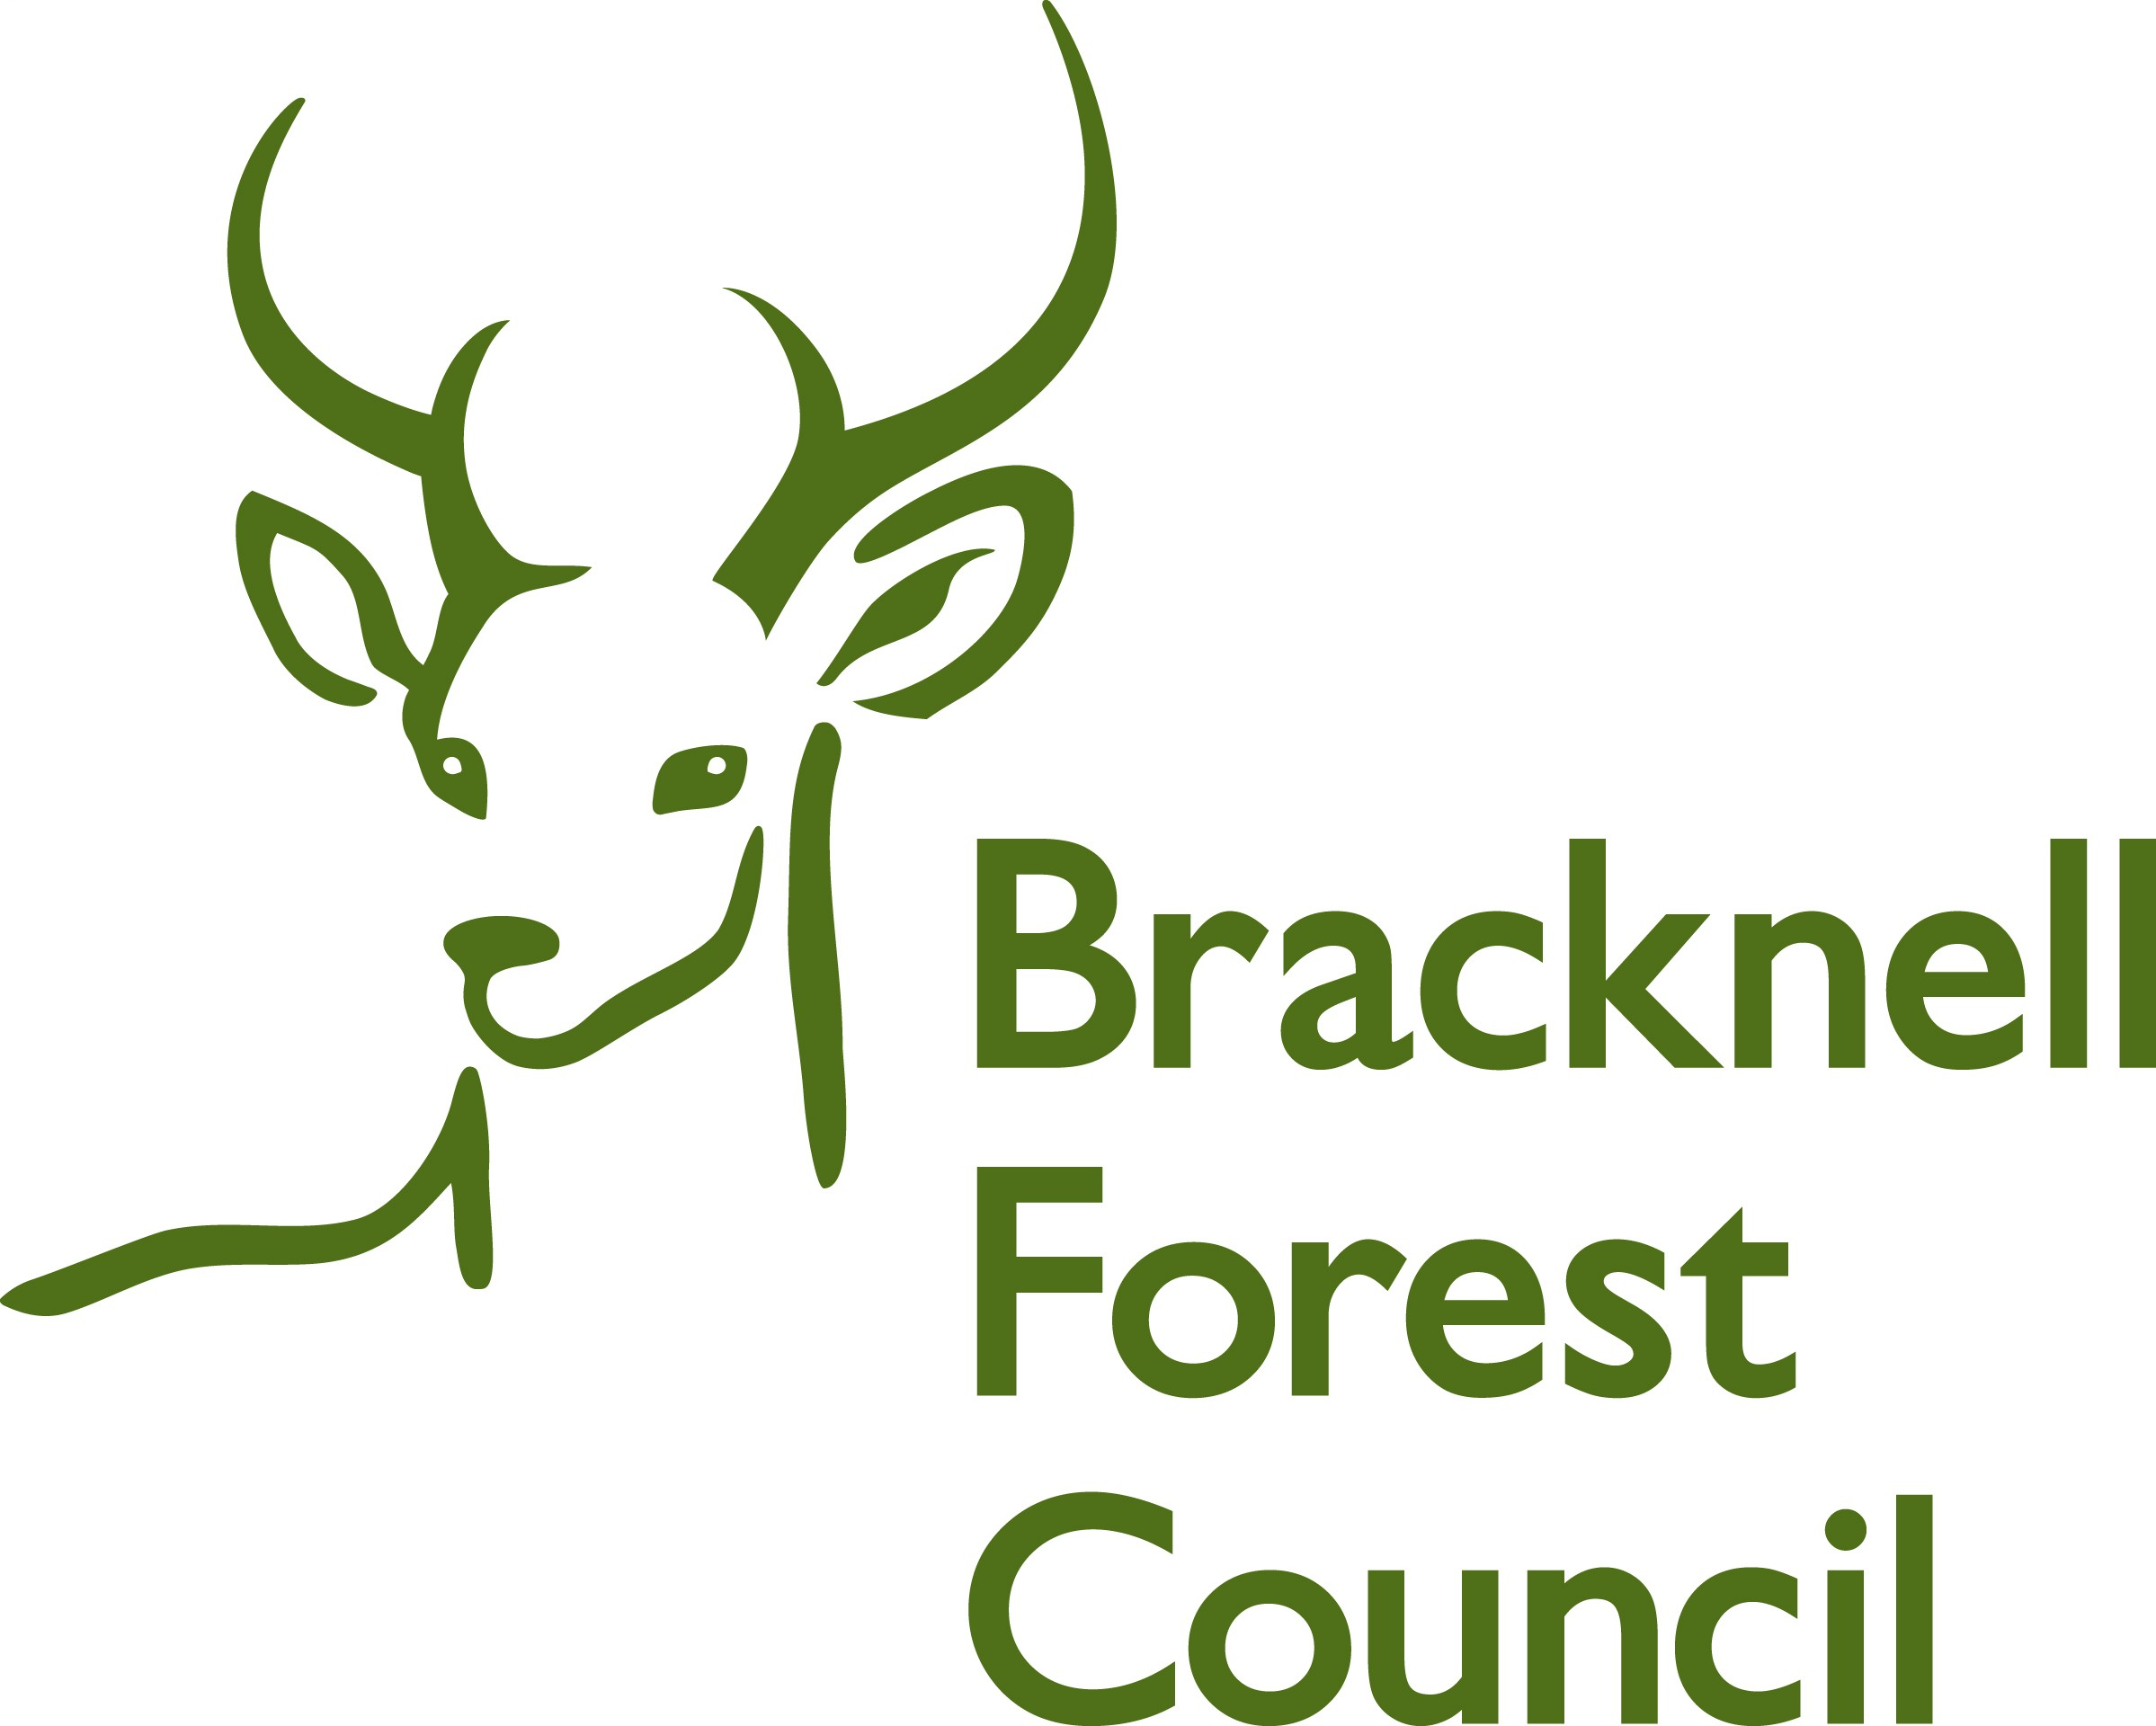

Young Person’s Feedback

Your name ___________________________

How long have your been with your foster carer?

Has anyone new joined the family ?

Yes No
√ X

Do you visit other people with your foster carers?

Yes No
√ X



How does your foster carer make you feel part of me, family. What special things do they do?

Do you have your own bedroom?

Yes No

√ X

If you don’t have your own bedroom, do you have a place to go to play on your own?

Yes No
√ X

Do your foster carers ask you what you
like to eat?

Yes No
√ X

Do you get something different to eat every day?

Yes No

√ X

If you want something different, can you ask for it?

Yes No

√ X

If you are sad,
do you tell your foster carer?

Yes No

√ X

When you are happy,
do you tell your foster carer?

Yes No

√ X

When you ask, does your foster carer let you take a friend home for example, to play games, watch TV or have tea?

Yes No

√ X

Can you join a group, such as a football team, or dance class if you want?

Yes No
√ X

Do you celebrate your birthday and other special occasions?

Yes No
√ X

What is good about where you live now?

What is not so good about where you live now?

Do you feel part of the foster carers family?

Yes No

√ X

Would you like to tell us anything else about your foster carer or your foster placement?

How happy are you with your foster carer?


Happy Not Happy

How happy are you with your placement?

Happy Not Happy

How happy are you with your social worker?

Happy Not Happy

