BRACKNELL FOREST FAMILY PLACEMENT TEAM
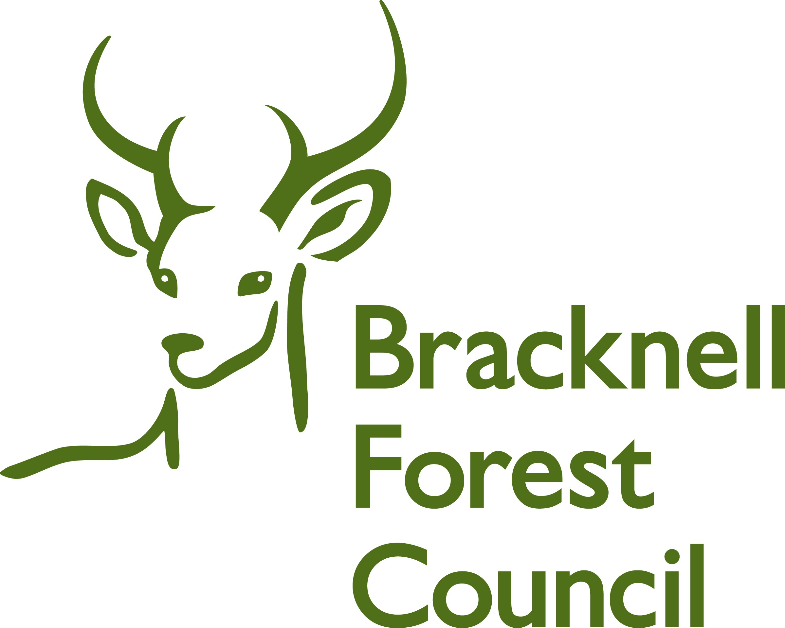

Young Person’s Feedback

Your name ___________________________

Before you met your foster carer, did your social worker tell you about them?

Yes No
√ X

Did your social worker tell you who else you would be living with?

Yes No
√ X

When you arrived at your new foster home, did you feel welcome?

Yes No
√ X



How did your foster carer make you feel welcome when you arrived?

Do you have your own bedroom?

Yes No

√ X

If you don’t have your own bedroom, do you have a place to go to play on your own?

Yes No
√ X

Do your foster carers ask you what you
like to eat?

Yes No
√ X

Do you get something different to eat every day?

Yes No

√ X

If you want something different, can you ask for it?

Yes No

√ X

If you are sad,
do you tell your foster carer?

Yes No

√ X

When you are happy,
do you tell your foster carer?

Yes No

√ X

When you ask, does your foster carer let you take a friend home for example, to play games, watch TV or have tea?

Yes No

√ X

Can you join a group, such as a football team, or dance class if you want?

Yes No
√ X

What is good about where you live now?

What is not so good about where you live now?

Do you feel part of plans about how long you will stay?

Yes No

√ X

If you have to move, do you feel part of plans about where you move to next?

Yes No
√ X

Would you like to tell us anything else about your foster carer or your foster placement?

How happy are you with your foster carer?


Happy Not Happy

How happy are you with your placement?

Happy Not Happy

How happy are you with your social worker?

Happy Not Happy

