BRACKNELL FOREST FAMILY PLACEMENT TEAM
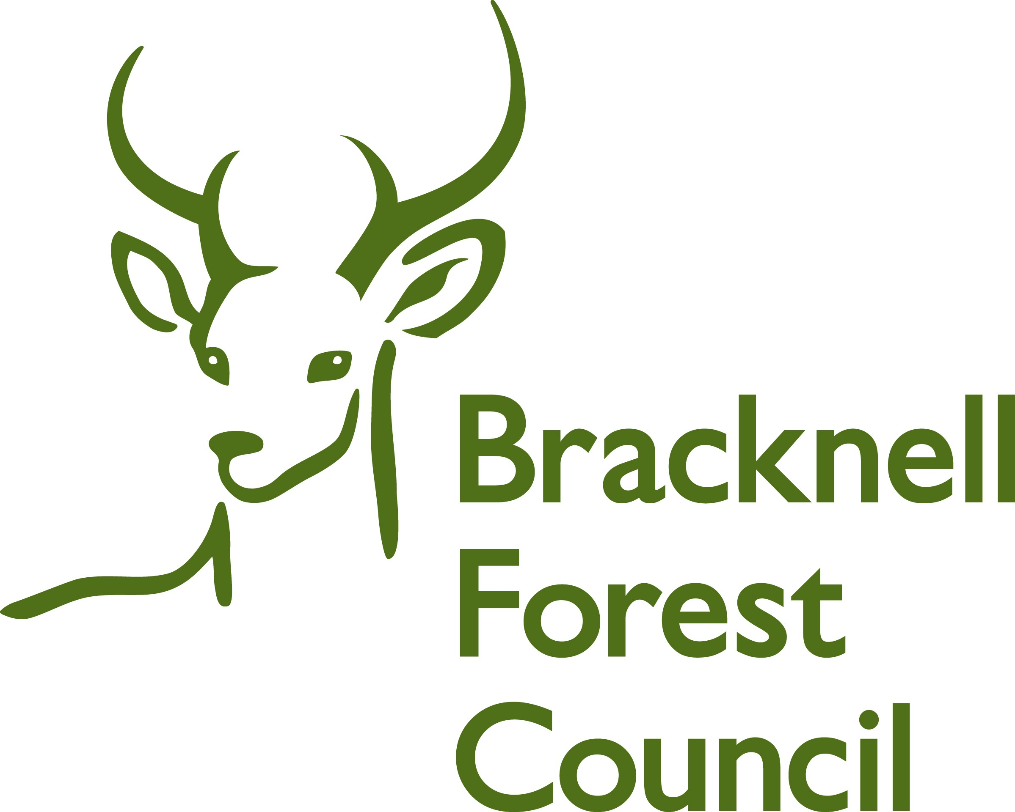

Young Person’s Feedback

Your name ___________________________

The feedback form is designed for you to tell us your thoughts and feelings about

- Your social worker
- Your foster carers
- Your foster placement

It will help us improve your care whilst you are with your foster family.

If you have any questions, your social worker is there to help you.

Q1 Do you get on well with your foster carers?

Yes

No

Q2 How long have you been living with your foster carers?

Q3 Has anyone new joined the family?

Yes

No

Q4 Do you visit other people with your foster carers?

Yes

No

Q5 Do you feel included in activities with your carer?

Yes

No

Q6 If you do not have your own bedroom, do you have space to chill on your own somewhere?

Yes

No

Q7 Do your foster carers ask you about what you like to eat?

Yes

No

Q8 Do you get something different to eat every day?

Yes

No

Q9 Do you get enough to eat?

Yes

No

Q10 If you want something different to eat, can you ask your foster carer?

Yes

No

Q11 Do you feel your foster carers listen to you?

Yes

No

Q12 When something has made your feel good, do you tell your foster carer about it?

Yes

No

Q13 When you ask, can you take friends home for a meal, to play games or watch TV?

Yes

No

Q14 Does your foster carer encourage you to attend activities?

Yes

No

Q15 Does your foster carer help you with your school/college work?

Yes

No

Q16 Does your foster carer take you to medical appointments e.g. dentist, optician, doctor?

Yes

No

Q17 Do you receive pocket money?

Yes

No

Q18 Do you have chores and responsibilities in the home?

Yes

No

Q19 Do you feel supported by your carer to keep in contact with your family?

Yes

No

Q20 Do you get on well with other foster children of foster carer’s own children/grandchildren.

Yes

No

Q21 Do you know who to talk to if you are unhappy?

Yes

No

Q22 What would you say is the best bit about your foster placement?

Q23 What would you say is not so good?

Q26 On a scale of 1-7 (with 1 being good and 7 being bad) how happy are you with your foster carer?


Happy Not
Happy

Q27 On a scale of 1-7 (with 1 being good and 7 being bad) How happy are you with your placement?

Happy Not
Happy

Q27 On a scale of 1-7 (with 1 being good and 7 being bad) How happy are you with your social worker?

Happy Not
Happy

Use this space to say anything else about your foster carer or foster placement which might like to change or be improved?

You can pass this form back to your social worker or email it to us at fostering.admin@bracknell-forest.gov.uk

