Family Safeguarding Service

Practice Guidance
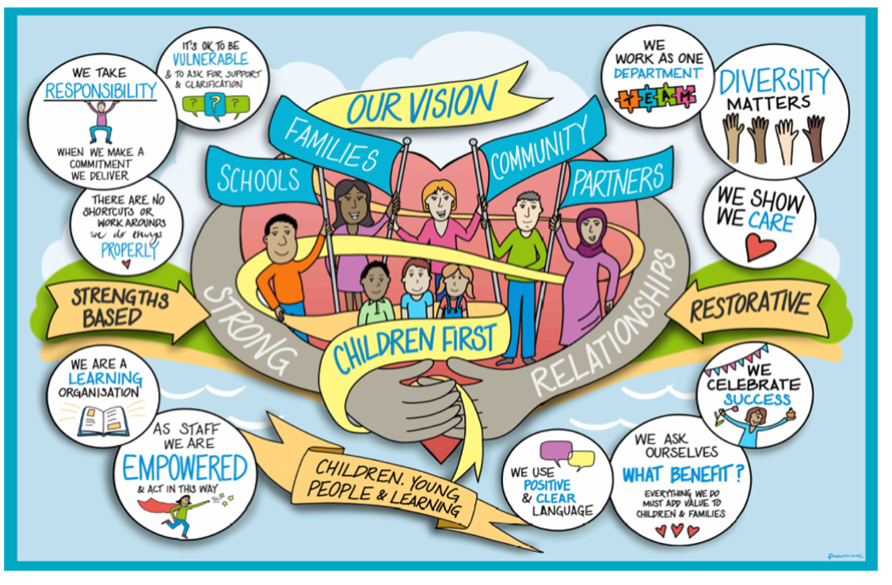

1. Introduction

Family Safeguarding is a strengths-based approach that was developed in Hertfordshire in 2015. This is a new way of working that focuses on supporting parents and carers with the aim of keeping children safely within their families.

This is achieved through a more collaborative way of working that encourages parents and carers to identify the changes needed within their own families. This approach will help us achieve better outcomes for children in West Sussex by reducing the need for children to come into care.

Family Safeguarding provides a whole family approach to child protection. Adult specialist practitioners are co-located into social work teams, making it easy to access the right help and support for adults and children. Combining the knowledge and expertise of all these specialist workers to assess and address the needs of the whole family enables more children to remain safely together with their families, reducing the need for children to come into care.

2. Key Components of Family Safeguarding

Multi-Disciplinary Teams
Specialist workers for substance and alcohol misuse, parental mental health and domestic abuse are co-located with social workers, working together as one team

Motivational interviewing
MI provides a unifying method of practice and is integral to working with families and professionals. It is a technique which supports ownership, accountability and commitment to change through a collaborative conversation style that creates confidence in parents to enhance readiness for change.

Family Safeguarding Case Supervision
All of the practitioners working with the child(ren) and family come together to discuss the progress of work with the family and share decision making.

Family Safeguarding Electronic Workbook
This is a new multi-agency recording system that improves information sharing and reduces bureaucracy. All practitioners from Family Safeguarding working with the family will record on the electronic workbook.

Family Programme
This forms the framework for direct work with children and families. This comprises 8 modules that guide direct work with the family, co-ordinated by the social worker, with the direct work undertaken by all the practitioners working with the family including adult specialist workers.

3. Practice principles

The practice principles of Family Safeguarding apply to all of our work with families that meet the threshold for children’s social care, whether or not they are on the Family Safeguarding pathway.
These principles are:
- Human rights and empowerment
- Choice
- Managing our anxieties and working with uncertainty
- Having difficult conversations
- Sharing risks and responsibilities
- Working with resistance
The aim of Family Safeguarding is to ensure families receive a tailored response to their needs, not solely based on the level of risk to the child. This means workers and managers should be flexible when making decisions about case allocation and case transfer to best meet the family’s needs.
4. Which families receive the Family Safeguarding approach?

All families with at least one child meeting the threshold for children’s social care (either Section 17 or Child Protection) enter the Family Safeguarding Teams and are allocated a social worker.
Some children and young peoples supported by the Family Safeguarding Team are children we care for, and they may:
- be subject to interim orders from the Court,
- be accommodated by the local authority under Section 20, with a plan to return home,
- be placed with parents under a care or supervision order,
- be living with connected carers arrangements (Reg24).
It is important to be clear who the family members are who are part of the Family Safeguarding workflow. This might include or exclude:
- children in the family who do not live at home
- connected carers and / or birth parents.

Some children and families may be best supported by other services, instead of, or alongside the Family Safeguarding Team, for example when a child has significant disabilities, or when the child or young person is care. It is the responsibility of the team manager, in discussion with colleague sin other teams to make arrangements to ensure the whole family get the right help at the right time.

5. Entering the Family Safeguarding Team
Families are referred to the Family Safeguarding Team following a Child and Family Assessment (CFA) by the Assessment & Intervention Service where this assessment identifies a need for longer-term work with the family. The Assessment & Intervention team:
- decides whether a family should follow the Family Safeguarding pathway, or another form of support based on the age of the children and the presence of parental mental health, substance misuse or domestic abuse needs.
- gains and records consent from the family to be referred to the Family Safeguarding Team as appropriate.
- opens a Family Safeguarding Workbook.
On entering the Family Safeguarding teams, a case allocation meeting is held. The outcome of the case allocation meeting is that:
- the family are allocated to a social worker
- where the family are following the Family Safeguarding pathway, a decision is taken as to the level of support from adults workers, based on the family’s needs and capacity to change and capacity within the team.
6. Roles and Responsibilities

Roles:

Team Manager
Line management of social care staff (social workers, domestic abuse practitioners and children’s practitioners), personal supervision, Family Safeguarding case supervision, allocating work to adult workers and decision making regarding the child.

Social Worker
Key worker responsibilities and co-ordinating the progression of the child’s multidisciplinary plan, co-ordinate Family Programme to identify and meet the family’s

needs that will impact on the child, motivating families to choose change, finalising assessments of parenting.

Children and Family Worker
Direct work with families using Motivational Interviewing and undertaking delegated parenting modules, mentoring and supporting improvement of parenting skills.

Domestic Abuse Practitioner
Direct work with victims/survivors of domestic abuse, deliver group work programmes, providing help with reflection on healthy relationships, understanding of the impact upon a child, boosting self-esteem, realistic safety plans via individual casework and group work.

Domestic Abuse Worker (Probation workers)
Undertake specialist assessments, including analysis of risk. Deliver group programmes for men and women convicted of or alleged to be perpetrators of domestic abuse, focusing on identification of abusive behaviours, impact of domestic abuse on children and partners, strategies to cope with feelings of anger, mindfulness and where group work is not appropriate, provide one to one session to support change.

Psychologists and Mental Health Practitioners
Assessments of parental mental health support needs and delivery of individual and group interventions including Cognitive and Dialectical Behavioural Therapies, and Mindfulness Programmes. Assessments of cognitive functioning, advice on working with parents with Learning Difficulties and Disabilities. Referrals to CMHTs and Psychiatry. Consultations for adults and children’s mental health support needs.

Recovery Worker
Undertake consultation, assessment and alcohol/drug testing as appropriate. Use Motivational Interviewing to motivate parents to commit to change their use of drugs/alcohol. Deliver parents recovery group programme, provide one to one support.

Embedded Co-ordinator
Coordinates team diaries, organises Family Safeguarding case and individual supervisions, minutes Family Safeguarding group case supervisions and inputs to case recording system, circulates meeting notes, various other administrative duties.
Responsibilities
The Family Safeguarding Team manager is responsible for overseeing the work of the Family Safeguarding team. This includes:
- Allocating cases to a social worker on arrival into the FS team
- Chairing the Family Safeguarding supervision meeting
- Agreeing to RAG rating
- Agreeing and recording management decisions relating to thresholds
- Agreeing ‘step across’ arrangement to Early Help.
- Managing disputes and disagreements between team members and between employing organisations of team members.
- Working with the service manager and other team managers to allocate work to the adult workers
(Some practitioners employed by other agencies will have separate and additional management arrangements that are out of scope of this practice guidance)

The allocated social worker is responsible for working with the family to understand their circumstances and capacity to change. This includes:
- Leading parenting assessments and direct work with families
- Sharing reports and assessments with the family
- Performing all relevant duties and statutory requirements related to the child’s status. This includes statutory duties for:
  - children in need under section 17,
  - children on a child protection plan or
  - children on a care or supervision order
  - any additional duties resulting from the child’s living situation (private fostering and informal kinship care, caring responsibilities)
- Ensuring records are kept in a timely and succinct manner
All members of the Family Safeguarding Team are responsible for working with the family to provide support and challenge to increase parental capacity to care for their children, or to better understand the limits on parents’ capacity to change:
- Undertaking interventions as agreed in Family Safeguarding supervision
- Maintaining routine records of their work with families
- Completing monthly summaries describing their work with families
- Participating in Family Safeguarding supervision
- Attending statutory case management meetings (Child in Need meeting and review, Child Protection Core Group and review meetings, Children We Care For reviews and Care Proceedings) as required.
Adult workers may have responsibilities and reporting arrangements outside of the Family Safeguarding Team due to the terms of their employment. Where relevant, these practitioners are responsible for
- Recording their work on any other systems required by their employer
- Participating in supervision and other management processes as required by their employer.

7. Description of Activities or Interventions

Motivational Interviewing
Motivational Interviewing provides a unifying method of practice and is integral to working with families and professionals. It is a technique which supports ownership, accountability and commitment to change through a collaborative conversation style that creates confidence in parents to enhance readiness for change.

We use motivational interviewing as a core approach to practice with families. The practice principles guiding motivational interviewing are:
- Express Empathy
- Develop Discrepancy
- Roll with Resistance
- Support Self-Efficacy

The Multi-agency Parenting assessment
The multi-agency parenting assessment is led by the allocated social worker, with contributions from adult workers, if allocated, reflecting their work with parents. It builds on the single assessment undertaken by the Assessment & Intervention Service and informs decision-making.
The parenting assessment provides a framework for discussing and exploring family life through different modules of the assessment. This should be used flexibly in line with the family circumstances.
Each parent within the family has their own multi-agency parenting assessment, unless they are presenting as a couple and then the assessment will be joint. Families should experience the assessment process as helpful in supporting them to reflect and adapt their parenting. It is a core part of the support offered to families, rather than a preliminary activity designed only to assess need for support.

Working with Adults
The capacity of adult workers to support parents is limited and it is important that families are prioritised according to need. Where the support of an adult worker is identified as an important part of the support for a family, the team manager should discuss the case allocation with the adult worker’s line manager. The adult worker’s line manager has the final decision as to whether the adult worker provides support.
The adult workers can provide a range of interventions to explore and support parental capacity to change. These interventions aim to support parents to address issues that affect the safety and welfare of the children, including mental health needs, substance misuse and domestic abuse.
Interventions and support might include:
- Direct work to engage parents with the support being offered
- One to one support
- Group work
- Risk assessments.
The adult workers may offer consultation, advice and support to other members of the Family Safeguarding Team when they are not allocated to the family for direct work.

8. Understanding levels of risk and need

RAG rating
The RAG rating is a measure of the need or harm to the child attributable to the parent or caregiver.
- RED – Highest level of need or harm to the child
- AMBER – Medium level of need or harm to the child
- GREEN – Lower level of need or harm to the child (CIN or Section 17 financial provision)
All families are given a RAG rating to help the team agree a shared understanding of the level of harm or need associated with the family. Each worker with the family decides on a RAG rating based on their work with the family.

RAG ratings are shared and reviewed at each Family Safeguarding supervision and agreed by the team manager. This is an opportunity to discuss the rationale behind the RAG rating, and to identify what has changed for the family since the last Family Safeguarding Supervision.
The RAG rating does not necessarily align with child protection thresholds as they can change in between statutory review meetings. The threshold decision should also be revisited at every Family Safeguarding supervision. Changes in RAG rating and recommendations about changes to the threshold decision made in group supervision should inform decisions made about child protection or other status in statutory meetings.
Making connections with statutory processes
At the point that the family is transferred to the Family Safeguarding Team, the Assessment and Intervention will have completed:
- A Child and Family assessment
- A threshold decision
- A strategy meeting and a S47 inquiry if required based on Child and Family assessment
- A relevant plan (Section 17 Child in Need or child protection plan or Care plan).
All the children in the family are recorded in the workbook, whether or not the individual child is on a Child in Need or Child Protection Plan. Each child with a plan will have statutory planning and review meetings in line with their plan.
All members of the Family Safeguarding Team working with the family, including adult workers, take part in the statutory planning and review process through attending child protection or child in need core group and review meetings where possible.
The allocated social worker is responsible for the statutory process from the point of allocation. This includes:
- Maintaining records of statutory activities on Mosaic (plans, visits, reviews etc)
- Writing the family report for the statutory planning or review meeting. This report draws together information from the workbook and monthly summaries produced by all those working with the family.
- Notifying the team manager if the threshold decision needs to be reviewed between Family Safeguarding supervision meetings.
The Family Safeguarding Team manager is responsible for:
- Agreeing threshold recommendations from the Family Safeguarding team through Family Safeguarding supervision to be fed into the plan review process
- Monitoring the completion of actions in the child’s plan that are the responsibility of members of the Family Safeguarding Team.
- Monitoring the completion of statutory recording, as well as completion of the workbook.

9. Case Management

Family Safeguarding supervision

The Family Safeguarding supervision meeting is at the heart of the multi-disciplinary work of the Family Safeguarding Team. Every family open to the Family Safeguarding pathway is discussed at Family Safeguarding supervision meetings at a frequency in line with the Supervision Policy.

Before the Group Supervision
- The allocated social worker and adult workers summarise the case recording into a monthly summary of their work with the family. Each worker writes their own monthly summary. This includes an individual assessment of the RAG rating of the assessed risk to the child. These are recorded in the workbook.
- The Embedded Co-ordinator makes arrangements for the meeting in liaison with the team manager. This includes inviting people from the Family Safeguarding Team and other relevant professionals to the meeting and identifying a suitable location for the meeting to take place or arranging a virtual space for the meeting to be held.

At the Group Supervision,
- All Family Safeguarding practitioners working with the family attend the Family Safeguarding supervision where that family is being discussed. Where this is not possible, the monthly summary and professional’s RAG rating is used to ensure that the work being done is reflected in the discussion.
- The relevant workers discuss and reflect on their work with the family, identifying progress made and next steps for support.
- The group discuss the current RAG rating for the family and decide if that needs to change. Where professionals give different RAG ratings the reasons for this difference in opinion should be explored.
- The Family Safeguarding supervision is guided by the principles of motivational interviewing. This means that everyone should talk and act in such a way as to promote:
o sharing risk and responsibility
o managing anxiety and uncertainty
o having difficult conversations
- The Embedded Co-ordinator makes notes of the discussion in the relevant form, during the meeting.

After the Group Supervision
- The Embedded co-ordinator completes any notes of the meeting and submits to the team manager for approval.
- The team manager approves the meeting notes as an authorised record of the meeting.
- The social worker uses information and decisions taken at the Family Safeguarding supervision to inform the statutory processes of child in need and child protection planning and review.

Step up and step down arrangements

Moving across thresholds within social care
Children and Families can move between Child in Need and Child Protection planning depending on the level of risk identified through the work of the Family Safeguarding Team. Moving over this threshold does not change the offer of help provided.
When a Child Protection Plan ends, it is recommended that a period of Child in Need planning takes place as part of the step-down process. Children stepped down from a Child Protection Plan to a Child in Need Plan remain within the Family Safeguarding Team.
Moving out of the Family Safeguarding Team
Families only leave the Family Safeguarding team when all casework has been completed with all members of the family, or when family is no longer consenting to work with within Child in Need planning and Child Protection planning is not required. When a family leaves the family Safeguarding Team, the workbook is shared as a read-only document to inform future work with the family.
When a decision has been taken to end a Child in Need plan and this is the last Child in Need plan for any child in the family, the social worker or team manager should consider if further support is required from early help. If so, the social worker or team manager must notify the Early Help team as early as possible that the case should be considered for transfer. The Early Help Team should be invited to the final Child in Need meeting to finalise the handover.
Where a decision is taken to apply for a care order, the social worker or team manager must follow the Public Law Outline process, including involving the clinical psychologist in any assessments of the child or parents required for court. The Family Safeguarding Team retains responsibility for the child throughout care proceedings. Once the Care Order is granted, responsibility for the looked after child transfers to the Children We Care For team. If there are children still living in the family home, then the rest of the family remain open to the Family Safeguarding Team until case work is finalised.

Recording principles and practice (See Appendix 6)
- There is one workbook per family, this remains open until the children have been closed to the Family Safeguarding Team, or a decision has been agreed that the child will be transferring to Children We Care For Service.
- Within each workbook, there is a parenting assessment for each parent presenting separately.
- The workbook provides the narrative and context for working with the family. This is the core record of work with the family.
- All case records, and particularly the workbook, are written in such a way that they can be shared with families openly.
- All recording relevant to the child’s needs are made by practitioners within the workbook or related modules. This contributes to the parenting assessment which is the main record of work with the family and progress made.

- Adult workers will collect and record much more information about parents than is necessary to include in the workbook. Adult workers should consider the relevance of information to the child’s needs and wellbeing and only include relevant information in the workbook. Other information about their work with the parents should be recorded on their own agency systems to preserve confidentiality.

10. Process and Quality Standards
Motivational interviewing and the principles underlying informs all of our work with families.

Working with families
- All case discussions, decisions and recording should be family-focussed, considering the whole family and the level of need or harm to each child individually.
- Families should give consent to all information sharing, to receiving particular interventions or support, and be involved in decisions about thresholds and case closure. This consent must be recorded clearly in the workbook, or a record made as to why consent is not required.

Timescales
- Cases should be allocated to a social worker within one week (maximum) of an Assessment and Intervention Service decision that further work is needed by the Family Safeguarding team.
- Monthly summaries must be completed at least 3 days before the Family Safeguarding supervision.
- Group case discussions must be signed off by the team manager within 3 days of the meeting.
- Statutory timescales apply depending on the status of the child’s plan – for example statutory visits must be recorded within 24 hours of the visit or contact.

11. Resources and Appendices

Appendices

Appendix 1: Flow Chart: Family Safeguarding Team Process
Appendix 2: Flow Chart: Supervision Process
Appendix 3: Template for Allocation of the Adult Specialists
Appendix 4: The Family Programme

Further Resources

Further Resources and tools to support practitioners can be found here.
Practice Examples of Completed Workbooks and Summaries can be found here.
Pro-forma template of Workbook Summary can be found here.

Appendix 1: Flow Chart: Family Safeguarding Team Process

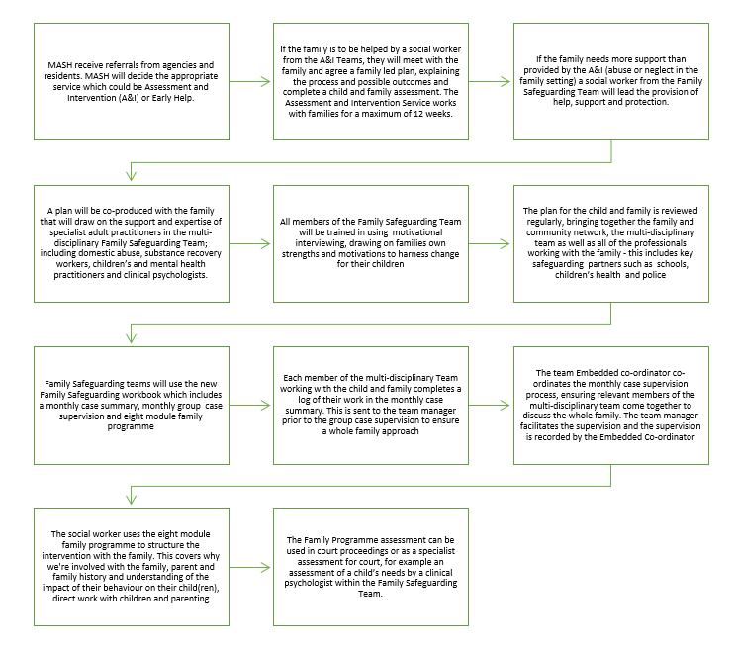

Appendix 2: Flow Chart: Supervision Process

Appendix 3: Template for Allocation of the Adult Specialists

This is decided within the Family Safeguarding Service. Social Workers will be required to complete a Request for Adult Specialist Form. This will enable decisions to be made about allocation amongst the pool of Adults Specialists. Service Managers will allocate work with Team Managers to make decisions about allocations of resources for families.

Request for work by:
please set out which
specialist(s)
Summary of the Family Situation
Purpose of work providing the outcomes that you wish to achieve
Planned Timescale for intervention

Appendix 4: The Family Programme
The Family Programme provides a framework for direct work with children and families. Once completed the modules will inform a balanced, evidence based and comprehensive parenting assessment, outlining the parents’ abilities to meet their children’s needs, progress of the parents in reducing harmful behaviours, engagement in support on offer and outcomes achieved.

- Why are we involved
- Parents and family history
- Parents’ understanding of the impact of behaviour
- Direct work with children
- Parenting capacity (part 1)
- Parenting capacity (part 2)
- Analysis and recommendations
- Parents’ comments and views

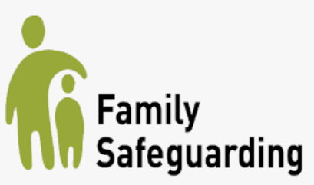

- Working through the Modules - All the modules should be completed. Each module may take more than one visit and they can be completed in any order.

When working through the modules it is important to work alongside the family as opposed to telling them what to do this will support them to choose to make the changes so they can see the progress they are making and how the changes positively impact the children.

This programme uses motivational interviewing skills throughout to engage UN support children and families to make and sustain the changes they need in order keep children safe at home. This strength-based approach is designed to look at what is working well with the aim to empower parents explore their strengths and risks and develop a joint plan of action.

This programme helps too really understand the family what life is like for them and enable more positive and considered decisions.

2. Parent and Family History
Aims
- To gain a more detailed understanding of parental and family history and how this may have influenced their current lifestyle, parenting capacity and family functioning.
- Identify significant events that have had an impact for the family.
- Identify the family’s values, identity, and culture.
- Identify positive and negative family friends supports.
Questions and areas for consideration
- What is the history (the individual story)?
- Who are key family members? (genogram)
- Educational history.
- What support networks does the family have?
- How realistic and practical are these?
- Are any of these not so positive or barriers to change?
- Use the information from the children and family’s assessment (C&F) to avoid duplication.
- Check accuracy and be mindful this may be traumatic for parents so sensitivity and planning the right time and surroundings is crucial.
- Expand upon significant areas.
- What is important to the family?
- What are their values, culture, routines?
- Can the parents link past childhood experiences with their current parenting?
- Have previous relationships impacted on expectations for current/future relationships?
- What are parents hopes for the future & what would they like to improve?
Outcomes
- Opportunity to gain an understanding of how childhood experiences may have impacted on the parents, individually and as a partner/parent.
- Know the family’s culture and values, what's important and defines them.
- understand how the above areas influence the family, the parents functioning and links to current behaviour/lifestyle and community.
- Information contributes to assessment of parent’s motivation to make changes and understand their future aspirations for themselves and their children.
- Identify strengths and positive aspects of family life/parenting.
- Identify potential support from wider family and friends

3. Parent’s Understanding of the Impact of Behaviour

Aims
- To allow the parent/s an opportunity to explore and gain understanding of the impact of their behaviour and lifestyle on their child/ren.
- Support parental needs to effect change in behaviour. Identify any barriers and what support they feel they need to sustain change.
Questions and areas for consideration
- What do the individual harmful behaviours look like?
- What are the impacts for the child/ren?
- Incorporate input from direct work with child/ren.
- What are the impacts for them as parents?
- What do they want to change and what do they need to make this happen?
- How could life be different for them and their child/ren if they made changes to their lifestyle or behaviour?
- What are the consequences of changing or not changing behaviours?
- What positive parenting behaviours all evidence and what do they do well?
- Do they understand what their child/ren need?
- What are the views of the adult specialist workers and the outcome of their interventions?
Outcomes
- Clarity of parents understanding of the impacts of their behaviour on the child/ren, and on their physical and emotional wellbeing. (This can be reviewed at stages and used to measure progress through the family programme.)
- An overview of the parents understanding of their child/ren needs.
- Parents are supported to take greater responsibility for their own actions and make the changes.
- Understanding of parent’s motivation and capacity to act to change and use the support available as well as being clear on the barriers to change.

4. Direct work with children
Aims
- Form a relationship with the child/ren to optimise successful direct work.
- Build and profile of the child/ren.
- Clarify the child/ren’s understanding of children services involvement.
- Obtain their views so these can be incorporated into their plan and shared.
- Gain an understanding of the child/ren’s lived experience from their perspective and how these impact upon them.
- Build child/ren’s self-esteem and emotional resilience.
Questions and areas for consideration
- What are the child/ren’s likes/interests for building rapport?
- Does the child/ren have any developmental/communication needs?
- What is the child/ren’s understanding/expectations of children’s services?
- What do the children want to happen or change?
- What’s life like for them? (Reviewed throughout the programme)
- Are the parents’ behaviours impacting the child/ren?
- What makes them happy, proud, sad, angry, worried, frightened, safe, etc? (What do they think makes their parents feel like this?) How do the parents provide them with comfort/love and how do they praise them?
- What do they think about themselves, identify good things about them/things they would like to change?
- What is their understanding of their cultural heritage? Are there gaps due to absent parent/extended family?
- What is their e-footprint and what does this mean for them?
- Is there any need for the parent/child relationship to be strengthened?
- Is there a need for protective behaviour work and to build resilience?
Outcomes
- To hear from the child/ren what life is like for them and what they want to happen.
- Children understand and contribute to their plan.
- Child/ren’s lived experiences feed into parent capacity to evidence strengths and areas of challenge.
- Evaluate the impact the parental interventions have had upon the child/ren. Are things better?
- The child/ren’s voice is clear recorded.
- Identify if a child/ren requires further support from specialist services (e.g. CAMHS).
- Identify key family/community resources that the child/ren feels are positive and who they can confide in/see support from.

5. Parenting Capacity (Part 1)
Aim
- Gain and understanding of parents’ capacity to meet the child/ren’s holistic needs and the quality of the relationships between parents and the child/ren.
Questions and areas for consideration
Basic Care
- How does the parent/s meet the child/ren’s physical and health needs providing appropriate food, warmth, and safety? (Be aware of the difference between neglect and material poverty.)
- What do other professionals say about parenting capacity? (e.g., School, HV)
Health
- How is the general health of the child/ren? (Dental/eye care/immunisations/dentist/optician and compliance with hospital appointments)
- Are there any disability or illness issues?
- How is the child’s emotional wellbeing? (Any self-harm, bullying issues?)
- Are there any dietary needs? (Obesity, eating disorders etc.)
Ensuring Safety
- What are the sleep arrangements? (Co-sleeping/safe sleeping)
- What are the protective factors in relation to harmful behaviours?
- Does the parent/s know how to make safe decisions for their child/ren? Is the parent/s able to make safe decisions.
- How do the parents deal with hazards? (Age related)
- Understanding of e safety and strategies to promote protection against exploitation?
- Can they identify risks from harmful adult behaviours and protect their child/ren themselves?
Guidance and Boundaries
- How do they communicate with the child/ren? (Warmly/harshly etc)
- Do they have routines/rules and boundaries?
- How do they ensure the safety and supervision of the child/ren?
- How do they offer praise/reprimand/discipline their child/ren? Are they consistent?
Outcomes
- Improved quality of care that the chid/ren are receiving.
- Identification of any ongoing neglect and the impact on the child/ren.
- Identify a plan for further support.
- Identify protective factors.
- Improve safety health and wellbeing of child/ren.

6. Parenting Capacity (Part 2)

Aims
- Provide a balanced view on parenting capacity to meet the child/ren’s holistic needs.
- Gain an understanding of the quality of the relationships between parents and the child/ren and their ability to adapt to the changing needs of the child/ren.
Questions and areas for consideration
Emotional Warmth
- What does the child represent for the parent/s?
- How do they put the child/ren’s needs above their own?
- What do they see as positive and negative values how are these passed on to the child/ren?
- How are the individual parental/sibling relationships including direct observations? How are the current adult relationships and how do they impact on functioning? Impact of these on child/ren?
- How do parents respond to the emotional needs of the children? (Are they affectionate, do they praise the child/ren are they consistent?)
Stability
- Is there positive contact between the child/ren and other important family members are significant others?
- Are there any impending risks to the children’s stability? (e.g., new partners, moving accommodation, absence of primary carer, indicators of chaotic lifestyle)
Stimulation and Education
- Is the parent promoting educational needs via school attendance/pre-school activities?
- Are the children supported with homework?
- Does the child access additional activities such as sports/clubs? Are there any barriers to this?
- Does the child/ren need or access additional support? E.g., tuition/counselling services?
- What was the parent/s own experience of education, what did they like about school/what did they struggle with?
- Did they have a good friendship group/did they experience bullying?
- Does the parent initiate play and interact with the child/ren at the child/ren’s level?
- What is the parent’s engagement, understanding/approach/role in child/ren’s education? (Attendance, communication, parents evening, social events etc)
- Is the child/ren achieving expected academic progress?
- What is the school’s view?
- Does the parent/s supervise social media access?
- Are there any issues of bullying/equality issues impacting upon the child/ren?

Outcomes
- Evidence based understanding of parents parenting capacity identifying strengths and areas of challenge and change.
- Clarity on attachment/quality of relationship between parent and the child/ren’s.
- Parents achieve changes, good educational outcomes and a stable home environment.
- Understanding of the child/ren’s needs and feelings.
- Building healthier relationships.

Outcomes
- Evidence based understanding of parents parenting capacity identifying strengths and areas of challenge and change.
- Clarity on attachment/quality of relationship between parent and the child/ren’s.
- Parents achieve changes, good educational outcomes and a stable home environment.
- Understanding of the child/ren’s needs and feelings.
- Building healthier relationships.

7. Analysis and Recommendations

Aims
- Critical and analytical overview of all the work undertaken with the family and information gathered.
- Have changes been made and what is the next step.
- Review of the child/ren’s plan.
Questions and areas for consideration
- How did the parent/s engage and how have they worked with you?
- Have the parent/s understood what the problems/issues are and any role their behaviours have upon this?
- Have the understood the impact on the children?
- Do they have the resources/support and sustain the changes needed?
- What were the strengths and what were challenges for their parenting?
- What has been the lived experience of the child/ren?
- What are the children telling us either verbally or through observation?
- From your interventions and assessment what conclusions have you reached regarding the outcomes for the future and the sustainability of any changes the family have made? (You must consider the long term as well as the short term)
- What support has been put in place and how effective was this?
- Are there any areas that the parent/s need further support or advice with?
- Is the children’s plan making a positive difference?
- Are the children suffering/continuing to suffer significant harm?
Outcomes
- We have a fuller understanding of parenting capacity of each parent and the impact upon the child/ren.
- There is a professional opinion (multi agency evidenced based) on whether the child/ren is safe to remain living at home.
- The parents have been provided with services to meet their needs and make changes needed.
- The needs of the child/ren are met/not met.
- Is change sustainable and what support is needed to make his happen?
- The child/ren’s and families views are clearly recorded.
- Recommendations for future-step up/down – what is in child’s immediate and long-term best interest?
- If care proceedings are being considered, how will care meet the children’s long-term needs/is there any compensatory care that can be put in place to maintain child in family.

8. Parent’s Comments and Views
Aims
- An opportunity to gain views from adults and children on what they think has changed, why and what they need to sustain this.
- Also, to have feedback of their experience of the support provided.
Questions and areas for consideration
- What is the parent/s and child/ren’s view on the work that has been undertaken with them?
- What is their view of the progress that has been made?
- Are things better for them now, or the same?
- What went well, what could have been better?
- What do parents want for their and the children’s future?
Outcomes
- The parents and child/ren have an opportunity to contribute their own experience and views.
- Parents and adults have an opportunity to have their comments recorded.
- Parents child/ren’s views on their future needs and support.

Appendix 6:

Recording is essential for professional accountability and to support effective decision-making, records are also of vital importance for the children and families to whom they refer.
British Association of Social Workers (BASW) England provided ‘ten top tips’ for Case Recording:
- Include the child throughout the recording.
- Where possible, write in such a way whereby the child (when old enough) or adult can understand
- Make records purposeful and analytical.
- Include memory objects (e.g. photos) sensitively and critically.
- Make sure records reflect the whole of the child’s story and why decisions were made.
- Chart the child’s journey with a chronology supported by a genogram.
- Include different views and opinions.
- Make records easy to access.
- Make sure recording is balanced and meaningful.
- Avoid jargon and vague language, do not record every piece of communication.
Our records should be written in such a way that if the if the child comes back later in life to read their files, as an adult, they would they be able to understand the decisions being made and the rationale for those decisions.

The “Workbook Summary” is for each practitioner working with the family to record a short synopsis of their work undertaken, since the previous supervision only, and to cross reference to the sections within the Family Programme modules that they have contributed towards. The majority of the practitioners’ work should be recorded within the relevant module, with the date undertaken.

The Workbook Summary for the allocated Social Worker in Family Safeguarding will have very little recorded within it as it has a strong focus on analysis. Using The Five Anchor principles of Assessment, the focus of our recording should weigh heavily on “What needs to happen?” and “How do we know we are making progress”?
- The focus in the child’s observation section of the Workbook Summary is to consider what we are seeing in each child, in relation to their needs and the harm that had led to our involvement.
For example, is the child demonstrating signs of unmet need, trauma or abuse?

- The focus in the Outcome and Analysis section of the Workbook Summary for the allocated Social Worker is to consider the work undertaken within the period since the last supervision. It is to consider, using The Five Anchor principles of Assessment, “How do we know we are making progress?” This would be based upon the child’s observation, the work undertaken and the input and analysis of any involved professionals not directly working within Family Safeguarding Team.

For example, is the child demonstrating signs of unmet need, trauma or abuse? and, most importantly what we as practitioners are doing about this?
The Workbook Summaries form the basis of the discussion during the Group Supervision. Each practitioner will bring their analyses to the Group to consider different

hypotheses and impact of interventions and agree SMART actions following the supervision for the next period of work with the family.

The Workbook Summary differs from Case Summaries; Case Summaries are wider in their purpose and are used for example, by Emergency Duty Team in their decision making outside of office hours should an immediate response be required. Case Summaries need

to be updated a minimum of every three months, and sooner if critical information impacting decision making occurs. Case Summaries include the:
- Child or young person's view on their current situation,
- Family background and key current issues,
- Current plan, safety plan and contingency plan, and
- Key contacts and essential information:

Review / Contacts / References
Document title: | Family Safeguarding Service Guidance
Date approved: | May 2022
Approving body: | Policy & Practice Steering Group
Last review date:
Revision history:
Next review date: | May 2024
Document owner: | Linda Steele Assistant Director Safeguarding and QA
Lead contact / author: | Amanda Cole – Service Development Lead Policy and Practice

