Pathway Plan Data

Accommodation and suitability

The accommodation and suitability of accommodation in performance reports is pulled from the latest pathway plan on the child’s record, from the ‘Safe and Suitable accommodation’ section.
There are 15 accommodation types that can you can select from the drop down. These are:
- With parents or relatives
- Community home (Young People with disabilities mainly)
- Semi-Independent (In Wandsworth, this is Pangea/Nacro/Centrepoint/Ekaya/spot purchase)
- Supported lodgings (we don’t currently have this in Wandsworth)
- Ordinary lodgings (This is where we would record a YP who has a tenancy to privately rent a room in a shared house, renting a room from a friend or sharing a student house)
- Residence not known
- No fixed abode (sofa surfing)
- Homeless (street homeless)
- Foyers (This is accommodation specifically linked to education e.g Uni halls, college accommodation)
- Independent living (Council or Housing Association tenancy, Own Property, private rented flat)
- Emergency accommodation (This is non-B&B HPU or other emergency accommodation)
- Bed and breakfast
- In custody
- With former foster carer (This is Staying Put)
- Other accommodation
After the accommodation type has been selected, you can then choose if the accommodation is considered suitable or unsuitable from the next drop down box. For reference, the below table indicates the DfE grouping of accommodation type and suitability however a decision should be made in each case to the suitability.
Suitability | Accommodation Type
Suitable | Parents/Relatives, Community home, Semi-independent, Supported lodgings, Ordinary lodgings, Foyers, Independent Living
Unsuitable | Emergency accommodation, Bed and Breakfast, No fixed abode, homeless, Custody, Other

Education Employment and Training

The education status of the care leaver is recorded in the Education employment and training section of the pathway plan. This is recorded in a table format.

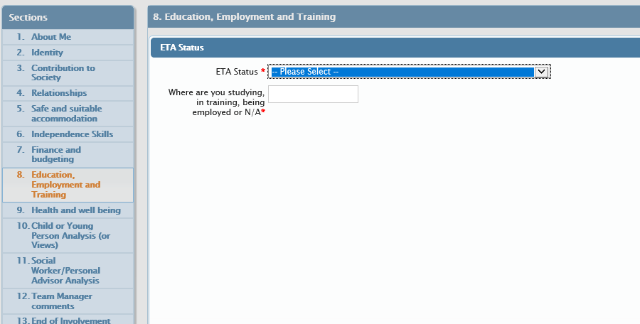
There are 9 choices of education/employment or training status to choose from. These are:
- In higher education i.e. studies beyond A level (full-time)
- In higher education i.e. studies beyond A level (part-time)
- In education other than higher education (full-time)
- In education other than higher education (part-time)
- In training or employment (full-time)
- In training or employment (part-time)
- Not in education, training or employment - illness/disability
- Not in education, training or employment - other reasons
- Not in education, training or employment - pregnancy/parenting

In terms of EET or NEET status, this is broken down as follows:
Status | Type
Education/Employment/Training | In higher education full time/part time, In education other than higher education full time/part time, In training or employment full time/part time
Not in Education/Employment/Training | Not in education, training or employment – illness/disability/Other reasons/Pregnancy/parenting

In touch

This is taken from the date of the pathway plan being in the last 12 months.
The performance team also takes information relating to in touch, accommodation and education/employment/training once a year from the care leavers tab on Mosaic which is updated either one month before their birthday or 3 months after their birthday. This is for statutory returns purpose whereas the data reported on monthly is taken from the pathway plan which is updated with more frequency than the care leavers screen.

PAs are responsible for making sure that they update the In-Touch data on Mosaic whenever their young person has a Birthday

