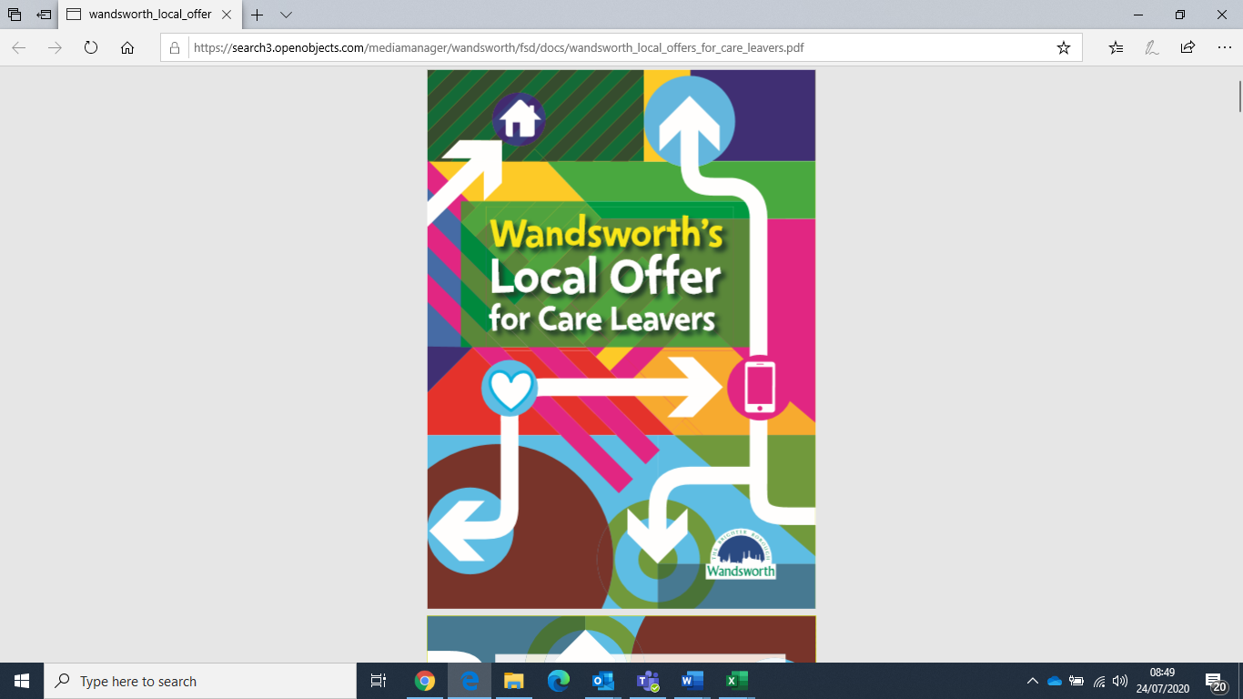

Pathway Plan for Looked after Young People

|  |  |
| --- | --- |
| My Details | |
| **Date of this Plan Review:** | Click here to enter text. |
| Name: | Click here to enter text. |

|  |  |
| --- | --- |
| My Address: | Click here to enter text. |
| My Phone numbers: | Click here to enter text. |
| My Email address: |  |

|  |  |
| --- | --- |
| My Trusted Adult is: | Click here to enter text. |
| Contact details: | Click here to enter text. |

|  |  |
| --- | --- |
| Name of my college, employer ortraining provider. Contact name and number for key person there, if I’m happy to share it. |  |

|  |  |  |  |  |  |  |  |  |
| --- | --- | --- | --- | --- | --- | --- | --- | --- |
| NI number: | | Click here to enter text. | | | |  | | 2 |
| My Looked After Status | |  | | | |  | |
| Birth Certificate | | YES |  | NO |  | Details/Actions needed: | |
| Passport | | YES |  | NO |  | Passport Number/Actions: | |
| Bank Account | | YES |  | NO |  | Details/Actions needed: | |
| ARC Card/Biometric card | | YES |  | NO |  | Details/Actions needed: | |
| Provisional license or other photo ID | | YES |  | NO |  | Details/Actions needed: | |
| Do I have an Independent Visitor? If not, my social worker can organise one. | | YES |  | NO |  | Details/Actions Needed: | |
| How often does my social worker come to see me? | |  |  |  |  | Details: | |
| What is the plan for my future care? Am I staying with my carers or will my plans be changing? What is my Permanancy Plan? | |  |  |  |  | Details: | |
|  | | | | | |  | |
|  | Name | | | | | | Contact Details (landline, mobile and email) |
| My Social Worker is: |  | | | | | |  |
| My IRO is: |  | | | | | |  |
| My Leaving Care Personal Advisor at Future First is: | Click here to enter text. | | | | | | Click here to enter text. |
| My Virtual School Advisory Teacher is: |  | | | | | |  |
| The manager to speak to if I am unhappy is: | Click here to enter text. | | | | | | Click here to enter text. |
| The People who support me and who have been involved in this Pathway Plan review are: |  | | | | | |  |

|  |
| --- |
| Citizenship (UASC) |

|  |  |
| --- | --- |
| Do I have Immigration or Asylum issues? **If not, skip this section.** |  |
| What is my current Immigration status and what support do I need with this? | Click here to enter text. |
| My Solicitor’s name and contact details: |  |
| Are my appeals rights exhausted? |  |
| My Social Worker’s view: | Click here to enter text. |
| The views of other important people in my life (my carers, the workers who support my education and my health, my Future First Personal Advisor and anybody else who is important to me): | Click here to enter text. |
| On a Scale of 1 to 10, where 1 is that I am not happy about my immigration issues and 10 is things are going really well, where am I at the moment? |  |

**Dual / Triple Planning**

**Plan A: I get long term leave to remain in the UK**

|  |  |  |  |  |
| --- | --- | --- | --- | --- |
| Action Required | Start Date | End Date | Who by? | Young Person’s agreement? |
|  |  |  |  |  |
|  |  |  |  |  |
|  |  |  |  |  |

**Plan B: I get limited or very conditional leave to remain in the UK**

|  |  |  |  |  |
| --- | --- | --- | --- | --- |
| Action Required | Start Date | End Date | Who by? | Young Person’s agreement? |
|  |  |  |  |  |
|  |  |  |  |  |
|  |  |  |  |  |

**Plan C: I am refused leave to remain in the UK**

|  |  |  |  |  |
| --- | --- | --- | --- | --- |
| Action Required | Start Date | End Date | Who by? | Young Person’s agreement? |
|  |  |  |  |  |
|  |  |  |  |  |
|  |  |  |  |  |

|  |
| --- |
| Who I am |

I define my ethnicity as:

I define my gender as:

My nationality is:

|  |  |
| --- | --- |
| What things are important to me about my identity, achievements and interests? What do I want to become in the future? | Click here to enter text. |
| My Social Worker’s view: | Click here to enter text. |
| The views of other important people in my life (My carers/keyworker, my Future First PA): | Click here to enter text. |

|  |
| --- |
| These are the things that I want help with, so that I can become the person that I want to be in the future |
|  |
| These are the questions I would like answered at the moment about my Care Experiences or about anything else in my life. |
| Click here to enter text. |
| These are the things that are important to me about my identity: |
|  |

|  |  |  |
| --- | --- | --- |
| What are the actions for the next six months regarding my Identity? | | |
| What needs to be done? | Who by? | By what date? |
| Click here to enter text. | Click here to enter text. | Click here to enter text. |
| Click here to enter text. | Click here to enter text. | Click here to enter text. |
| Plan B– what will I do if these actions are not completed? | Click here to enter text. | |

|  |  |  |  |  |
| --- | --- | --- | --- | --- |
| Do I know about the social events and activities that Click, ClickPlus and Children’s Social Care offer? | Yes | ☐ | No | ☐ |
| Have I met my Personal Advisor (PA) from Future First? Have we got a date booked in to meet to discuss the support I will get when I turn 18? | Yes |  | No |  |
| Have I been told about Staying Put and what it means? | Yes |  | No |  |
| Have I been to the Future First hub and do I know about the facilities that they have there e.g free internet and printing? | Yes | ☐ | No | ☐ |
| Am I aware of my right to complain about the services Children’s Social Care offer? | Yes | ☐ | No | ☐ |
| Would I like to make comment, compliment or complaint about the services I’ve had from Children’s Social Care? | Yes | ☐ | No | ☐ |

|  |  |
| --- | --- |
| **Comments, compliments or complaints** | Click here to enter text. |

|  |
| --- |
| Where I live |

|  |  |
| --- | --- |
| What I think about where I live now and what I would like my accommodation to be like in the future: | Click here to enter text. |
| My Social Worker’s view: | Click here to enter text. |
| The views of other people who are involved in my placement e.g Foster Carer, Keyworker, Supervising Social Worker, PA | Click here to enter text. |
| On a scale of 1 to 10 (where 1 is that I am really unhappy where I live and 10 is things are really good where I live), where am I at the moment? |  |

|  |  |  |
| --- | --- | --- |
| What are the actions for the next 6 months regarding where I live? | | |
| What needs to be done? | Who by? | By what date? |
| Click here to enter text. | Click here to enter text. | Click here to enter text. |
| Click here to enter text. | Click here to enter text. | Click here to enter text. |
| Plan B– what will I do if I am having problems with where I live? | Click here to enter text. | |

|  |
| --- |
| My Education Training and Employment |

|  |  |  |  |  |
| --- | --- | --- | --- | --- |
| What do I think about my education, training and employment? What am I working towards? | Click here to enter text. | | | |
| My Social Worker’s view: | Click here to enter text. | | | |
| What do other people involved in my Education, Training or employment plans want to say  my Virtual School Worker, Tutor/teachers, PA)? | Click here to enter text. | | | |
| Date of my last PEP? |  | | | |
| On a scale of 1 to 10 (where 1 is that I’m not doing very well with my education or training and 10 is that it’s going really well), where would I put myself? |  | | | |
| What are the actions for the next 6 months regarding my education, employment and training? | | | |
| What needs to be done? | | Who by? | By what date? |
| Click here to enter text. | | Click here to enter text. | Click here to enter text. |
| Click here to enter text. | | Click here to enter text. | Click here to enter text. |
| Plan B – what will I do if there are problems in my education, training and employment? | | Click here to enter text. | |

|  |
| --- |
| My family, Friends and people who are important to me |

|  |  |
| --- | --- |
| What do I think about my relationships with my family, friends and people who are important to me?: | Click here to enter text. |
| My Social Worker’s view: | Click here to enter text. |
| The views of other important people in my life (my carers, my family, my PA, any other workers that support me) | Click here to enter text. |

|  |
| --- |
| Am I able to have contact with everyone that I want to? |
| Click here to enter text. |
| Am I or anyone that knows me worried about the choices that I am making about friendships and relationships? |
|  |
| On a Scale of 1 to 10, where 1 is that my relationships with my family, friends and other people are really hard and 10 is that my relationships are really good, where would I put myself? |
|  |

|  |  |  |
| --- | --- | --- |
| What are the actions for the next six months regarding my family, friends and other relationships? | | |
| What needs to be done? | Who by? | By what date? |
| Click here to enter text. | Click here to enter text. | Click here to enter text. |
| Click here to enter text. | Click here to enter text. | Click here to enter text. |
| Plan B – what will you happen if there are problems in my relationships? | Click here to enter text. | |

|  |
| --- |
| My Independence skills |

|  |  |
| --- | --- |
| How am I building my independence skills? What things are hard? What things have I learnt? What do I still need help with? | Click here to enter text. |
| My Social Worker’s view: | Click here to enter text. |
| The views of other important people in my life who are helping me build my independence skills (e.g my Foster Carer, keyworker, PA) | Click here to enter text. |
| On a Scale of 1 to 10, (where 1 is that I’m not doing very well with my life skills and 10 is that I’m doing really well) where would I put myself? |  |
| Have I done my Needs Assessment Checklist and what did I think about it?: |  |

|  |  |  |  |
| --- | --- | --- | --- |
| What are the actions for the next six months regarding my independence skills? | | | |
| What needs to be done? | | Who by? | By what date? |
| Click here to enter text. | | Click here to enter text. | Click here to enter text. |
| Click here to enter text. | | Click here to enter text. | Click here to enter text. |
| What are the likely consequences of these actions not being done? | Click here to enter text. | | |

|  |
| --- |
| My Money |

|  |  |
| --- | --- |
| What I think about the way I manage my money: | Click here to enter text. |
| What are my savings and where are these held? | Click here to enter text. |
| My Social Worker’s View |  |
| The views of other important people in my life (my carers, my family, the workers who support my education and my health, my Future First Personal Advisor and anybody else who is important to me) | Click here to enter text. |
| What are my current financial arrangements? What money do I get and how do I spend it? |  |
| This is about where I get my money, how much I get and what I do with it. On a Scale of 1 to 10 (where 1 is not doing very well with my money and 10 is doing really well) where would I place myself? |  |

|  |  |  |
| --- | --- | --- |
| What are the actions for the next six months regarding my money? | | |
| What needs to be done? | Who by? | By what date? |
| Click here to enter text. | Click here to enter text. | Click here to enter text. |
| Click here to enter text. | Click here to enter text. | Click here to enter text. |
| Plan B– what will I do if I have no money? | Click here to enter text. | Click here to enter text. |

|  |
| --- |
| Me staying safe |

|  |  |
| --- | --- |
| How do I keep myself safe online and in the community? | Click here to enter text. |
| My social worker’s view |  |
| The views of other important people in my life (my carers, my family, the workers who support my education and my health, my Future First Personal Advisor and anybody else who is important to me): | Click here to enter text. |

|  |
| --- |
| Personal relationships  Are there any relationships in my life which make me feel unsafe or which cause me to feel upset or to be hurt? Is there anything that I want help to change? |
| Click here to enter text. |
| Social media and the internet  Do I feel that I’m using social media safely? Am I worried or upset about anything to do with being online? |
| Click here to enter text. |
| Relationships in the community.  Do I feel safe in and around where I live? Is there anything that worries me? Are there areas or locations that are not safe for me? |
|  |
| On a Scale of 1 to 10, where 1 is that I’m very worried that I’m not safe and 10 is that I’m feeling totally safe, where would I place myself? |
|  |

|  |  |  |
| --- | --- | --- |
| What are the actions for the next six months regarding my safety? | | |
| What needs to be done? | Who by? | By when? |
| Click here to enter text. | Click here to enter text. | Click here to enter text. |
| Click here to enter text. | Click here to enter text. | Click here to enter text. |
| Plan B – what will I do if I feel unsafe? | Click here to enter text. | |

|  |
| --- |
| My Health |

|  |  |
| --- | --- |
| What I think about my physical and emotional health at the moment? | Click here to enter text. |
| These are the things that I want people to know make me angry/sad/happy/frustrated/irritated and the rest… |  |
| My Social Worker’s View | Click here to enter text. |
| The views of other important people connected with my health (my carers, my family, the workers who support my education and my health, my Future First Personal Advisor and anybody else who is important to me): | Click here to enter text. |
| On a Scale of 1 to 10, where 1 is that you have lots of health worries and 10 is doing really well, where would you place yourself? |  |

|  |
| --- |
| If I was worried about any part of my health or if I needed advice, these are the places I would go: (Here is a list of all the support services that I know about) |
| Click here to enter text. |

|  |  |  |
| --- | --- | --- |
| What are the actions for the next six months regarding my health? | | |
| What needs to be done? | Who by? | By what date? |
| Click here to enter text. | Click here to enter text. | Click here to enter text. |
| Click here to enter text. | Click here to enter text. | Click here to enter text. |
| Plan B– what I do if I have any health problems? | Click here to enter text. | |

|  |
| --- |
| From all of the things we’ve discussed …………….. |
| **What are the 3 most important things (goals) that I want to achieve in the next 6 months?** |

|  |  |  |
| --- | --- | --- |
| Goal | | Who will help me? |
| 1. | Click here to enter text. | Click here to enter text. |
| 2. | Click here to enter text. | Click here to enter text. |
| 3. | Click here to enter text. | Click here to enter text. |

Signed:

Me ____________________________________________________________Date:

My Social Worker_____________________________________________________Date:

This signed copy needs to be scanned into my records and I need to be given a copy.