March 2022

ANNUAL
REPORT
of the Virtual School Headteacher
Vision, Aims, Mission and Values
Our vision is to provide the best possible support to all the Children in Care (CIC) and Previously Looked After Children of North Somerset (PLAC) to enable them to benefit from the opportunities that education, employment, and training has to offer them for them to achieve their very best. We believe in being aspirational for our young people, whilst fully understanding the contexts and circumstances relating to individual’s lives. We aim to support our children and young people to make better than expected progress and to achieve in line with national expectations: narrowing the gap between our children and young people and their peers. To achieve this, we aim that our children and young people will achieve a minimum of 95% attendance in an appropriate educational setting; there is a reduction in any fixed-term exclusions and that no “child in care” is permanently excluded from school. We aim to secure 100% participation in education, employment, or training for individuals in national curriculum years 12 and 13. We value the support and partnership working with schools, carers, and parents as well as other professionals, such as those from the SEND Team, the NEET Team, social care, and health. We value the wishes and feelings of our children and young people themselves and will aim to work with everyone involved to ensure the best possible outcomes for each and every individual.
WENDY PACKER
Virtual School Headteacher
Contents:
Virtual School
Introduction…. …2
Profile of the Virtual School – Primary and Secondary … …4
Early Years… …5
Post 16 … …6
Developmental Focus 1 - Education Provision… …7
Developmental Focus 2- Attendance and Exclusions… …9
Developmental Focus 3 - Narrowing the Attainment Gap… …11
Developmental Focus 4 - Trauma Informed Schools… …15
Developmental Focus 5 - Governance and Accountability… …17
Developmental Focus 6 - Education, Training and Employment Post 16… …18
Developmental Focus 7 - Widening Cultural Experiences… …19
Developmental Focus 8 – SEND… …20
Developmental Focus 9 – PLAC… …23

INTRODUCTION

The academic year 2020/21 was another impacted upon by Covid 19, with different pressures and expectations being placed upon our children and young people as indeed the whole population. In this period the Virtual School worked “remotely” for much of the time, which meant that staff were able to “attend” more Personal Education Plan meetings as they were frequently carried out online.
As always, we have worked to assist schools in identifying and supporting the best ways to meet our young people’s needs, adapting their provision where necessary to enable our individuals to be able to engage effectively with their education. Above all we have remained ambitious for our children and young people and have continued to seek ways to ensure that they can benefit from every opportunity.

Staffing
In June 2021, the Virtual School Head’s role was extended by the DfE to include additional responsibilities for promoting the education of children with a social worker. The Virtual School’s brief is to work with early years settings, schools, colleges, and social care leaders to create a culture of high aspirations that helps all children with social workers to make educational progress. This is a strategic role as opposed to direct work with individuals. A successful appointment was made in early February 2022, with the candidate expected to take up her post in mid- March until the end of the school’s calendar year.

The Virtual School are already involved in several interventions to monitor and approve attendance and engagement of all the Local Authority’s vulnerable children and young people with a focus on removing barriers to learning, increasing education hours for any individual currently receiving less than 25 hours and reducing exclusions.

In January 2022 our Secondary Education Advisory Teacher’s contractual hours were changed. Whilst we are in the process of recruiting to the vacant hours, with an increase from a 0.4 - 0.6 FTE contract, there has been a period where we have had a reduction in the capacity to support secondary aged students.

In September we successfully appointed Sarah Vincent to replace Claire Hodgkin as our Virtual School Support Officer.

Virtual School Team Plan

The Virtual School Team Plan 2020/21 had 8 priority areas, which provided the developmental areas the Team focused on and which are presented later in this report.
Virtual School

Working with Schools
Much of the work of the Virtual Staff focuses on quality assuring, supporting, and challenging the educational provision our children and young people receive through the monitoring of the e- PEPS and use of Pupil Premium Plus funding. Time is spent in working with schools to ensure that our children and young people are receiving their full educational entitlement and a focus has been on monitoring whether individual children and young people are receiving 25 hours of education provision.
Inclusion Support
In addition to this work, our Specialist Inclusion Worker has been involved in a number of direct interventions with students. These have included:
- A successful re-start in a secondary school for a Year 8 school refuser/ non-attender.
- “Keep in touch” visits to school for a Year 10 student, who is unable to attend full-time because of a medical condition.
- Starting a nurture group for 3 of our secondary girls focusing on social skills and motivation.
- Supporting key staff in schools who are new to working with Children in Care with resources and strategies to use in class.

Virtual School
PROFILE OF THE VIRTUAL SCHOOL: PRIMARY AND SECONDARY

Virtual School
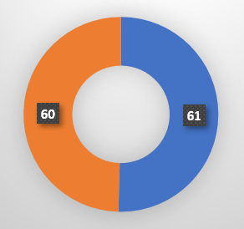
121
Children in care

Boys

Girls

63
Education Provisions

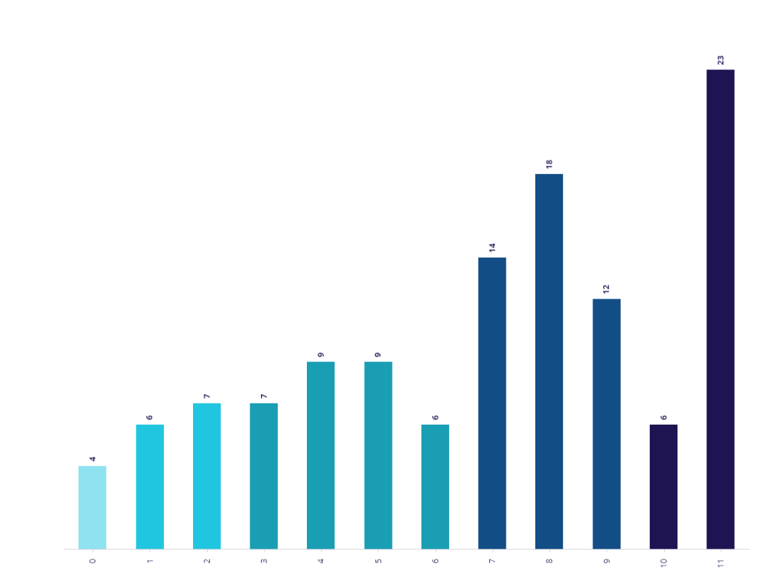
Largest Key Stage:
KS3 – 44 pupils
R 1 2 3 4 5 6 7 8 9 10 11
White British
2 Unaccompanied Asylum seekers
87%
Pupils attend schools in other local authority areas
34
34
PROFILE OF THE VIRTUAL SCHOOL – EARLY YEARS
Virtual School
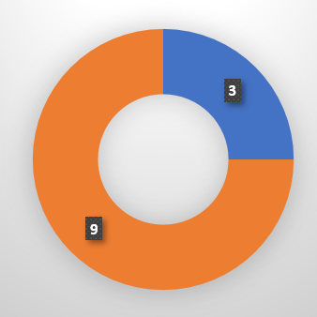

Virtual School
12
Boys
Children in care

Girls

9
Education Provisions

75%
White
British
Pupils attend schools in other local authority areas

4

Key areas of Virtual School work:
- Joint working with North Somerset Early Years department to monitor funding, Special Education Needs, and settings
- Encouraging the take up of Early Years’ funding: 2-year-old, 15 hours, and 30 hours
- Supporting nursery or pre-school placements
- Monitoring individual’s progress and Personal Education Plan meetings (age 3 +)
- Supporting school transitions (Y-1 to Reception) and the Link Programme
- Delivering Personal Education Plan training for settings
- Delivering Attachment and Trauma training
- Supporting the identification of Special Education Needs and support for Top-up Funding applications
8 Children supported through the adoption process in 2020-21
- Adoption support

PROFILE OF THE VIRTUAL SCHOOL: POST 16
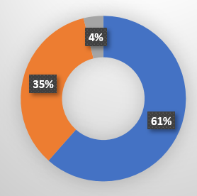
Virtual School

Virtual School
Young people in care
Yet to clarify
52

Female
Male

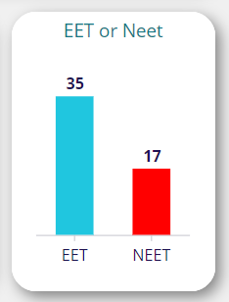

11
Education Provisions

Pupils attend schools in other local authority areas
19
White British
12 Unaccompanied Asylum seekers
60%
34

DEVELOPMENT FOCUS 1: EDUCATION PROVISION
Virtual School
- Ensuring that all children in care have educational provision that is appropriate to their needs
- Ensuring that transitions are carefully planned
- Ensuring that education moves are kept to the minimum
- Ensuring that the individual CiC/ PLAC and their views are listened to

Progress against Development Focus 1
Pupils aged 5-16
129

LAs
14

159
5
Educational Provision:

All 3- & 4-year-old children in care are accessing nursery or preschool for 15 hours a week or more.
All Primary children in care are currently on roll at a school.
1 (YR) currently being educated at home due to care move and awaiting final care plan. VS involved in providing resources, supporting, and monitoring education.
2 Primary aged children in care currently attending school part time due to individual needs. Mentoring provision in place for when they’re not attending. V.S monitoring weekly.
1 Primary aged child not currently attending school as has recently moved to an adoptive family. VS involved in transition to new school.

Provisions
85

Pupils attending special provision
17

66 provisions rated OFSTED Good or Outstanding

Transitions:
36 mid-school moves for 34 children
KS1-KS4
8 of 11 Y-1 EYFS children changed Early Years setting
31
16
left care
into care

All Primary to Secondary transitions were supported by our Virtual School Advisory Teachers and by our Education Psychology service.
Our Specialist Inclusion Worker supported 5 of these students by working with them individually around transition and taking them on visits to their new secondary schools.
Most in-year transitions were supported by Virtual School Advisory Teachers.
There are fewer school moves made by social workers without consulting the Virtual School, but this area continues to need monitoring.
Pupil Voice
All Personal Education Plans (PEPs) start with the Pupil Voice and a Personal Education Plan is marked red if this is not completed.
All pupils are asked to set their own educational target as part of the Personal Education Plan.
Upper Key Stage 2 and all secondary and Post 16 pupils are encouraged to attend and chair their PEP meetings.
New questions have been added to the PEP because of the last Bright Spots’ Survey.

“I don’t know what’s going on. I’m confused
Pupil Voice
17 of 20 KS1 and 2 children stated in their PEP that they don’t feel worried about going to school
21 of 29 KS3 and 4 children stated in their PEP that they don’t feel worried about going to school
Only one child commented on the question “Is there anything else you would like to discuss at the meeting about your education or your care arrangements?” saying….

Virtual School

- Minimum attendance of 95%
- Target of no permanent exclusions (PEX)
- Reduction in the number of Fixed Term Exclusions (FTEs)
- Monitoring of Post 16 attendance

Progress against Development Focus 2

Attendance:
Virtual School

- 52 pupils 95% attendance or higher during academic year 2020-21
DEVELOPMENT FOCUS 2: ATTENDANCE AND EXCLUSIONS

- 87.15% average attendance for academic year 2020-21
- 89.75% average attendance so far, this academic year
Attendance during the last academic year was significantly impacted upon by Covid, with rises and falls in attendance rates reflecting both lockdowns and times when schools were sending home “bubbles” due to high infection rates. The bar graph shows the number of students who were not in school due to Covid during the last academic year for at least one session month by month. In July 2021, Covid numbers were rising, and schools were still using “bubbles” to group children which meant schools were still having to send home the entire “bubble” if there was one confirmed case of Covid.

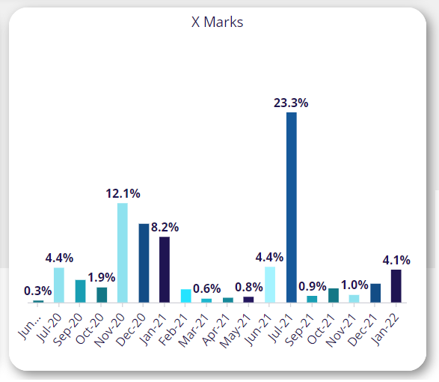
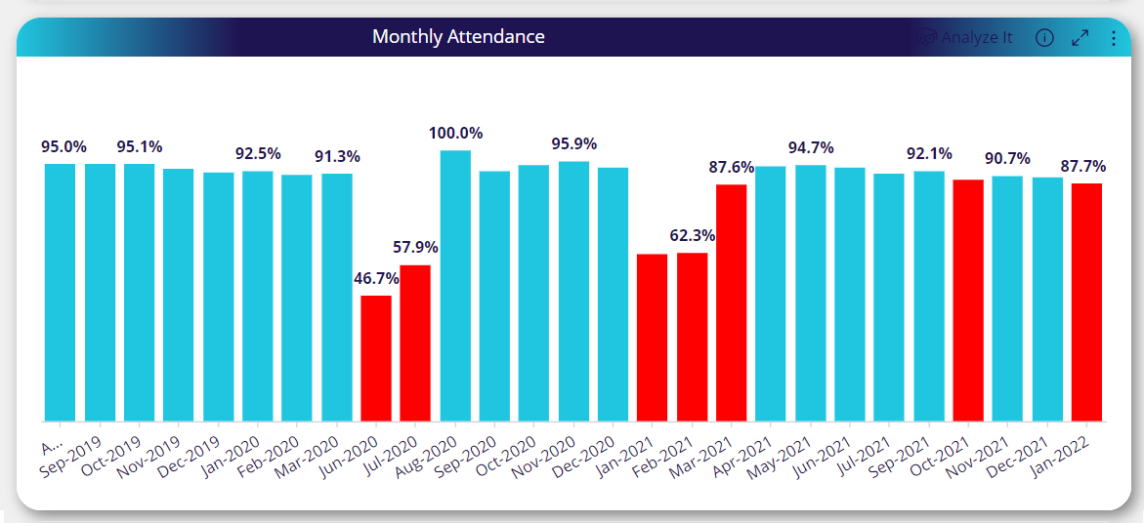

0
Exclusions:
Permanent Exclusions

81
5

10

Sessions lost

- The number of pupils who received fixed term exclusions in 2020/21 was down from 23 in 2019-20 to 10 in 2020-21, with 319 sessions lost in 2019-20 and 81 lost in 2020-21.
- In the 2021-22 academic year to date, there have been 7 pupils who have received fixed term exclusions and 37 sessions lost.
- The number of permanent exclusions was down to 0 from the 1 in 2019-20. In 2021-22 there have been none to date.

Fixed Term Exclusions 2020-21

Pupils
Different Schools
Virtual School

- Working towards narrowing any attainment gap so that Children in Care achieve at least in line with their peers
DEVELOPMENT FOCUS 3: PROGRESS AND ATTAINMENT

Progress against Development Focus 3
Attainment and progress are monitored through the Personal Education Plan (PEP) process. The Virtual School Advisory Teachers attend the majority of PEPs and ensure SMART and aspirational targets are set. If a child is not making expected progress, we refer the child to our Educational Psychologists who work with the schools to reduce barriers to learning.

North Somerset Children Looked After Summer 2021 Key Stage Results
There has been no national Key Stage data published for 2020 or 2021 results. The comparators below are taken from 2019.
For national comparisons, attainment data is given for looked after children in any educational setting who are at the end of the key stage and have key stage data available. Therefore, North Somerset children who did not sit / undertake the assessment have not been included in the calculated percentages of those who have achieved the expected standard.
EYFS One child has an EHCP
 | North Somerset CLA | National (2019 results) | National CLA (2019)
Number of pupils | 6 | - | -
Met Good Level of Development (GLD) | 3 | - | -
% GLD | 50% | 71.8% | 44%
Average Point Score (out of 51) 17 le | 29.2 | 34.6 | Not available

Key Stage 1
Three out of five Year 2 pupils were assessed for KS1. Two of the cohort have EHCPs of which one was assessed.
Virtual School

KS1 | Reading | Writing | Spelling | Maths | Science
North Somerset CLA % reaching expected standard | 33% | 33% | 33% | 100% | 100%
National CLA (2019) | 52% | 43% | - | 49% | 60%
National (2019 results) | 75% | 69% | - | 76% | 82%

Phonics Two have SEN support
If you do not pass your phonics in Year 1 you re-take it in Year 2. All the North Somerset children who retook passed in Year 2.
Virtual School

Year 1 | North Somerset CLA | National (2019 results) | National CLA (2019)
Number of pupils | 6 | - | -
Met expected standard | 2 | - | -
% met expected standard | 33% | 82% | -
Key Stage 2
Twelve out of fourteen pupils were assessed for KS2. The two not assessed both have EHCPs and one child assessed for KS2 also has an EHCP. Two are in the EHCP assessment process. Including the two in the EHCP assessment process, five children have SEN support in the cohort.
KS2 12 assessed pupils | Reading | Writing | Spelling, Punctuation and Grammar | Maths | Science | Reading, writing and maths
North Somerset CLA (2021) | 42% | 25% | 33% | 33% | 50% | 8%
National CLA (2019) | 49% | 48% | 49% | 48% | - | 34%
National (2019 results) | 73% | 48% | 78% | 79% | - | 65%

Reading, writing and maths | All pupils | No identified SEN | EHCP | SEN support
North Somerset CLA (2021) | 8% | 17% | 0% | 0%
National CLA (2019) | 37% | 63% | 5% | 25%

GCSE results 2021
We had unprecedented success with our year 11s this year, this was due to in part the changes in the way exams were assessed, which suit our young people better, and in having an exceptionally able year group.
England Source: https://explore-education-statistics.service.gov.uk/find-statistics/outcomes-for-children-in-need-including-children-looked-after-by-local-authorities-in-england/2020 | England CLA |  | North Somerset  CLA | England CLA  Statement or EHC plan |  | North Somerset  EHCP CLA
 |  | 2019/20 | NS CLA 2020-21 results  (19 pupils) |  | 2019/20 | 2020-21 results  (8 pupils)
Percentage of pupils achieving grades 4+ in English and mathematics GCSEs |  | 23.4% | 47.4% |  | 5.9% | 25.0%
Percentage of pupils achieving grades 5+ in English and mathematics GCSEs |  | 10.2% | 10.5% |  | 1.6% | 0.0%
(1) The cancellation of summer 2020 GCSE exams and the new method of awarding grades has led to a set of pupil attainment statistics that are unlike previous years. As a result, the 2019/20 data should not be directly compared to attainment data from previous years for the purposes of measuring changes in student performance. .
Virtual School

The following graph and table illustrate how our Children in Care did exceptionally well in achieving Grade 4 or higher in Maths and English.
One of our children at Broadoak achieved 9 GCSEs at Grade 4 and above, and our other North Somerset schools had good results with 3 children getting 7 GCSEs at Grade 4 and above
All these children received additional tutoring support from a tutor funded by the Virtual School and had excellent support from their schools.

Number of GCSE’s (grade 4 and above) achieved | Number in Mainstream | Number in Special education
0 | 1 | 5
1 to 4 | 3 | 2
5 to 9 | 6
Total year 11 | 10
Virtual School

- Working with schools and agencies to strengthen the resilience, emotional health, and well-being of looked after and previously looked after children in school
- Enabling schools to become trauma informed and attachment aware
- Developing training opportunities
- Working towards having one member of support staff in each school/ college supporting with trauma
DEVELOPMENT FOCUSS 4: TRAUMA INFORMED SCHOOLS

Progress against Development Focus 4
Strengths and Difficulties Questionnaires (SDQ’s) are completed annually for all our young people aged 5-18 years. If the SDQ report identifies moderate or severe difficulties in any area, we ask schools to detail what support is in place to address this. This is recorded and monitored on the PEP.
We ask that every child in care has a named key adult in school that they can talk to.
Systemic Work – Educational Psychology Service
To enable work at a systemic level to support Trauma informed practices in schools, the Timpson Project was successfully run with an identified secondary school in North Somerset. All staff at the school were trained in trauma informed and attachment aware practices. The project had already been conducted in BANES. The outcomes from this are available at http://www.education.ox.ac.uk/research/attachment-aware-schools-programme-evaluation/
The overarching research questions for the programme:
1. How do staff adapt their everyday practices as a result of attachment and trauma awareness training?
2. How do schools change their policies and practices with increased understanding of attachment and trauma?
3. Do staff and young people report changes to the school climate as a result of attachment and trauma awareness?
4. Do young people attend better and make more progress in attachment and trauma aware schools?

Virtual School

Training of Designated Teachers
Three training sessions were delivered to the designated teachers in North Somerset by the Educational Psychology Service. Positive feedback was given by those who attended. Key topics covered included:
- Current trends in theory and research in practice
- Problem solving and understanding the difficulties that young people may be presenting with - using the Circles of Understanding model.
- Supporting previously looked after children and young people.

Research
To build on good practice already in place in the Authority, the Educational Psychology Service conducted an Appreciative Inquiry using one primary school as an example of good practice. They used a focus group to explore what good practice for supporting Children in Care currently looks like in North Somerset and how we can build on that good practice in the future. The findings from this focus group are being used to develop training to highlight and share good practice with all the designated teachers in the Local Authority. Designated Teachers can book onto this train in Spring 2022.
Early Years Training: Three training sessions were delivered to Early Years settings in North Somerset on Meeting the Needs of Previously Looked After Children. The success of these will be built upon in the training, which is planned for 2022.
Training planned for 2022
DT training x2 (January & February)
DT training -Post 16 (March)
Training for 1:1 support staff 3x1 hour sessions (March and then ongoing)
Best practice approaches for supporting children in care in primary schools – Education Psychology Service (May)
Foetal Alcohol Syndrome (FAS), Foetal Alcohol Spectrum Disorder (FASD) and implications for practice – Education Psychology Service (May)
Designated Teacher Training – Supporting Previously Looked After Children (PLAC) (June)
Virtual School
Virtual School

- Strengthening governance and accountability
DEVELOPMENT FOCUS 5: GOVERNANCE AND ACCOUNTABILITY
- Independent Chair in place
- Extension of members of the Governing Body
- Regular attendance of members to the 3x year meetings
- Clear reporting format covering all areas of accountability: inclusion of impact reports and budget

Progress against Development Focus 5

During 202/21 all meetings of the Virtual School Governing Body were held remotely. Three meetings a year took place for which there were more detailed presentations covering information relating to key areas of accountability and the budget as well as specific issues relating to Covid and its impact upon our children. Themes for specific impact reports covered Pupil Premium Plus funding; Early Years and Primary support and Post 16 support.

The Governing Body now has an independent chair: Paul Jacobs.

Membership includes:

- Representative from Secondary Academy: Head Teacher … Nailsea School
- Representative from Primary School: Head Teacher Worle Village Primary
- Representative from Post 16: Weston College
- Representative from Special Schools… retired Head Teacher Ravenswood Special School
- Representative from Alternative Provision/ Pupil Referral Unit… Principal of the Voyage Learning Campus
- Representative from Bath and Wells Schools
- Representative from NS Council … Councillor Richard Soloman
Council Officers
- Head of Family Well-being and Front Door
- Head of Strategic Planning and Governance
- Education Funding Manager
- Head of Education Inclusion Service and Virtual School Head Teacher
- Virtual School Advisory Teachers and Post 16 Officer

Virtual School

- New Post 16 Officer post to start September 2020: increased hours and reviewed job description
- Development of practice in conjunction with the Education Inclusion Service NEET Team
- Tracking Post 16 attendance to enable Post 16 Officer to put in support at an earlier stage
DEVELOPMENT FOCUS 6: EDUCATION, TRAINING & EMPLOYMENT POST-16
Progress against Development Focus 6

Vicky Nelson started as Post 16 Officer in September 2020.
Virtual School
Her work during the year has enabled us to:
- develop the role of supporting children in care in Post 16 education and those NEET (Not in Education, Employment or Training) being supported into EET (Education, Employment or Training).
- share best practice of Post 16 provision and supporting transition from Year11 to post16.
- develop strategies for NEET children in care.
- work closely with social care teams to support engagement with colleges and other training providers.
- monitor, through Personal Education Plans, all Post16 children in care and care leavers still in education.
- work within the wider care teams to ensure all education and training opportunities are being researched and followed up.
- encourage parents and carers to be actively involved in all Personal Education Plan reviews and having their wishes/views recorded.
- ensure that actions are set, and feedback is arranged in a timely manner so that outcomes and purpose of meetings are recognised.
Unaccompanied Asylum Seekers
In 2020/21 there were 11 Post 16 and 3 Under 16 Asylum Seekers. Staff from the Virtual School have worked closely with colleagues in social care to ensure that appropriate support in made available for these young people. This has involved challenging education settings to ensure that any issues and concerns have been addressed.

DEVELOPMENT FOCUS 7: WIDENING CULTURAL EXPERIENCES

- In response to Covid, offer support to access more events/ activities in a virtual/ remote world as opposed to creating “real” experiences or investing in staff to deliver / manage “real” opportunities and experiences. This will involve liaising with the Resource Service, who have an existing post, who will manage some of this work

Progress against Development Focus 7

With Covid restrictions and pressures impacting on certain areas, this area remains one where only limited progress was made during the last academic year. Contact has now been made with the Music Service to explore possible opportunities for developing creative options. This will remain a priority area.
Virtual School
DEVELOPMENT FOCUS 8: SEND

- Investment in 22.20 hours (term-time only) post to be considered to support the processes for our children with Education Health Care Plans (EHCPs); to manage Alternative Provision packages and to support the advisory teachers with work associated with Previously Looked After Children (PLAC).
- Increase liaison with the SEND Team through regular meetings

Progress against Development Focus 8

5 Children in Care were awarded EHCP’s in the academic year 2020/21
3 Children in Care have been awarded EHCP’s since September 2022

To date there has been no further expansion in the roles within the Virtual School. Meetings took place with representatives from the SEND Team to create greater links and these continue to be developed.

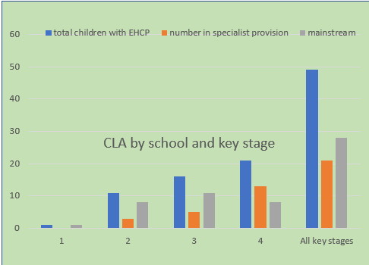
Virtual School
CLA with no SEN need or those who are supported in a recognised need progress as well as non-looked after children across all subjects

Virtual School

POST 16 SEND:

(Data accurate as of January 2022)
18 with EHCP's (38%)
11 of these 18 are NEET (23% of the total Post 16 CIC)
7 of these 18 are EET (15% of the total Post-16 CIC)
Of these 7 students with an EHCP who are currently in education, employment, or training, 5 are in Mainstream FE College (4 Weston College, 1 Bridgwater) and 2 are in Specialist provision.
The chart below shows the breakdown of these 18 Post-16 who have an EHCP

Virtual School

- Investment in 22.20 hours (term-time only) post to be considered to support the processes for our children with Education Health Care Plans (EHCPs); to manage Alternative Provision packages and to support the advisory teachers with work associated with Previously Looked After Children (PLAC).
DEVELOPMENT FOCUS 9: PLAC
- Consideration of an additional post to increase level of support for PLAC.

Progress against Development Focus 9

In 2020/21 this area of work was covered by the Early Years and Primary Advisory teacher. This remains the case in 2021/22.
Work in 2020/21 included:
- Support and advice to schools and adoptive parents (usually an average of 3-4 enquiries a week.)
- Referrals from Adoption West for support for Adoptive Parents
- Updating Virtual School website on PLAC so that it can be used as a resource
- Development of a PLAC Personal Education Plan
- Contact with North Somerset Special Guardianship Social Workers to promote the Virtual School support where needed
- PLAC information for schools on our VS newsletter
- PLAC training (Early Years and Statutory School Age)
- Termly networking meetings with Virtual School PLAC leads in South West to share information and ideas
Virtual School
PRIORITIES FOR 2022

A review of the academic year 2020/1 illustrates that despite continued restrictions and limitations caused by the Covid 19 pandemic, the Virtual School has successfully continued to support our Children in Care, those who are Previously Looked After and Adopted and is about to embrace the new responsibilities for those children and young people with a social worker. Our focus for 2022 is a continuation of much of the work from the previous year, particularly being ambitious for all our children and supporting them to be able to access their full educational entitlement and achieve their full potential.
Virtual School

