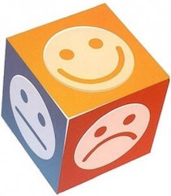
Emotion Regulation
Skills

These are skills to increase positive emotions and reduce vulnerability to difficult emotions

Factors to consider about emotions:-
The importance of taking charge of emotions:-
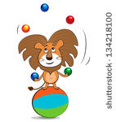
- Adolescents often have intense
emotions that are difficult to manage


- Difficulties controlling these emotions can often lead to problematic behaviours, affecting the young person and those around

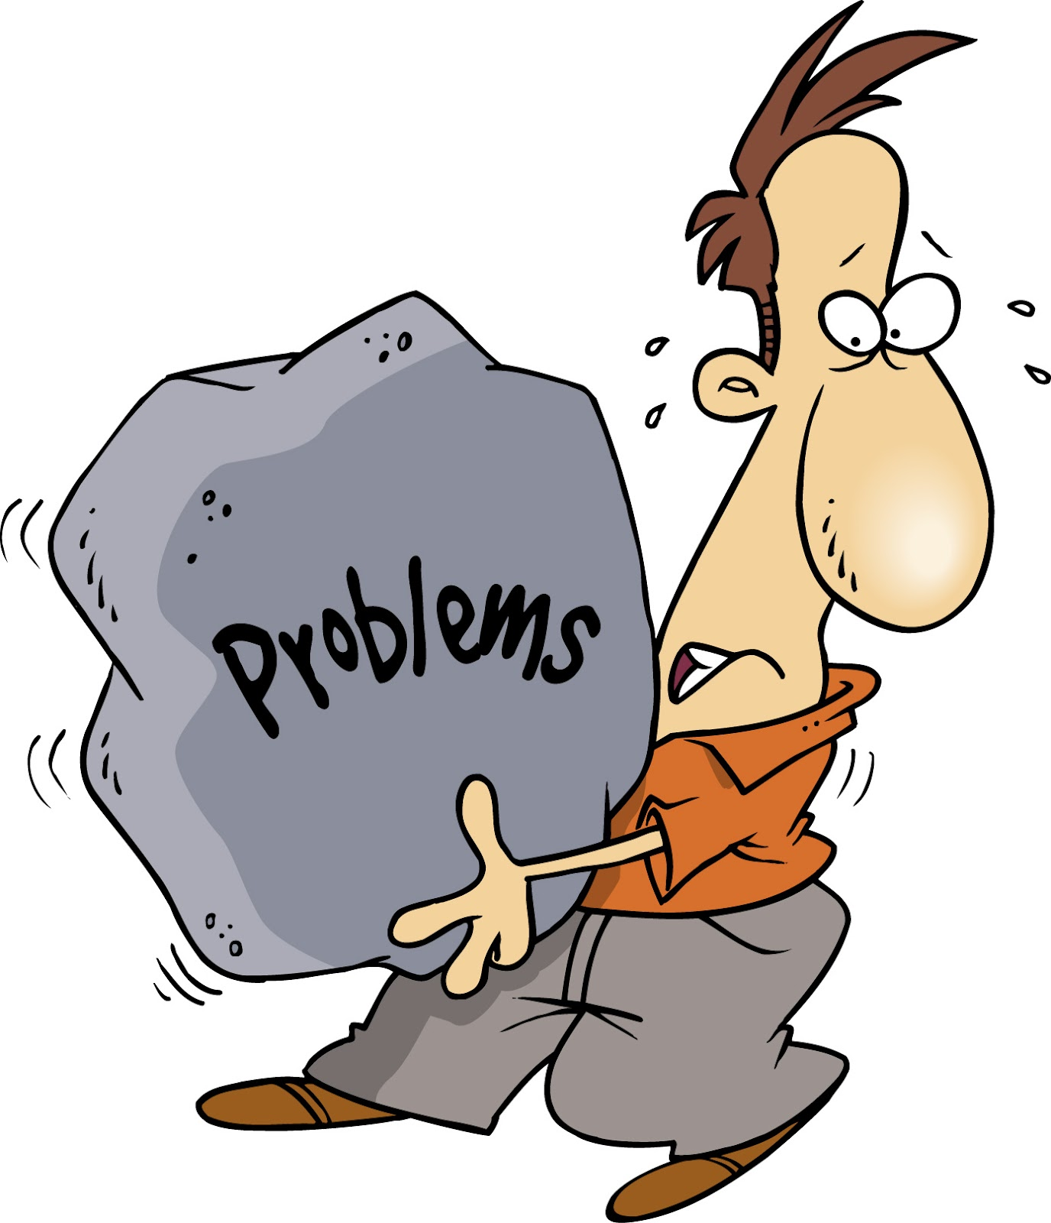
- Problematic behaviours are often ineffective solutions to intensely painful emotions

The intended goals of using emotion regulation skills:-

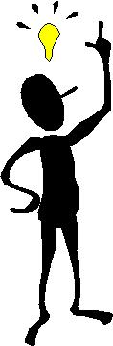

- To understand the emotions
that are being experienced

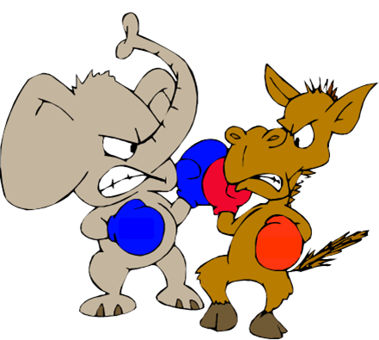
- To consider whether emotions are working for you or against you


- To consider ways to reduce emotional vulnerability and to help contain unwanted emotions by – increasing positive emotions and decreasing vulnerability to emotion mind

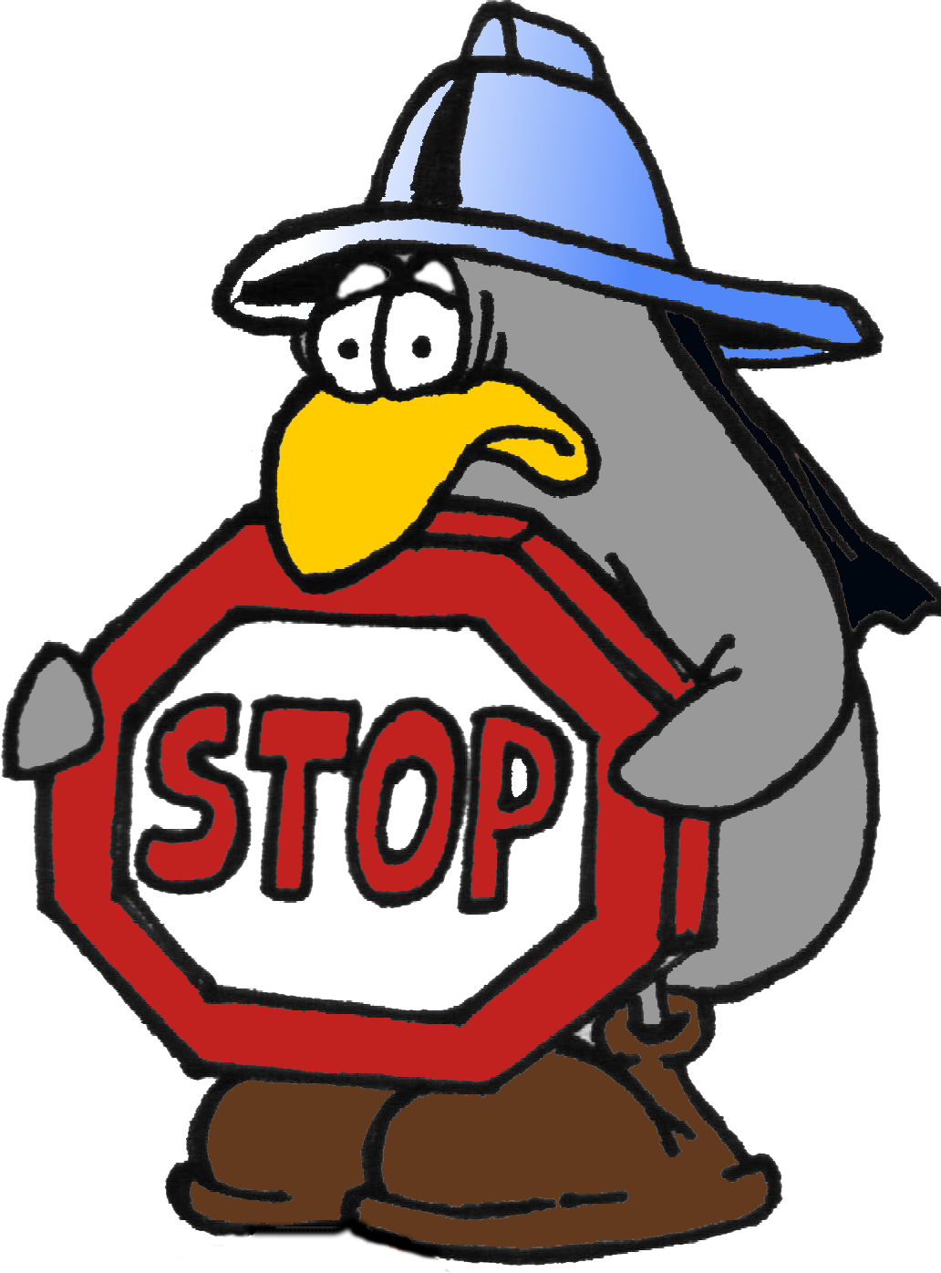
- To stop or reduce unwanted emotions

Emotions – What are they good for?


- Emotions give us information i.e. that something is happening that is impacting on you or someone else. It can give us a gut feeling. Remember however, emotions do not equal facts – check the facts!


- Emotions communicate to, and influence, others – via facial expressions, tone of voice and body language


- Emotions motivate and prepare us for action – e.g. to jump out of the way of an approaching car (act then think) or to overcome obstacles.

The Skills:-

- Accumulating short term positive experiences

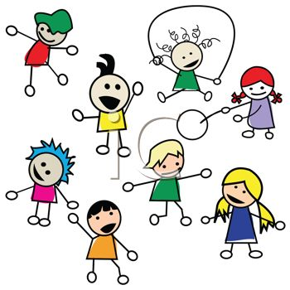
When you are not feeling great, it is important to get active. It’s important to focus on what you are doing and not judging how you are doing. Here is a list of (just a few!) ideas:-

1. Exercise 2. Put on fake tattoos
3. Draw on yourself with washable red marker 4. Scribble on paper then take a shower and wash away your pain
5. Write poetry 6. Cuddle with a stuffed toy
7. Be with other people 8. Paint your nails
9. Post on web boards or try answering other 10. Go out to see a film people's posts
11. Think "I DON'T WANT SCARS FOR THE 12. Watch TV SUMMER!!"
13. Eating something nice 14. Do your school work
15. Write a letter to someone but never send it 16. Go into (safe) chat rooms to talk
17. Invite a friend out 18. Play a musical instrument
19. Sing 20. Snap a band on your wrist
21. Look up at the sky, to the clouds / the moon 22. Go to the zoo and rename the animals Study what you see
23. Make your own list of things to do instead of 24. Let yourself cry harming
25. Buy a punch bag (with gloves). Name it 26. Have a sleep (if tired)
27. Cover yourself with plasters where you want to 28. Do the exact opposite of what you cut really want
29. Play with a pet 30. Smile to at least 5 people
31. Re-organize your clothes drawers 32. Go out and perform one act of kindness
33. Have a pillow fight with the wall 34. Knit a scarf
35. Read a good book 36. Dress up and makeup
37. Colour your hair 38. Listen to music (no triggering)
39. Watch a candle (safely) 40. Find someone else you can help. Do voluntary work
41. Track your breathing 42. Call a friend
43. Make a web site 44. Day dream
45. Go to a public place and observe people 46. Bake
47. Reorganise your room 48. Chew gum.
49. Buy a henna tattoo kit 50. Paint / draw
51. Rip paper into small pieces 52. Give someone a hug
53. Write a letter or email 54. Talk to yourself
55. Hug a pillow 56. Hyper-focus on something like a rock
57. Finger-paint 58. Scream out loud
59. Dance 60. Make hot chocolate
61. Pop bubble wrap 62. Play with play dough
63. Count to 100 64. Build a pillow fort
65. Blow up a balloon and pop it 66. Hug yourself.
67. Write an "I love myself because" letter 68. Read things in a different language Read it when you feel down
69. Go for a nice long drive, walk, or jog. 70. Complete something you have been putting off.
71. Drink a cup of herbal tea 72. Fold paper and invent a
72. Fold paper and invent a new origami shape. 73. Write your diary
74. Build something 75. Take up archery
76. Go rock climbing 77. Take up a new hobby
78. Organize bills, receipts, etc. 79. Cook a meal
80. Go out for ice cream 81. Buy a soft toy
82. Look at pretty things-like flowers or art work. 83. Create something.
84. Pray or read the Bible. 85. Throw socks against the wall.
86. Make a list of blessings in your life. 87. Organize bills, receipts, etc.
79. Cook a meal. 80. Go out for ice cream
81. Buy a stuffed animal. 82. Look at pretty things-like flowers or art work
83. Create something 84. Pray or read the Bible
85. Throw socks against the wall 86. Make a list of blessings in your life
87. Go to a friend's house and open up 88. Take up a hobby
89. Watch an old comedy movie 90. Call your therapist or make an appointment
91. Talk to someone you trust 92. Throw a temper tantrum
93. Ride a bicycle 94. Polish silver or jewellery
95. Start a garden or water your house plants 96. Re-arrange a room
97. Feed the ducks, birds, or squirrels 98. Paint with watercolours
99. Play with face paint 100. Play jacks or pick up sticks
101. Colour with crayons 102. Put on boots and stomp
103. Memorize a song and sing it 104. Stretch
105. Catch a butterfly 106. Watch fish
107. Come up with a long list of names 108. Make a playlist of your favourite songs.
109. Name all of your stuffed animals 110. Go shopping
111. Get into your PJ's and just veg 112. Sew something
113. Take your anger out on soft toys. 114. Throw everything on the ground except glass.
115. Go to a loud concert 116. Plan a special (someday) day
117. Think about your ideal life. What do you 118. Hunt for stuff on Ebay have to do to get there?
119. Alphabetize your books and magazines 120. Take up Tai Chi
121. Hunt for your perfect home online 122. Count tiles or lights
123. Try to make as many words as possible out of 124. Search for ridiculous things on the web your full name
124. Buy yourself some flowers 126. Colour co-ordinate your wardrobe
127. Do a home tan on yourself 128. Take a hot bath and "be" in the moment
129. Sort all you photographs 130. Give yourself a pedicure
131. Colour or scribble over magazines 132. Take a mindful walk in the woods- Breathe the air
133. Donate old things to charity 134. Start to collect something
135. Start a mood journal and write in it every day 136. Take up kick-boxing Do patterns surface? Track your triggers.
137. Buy yourself some toys and act 5 again! 138. Read a magazine or newspaper
139. Plan a dinner 140. Take your own dog, or a friend's dog for a walk

2. Accumulating Longer Term Positive Experiences:-
This is about making changes so that more positive events are likely to happen.
Goals and values can relate to:-

- Being a contributor, wanting to build positive relationships, being part of a social group, focusing on building certain characteristics (e.g. being loyal, honest etc) about yourself, achieving, learning, being healthy, being responsible
- When you get time - identify a goal /value and consider the first and later small steps you can make towards the goal /value and plan for when you will start on these step

***** Try to plan to do something difficult, BUT possible every day towards this (plan for success).


- Cope Ahead
Problem solve by:-
1). Describe a situation that is likely to create negative emotions (remember to check the facts i.e is the situation as bad as you are making out?)
2). Think about ways you may be able to manage the situation better. Ask others for their ideas too
3). Imagine yourself solving the problem
4). Rehearse your actions and what you are going to say


- Stay healthy
- Treat physical illnesses – Take care of yourself and see your GP when you need to
- Balanced eating –
Be aware of the negative foods –
Sugary foods can lead to tiredness and irritability.
Fatty foods can make you feel sluggish and caffeine can lead to feeling jittery, anxious and can interfere with sleep.

Positive foods include –
Complex carbohydrates to give slow and steady energy
Proteins – help you to stay physically and mentally active.
Dairy foods help with energy and bone strength.
Fruits and veg help with energy and health.

- Avoid mood altering drugs
- Balanced sleep

- Create a schedule for bedtimes
- Get a bedtime routine
- Don’t eat or drink a lot before bed.
- Avoid Caffeine and cigarettes (for 8 hours before bed).
- Exercise
- Keep room cool
- Keep sleep for night time (no after School / College napping!)
- Keep the room dark and quiet with no screens for at least an hour before bed.

- Get exercise.


- The Wave Skill

- Observe your emotion
- Step back and just notice it
- Get unstuck
- Experience it as a wave (coming and going).
- Don’t try to get rid of it or push it away.
- And don’t try to keep hold of it.
REMEMBER: YOU ARE NOT YOUR EMOTION

- Problem Solve

Identify goal in solving the problem (i.e. what do you need to happen to feel ok?) – keep it simple
Brain storm lots of possible solutions (don’t evaluate on way)
Choose one that is most likely to work.
Put into action
Evaluate…if it doesn’t work, try another.

- Opposite Action
Use when you decide an emotion is not helping you. The skill can change or reduce the emotion.
It can help reduce the intensity of the emotion
Every action has an action urge e.g. fear urge is to run away / avoid. This is great when threat is real but impairs your life when it is not. Therefore use opposite action when emotion doesn’t fit the facts or when the emotion is too intense.
Some ideas:-
Fear is likely to make you want to escape or avoid, therefore approach.

Anger is likely to make you want to attack or shout, instead gently avoid and then approach with kindness.
Sadness is likely to make you withdraw and isolate yourself, instead get active.
Shame is likely to make you want to avoid, instead – face the situation and apologise and think about what you can do to repair.
NOTE: - We can change our emotions by acting opposite to how we feel AND we have to keep practicing.

Good Luck with trying out these skills!


