Becoming an anti-racist
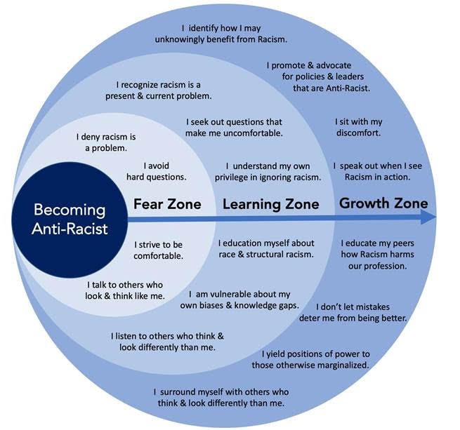
credit to Andrew M Ibrahim.

