Staffordshire Children’s Homes

Safe Use and Storage of Ligature Cutters

References
- My Health and Safety
- Incident Reporting
- Accident and Incident Management HR52
- Accident and Investigation Guidance
- SCSB – Children and Young People Who Self Harm

Contents
- Introduction
- Risk Assessment and Provision of Ligature Cutters
- Storage of Ligature Cutters , and Grab Bags
- Procedure for Using Ligature Cutters
- How to Use
- Action Following Use

Introduction –
Despite risk assessments and efforts to ensure the safety and wellbeing of all young people , there may be a situation when a young person may attempt to self-ligate or use a ligature to harm others.

This may be by securing a ligature around the neck and attempting to suspend from a ligature point, or by tightening a ligature around the neck sufficiently tight enough to compromise the airway.
In these emergency situations, ligature cutters may need to be used rapidly to safeguard the young person and the staff.

All staff working in areas where ligature cutters are provided will be instructed in the use of the ligature cutter and will attain self-confidence in its use.

It is the responsibility of the member of staff to seek further instruction from the Registered Manager if required and this will be made available when needed.

Risk Assessment and provision of ligature cutters -

Young people will have a complete risk assessment carried out referred to as the PSP. If there is current risk or has been a historical risk of ligatures this will be recorded in the original referral and request for service. The PSP will detail how the young person is managed individually regarding the risk of ligatures. It will be the responsibility of the referrer to the service (Social Worker) to ensure that any historical or current attempts to use a ligature are shared in the referral.

Each young person where there is a risk of ligatures will have a risk assessment completed detailing any potential environmental risks in relation to potential ligature points.

The individual risk assessment (PSP) for a young person will detail where the ligature cutters will be located for that young person (grab bags and risers next to bedroom doors)

Storage of ligature cutters -

There will be a set of ligature cutters located inside the door of each electrical store cupboard between the young person’s bedroom – equating to 3 sets of ligature cutters being available on the first floor of the building. 3 sets being available in this area is for quick access as bedrooms and bathrooms tend to be areas of high risk when relating to the use of ligatures.

There will also be 2x Black zipped grab bags available with different types of ligature cutters inside including, 1x Shark Cutter, 1x Barrington Cutter, 1x Wire cutter and 1x Ligature scissors. Accessibility to these cutters will ensure that there is a cutter available for all types of ligature that could be used. One grab bag will be in the main staff office on top of the tall filing cabinet and one grab bag will be located in the night awake office on top of the tall computer cabinet.

There will also be a set of ligature cutters located in every first aid box including in the cars first aid boxes

Ligature cutters can only be permanently removed from these areas when they are being used and then immediately replaced.

Daily checks will be undertaken that the ligature cutters are located in the correct place by the duty officer when carrying out the daily fire checks and the check will be documented in the daily logbook and also on the handover to the next team on duty.

The grab bags will be checked by the night awake staff and their contents checked and this will be recorded in the daily logbook.

If when checking it appears that a set are missing, they must be replaced immediately. Spare sets are located in the administration office and when they are used to replace a broken or missing set the administration team must be informed to enable the purchase of a new set.

If a set is used at any time to remove a ligature they must be replaced by a new set. The cutters that we have on site can only be used once
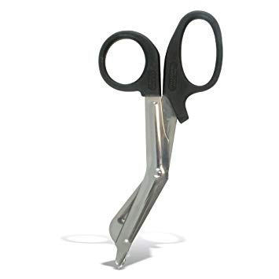
These are the main Ligature Cutters used

The ligature cutters contained inside the grab bags are:
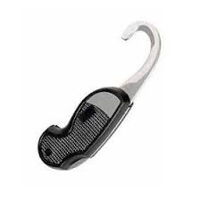

Barrington Cutter 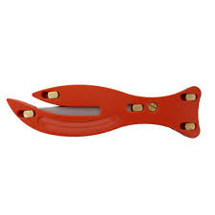Shark Cutter

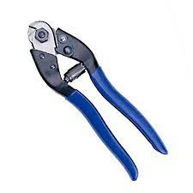
Wire Cutter 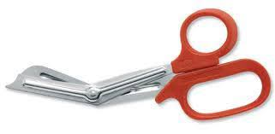Ligature Scissors

Procedure for Using Ligature Cutters –

Any staff member may be required to use a ligature cutter in an emergency. It is essential that all residential staff, working in areas where ligature cutters are provided, are trained and feel confident to use the cutter. Training has been undertaken and completed by most of the team in the use of ligature rescue (Nov 2021) and will be reviewed and updated every 2 years. We will aim to train all new staff within the first 6 months of employment

Use -
- Where possible, staff must avoid cutting the knot, as this makes removal more difficult and it may be required later for forensic investigation.
- Where possible, it is recommended to try and cut to the side of the neck. The natural soft tissues and hollows may ease the insertion of the cutter blade. This will also reduce any pulling onto the airway upon cutting (as would occur if the cutter is inserted at the back) and reduce likelihood of causing further trauma to the airway or the spinal cord, as may occur if inserting from the front.
- Once the ligature cutter has been located between the person’s body and the ligature, the ligature cutter should be turned so that the sharp edge of blade faces the ligature i.e. with the opening away from the person.
- At this point staff should pull away from the person’s body, using a rocking or sawing motion, so that the ligature cutter cuts through the ligature material.
- Appropriate treatment must be given following the removal of the ligature. If the young person is unconscious the emergency services will be contacted immediately and if necessary, staff will perform CPR as trained to do so in their First Aid training.

Action Following the Use of a Ligature -

- Following removal of a ligature the young person must be seen by a doctor even if it appears that no injury has occurred and there has not been a compromise to their airway, breathing or circulation. We are not medical professionals and must seek medical advice for the young person and ensure that they are checked over.
- Staff must retain the cut ligature for later inspection. In the event of injury to the young person, or fatality the ligature will form part of an investigation.
- If there are any injuries relating to the cutter being used, these must be recorded using the “My Health and Safety” system.
- All relevant documentation relating to a serious untoward incident involving the use and removal of a ligature must be completed.
- Immediately following use, the cutter that was used, must be replaced with a sharpened new set.

