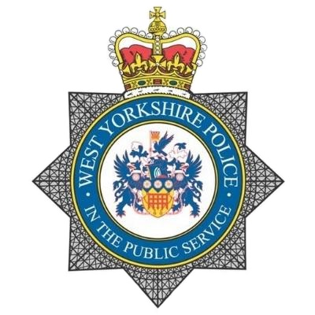 |  | Partnership Intelligence Portal
https://www.westyorkshire.police.uk/form/intelligence-portal-request-form  Contact  PHONE: 101  ADDRESS:  Children Vulnerable To Exploitation Team  Javelin House Police Station,  Javelin Close,  Eccleshill,  BD10 8SD  EMAIL: bd.cse@westyorkshire.pnn.police.uk |  | There is a drive from West Yorkshire Police to improve our intelligence picture as regards matters of serious criminality including organised crime and exploitations. However we are also aware that individuals involved in such behaviour often become involved at much lower levels of offending where there are still significant gaps in what we know and how we can protect vulnerable victims at a much earlier stage.  The PARTNERSHIP INTELLIGENCE PORTAL is an effective way of addressing this by providing an online intelligence submission gateway to partner agencies who set up and host an account. It means that partners can submit intelligence directly via an online account and when receiving a confirmation they can be assured that it has been received and where necessary used to develop our picture of key issues.  The following link can be shared with partner agencies and if appropriate they can set up an account through which they can tell us about issues that their frontline staff may be aware of or encountering.  https://www.westyorkshire.police.uk/form/intelligence-portal-request-form  Please Note: this is NOT a reporting mechanism for incidents or replacing matters for which they you responsibility for taking action.  Any crimes should be reported in the normal way via 999 in an emergency or by using 101 in a non-emergency.

