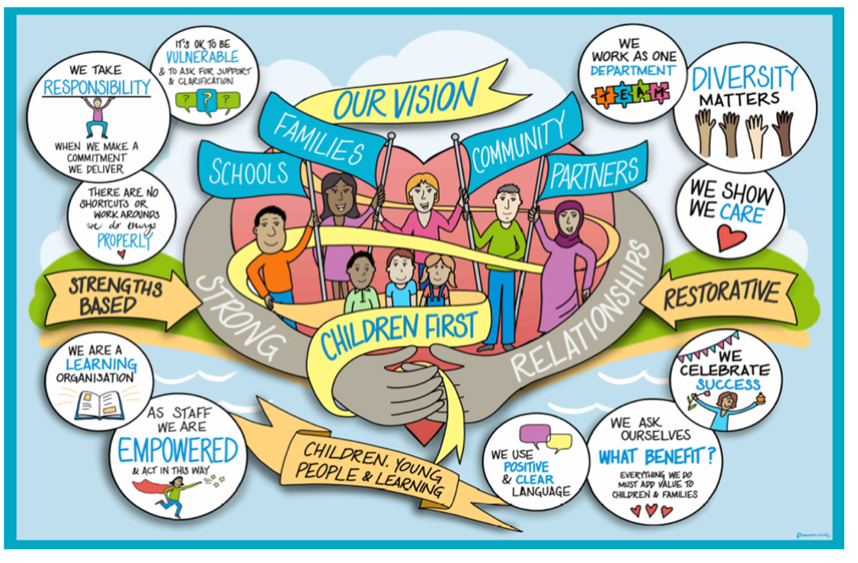

Practice Guidance: Case Summary

Case Summary Guidance

Case summaries are an important overview of a child or young person's life, status and journey. All Children and Young People open to Children’s Social Care for more than 20 working days should have a case summary on their file, which is updated at least every 3 months or after a significant event.

Case summaries are completed as Steps on MOSAIC. For new children open to Children’s Social Care Assessment and Intervention Teams, the team manager will take responsibility to ensure that a case summary Step is opened after 20 days, in line with the Child and Family Assessment Timeline.

Case Summaries should be brief, analytic pieces of work that help a worker to think through the progress of our involvement with a child and their family. They do not need to contain lengthy descriptions of events described elsewhere in case records.

Each Case Summary should be a current reflection of what is happening for the individual child and family; it should not be repetitive or hold non relevant historical information. All previous case summaries will be evident in the Documents Section or the Step History within MOSIAC.

A Case Summary should be a chance to critically reflect on whether we are making a difference for a child and why change is or is not happening. The why question is crucial because this will inform planning about what needs to happen next. If we can examine why there have been positive changes, this will help to understand what is needed to maintain these changes. If things are not changing and there continues to be concerns about a child’s safety and wellbeing, or if things are deteriorating, then it is important to think about what needs to happen to address this. This should include rethinking the current plan and reflecting on the barriers to change and what can done to address these barriers or move forward in a different way. This analysis should also consider whether escalation of the current level of involvement with the family is required.

A Case Summary sits alongside a Child’s Plan and reviews the progress of that plan, but it fulfils a different function. A Case Summary provides an overview of the direction of our work with a child and their family allowing us to reflect on the impact we are having; a Child’s Plan provides a more detailed SMART breakdown of the work being done to support and create change with a child and their family.

Pen picture of the child and reason for our involvement
Describe the child in a way that makes them unique, as if you were describing your own child or a child you know really well. Describe their age, appearance, character, likes and dislikes, the things they are good at and their hobbies.
Describe their family composition, where they live, who are they closest to in their family/wider family. Where do they go to school, what are their favourite subjects, what do they find difficult at school, what are their hopes and aspirations.

Set out the reason we became involved with their family, who made the referral, what was the main area of concern. Include any previous history of involvement if it is still relevant. What was the main purpose of our intervention when we became involved?
What has happened in the last 3 months?
Update on any significant changes in the last 3 months?
Think about key changes for any child and family eg births, deaths, moving home, changing school etc as well as incidents, new referrals.
Any progress that has been made working with the family? What has been the impact on the child? Have there been any new concerns, and how has this impacted on the child? Are there any current dilemmas or grey areas?

Review / Contacts / References
Document title: | Case Summary Practice Guidance
Date approved: | 18.8.2022
Approving body: | P&P Steering Group
Last review date: | 29.1.2020
Revision history:
Next review date: | 18.8.2024
Document owner: | Karin Courtman – Interim Principal Social Worker
Lead contact / author: | Amanda Cole – Practice Development and Improvement Lead

