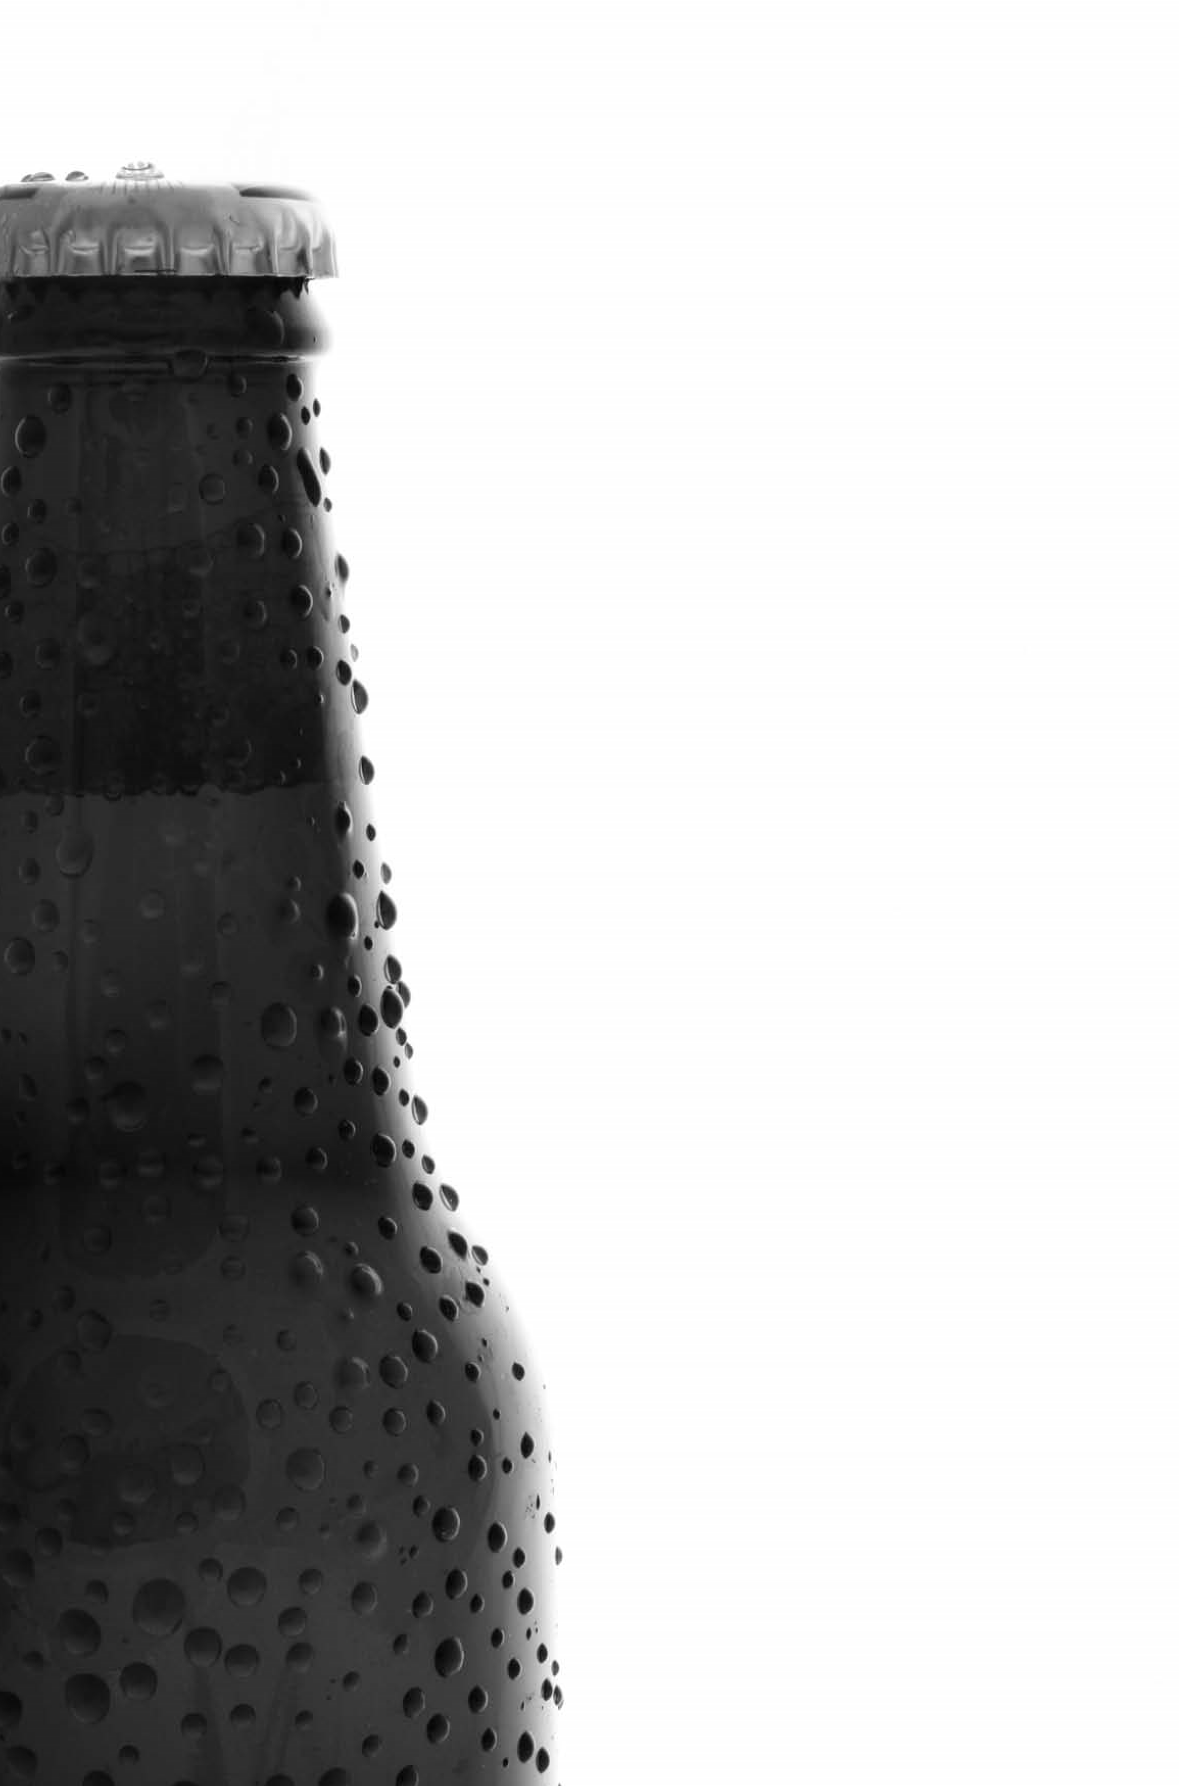
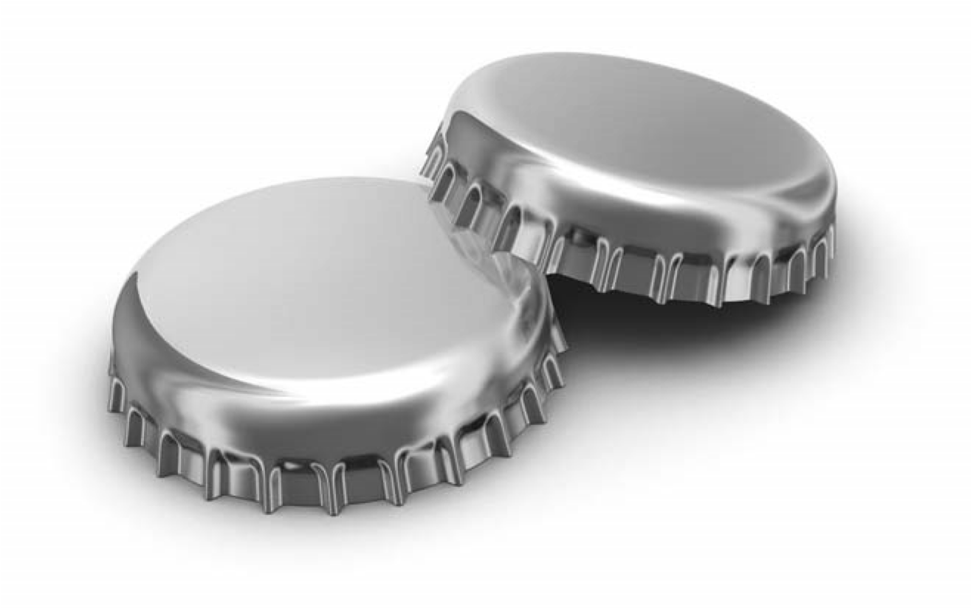
Screening
Tools
for alcohol related risk
How much is too much?
Alcohol Users Disorders Identification Test (AUDIT)
 |  | Questions | 0 | Scoring System  1 2 3 |  |  | 4 | Your Score
 | 1 | How often do you have a drink that contains alcohol? | Never | Monthly or less | 2-4 times per month | 2-3 times per week | 4+ times per week
 | 2 | How many units of alcohol do you drink on a typical day when you are drinking? | 1-2 | 3-4 | 5-6 | 7-9 | 10+
 | 3 | How often have you had 6 or more units if female, or 8 or more if male, on a single occasion in the last year? | Never | Less than monthly | Monthly | Weekly | Daily or almost daily
Units | 2 | 1.5 | 2 | 1 | 9
 | Pint of Regular Beer/Lager/Cider | Alcopop or Can of Lager | Glass of Wine (175ml) | Single Measure of Spirits | Bottle of Wine
Scoring: A total of 5+ indicates increasing or higher risk drinking - please continue with Audit.
This brief intervention package is based on the Drink-Less programme originally
developed at the University of Sydney as part of a W.H.O. collaberative study. ©
2006
Institute of Health & Society, Newcastle University. Reproduced by County
Durham DAAT 2007. Designed and printed by
hpm
group
.
4 |  | How often in the last year have you found you were not able to stop drinking once you had started? | Never | Less than monthly | Monthly | Weekly | Daily or almost daily
5 |  | How often in the last year have you failed to do what was expected of you because of drinking? | Never | Less than monthly | Monthly | Weekly | Daily or almost daily
6 |  | How often in the last year have you needed an alcoholic drink in the morning to get you going? | Never | Less than monthly | Monthly | Weekly | Daily or almost daily
7 |  | How often in the last year have you had a feeling of guilt or regret after drinking? | Never | Less than monthly | Monthly | Weekly | Daily or almost daily
8 |  | How often in the last year have you not been able to remember what happened when drinking the night before? | Never | Less than monthly | Monthly | Weekly | Daily or almost daily
9 |  | Have you or someone else been injured as a result of your drinking? | No |  | Yes but not in the last year |  | Yes, during the last year
10 |  | Has a relative/friend/doctor/health worker been concerned about your drinking or advised you to cut down? | No |  | Yes but not in the last year |  | Yes, during the last year
Scoring: 0-7=Lower Risk, 8-15=Increasing Risk, 16-19=Higher Risk and 20+=Possible Dependence
Units | 2 | 1.5 | 2 | 1 | 9
 | Pint of Regular Beer/Lager/Cider | Alcopop or Can of Lager | Glass of Wine (175ml) | Single Measure of Spirits | Bottle of Wine
Are you at risk from drinking alcohol?
How much is too much?
Simple Structured Advice
Your screening outcome is
How do you feel?
Risk |  | AUDIT Score | Men | Women | Common  Effects
Lower Risk | 0-7 |  | 21 units or fewer per week or up to 4 units per day | 14 units or fewer per week or up to 3 units per day | •Increased relaxation  •Reduced risk of heart disease  •Sociability
Increasing Risk | 8-15 |  | 22-49 units per week or regular drinking of more than 4 units per day | 15-35  units per week or  regular drinking of more  than 3 units per day | •Less energy  •Depression/Stress  •Insomnia  •Impotence  •Risk of injury  •High blood pressure  •Relationship problems
Higher Risk | 16-19 |  | 50+ units per week | 36+ units per week | •All of the above and...  •Memory loss  •Increased risk of liver disease  •Increased risk of cancer  •Possible alcohol dependence
Possible  Dependence | 20+ |  | Referral into the Community Alcohol Service (CAS)
- Binge drinking is considered to be drinking twice the daily limit in one sitting (8+ units for men, 6+ units for women).
- There are times when you will be at risk even after two or three drinks. For example, when exercising, operatingheavy machinery, driving or if you are on certain medication.
- If you are pregnant it is recommended that you completely abstain from drinking alcohol.
- As well as keeping to weekly and daily limits it is recommended that 2 days of the week should be alcohol-free.
This brief intervention package is based on the Drink-Less programme originally developed at the University
of Sydney as part of a W.H.O. collaberative study. © 2006 Institute of Health & Society, Newcastle University.
Reproduced by County Durham DAAT 2007. Designed and printed by
hpm
group
.
Making your plan
• Have your first alcoholic drink after
starting to eat
• Quench your thirst with non-alcoholic
drinks before alcohol
• Avoid salty snacks when drinking alcohol
• Avoid drinking in rounds or in large groups
• Switch to low alcohol beer/lager
• Take smaller sips
• Plan activities and ta
sks at those times you
usually drink
• When bored or stressed have a workout
instead of drinking
• Explore interests - cinema, exercise, etc.
• Avoid going to
the pub after work
• Avoid or limit the time spent with ‘heavy’
drinking friends
• Any ideas
?
Things you have tried
-
?
What are the benefits of
cutting down?
Physical
• Reduced risk of injury
• Reduced risk of high blood pressure
• Reduced risk of cancer
• Reduced risk of liver disease
• Reduced risk of brain damage
• Sleep better
• More energy
• Lose weight / Better physical shape
• No hangovers
• Improved memory
Psychological/Social/Financial
• Improved mood
• Less hassle from family
• Reduced risk of drink driving
• Save money
• Better relationships
What targets should
you aim for?
‘How to do it’
Men
no more than 3-4 units a day
21
units or fewer per week
Women
no more than 2-3 units a day
units or fewer per week
14
No alcohol advised during pregnancy
Dependent Drinkers
No alcohol is safe
What is everyone else like?
%
70
60
%
%
50
%
40
%
30
%
20
%
10
%
0
Abstain
Lower
Risk
Increasing
Risk
Higher
Risk
Male
Female
Most people are sensible drinkers.
Remember, nobody’s perfect!
If at first you don’t succeed, try again.
The pros and cons of changing your drinking
What are the good things about changing your drinking and what are the not so good things?
Pros Cons
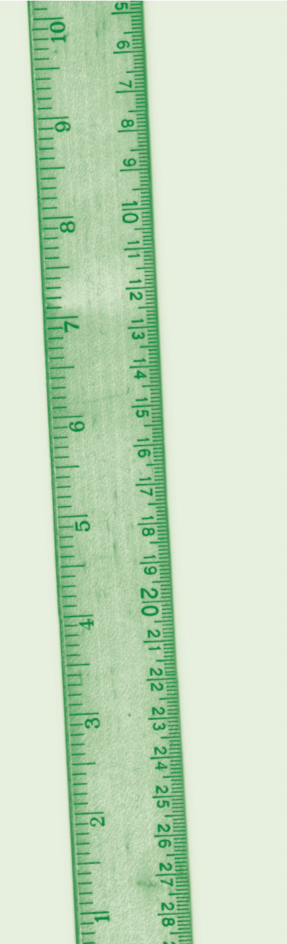
............................... ...............................
ASSESSING READINESS TO CHANGE
Importance of changing drinking behaviour
On a scale of 0 (not at all) to 10 (very important)
what number would you give yourself right now?
• Why are you here and not higher
?
Or lower
?
• What would need to happen for you to get to a higher point
?
• How can I help you get from where you are now to a
higher number
?
Confidence about changing drinking behaviour
On a scale of 0 (not at all) to 10 (very confident)
what number would you give yourself right now?
• Why are you here and not higher
?
Or lower
?
• What would need to happen for you to get to a higher point
?
• How can I help you get from where you are now to a
higher number
?
My rating:
My rating:
How much is too much?
Extended Brief Intervention
............................... ...............................
............................... ...............................
............................... ...............................
............................... ...............................
Where does this leave you?
A six-step plan for changing your drinking habits
This brief intervention package is based on the Drink-Less programme originally developed at the University
of Sydney as part of a W.H.O. collaberative study. © 2006 Institute of Health & Society, Newcastle University.
Reproduced by County Durham DAAT 2007. Designed and printed by
hpm
group
.
Remember, nobody’s perfect!
If at first you don’t succeed, try again.
Identify good reasons for changing: Can you think of 2-3 good reasons?
Reason 1 .......................................................................................................
Reason 2 .......................................................................................................
Reason 3 ........................................................................................................
Set yourself a goal to achieve change: Is this achievable?
What? ....................................................................................................... Where? .......................................................................................................
When? .......................................................................................................
Recognise difficult times or situations: When might be the hardest times?
Reason 1 .......................................................................................................
Reason 2 .......................................................................................................
Reason 3 .......................................................................................................
Prepare for difficult times/situations: Think of ways of dealing with hard times?
Time 1 ......................................................................................................
Time 2 ......................................................................................................
Time 3 ......................................................................................................
Find someone to support you: Is there a family member/friend who might help?
Who? .......................................................................................................

Treatment Tiers
Remember, nobody’s perfect!
If at first you don’t succeed, try again.
Integrated Community Alcohol Service
Community Detoxification, Group work, ongoing support and after care
(for referral see Form A1)
Inpatient Treatment / rehab
Tier 4
Training Workshops
A&E
Audit
Screening Tool
Questions 1 -3
Score 0 -4
No Action
Score 5+
Full Audit
Q 4 –
10)
(
Score 0 -7
No Action
Score 8 –15
Simple Structured
Advice (5mins)
Score 16 - 19
Extended Brief
Intervention (11-20 mins)
Score 20+
Treatment Intervention
How to make changes
Risks to Health
Advice, leaflets, signposting,etc
Tier 1
Tier 2
Tier 3
Criminal Justice
Public Health
Primary Care
Other

