Feelings or Emotions Jars
You will need:
- A clear jar or bottle (plastic or glass).
- Salt
- Coloured chalks
- Paper plates or small, sealable plastic food bags
- Cotton wool

1. Fill your jar or bottle with salt, gently tap it on a hard surface to settle the salt, and then top up any gap.
2. Identify which colour of chalk is associated with what feeling or emotion and place either on the paper plate or in the food bag.
3. Using either the paper plates or the food bags, pour some of the salt from the jar onto each plate or into each bag. The amount in each will depend on how much of the salt the child or young person feels represents how often they feel a particular emotion.
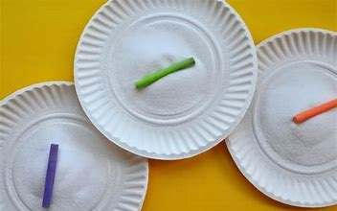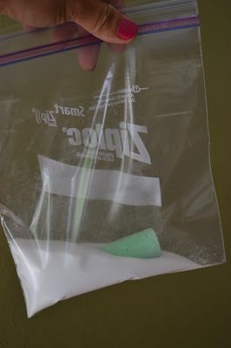
4. Gently rub the chalk into the salt until you are happy with the depth of colour.
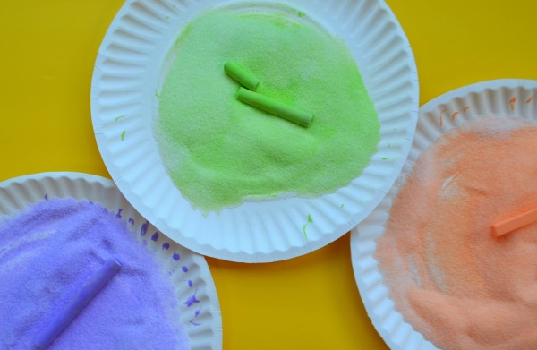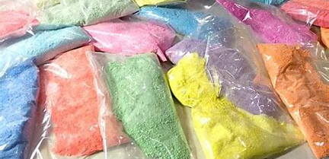
5. One at a time, pour the salt back into the jar or bottle. Place some cotton wool at the very top (to pack the salt in place) and seal with lid or cork.
