

POLICY AND PRACTICE GUIDANCE
GOVERNANCE ARRANGEMENTS

SEPTEMBER 2022
V1.0

 | CONTENTS | PAGE
1. | Introduction | 2
2. | Policy, procedure, practice standards and practice guidance | 2
3. | Policy Process | 3
4. | Responsibilities within the policy process | 4
5. | Reviewing policies, procedures, practice standards and practice guidance | 5

- Introduction
This policy provides a framework and structure for developing, reviewing and authorising Trust policies, procedures, practice standards and practice guidance.
It provides an overview of the various types of documents, details of the policy process and responsibilities for drafting, reviewing and signing off policies and procedures.
- Policy, procedure, practice standards and practice guidance

The terms Policy, Procedure, Practice Standards and Practice Guidance are often used interchangeably but it is important to understand the difference between them as there is a specific authorisation arrangement for each of the document types.

The following table contains the Trust’s definitions of each type of document.
Policy | Policy provides the position and values of the Trust on specific areas of practice with children and young people and their families. It sets the Trust’s expectations of behaviour and the way we approach our work, and provides the ‘why’ behind procedures, practice standards and practice guidance.  Policy is mandatory, in that it must be followed by everyone in the Trust. Should dispute arise, or a complaint be made about the service, practice will be measured against the Trust Policy.
Procedure | Procedures provide detail of the actions required to comply with the Trust policy, the ‘how’.  Procedures can be found in various forms:  - In detailed step by step instructions and flowcharts accompanying policy statements in policy and procedures documents.  - In our electronic Children’s Trust Policies and Practice Guidance Manual (Trix)  Everyone in the Trust is required to follow the Trust’s procedures in order that you comply with the Trust policy
Practice Standards | Practice standards detail how we work with children and young people and their families, and what good practice looks like.  Practice standards cover all areas of activity and set the standards which we should work towards and the ‘bottom lines’ which we must work to.
Practice Guidance | Practice guidance supports the Trust’s policy, procedure and practice standards by providing general guidance for practitioners and managers across specific areas of practice. Practice guidance is not mandatory, it aims to support and achieve best practice.

- Policy Process

All requests for support with developing or refreshing policies, procedures, practice standards or practice guidance should be emailed to the Policy Service within the Practice Hub:
Policy@birminghamchildrenstrust.co.uk

The following diagram illustrates the process which should be followed once there is an identified need for policy development or review:
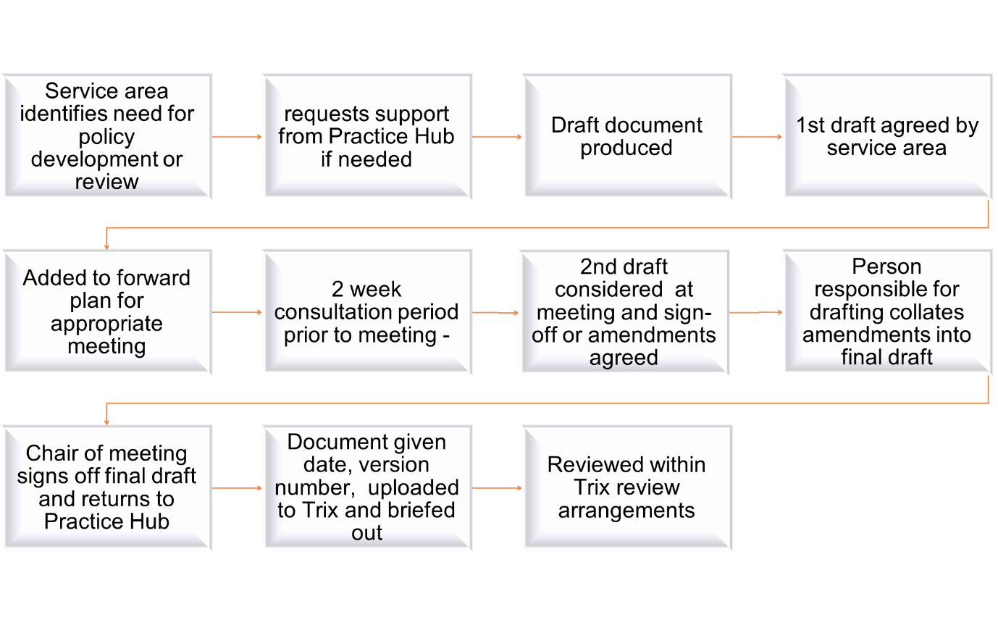

First drafts will be agreed by the responsible person within the relevant service area, who will be responsible for consulting within their service area if they need to.

Once first drafts have been signed off, the Practice Hub will arrange for the document to go on the forward plan and send document out to meeting attendees for consultation. The deadline for responses will be three days prior to the meeting.

Second drafts will incorporate comments/ amendments received during the consultation period, plus questions for consideration at the meeting. They will be sent out with agendas, assuming agendas for all meetings are sent out one or two days in advance of the meeting. They will be presented at the meeting by the person responsible for signing off the consultation draft. Lack of response by the consultation deadline will be taken as agreement with the content of the document.

If it is agreed at a meeting that the document needs to be considered by a higher body, the Chair will be responsible for arranging for it to go on the forward plan; The Practice Hub can help with this on request. Otherwise, any decisions made at this meeting will be considered final and the document taken as agreed, subject to any amendments agreed at the meeting.

Once finally signed off, documents will be given version numbers, dated and uploaded onto Trix/ intranet by the Practice Hub. Unless a specific launch is planned, updates will be communicated via the ‘news’ section of Trix and the weekly email communication.
 | Responsibility for drafting and reviewing | Consultation arrangements and timescales | Responsibility for sign-off
POLICY
Overarching Trust policy (e.g. practice model, HR policies, Information sharing protocols, multi-agency protocols) | AD identified by Executive Team, supported by Practice Hub | Directors /AD’s group - to be shared two weeks prior to meeting to seek comments | Executive Team meeting (or Trust Board as appropriate)
Policy regarding specific area of practice (e.g. CiN, Short Breaks for children with disabilities, Voice of the Child) | AD/ HoS identified by Director Leadership Group, supported by Practice Hub | Directors /AD’s group - to be shared two weeks prior to meeting to seek comments | Director Leadership Group
PROCEDURE
Procedure accompanying policy for specific area of practice (e.g. CiN, Short Breaks for children with disabilities, Voice of the Child) | AD/ HoS identified by Director Leadership Group, supported by Practice Hub | Directors /AD’s group - to be shared two weeks prior to meeting to seek comments | Director Leadership Group
Twice yearly review of Trix main chapters | Developed by Practice Hub supported by relevant HoS | AD/HoS group for specific area of practice, via email with timescale for response (Trix have tight timescales for twice-yearly reviews) | AD of relevant practice area  (Shared with Director Leadership Group)
Procedure for single service area/ activity | Developed by HoS with support from Practice Hub | AD/HoS group for specific area - to be shared two weeks prior to meeting to seek comments | AD of relevant practice area  (Shared with Director Leadership Group)
PRACTICE STANDARDS
Trust Practice Standards | Developed by Practice Hub supported by relevant HoS | Directors /AD’s group -to be shared two weeks prior to meeting to seek comments | Director Leadership Group
- Responsibilities within the policy process
- Reviewing policies, procedures, practice standards and practice guidance
Although the majority of the main guidance is written by Trix and reviewed and updated by them every six months, some chapters are bespoke to the Trust and these need to be updated six monthly in line with the Trix reviewing schedule.
Trust Practice Guidance documents held on Trix will be reviewed annually, on a rolling program supported by the Practice Hub in partnership with the appropriate Assistant Director/ Heads of Service.
Outside of the regular reviewing cycle, once a policy or procedure is signed off it should only be amended in the following circumstances:
- If there is a change in Trust policy
- If there is a change in working practices, e.g. in line changes in the practice model or structural changes
- If there is a change in national guidance or legislation
- In response to learning from e.g. a Safeguarding Practice Review or an internal review following a significant incident
- Other circumstances, e.g on advice from Ofsted or as part of a service improvement initiative

Assistant Director
Head of Service

