Meeting Children’s Needs across Wandsworth (Transfer Policy)

Author | Approved by | Approval date
Iain low | Iain Low | September 22
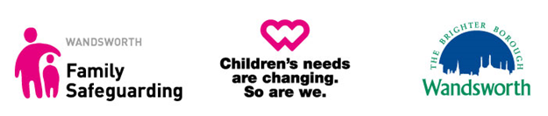
  - Outstanding practice is the key to safeguarding young people, enabling them
and their families to create change and improve their lives.
1.2 In Wandsworth, our social work practice is underpinned by our core value that: “a family is the best place for a child or young person to thrive and meet their potential”
1.3 Families come in many different shapes and forms and are not just confined to those who live in the same home or those who are related to each other. A family is a nurturing, loving social unit that provides a supportive environment for those included to thrive and meet their potential, especially children.
1.4 Families are complex, so to help and support them in the best way we must always consider who families are, where they come from and where they are going or need to get to, so we can help them on their journey.
1.5 The relationships we build with families is central to the help we can offer and how they will experience and receive this. This means that families need to be really heard. We will focus on the relationships families have with each other, their local community, and professionals so we can tailor our support to their needs

The Wandsworth Trajectory Model
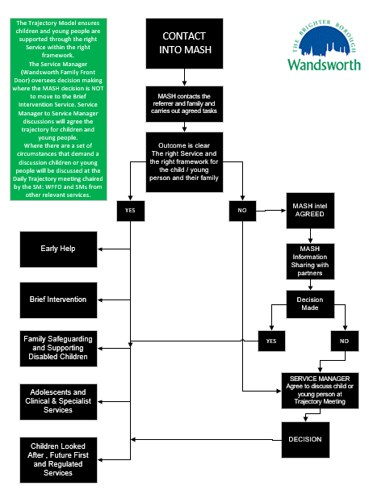
1.6 Through our Trajectory Model at MASH, we will ensure children and families move to the right service, resulting in families not having to move from one service to another.
1.7 Where we agree there is a need for another service to work with a family, the transfer will be conducted in a timely fashion, providing a seamless service. Where this happens, we will ensure we discuss this with children, young people and their families and explain our rationale.
1.8 We will ensure new workers are introduced before responsibilities move to the new service. and young people are supported through the right Service within t
1.9 The Service Manager (Wandsworth Family Front Door) oversees decision making at the MASH where the decision is NOT for children, young people, and their families to receive support from the Brief Intervention Service.
1.10 Service Manager to Service Manager discussions will agree the trajectory for children and young people.
1.11 Where there are a set of circumstances that demand a discussion, children or young people will be discussed at a Trajectory meeting chaired by the Service Manager Wandsworth Family Front Door and other relevant Service Managers.
1.12 There are a number of circumstance where children and families will move from the MASH to the right service: -
- Requests for a transfer in Conference – Family Safeguarding
- Request from the Courts for a Section 37 report
- Request for support for a Special Guardianship Order (SGO) placement – Children looked After
- A young person who becomes looked after as a result of a remand to local authority accommodation or to youth detention accommodation - Children looked After
- Adoption support - Children looked After
- Private fostering - Children looked After
- Families who have No Recourse to Public Funds (NRPF) - Specialist Services
- Unaccompanied asylum-seeking children - Children looked After
- Assessment of need and services for a child with a disability
- Request for Leaving Care services for a relevant or former relevant child - Children looked After

