Think, feel, do bear (Rose 2012)

Notes:
A useful activity when children are struggling with feelings, emotions and how they should respond. It provides them with a visual clue as a reminder of what they can do to help themselves. Particularly good activity if the child loves soft toys. Reinforce the messages as you are making the bear.

Guidance: -
- If time allows you can make a bear from scratch but alternatively you can adapt an existing soft toy, either one you take with you or one the child provides one. Involved the child/young person in making the decisions: what soft toy, colour felt in needed to represent the ‘brain’ and the ‘heart’.
- Using felt ask the child to cut out a shape to represent the brain ‘thinking’, round, teardrop, whatever the child wants. Attach this to the soft toys forehead.
- Cut out a heart shape to represent ‘feeling’ and attach this to the chest area of the soft toy.
- Then attach Velcro to the hands area, this represents ‘doing’.

Talk to the child about the teddy and how it could help them:
Think (brain) – What are they thinking about, this could be a worry, anxiety, fear etc.
Feel (heart)– Try and help them understand how it makes them feel within their body, do they have a sore tummy, sore head, hot, cold etc.
Do (Velcro) – What can they do to help themselves, could they talk to, foster carer, social worker, family support worker or teacher.
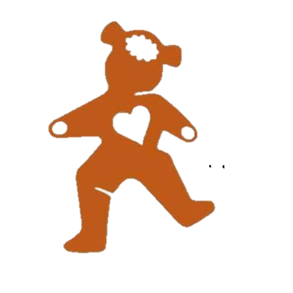
- Write the important comments the child says on the wallpaper.
- Take photos, print them, and stick them into the child’s life story book.
- End with a game to reconnect

Resources:
- Wallpaper
- A variety of pens
- Portable printer
- Life Story book
- Soft toy
- Fabric glue
- Felt (two colours)
- Velcro

