Introduce the wallpaper

Note: -
Encourage the child/YP to writing their name on the wallpaper, you are wanting them to take ownership of the wallpaper and to make it their own and feel comfortable when using it.

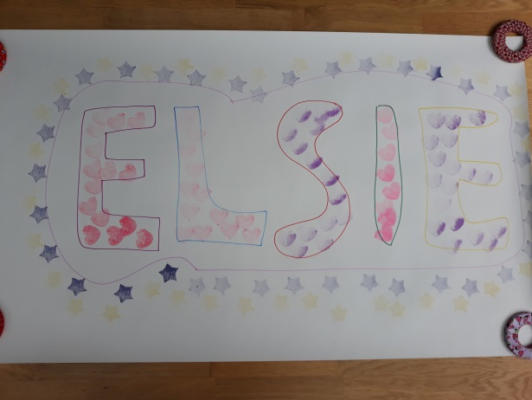
Children sometimes write their name small on the edge of the paper first. Be curious about it, play a game or ask them to draw or doodle, there could be a little block when writing on such a big new piece of paper. Ask them to write their name again and offer to help if need be. Allow them to be creative as he/she wants; write big, use sticker, coloured pens, ink stamps etc.
Resources:
- Wallpaper
- A variety of pens
- Portable printer
- stickers
- Life Story book
- Write the important comments the child says on the wallpaper.
- Take photos, print them and stick them into the child’s life story book.
- End with a game to reconnect

