Pan Berkshire Child Protection Procedures
Child Exploitation (CE) and Serious Youth Violence (SYV) Indicator and Analysis Tool

Guidance
When considering child exploitation the following domains are helpful to consider:
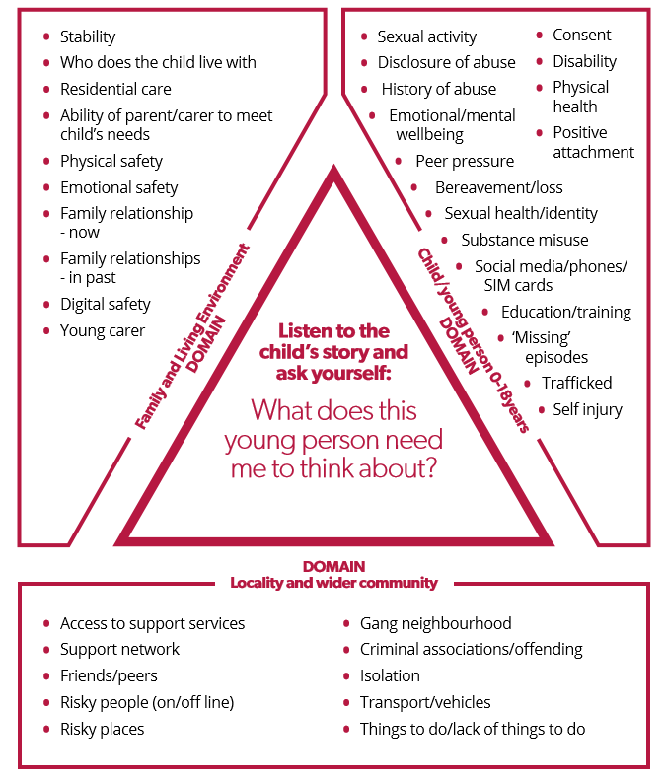

1. Child Details
Child’s name:
Date of birth:
Ethnicity:
School / College:
Is this child looked after? | Yes No
Do they live in residential care? | Yes No
Are they placed at a distance? | Yes No

2. Your Details
Your name:
Job title:
Contact details:
Date completed:

3. Information Sharing and Disclosure
Is child aware that this tool has been completed? | Yes No
Are Parents/Carers aware that this tool has been completed? | Yes No
Has the child made a disclosure of exploitation (abuse)?
Current Yes No If ‘Yes’ you must refer to Children’s Social Care immediately
Historic Yes No If ‘Yes’ you must refer to Children’s Social Care to determine current risk
Are the people who may be grooming or exploiting the child:
Known to the child? | Yes No Unknown
A family member? | Yes No Unknown
(if you answer Yes to either of the above questions please state who this person is)

Names of the child/child’s friends/family who you think are or might be affected by Child Criminal Exploitation also:

4. Evidence  The following is evidence of child exploitation or activities of a comparable level requiring rapid and rigorous response. If you identify any of the following please make an immediate child protection referral. | Yes (Y) / No (N) | Current (C) / Previous (P)
Child under the age of 13 has been coerced, exploited or sexually abused
Being trafficked to an area/place for the purposes of exploitation, e.g. to sell drugs or engage in sexual activity
Abduction and/or false imprisonment.
Being groomed online for exploitation.
Unexplained marks/scars/physical injuries and attempts to conceal these.
Attendance at a hospital / surgery with a stab wound or other non-accidental injury
Comments/description/evidence of concerns marked ‘Yes’

5. Risk Indicators  Children are groomed and exploited in different ways. Below are some signs that may signify if the child is being groomed for exploitation or actually being exploited. | Yes (Y) / No (N) | Current (C) / Previous (P)
Child located in areas known for on/off street sex work and/or drug supply
Disclosure of sexual/physical assault, possibly followed by withdrawal of allegation.
Arrested for PWITs (Possession (drugs) with Intent to Supply
Carrying, or in possession knife / other weapon (or intelligence to suggest this)
Entering/leaving vehicles driven by unknown adults.
Knowledge of/connection to town or cities child has no previous connection with.
Identified links to taxi firms/takeaway owners/hotels/B&Bs etc
Evidence of unexplained / suspicious use of public transport - rail / bus tickets to places where they have no trusted association
Seen in hotspots/places of concerns.
Change in behaviour – being more secretive/ withdrawn/ isolated from peers and not mixing with usual friends.
Increasingly disruptive, hostile or physically aggressive at home or school, including to animals, and the use of sexualised language.
Older person(s) contacting the child online/offline, and encouraging emotional dependence, loyalty and isolation.
Physical/emotional abuse from a partner, controlling adult or peer, including use of manipulation, violence and/or threats.
Victim of a violent offence or threatened with violence/physical assault
Possession of keys to unknown premises and/or hotel key cards.
Phone calls, texts, letters from unknown adults.
Persistently missing from home/care/school for different periods including overnight, including episodes that aren’t reported to Police.
Returning home after long intervals appearing well cared for or dirty/disheveled.
Change in physical appearance (more/new clothes, more/less make up, weight gain/loss).
Marks/scars/physical injuries and attempts to conceal these.
Expression of despair (depression, mental health, self-harm, suicidal thoughts/attempts, eating disorder).
Repeat/unplanned pregnancy(s) and/or seeking termination/emergency contraception.
Adults/unexplained person(s) loitering outside the child/young person’s usual place of residence or school.
Sexually transmitted infections (STI’s) and/or repeat visits to the sexual health clinic.
Concealed/concerning use of the internet and/or mobile phone, including during the night (webcam, online gaming, web chat, social media, online dating apps/websites).
Concern that an online relationship has developed into an offline relationship.
Involvement in offending / violent offending
Peers / siblings involvement in violent offending / weapon carrying / PWITS
Exclusion from school, reduced timetable, disengaged from education, unexplained absences from school.
Disengaging from usual/age appropriate extra-curricular activities, or showing a lack of interest in these activities.
No response to attempts from workers/carers to keep in touch/disengagement from professionals.
Distrust of the police i.e. not reporting crime, negative attitude to the police
Evidence of older, or unknown persons sending sexualized messages to the child
Young person’s sexuality being explored in a risky and unsupported way
Association with groups/gangs/fear of victimisation from groups/gangs.
Increasing use of drugs/alcohol or misuse of drugs/alcohol.
Concern that the child/young person is being coerced/bribed/threatened to provide sexually explicit images/engage in inappropriate online activity.
Unexplained money/clothing/goods/activities.
Possessing multiple mobile phones, sim cards, or concerning use of a phone, i.e. multiple callers, frequent messages, phone answered by adult/unknown person.
Harmful sexual behavior.
Becoming angry/hostile if any suspicions or concerns are expressed about their activities
Changes in language use – new alias,/nickname, use of gang slang, drug terminology, sex language
Comments/description/evidence of concerns marked ‘Yes’

6. Vulnerabilities  These are things which may make a child more at risk of being targeted for exploitation. The absence of these vulnerabilities does not preclude children being targeted; evidence shows victims can come from any background and without any prior vulnerability. | Yes (Y) / No (N) | Current (C) / Previous (P)
Spending time with other exploited children.
Migrant/refugee/asylum seeker/trafficked status.
Currently/previously known to Children’s social care.
Physical/learning disability(s)/communication disorder(s) ADHD or mental health disorders
Living in a chaotic or dysfunctional household.
History of emotional/physical/sexual abuse and/or neglect.
Living in residential care/hostel/B&B/sofa surfing/homeless.
Places and spaces the child spends their time noted for high crime rates and/or anti-social behaviour?
Gang affected through family/friends/neighbourhood.
Unsure about sexual orientation or unable to disclose sexual orientation.
Parental difficulties; drug and alcohol misuse, mental health problems, physical or learning difficulty. Child or young person is a young carer.
Recent bereavement or loss.
Low self-esteem/self-confidence.
Exploitation previously identified as a concern for the child.
Poverty or deprivation.
Current/historical exposure to domestic abuse.
Breakdown of family relationships and/or conflict around boundaries, e.g. staying out late.
Family involvement in trading sex/drug supply network/criminal activity
Lacking friends of their own age.
Comments/description/evidence of concerns marked ‘Yes’

7. Summary of Concerns
Please note scoring of the below is not prescriptive of risk
 | Evidence | Indicators | Vulnerabilities
Number of concerns marked as ‘Yes’ and ‘Current’
Number of concerns marked as ‘yes’ and ‘Previous’
Total
What type of exploitation has been identified through completion of the assessment tool;
Child Exploitation currently not a factor at this time/concerns relate to age appropriate behaviours
Evidence of vulnerability to child criminal exploitation
Evidence of vulnerability to child sexual exploitation
Evidence of child being groomed (including online)or targeted for the purposes of sexual exploitation
Evidence of child being groomed into membership of a criminally active gang
Evidence that child is being sexually exploited
Evidence that the child is being criminally exploited
Evidence of other child exploitation / modern day slavery
Evidence of involvement in serious violence/weapon carrying
Please note that the threshold for referral to National Referral Mechanism (NRM) is that there are reasonable grounds to believe the individual is a potential victim of human trafficking and modern slavery and if this tool has identified reasonable grounds then a referral should be made to the NRM.
What information has this indicator tool identified about other children, including siblings and friends, who may be at risk of, or are, being exploited, or may be involved in serious violence or carrying weapons?
This is really important for early intervention.

Specific planned or completed actions as result of tool completion:

Date assessment completed:
Date for next review:
MEETS THE CRITERIA FOR EMRAC: YES/NO
REASON:

TO BE CONFIRMED AND SIGNED BY CO-CHAIR:
DATE:

