Bradford Youth Justice Service Induction Plan
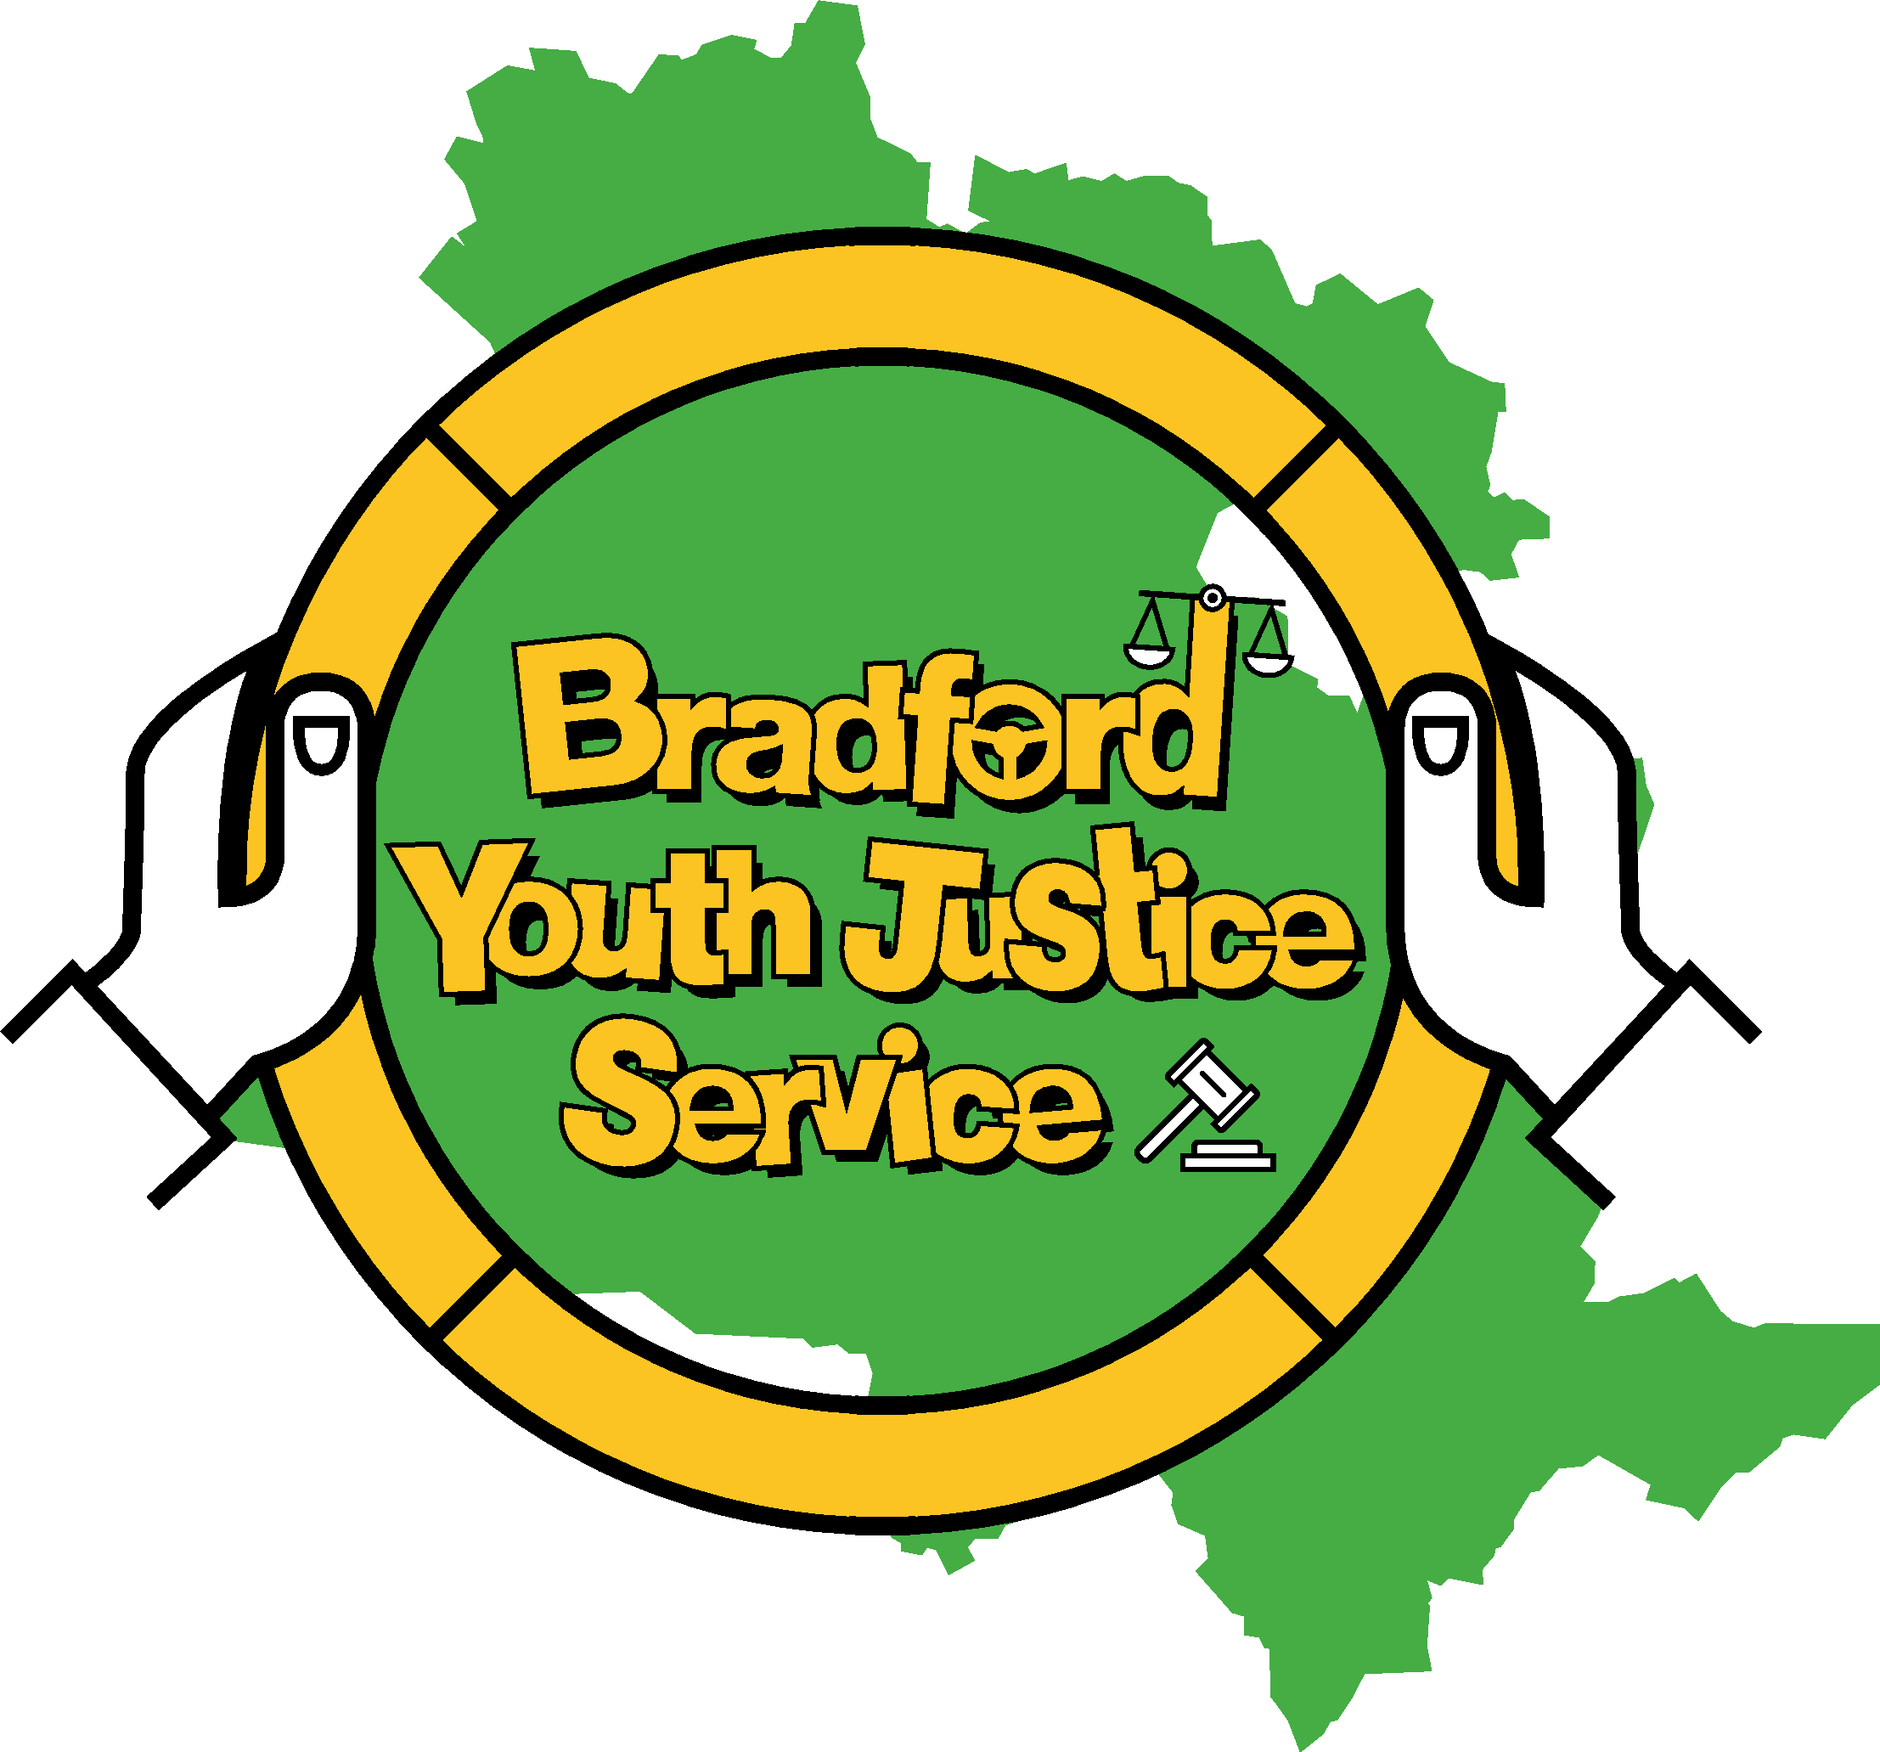
Sir Henry Mitchell House, 4 Manchester Road, Bradford BD5 0QL
Telephone: 01274-436060

BRADFORD YJS INDUCTION PLAN
TERMS OF REFERENCE

Document details: | Bradford YJS Induction Plan
Version: | 1
Approved by: | Youth Justice Service Management Team
Ratified by: | Sarah Griffin
Date approved: | 13/5/22
Date ratified: | 1/6/22
Job title of author: | Donna Carroll (Practice Development Lead)
Job title of responsible Head of Service: | Lisa Brett (Early Help & Prevention)
Date issued:
Review date: | 1 year
Frequency of review: | Annual
Amendment Summary:
1:
2:

Purpose

This is a 4 week induction plan for new starters at Bradford YJS. It will ensure that all new starters have the relevant training, and knowledge in relation to protocols and procedures to enable them to complete all tasks relevant to their role within the YJS. Not all tasks will be relevant to all roles. Your Team Manager and Practice Development Lead will guide you in completion of relevant tasks and training. All text in blue is a link page

Bradford Youth Justice Service Induction Plan

Name of YJS Worker or Partner/ Seconded/ Commissioned (P/S/C):
In post from:
Area:
Worker Mobile Number:

Key contacts for induction
Names and Roles | Contact Numbers
Team Manager
Practice Development Lead
Service Manager – Sarah Griffin | 07973814052
Head of Service – Lisa Brett | 07582104826

Organisational contacts
IT | ITSupport@bradford.gov.uk
LCS | LCSQuality.Support@bradford.gov.uk
ESS | ESSMSShelp@bradford.gov.uk
HR | hrgeneralenquiries@bradford.gov.uk
Payroll | Payroll.enquiries@bradford.gov.uk
Learning and Development Team | Gill.Ward@bradford.gov.uk
Evolve | evolve@bradford.gov.uk
Smartlog for Fire awareness training | tommy.Conroy@bradford.gov.uk

Week One |  | Target date for completion of task | TM/PDL  Confirmation
Prior to start date Team Manager or Business Support Lead (Clare Hargate) will complete a New Starter Form
https://bradford.cherwellondemand.com/CherwellPortal/IT?_=60b468ae%230

Meet with Team Manager/Practice Development Lead on day 1:

- Welcome and introductions to team

IT:

- Sort Laptop and mobile phone.
- Passwords and set up for CV, Outlook, Virtual Learning
- Set up on Photocopying
- Log onto Evolve and discuss purpose of Evolve.
- Log onto ESS and discuss purpose if required for P/S/C
- Electronic Diary and guidance re minimum requirements and RAG system
- Update Bradnet with contact details
- Log on to secure email CJSM
- Arrange for new starter to be added to Team Meeting invites

Health and safety induction to the office, to include:

- Location of facilities – bathrooms, kitchens
- Security - opening hours of premises. Use of scanning device.
- Collect office fob/pass and Bradford ID
- Emergency procedures and exits, including fire testing
- Health and Safety guidance and information – includes accident reporting, lone working, covid policy
- Prayer room
- Personal locker and clear desk policy
- Personal mobile number and next of kin details to be given to Team Leader in case of emergency
- Arrangements regarding sickness absence reporting
- Check car insurance and record on ESS. This will depend on the role of the new starter. Car indemnity
Arrange other initial meetings and observations – discussion between Team Manager/PDL and New staff member:

- Make arrangements to shadow staff in practice.
- Discuss resources available – i.e. programmes and activities. SAL resources
- Multi-Agency Information Planning Panel (MIPP)
- Referral Order Panel
- Out of Court Disposal Panel (OOCD)
- Risk, Safety and Wellbeing Meeting (RSW)
- Court
- Business Support
- Duty
- YJS Health Team (YJS Nurses, Child and Adolescent Mental Health Services (CAMHS), Speech and Language Team (SALT)
- YJS Police
- Education link worker details

Meetings/observations and shadowing to be input on outlook calendar

Assessments to complete

- Display Screen Equipment (DSE) assessment for flexible workers to be completed

Locate and become familiar with the following key IT systems and documents:

- Bradford Multi Agency Referral Form (MARF) can be found here
- Tri X – Practice Guidance (Youth Justice Services)
- LCS – Children’s Social Care System
- Electronic Library
- Flex – accessed on desktop
- ESS – Annual Leave/Mileage. Access through Bradnet

Virtual and eLearning Training and Resources

- About Evolve.docx – this document gives information about how to log into Evolve for Bradford Council Employees, Casual staff, other agency staff, students and graduates on placement, volunteers, and personnel seconded to but not employed by the Council, Agency staff working with Children’s Services.

Once you have an account you can click on the links below to complete training, or access from you desktop.

New Starter Learning Programme

The new starter programme includes:
Introduction to Evolve learn
Welcome new starter eLearning
Fire Awareness – this is just information. See link below for compulsory training.
Evolve Performance
Protecting Information Level 1
Fraud Awareness
Health and Safety Induction
Equality and Diversity
Unconscious Bias

Fire Awareness to be completed annually

Induction for Childrens Services New Starters

Objectives:

Understand the current structure of Bradford children’s services and what this means for the children and young people of our City.

Understand the demographics and diversity of Bradford.

Basic knowledge about the Bradford Practice Model and how we keep the child at the heart of everything that we do.

- Practice Focus months training – This is bi monthly mandatory training for all YJS staff. Information will be sent in key messages in relation to the theme. Register on Evolve for face to face or virtual classes. This will be followed up with a reflective learning session with PDL.

Enable Training Platform:

Enable is a face to face/virtual training platform for all Adults and Childrens training that is provided by The Bradford Partnership – working together to Safeguard children (TBP) and Bradford Safeguarding Adults Board (BSAB). Bradford Safeguarding Partnership Registration

Courses change on this training platform. Discuss with team manager and PDL what other training may be applicable at the time

Training to be completed over the 4 week induction period.

Research in Practice use this link to create an account and get access to resources to work with children and families, young people and adults.

Bradford YJS Training Policy Bradford YJS Training Policy Final.docx – This document gives an overview of mandatory, developmental, and aspirational training available to staff.

Following training will be ongoing and delivered within 3 month period:

- Child View
- Case Management
- ASSET+
- LCS (Children’s Social Care System)
- Out of Court Disposals
- Court Orders (Referral Orders and Youth Rehabilitation Orders)
- Child Friendly Plans
- Breach Procedures
- Risk Safety and Wellbeing forms

This will depend on role of new staff member.

Meet with Team Manager/PDL at end of week 1:

- Reflections on week 1

- Review first week – confirm which tasks/training has been completed and update induction plan to reflect.

- Supervision Arrangements. This will depend upon the role of the new starter.

Month 1 – weekly
Month 2 – fortnightly
Month 3 - monthly

Week Two |  | Target date for completion of task | SM confirmation
Meet with Team Manager/PDL:

- Discuss initial plan for allocation of first cases, or, if not case manager then, alternative allocation of initial work load.
- Continue with Evolve online and virtual training
- Attend meeting observations/shadowing opportunities arranged in week 1
- Ongoing training with Practice Development Lead

Guidance and Policies to be read:

- Expenses
- Supervision Policy
- HR Plus includes Sickness Policy, Annual Leave
- Bradford Standards Checklist
- Continuum of Need
- Bradford Criminal Exploitation (CE) Protocol
- Risk Safety and Wellbeing policy
- Information Governance
- Supporting flexible working

Guidance and Policies to be read over the 4 week induction period.

It is the staff member’s responsibility to ensure they are familiar with all policies and protocols and to check these regularly for updates here

Week three |  | Target date for completion of task | SM confirmation
Meet Team Manager/PDL:

- Reflection on week 2
- Review any tasks from previous weeks– sign off completed tasks and reviewing outstanding tasks identifying when they will be completed
- Update/revise induction plan, if necessary
- Review/discussion of any allocated cases
- Continue with Evolve online and virtual training
- Attend meeting observations/shadowing opportunities arranged in week 2
- Ongoing training with Practice Development Lead

Week four |  | Target date for completion of task | SM confirmation
Meet Team Manager/PDL:

- Expectations regarding Continuous Professional Development.
- Review of induction plan and reflection of learning to date, consider future learning needs
- Review of shadowing opportunities and what’s not been covered and plan in for week 4
- Discussion of progress of any allocated cases
- Continue with Evolve online and virtual training
- Attend meeting observations/shadowing opportunities arranged in week 3
- Ongoing training with Practice Development Lead

Confirmation that all tasks in this document have been completed and that YJS worker is familiar with all practice standards, policies, procedures and practice standards:
YJS worker signature: | TM/PDL signature: | SM signature:
Date: | Date: | Date:

Created by Donna Carroll

