What do you think Child Sexual Exploitation is?

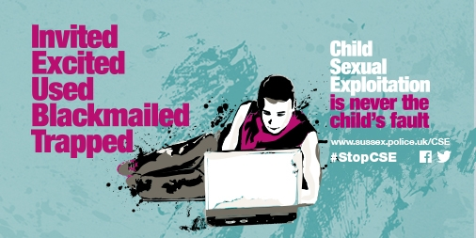

The definition of child sexual exploitation is as follows:

Child sexual exploitation is a form of child sexual abuse. It occurs where an individual or group takes advantage of an imbalance of power to coerce, manipulate or deceive a child or young person under the age of 18 into sexual activity (a) in exchange for something the victim needs or wants, and/or (b) for the financial advantage or increased status of the perpetrator or facilitator. The victim may have been sexually exploited even if the sexual activity appears consensual. Child sexual exploitation does not always involve physical contact; it can also occur through the use of technology.

Thoughts?

How do you keep yourself safe online?

Have you ever spoken to a stranger online?

Did you seek them out or did they seek you out?

Privacy settings?
Not just who can speak to you but what others can see, where you are tagged, who you know etc.

Do you think that people have a false confidence when they are talking online? What are the dangers of this?

What do you think an online reputation is?
Future employees etc.

What are different ways of replying to someone who is asking for inappropriate pictures or texts?

