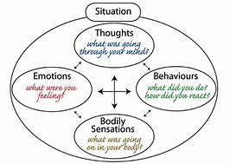

Relationship of Behaviour to Automatic Thoughts

Core beliefs

Intermediate beliefs (rules, attitudes, assumptions)

Situation

Automatic Thoughts

Reaction (emotional, behavioural, physiological)

Example of how this model is used:

Core beliefs “I’m incompetent”

Intermediate beliefs
Attitude: “It’s terrible to fail”
Rule: “I should give up if a challenge seems too great”
Assumptions: “If I try to do something difficult, I’ll fail. If I avoid doing it, I’ll be okay”

Situation: “Reading a new text/book”

Automatic Thoughts: “This is too hard. I’m so dumb. I will never master this. There is no point”

Reaction:
Emotional: Discouragement
Physiological: Heaviness in body
Behavioural: Avoidance of task and watches TV instead

Once using this we can use it to think about the mood we are in, weather this be anxious/low mood/happiness – why and how have we got to this place? It is important to be able to reflect on these feelings and understand how we got there and what we can then change.

Further looking at our core beliefs and how this affects our reactions?
Beliefs are generally formed in two ways, this is by our experiences, inferences and deductions, or by accepting what others tell us to be true. Most of our core beliefs are formed when we are children. When we are born, we enter this world with a clean slate and without preconceived beliefs.
With this in my mind when we think of our core beliefs, we must look at our surroundings, our family/friends, the environment we grew up in and the changes we went through as we were growing up.

Usually when working with a young person I then do a timeline. This helps young people to think about key events in their lives as well as thinking about any specific memories they have both negative and positive. Once you have done this, we are able to look closer and specific situations, this is where I bring in the model as seen above. Think about their reactions to the situation and note these down, how were they feeling if they can remember? The best way to do this is to create a body map, find out where they felt what, did they laugh, were they shaking, did they become dizzy or hot or cold. Note all these down on the body map and then start to speak to the young person about what they were thinking while this was occurring. Add these thoughts to the body map by adding speech bubbles at the sides. Write the situation at the top and then start to look closer at the attitude and assumptions made by those around them at the time. Add this to the bottom of the body map. By the end of this you will have something similar to what you see below.

This process allows us to look closer into a situation/incident to allow the understanding and reflection of what occurred and what we could change next time. This gives different ways for a young person to look at an event and think about not only their own emotions and recognising these further but also why others within the situation or observing may have reacted in the way that they did.

EXAMPLE - Argument with Dad in the Galleries

Timeline of event:

My thoughts:

Body map of
feelings/sensations

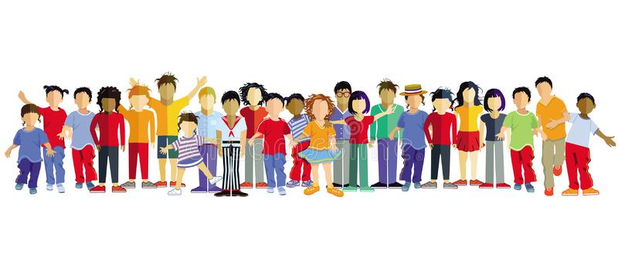
What were the thoughts of those around you?

