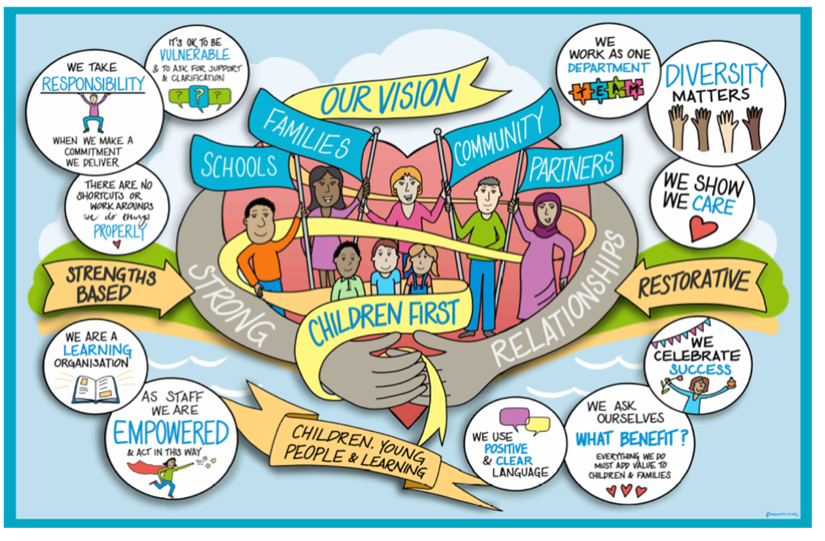

Guidance on suspension and permanent exclusion from schools

In September 2022, the department of education issued updated guidance to schools on the suspension and permanent exclusion. This included guidance on the expected communication with and actions for social workers and the Virtual School. The full guidance can be found here.
Key words:
Suspension – when a pupil is temporarily removed from school. This used to be referred to as a fixed term exclusion
Permanent exclusion – when a pupil is no longer allowed to attend their current school.
Governing Board Meeting (GBM) – a meeting of school governors to review permanent exclusions and long-term suspensions. Within West Sussex this meeting is often referred to as the Governors Disciplinary Committee (GDC)

Children with a social worker (CIN/CP):
- When a child with a social worker is at risk of suspension or permanent exclusion, the headteacher should inform the social worker at the earliest possible time.
- If the decision to suspend or permanently exclude a child is taken, it should be communicated to the parents/carers and the social worker with immediate effect.
- The social worker must be invited to the GBM/GDC and should attend if at all possible. This is to support the family and to share appropriate information and to help the governors understand how the pupils’ circumstances may have influenced their behaviour. It is also helpful to ensure that all safeguarding risks are considered

The Virtual School Advisory Service can offer advice and guidance around pupils at risk of suspension or permanent exclusion. vsas@westsussex.gov.uk

Children we care for:
- When a child we care for is at risk of suspension or permanent exclusion, the headteacher should inform the social worker and the Virtual School as soon as possible. The Virtual School, working with the designated teacher and others, should consider what other assessments and interventions could be utilised to support the child and prevent the suspension of exclusion.
- If a headteacher decides to suspend or permanently exclude a child we care for, they must inform the social worker and the Virtual School head. The Virtual School head and social worker must also be invited to the GBM/GDC.
- As the corporate parent we do not support the exclusion of the children we care for, and all officers will work with schools to try and avoid the permanent exclusion. The Virtual School Head and the social worker should attend the GBM/GDC. This is to share information and to help the Governors understand the pupils background and how this may have contributed to the situation.

Review / Contacts / References
Document title:
Date approved:
Approving body:
Last review date:
Revision history:
Next review date:
Document owner:
Lead contact / author:

