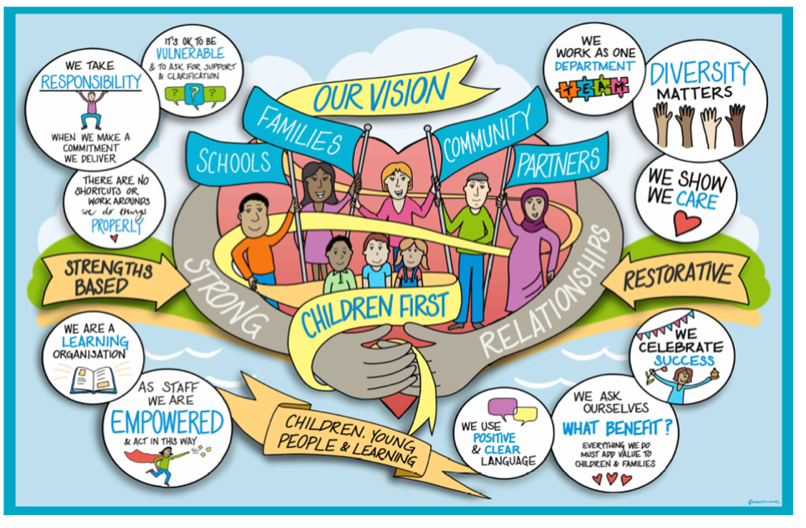

Post 16 Private Fostering Offer Policy

Unless a young person has a disability, private fostering ends at age 16 years. If the child is to remain with their private foster carer after reaching their 16th birthday, they are considered a ‘Qualifying’ young people.
Qualifying young people are defined as young people aged between 16 and 21, or under 25 if in full-time further education or training, who:
- are the subject of a Special Guardianship Order (or were when they reached 18) and were Looked After immediately before the Special Guardianship Order was made, and,
- at any time after 16 (but whilst still a child) have been Looked After or,
- if disabled, have been Privately Fostered after reaching 16, but do not qualify as Eligible, Relevant or Former Relevant.
(Note that the DfE Volume 3: Planning Transition to Adulthood for Care Leavers acknowledges that some ‘Qualifying children’ will be as vulnerable and have similar support needs as those who are Eligible, Relevant or Former Relevant).
In the lead up to the young person’s 16th birthday, West Sussex Children's Services will review the young person's circumstances and future plans, as part of their updating annual assessment, completed in the year following their 15th birthday, either within the Family Programme (for young people with a dual child in need / private fostering status) or within the Private Fostering Annual Assessment and Review. This will consider their needs including both practical and emotional support and living arrangements beyond their 16th birthday.
Where a young person remains with the private foster carers after the age of 16, and is assessed to require continuing support under Section 17 (Children Act 1989), he or she should be assisted as a Child in Need. In the event that a young person will become homeless or will be at risk of homelessness, please refer to Practice Guidance regarding 16/17 yr homeless young people.
As a qualifying child, support can be provided to them from 16 to 25yrs as he or she will fall within the definition of qualifying young people.
The support offered to qualifying young people may include advice, befriending and discretionary financial assistance, where the young person has no other means.
Any support offered to qualifying young people, including financial support, will focus upon helping the young person to manage and cope in the community and to manage the transition to adulthood. Attempts will be made to ensure that they are able to access suitable accommodation and maintain social and family links.
Any financial assistance provided will be to provide support with expenses incurred in living near the place where the young person is, will be, or is seeking work or where they will be receiving education or training; or where the person is in full time further or higher education.
Any request by the young person should be made to the local authority in which they are resident or where the education and training is being provided.
Where necessary, in addition to the support outlined above, practical help should be offered to the young person. This could include helping to acquire basic living skills and consideration of health needs and choices.

Where necessary, links will be made with other services and assistance can be provided when they have to have contact with other agencies. Advice and support should also be offered in relation to employment, training and educational opportunities. The young person will also be signposted to Your Space West Sussex where they can find information and advice for young people aged up to 25 years living in West Sussex including:
- Details of events for young people
- Fact sheets about learning difficulties
- Links with Youth Cabinet
- Opportunities for Youth Consultations
- Advice and Guidance for Education, Training and Employment
(See: Your Space - West Sussex County Council)
Services for Qualifying Young People will be determined by an assessment of need carried out by the Leaving Care Team and can continue up to the age of 25 or if the young person is in higher education, up to the end of the course. Note that in these circumstances, the young person's social worker can also help to identify, secure and pay for vacation accommodation, for those qualifying young people who have accessed higher education, or residential further education courses.
Approval for the provision of such financial support must be sought by the young person's social worker by making a written request to the Service Manager (Leaving Care). The request should specify the type of financial support sought, the reason for the request and the total cost involved.
(See: Link to West Sussex Local Offer)

Review / Contacts / References
Document title: | Post 16 Private Fostering Offer Policy
Date approved: | 27 October 2022
Approving body: | Policy and Practice Steering Group
Last review date:
Revision history:
Next review date: | 27 October 2024
Document owner: | Rebecca Walsh – Head of Service Family Safeguarding
Lead contact / author: | Moira Keen – Service Manager Family Safegaurding

