**cid:image001.png@01D38BC9.198C9F90**

**Parenting Assessment Plan for XX**

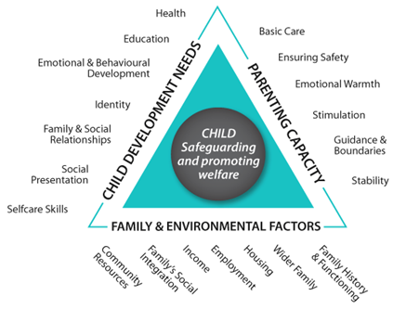

**Assessment Details**

|  |  |
| --- | --- |
| Social Worker undertaking assessment: |  |
| Team Manager: |  |
| Assessment Start Date: |  |
| Assessment completion date |  |

**Family Composition.**

|  |  |  |  |  |
| --- | --- | --- | --- | --- |
| **Name** | **DOB** | **Relationship to child** | **Legal Status/ Plan Type** | **Address** |
|  |  |  |  |  |
|  |  |  |  |  |
|  |  |  |  |  |
|  |  |  |  |  |
|  |  |  |  |  |
|  |  |  |  |  |

1. **Purpose of Assessment.** *Reason for assessment, specific issues that are being assessed. Confirm parents understand the purpose of the assessment. The purpose of an assessment is to identify and analyse a child’s needs, to consider any risks, or harm being suffered and what level of support and intervention is required to improve the child’s outcomes and welfare and where necessary to make them safe****.***
2. **Sources of Information and Plan.** *child and family members to be seen by Social Worker (specific to the assessment*
3. **Formal assessment, intervention and support sessions are to be completed**. To Include observations of the child or children

The following areas will be covered in using the template assessment model

* Background and Current Situation
* Profile of the Parent(s)
* Domain of Parenting Capacity
  + *Basic Care*
  + *Ensuring Safety*
  + *Emotional Warmth*
  + *Stimulation*
  + *Guidance and Boundaries*
  + *Stability*
* *Analysis of parent’s understanding and acceptance of worries/concerns identified within the domain of parenting capacity.*
* Domain of Family History and Functioning
  + Family History and Functioning
  + Wider Family
  + Housing
  + Employment and Money Management
  + Family’s Social Integration
  + Parent/s understanding and acceptance of worries/concerns identified within the domain of Family History and Functioning.
* Domain of Child’s Development Needs
  + *Health*
  + *Education*
  + *Emotional and Behavioural Development*
  + *Identity*
  + *Family and Social Relationships*
  + *Social Presentation and Self-Care Skills*
* Analysis of parent’s understanding and acceptance of worries/concerns identified for the domain of child development needs.
* Child’s Wishes and Feelings
* Analysis of Capacity to Change

* Analysis of Current Risk to Children and Future Harm
* Recommendations and Plan

1. **Assessment dates, details and other professional consulted and contribution**

|  |  |  |
| --- | --- | --- |
| **Date** | **Details of Session** | **Location** |
|  |  |  |
|  |  |  |
|  |  |  |
|  |  |  |
|  |  |  |
|  |  |  |
|  |  |  |
|  |  |  |

Social Worker

Team Manager

Dated