Adult Social Care and Health Directorate

Residential and nursing homes placements

Practice Guidance
Ending a third party top up agreement

Issue Date: | November 2021
Review Date: | November 2023
Owner: | Policy and Quality Assurance Team

Document Information

Working Title: | Ending a third party top up agreement
Status: | Final
Version No: | 1
Date Approved by | SMT on 16 /11/21
Date Issued | November 2021
Review by: | Policy and Quality Assurance Team
Review Date | November 2023
Lead Officer/s: | Jean Wells
Master Location | Policy and Quality Assurance Team (BDU)
Publication | Tri-X
Authorised to vary | Sarah Denson/Jean Wells
Replaces | New

Version control

Version | Date re issued | Summary changes | Reviewed by

References

Care Act (2014) Click here
Care and Support Statutory Guidance issues with the Care Act. Click here
The Care and Support and After-care (Choice of Accommodation) Regulations 2014.
Click here
Care and Support Statutory Guidance Annex A -(Choice of accommodation and additional payments). Click here
for authorisation levels check the “Authorisation (of Funding) levels policy”
https://kentcountycouncil.sharepoint.com/sites/KNet/asch/asch-documents/Authorisation%20(of%20funding)%20Levels%20Policy%202020.pdf

Contents
1. Introduction 4
2. National Guidance 5
3. Practice Guidance 6

- Action
  - Step one. Find out the issue.
  - Step two. Keep people informed.
  - Step three. Decision options.
3.4. Step four. Implement decision.

Appendices .......................................................................................................................... 9
- Summary action flowchart
- Correspondence outline (adapt accordingly)
- Remaining in the care home - wellbeing principles

PRACTICE GUIDANCE

1. Introduction.

1.1 The following guidance only applies when a third party top up arrangement fails for any reason, including when Kent County Council (KCC) becomes aware the agreed top up amount is no longer sustainable.

1.2 When a person is placed by adult social care in residential or nursing care (from this point of the guidance on will be referred to as “care home”), it is expected that they will make a contribution towards the cost of their care. How much they pay depends on their financial circumstances.

1.3 Sometimes a person (or their representative LPA – Health and Welfare) may choose a care home which costs more than KCC expects to pay to meet the persons level of needs. When this happens, another person (called a ‘third party’) has to agree to pay the difference (called a ‘top up’) and keep up those payments on a regular basis for as long as required.

1.4 When KCC has decided to proceed with this top up arrangement, subject to being satisfied of the third party (from this point of the guidance on will be referred to as the ”payer”) ability to meet the top up payments on an ongoing basis, the payer is required to complete and sign a ‘Third Party Top-up Agreement’ ((from this point of the guidance on will be referred to as “agreement”).

1.5 The payer pays the top-up amount to KCC through a 4 weekly arrangement using their chosen payment method. KCC then pays the full care home fees amount to the provider. Top ups are not (must not be) paid directly to the provider.

1.6 The arrangements to meet the cost of the top up will be reviewed at least annually in line with the wider reviews of the care and support plan. Any party can request a review of the arrangement at any time.

1.7 Sometimes payments are not maintained. If there is a break down in the top up arrangement/payment, KCC is liable for the care home fees until it has either recovered the additional costs it incurs or made alternative arrangements to meet the cared for person’s needs (see section 3: step three below for other options).

2. National Guidance

Care Act (2014)
2
.
1

s30 (2) The regulations may provide for the adult or a person of a specified description to pay for some or all of the additional cost in specified cases or circumstances.
(3) “Additional cost” means the cost of providing or arranging for the provision of the preferred accommodation less that part of the amount specified in the personal budget for the purposes of section 26(1)(a) that relates to the provision of accommodation of that type.

2.2 The Care and Support and After-care (Choice of Accommodation) Regulations 2014
The additional cost condition.
5.—(1) The additional cost condition is met if— (a) the local authority is satisfied that— (i) a person other than the adult, or
(ii) in a case to which paragraph (5) applies, the adult,
(“the payer”) is able and willing to pay the additional cost of the preferred accommodation for the period during which the local authority expects to meet the adult’s needs by providing or arranging for the provision of that accommodation; and
(b) the payer enters a written agreement with the local authority in which the payer agrees to pay the additional cost.
(2) The local authority must provide the payer with access to sufficient information and advice to enable the payer to understand the terms of the proposed written agreement before entering into it.

2.3 Care and Support Statutory Guidance Annex A -(Choice of accommodation and additional payments)
2) The care and support planning process will have determined what type of accommodation will best suit the person’s needs……Where this is the case, …. local authorities should have regard to the following principles:……
•clear understanding of potential consequences should ‘top-up’ arrangements fail with clear exit strategies
33) The local authority must make clear in writing the consequences should there be a break down in the arrangement to meet the cost of the ‘top-up’…... As with any change of circumstance, a local authority must undertake a new assessment before considering this course of action, including consideration of a requirement for an assessment of health needs, and have regard to the person’s wellbeing.
3. Practice Guidance

Action
3.1 Step one: Find out the issue.
3.1.1 When a debt is accruing, before steps are taken by KCC to end the agreement, the circumstances must be fully explored by the practitioner to determine the reasons for non-payment. The practitioner must liaise with the Debt Recovery Team appropriately.
3.1.2 When the payer informs KCC of a change to their personal circumstances impacting on their ability or willingness to continue to pay the top up amount, the agreement, actioned by the practitioner, will either:
- end
- be suspended
- be reviewed to reduce the top up amount (temporarily or permanently).

3.1.3 In addition to the payer accruing a debt or expected change to the payers’ personal circumstances, there may be a number of other reasons for revising/ending an agreement including, but not limited to:
- care home no longer suitable to meet the person’s needs
- care home no longer available
- care home fails to honour its contractual conditions with KCC
- change in provider costs
- person chooses to move to another care home.
- change in circumstances for the cared for person
- safeguarding concerns about the provider (CQC enforcement to move)
- agreement not signed
- payer deceased
- person is now eligible for NHS Continuing Healthcare
- alternative funding arrangements

3.2 Step two: Keeping people informed.
Practitioner will:
- keep in touch with the payer
- notify Client Financial Services of any change to the third party top up amount
- keep Debt Recovery Team informed (part of Client Financial Services)
- update the persons System Record

3.3 Step three: The decision options (no particular order).
- The person remains in the care home. A risk assessment demonstrates that a move to another care home will be detrimental to aspects of the person’s wellbeing or outcomes most relevant to them (See Appendix 3). Agreement ends. Exceed the guide price process applies.
- Make alternative care home arrangements. Before considering this course of action the practitioner must undertake a proportionate review and reassessment of needs if required, including consideration of a requirement for an assessment of health needs (e.g. NHS continuing healthcare checklist).
- Suspend or reduce the third party top up. KCC decision to either suspend the top up payment or reduce the top up amount either temporarily or permanently. Person remains in the care home.
- Identify another suitable and willing third party. It may be possible to identify another suitable and willing third party. Third party top ups can be shared with siblings. The new payer/s required to complete a new agreement. The new payer/s will be subject to a third party light touch financial assessment, undertaken by the County Placement Team.
3.4 Step four: implement decision.

Option | Decision | Action for the adult social care practitioner unless otherwise stated.
a) | The person remains in the care home | - Undertake a risk assessment (i.e., is it detrimental to move - See Appendix 3 for considerations)  - Review and revise care and support plan accordingly.  - Follow exceed the guide price normal process.  - Follow normal process to increase personal budget to cover the full care home fees.  - Normal System Recording process
b) | Make  alternative care home arrangements | - Subject to a review and reassessment of needs if required.  - As with any change in circumstances that affects the content of the care and support plan, revise the plan and personal budget accordingly.  - Notify Client Financial Services.  - Inform County Placement Team.  - Practitioner to liaise with Debt Recovery Team in Client Financial Services about seeking to recover any outstanding debt.  - Normal System Record process.
c) | Suspend or reduce the top  up  (Appendix 1 summary  actions and Appendix 2 suggested correspondence wording). | - Refer to Authorisation (of funding) levels policy  - Agree how long the temporary arrangement (should not exceed a 52-week period depending on the circumstances). The arrangement must be reviewed by the practitioner at 8 weeks, then regularly thereafter.  - Notify Client Financial Services of the change of third party top up amount – normal workflow process.  - Correspond with the payer to acknowledge payer telling KCC (adult social care) about their financial hardship to pay the third party top up and the issue (as KCC understands it).  - Inform the payer (in writing within 10 working days) of the decision including telling payer the suspension end date and what will happen at the end date.  - Maintain contact with payer to discuss current circumstances. Has anything changed? Update case note. (If original decision requires review - see step three above for other options.  - If review not required, reaffirm end date with payer.  - Reminder (in writing) to payer the suspension coming to an end.
 |  | • Update System Record.
d) | Another suitable and willing third party | - Practitioner to undertake wider conversations with the cared for family (if appropriate) to agree another payer. Follow normal process for ending and setting up a new third party top up.  - County Placement Team responsible for undertaking the third-party light touch financial assessment, coordinating the completion, return (signed) and dissemination of the Third Party Top Up Letter/ Agreement.

Appendix 1. Summary ending/reviewing the Third Party Top Up
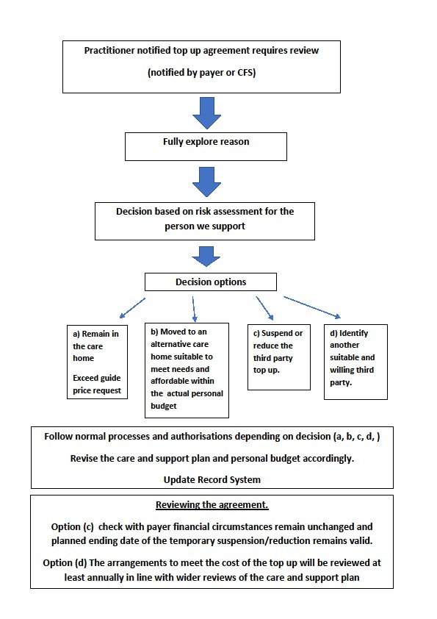

Appendix 2
Correspondence. Amend as required. Consider accessibility

Acknowledgement to suspend or reduce the top up amount
Thank you for letting us know about the temporary change in your financial circumstances which has/will affect/ed your ability to continue to pay the third party top up amount. You have explained that ……. (add the detail)
1.
2.
We will be in touch within the next 10 days to let you know what will happen next.

Option 1 letter: Follow up correspondence (relating to either suspending or temporarily reducing the top up amount)
I am writing in reference to the Third Party Top Up agreement that you entered for (name) on (dd/m/yyyy)
Further to my previous correspondence, I am writing to let you know the third party top up amount will be (suspended or reduced) on xx and restart on xx using your chosen payment method.
If the temporary change to your financial circumstances is unlikely to be resolved by the restart date, you must let us know. We will then consider other options.

Option 2 letter. Follow up correspondence (relating to either suspending or temporarily reducing the top up amount)
I am writing in reference to the Third Party Top Up agreement that you entered for (name) on (dd/m/yyyy)
You have contacted us to request (end or suspend or reduce). The agreement that you had entered into is now void and we are reviewing your change of circumstances in conjunction with the care and support needs of (name)
I wanted to take this opportunity to explain to you the next steps we will take: 1) and 2) …

Appendix 3. Remaining in the care home

This appendix will help practitioners to think through issues related to a person’s wellbeing when undertaking a risk assessment. This will support practitioners to demonstrate their reasoning for any subsequent decisions made.

Thinking about: Could the move be detrimental to a person’s wellbeing?

The wellbeing principles of the Care Act 2014 are underpinned by respect for people’s dignity and autonomy and their right to freedom from inhuman treatment (Article 3 European Convention on Human Rights):
Practitioner to consider:
- person’s need for social contact and emotional support
- the extent of their existing local social network
- how vital contact with family/ friends is to the person’s health and wellbeing - i.e., to meeting their needs and/or Article 8 European Convention on Human Rights: right to a private and family life
- physical frailty and disability for some visiting relatives/friends. This may be a limiting factor for some and for others cost will be a factor
Having considered the factors above, the practitioner may need to have what could be difficult conversations with family members with the aim of finding the best solutions for the person when neither party can afford to continue supporting the person within the care home where they currently reside.

Practitioners will need to engage everyone in considering that there may be mitigations to take into consideration to support a move such as:

- when thinking about contact with loved ones, consider paying for transport for family member(s) which may prove a more cost-effective option than the person staying in the home.
- Consider use of technology such as a Kara device to enable virtual calls between visits
- Consider what the person particularly likes about the current home and whether this can be replicated elsewhere

