Savings Policy for Children Looked After

Policy Development Officer

Version number | Date updated | Updated by | Review date
Version number 1 | 18/08/2022 | Kayte Luton | 18/08/2024

Contents
1. Introduction 1
2. Purpose 4
3. Legal Context 4
4. Required minimum savings amount 5
5. Responsibilities and Process 6
6. Flowchart- Professionals’ 7
5. Flowchart 2 -Carers and providers 9
5. Flowchart 3 – Children Looked After 10
7. Disability Living Allowance (DLA), Personal Independent Payments (PIP) and Savings 11
7. FAQ’s 13

Introduction

Somerset County Council expects that all carers and partner agencies look after our children in care as any responsible parent would look after their own children. Corporate Parenting has been strengthened by the introduction of some of these principles in the Children and Social Work Act 2017:

…to help those children and young people gain access to, and make the best use of, services provided by the local authority and its relevant partners [and] … to prepare those children and young people for adulthood and independent living.

Somerset County Council wants to help children and young people with the expenses of becoming independent, such as: setting up their own home, moving to supported lodgings, or staying put and remaining with their foster carers. There are two types of saving schemes set up by national government for children and young people who are in care until they are 18. These are the Child Trust Fund (CTF) and Junior ISA (JISA) schemes.

These savings accounts can be paid into by the child or young person, carer, provider, corporate parent, and family members throughout their time in care and are not accessible by the child or young person until they reach the age of 18 years old.

Since 2012 The Share Foundation (TSF), 'Sharefound' for short, have been the government agency that facilitates both these schemes for children and young people in care. From 2nd October 2017, TSF also took over responsibility for the CTF scheme from the Official Solicitor. Somerset County Council work with TSF to ensure these accounts are established. More information can be found here: The Share Foundation

Child Trust Fund (CTF):
Child Trust Funds (CTF's) are tax-free children’s saving accounts set up by government to help ensure that every qualifying child arrives at adulthood with a savings account.

CTF's were available to children born between 1 September 2002 and 2 January 2011. Eligibility for CTF accounts was discontinued in 2010 for any child born on or after 3 January 2011.

Children born before 1 September 2002 were also not eligible for a CTF.

The government make a £250 initial contribution via a voucher which is sent to the person with parental responsibility for the child. The voucher is used to open the account. For those who are a Child Looked After (CLA), The Share Foundation (TSF) manages this for the Local Authority. Anyone can pay money into the accounts, but the funds cannot then be accessed by the account holder until their 18th birthday. At this age, the account will mature into a standard (adult) account.

For those children or young people whom have a CTF, TSF have attempted to locate where and whom holds each account. There are tools available to help young people link to their accounts which SCC Finance Assistant, Children's Finance, Peter Coward can provide more information about.

Further guidance about the scheme is available at Child Trust Fund - GOV.UK (www.gov.uk)

Junior ISA (JISA):
JISA's are long term tax-advantaged saving accounts launched in November 2011 for children up to the age of 18 who are not eligible for a Child Trust Fund (CTF). The JISA for looked after children scheme replaces the support previously provided through CTF's. Children are eligible for JISA if they are under 18, resident in the UK, and not eligible for a CTF.

A JISA will be opened for every child (if they do not already have one) who has been looked after for any continuous period of 12 months or more, who is not eligible for a CTF and was born on or after 3 January 2011 or before 1st September 2002.

There is an exception for JISA's. If a child/young person is an Unaccompanied Asylum Seeker (UASC) and born in period that usually means they would be eligible for CTF, TSF will set up a JISA for these children/young people irrespective of their date of birth. They still need to have been in care for a consecutive period of 12 months.

The Government will provide an initial deposit of £200 to open the accounts. Anyone can pay money into the accounts, but the funds cannot then be accessed by the account holder until their 18th birthday. At this age, the account will mature into a standard (adult) ISA.

For those children and young people who become looked after and who don’t have or who have not yet been able to locate their Child Trust (CTF) and or, who are not yet eligible for a JISA to be opened for them (i.e. they have not yet been looked after for a consecutive period of 12 months), it is expected that savings will initially be made by their carer/provider/IFA into a separate savings account in the child’s name, or alternatively, if this is not possible, into a savings account in the name of the carer or provider. Once the child has located their CTF or becomes eligible for a JISA, arrangements to transfer the savings into CTF/JISA should be made, and all ongoing contributions should be made directly into those savings accounts thereafter.

Purpose

This document sets out Somerset County Council's Children and Young People's Service policy on savings for Children Looked After (CLA), as well as identifying our responsibilities regarding the two saving schemes as referenced above. It is also to enable The Share Foundation (TSF) to ensure that entitled looked after children in Somerset receive their CTF and JISA accounts at age 18.

Since May 2005 a monthly return, with the details of all children who have become looked after in that month and were born on or after 1st September 2002, has been sent to the Inland Revenue (since 2017 this has been sent to TSF). This information has been used to identify children who did not have a CTF account and to ensure that one was opened for them. For those born on or after 3rd January 2011 who are not eligible for a CTF and who have been looked after for at least a 12-month continuous period, the same process has been followed and a JISA will have been opened for them.

There are various ways as to how CLA savings are being managed across all forms of care within Somerset whether that be Local Authority or external provision. This policy is designed to streamline savings processes and guide all towards a process to be followed. This policy should be read alongside the following Somerset policies and guidance documents:

Fees and Allowances Booklet/Information which can be found on the Fostering in Somerset Website
Staying Put Policy
Leaving Care Finance Policy
Unaccompanied Asylum-Seeking Children and Trafficked Children Policy
P2I Information, all of which can be found on tri-x.

Legal Context

Section 7 of the Local Authority Social Service Act 1970 requires local authorities, in exercising their social services functions, to act under the general guidance of the Secretary of State. The Department for Education has issued guidance in relation to savings under this Act. Section 3(10) of the Child Trust Funds Act 2004, The Child Trust Funds Regulations 2004 and Section 22 of the Children Act 1989 provide the legal framework of the savings scheme.

Local Authorities have a statutory duty to provide some basic information to TSF about CLA to ensure these children receive their CTF or JISA. Regulation 33 of 27th May 2004 regulations (SI 1450) sets out in full what a local authority’s duties are. The regulations can be accessed from: http://www.legislation.hmso.gov.uk/si/si2004/20041450.htm.

Other Legal documentation referred to are: -
· Section 7 of the Mental Health Act
· Section 20(1)(b) of the Children Act 1989

For the purposes of these Regulations, "looked after children" are as defined by section 22(1) of the Children Act 1989, extended to include a child accommodated by the local authority under section 17 of that Act. This includes children who are looked after under the short break/respite care provisions; however these children are exempt from this policy for reasons outlined in section 3 of this policy.

Required minimum savings amount

Child/young person's age | Minimum weekly savings amount
Ages 0-10 | £4
Ages 11-until their 18th birthday (unless the Young person is 16+ and placed in one of the semi-independent provisions which are excluded, as listed above) | £6

Responsibilities and Process

It is important that children learn about money management, banking and
savings and as such should be supported to also have their own bank account, alongside any CTF/JISA savings account.

Opening a Bank Account

When opening an account for a child or young person, the majority of banks and building societies require an adult to act as a sponsor, particularly for children under the age of 7. This cannot be a member of staff and can be a problem for foster carers
in situations where children/young people move between placements as they would be responsible for transferring the savings account to another adult sponsor, which usually requires both the new and old adult sponsors agreement and signature at the time of transfer.

Some building societies offer suitable accounts for Children and young people aged 7 and above that do not require an adult sponsor to open the account. In these circumstances, an adult will have to accompany them to open the account and
the child or young person will have to provide a form of proof of address and an identity document. Children’s Services, as the corporate parent, recommends that each child/young person has their own account. Children’s Services can provide a proof of address letter (i.e. a letter sent to the child/young person on headed paper) which will be accepted by a building society for this purpose and will ensure each child or young person has birth certificate and or passport for identification.

Carers/key workers should support the opening of a bank account in the child/young person’s name from the age of 7 when they will be able to open one without an adult sponsor. It is expected that all children/young people would have an account by their 14th birthday in readiness for when they reach adulthood and move to independence. These accounts can be used for the management of pocket money and clothing allowances and day-to-day spending. The arrangements for a child opening and managing an account should be discussed with the child, their social worker and parents as appropriate and be set out in the child’s care/pathway
and placement plans.

See flowchart below which applies to all children unless accommodation arrangements for them means they are exempt as per section 3 above.

Where this is the first-time care episode, it is expected that savings deposits are made in line with the above minimum amounts per week, from week 13 of the care of the child commencing. There should be no break in savings being accrued for CLA past this point.

The requirement for and arrangements for making savings will be discussed at the placement planning meeting, on or shortly after the child is placed. This will then be reviewed at the initial and subsequent Child Looked After Review Meetings. For further information about specific circumstances, see FAQ's section below (section 8).

Flowchart- Professionals’

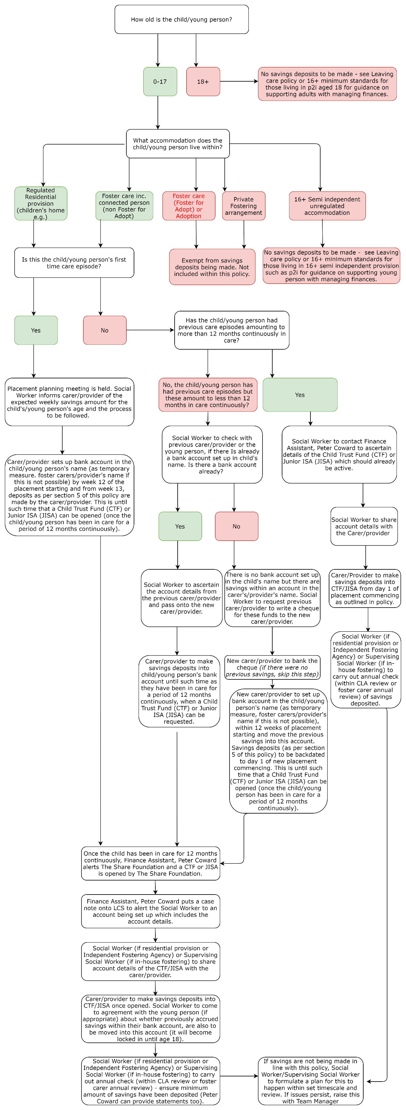

5. Flowchart 2 -Carers and providers

Dependent on the age of the young person in your care and the length of time they have been a Child Looked After (CLA), you may be asked by the child's Social Worker or your Supervising Social Worker to make savings deposits for them each week.

If the child/young person is aged 0-17, you will need to make savings deposits. If they are aged 18+, you will not be expected to make savings deposits. The specific expectations will be outlined within the placement planning meeting by the child's Social Worker/Supervising Social Worker.

Some children/young people will be eligible for either a Child Trust Fund (CTF) or Junior ISA (JISA). This is dependent on whether they have been in care for a consecutive 12 month period.

If you are a carer from an Independent Fostering Agency (IFA), your agency may have it's own savings policy in place to follow.

The below simple flowchart explains the process generically:

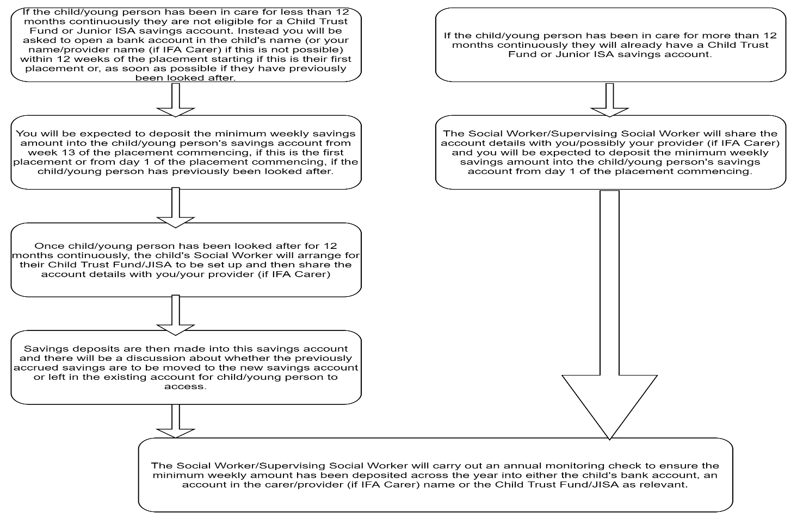

If the placement ends, and there are savings in your name, please arrange with the Social Worker to transfer the funds to either the child or the Council.

5. Flowchart 3 – Children Looked After

Somerset County Council wants to help children and young people with the cost of becoming independent, such as: setting up their own home, moving to supported lodgings, or staying put and remaining with their foster carers.

All Children Looked After (CLA), who live in either foster care or a children's home are able to have savings made for them from week 13 of coming into care until they turn 18. Once you have been, a CLA for 12 months consecutively (no break in you being in care), you are able to have either a Child Trust Fund (CTF) or Junior ISA (JISA) savings account opened for you. When you were born decides which one and the Council sets it up for you.

These savings accounts can be paid into by you, your carer, a care provider (if you are in a residential children's home or what we call an independent fostering agency), your corporate parent and family members throughout your time in care. These accounts are made available to you when you become 18 years old and move with you if you change placement.

The below simple flow chart explains the process:
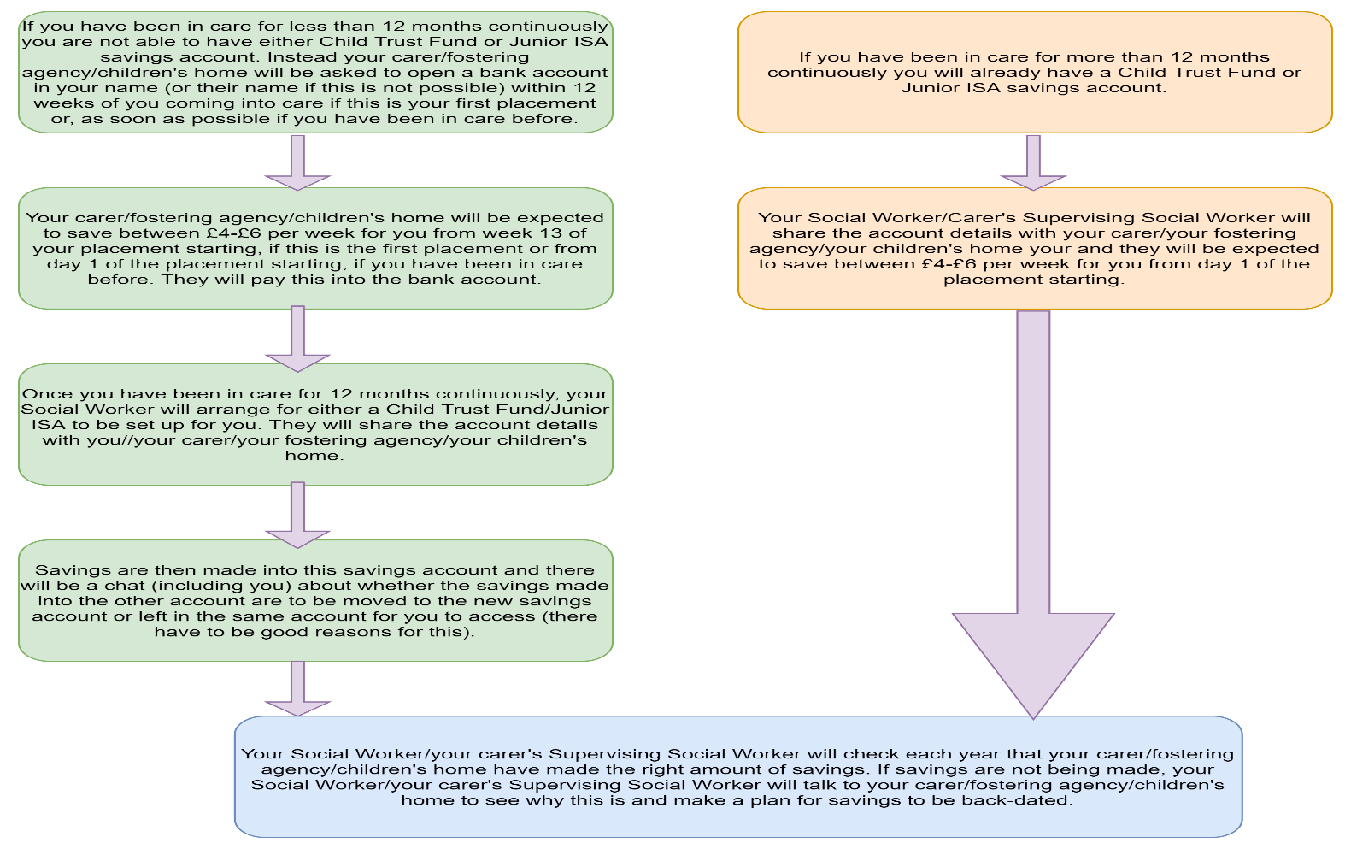

Disability Living Allowance (DLA), Personal Independent Payments (PIP) and Savings

DLA 0-16 years
A child in care with extra needs or disabilities may be eligible for DLA for children as this helps with the extra costs of looking after a child. See here for more information: Disability Living Allowance (DLA) for children: DLA rates for children - GOV.UK (www.gov.uk)

DLA can be applied for by foster carers on behalf of the child they are caring for, on behalf of Somerset County Council. Payments should be used to support the care arrangements for the child, for example specific equipment, travel to and from health appointments and therapy. In addition, DLA is for assistance or help with children’s care needs for holidays, where special equipment or assistance is required or activities where assistance is needed.

It is good practice for foster carers to communicate with professionals involved, regarding how the DLA has been used to benefit the child. We trust all of our foster carers, to utilise the DLA to help care for children and spent on additional needs.

Receipt of DLA does not affect Somerset County Councils' requirement for all foster carers/providers to deposit savings for the child(ren) in their care. Children and young people who are entitled to DLA should still accrue savings within their CTF/JISA as outlined within this policy.

PIP (Personal Independent Payment) 16+
PIP can be applied for by the young person in their own right if they have the mental capacity to manage their own money at 16 years. Foster carers/providers can be nominated to support with the phone call made to apply for the payment, but the young person needs to be present at the time.
This assessment can be carried out by a medical or social care professional preferably who is known to the young person. If deemed that the young person does not have capacity to manage their own money, the foster carer can apply for an Appointee-ship which will enable the foster carer to take care of the young person’s allowance. This process will change again at the age of 18 years where a Power Of Attorney will need to be sought if the young person continues to remain in the care of the foster carer, this will be sought by the Local Authority.
As money from these benefits will need to be accessed at regular intervals for daily living expenses, it is not advised that payments are deposited into the CTF or JISA a child may have. It is advisable for these payments to go into a separate bank account for the child/young person to be able to access as and when needed.
Receipt of PIP does not affect Somerset County Councils' requirement for all foster carers/providers to deposit savings for the child(ren) in their care. Children and young people who are entitled to PIP should still accrue savings within their CTF/JISA as outlined within this policy.

FAQ’s

Accessing a Child Trust Fund or Junior ISA:
At age 18 young people become entitled to access their account. The young person can decide to either move their account to another provider or withdraw the funds and close their account. The account cannot remain with TSF past 18.

During the month before the young person turns 18, TSF provides the Finance Assistant, Children's Finance with a letter detailing options for their CTF/JISA (for CTF this will be at age 16). The Finance Officer shares this with the Social Worker/Leaving Care Worker wo is expected to share with the young person and support them to access their account and make decisions about this going forwards.

If there are safeguarding concerns about a large amount of savings being accessible to the young person/adult, professionals supporting them need to consider how they can assist with building knowledge about using this money appropriately e.g. not sharing with friends about how much money they have etc.

When a child leaves the care of the Local Authority:
When a child leaves its care, a local authority should encourage the child or the new carers of the child to take an interest in their Child Trust Fund/Junior ISA account. For example, if the child returns home, parents should be advised to contact The Share Foundation to get the details of their child’s CTF/JISA account so that they can take an active role in the account.

For those who become a care leaver, the Pathway Plan coordinated by the Leaving Care Worker currently maps out a route to independence including assessing and meeting their financial needs. The Child Trust Fund/JISA should be included automatically into this financial assessment of their needs.

If a child/young person moves placement out of county, the responsibility remains with Somerset LA. If a child/young person changes Local Authority area permanently, the Local Authority with legal responsibility for the child takes over responsibility for savings (CTF and JISA).

In the event a child dies whilst they are looked after or are a former relevant care leaver:
In the event a child/young person dies and has a Junior ISA in their name, the savings accrued form part of their estate. The Share Foundation will issue Somerset County Council (The Children's Finance Assistant, ) with a letter outlining what happens next. This will be shared with the child/young person's Social Worker/Leaving Care Worker and includes a letter and claim form to forward onto the child/young person's personal representatives. On return of the claim form, The Share Foundation will ensure payment is made to the relevant named person.

Savings made in alternative accounts for children/young people not eligible for a CTF or JISA (this should only apply to children who have not had a continuous period of care for 12 months)

Turning 18 at the same time as being in care for 12 months:
Where a young person turns 18 around the same time as they have been in care for 12 months, TSF do not have sufficient time to set up a JISA (they need to request the funding from the DfE then set up an account which can take a few weeks). In these circumstances, TSF will offer a cheque to the young person via SCC (if they do not have a bank account, the young person will need to open one in order to bank the cheque) in lieu of the initial deposit (£200) and this can be paid directly to the young person.

Children and young people who have been in residential provision and have been CLA for less than 12 months with provider making savings deposits:
If children and young people have been in residential provision and have been a CLA for less than 12 months and the provider has been saving into an agency bank account for them and they have not been eligible for a CTF/JISA, the funds will need to be transferred to an account held by the new carer or the child’s own savings account (if they have one). In the event that this is not possible, the funds will need to be returned to the Local Authority, who will make arrangements for the funds to be transferred into a suitable savings account/JISA at a later date. In these circumstances, the amount of savings should be recorded on the child’s file and arrangements for transferring the funds should be reviewed in the CLA review/ Foster Carer annual review meetings.

Young person has been in care for 12 months' or more but this has been sporadic and not continuous:
A Young person doesn’t become eligible for a Child Trust Fund or Junior ISA until they have been in care for a period of 12 continuous months. Once the child/young person has been in care for 13 weeks, the carer/provider should be making savings deposits for them into an alternative bank account. This should be annually monitored through CLA reviews/Foster Carer annual reviews as relevant and in line with the flowchart.

Child/Young person has not had a continuous period of care for 12 months and returns home:
If the child or young person does not become eligible for a Child Trust Fund or JISA and returns home, the child’s parents should be encouraged to open a suitable ISA or savings account on behalf of their child so that any savings accumulated on behalf of the child can be transferred to the child.
Child/Young person has not had a continuous period of care for 12 months and is adopted, or placed with approved kinship or connected carers:
If the child or young person does not become eligible for a Child Trust Fund or JISA and is adopted or placed with kinship or connected carers, the child’s new carers should be encouraged to open a suitable ISA or savings account on behalf of their child so that any savings accumulated on behalf of the child can be transferred to the child. If the child or young person’s name has changed, the child’s Social Worker to advise Business Support who in turn will contact TSF to make the necessary amendments to the JISA/CTF.
Unaccompanied Asylum Seeking Children (UASC) and CTF/JISA:
If the cheques are for an UASC and they do not have a bank account, TSF will unfortunately not make any alternative payment arrangements. All cheques will be made payable to the young person's name only. In these cases the only way seems to be for the young person to go to cash converters, or the like, to access the money (in doing so they will lose an admin fee).

